Jihad Report
Jan 14, 2017 -
Jan 20, 2017
Attacks | 37
Killed | 389
Injured | 392
Suicide Blasts | 9
Countries | 13

The Gold Backed Dollar
On August 15, 1971, President Nixon killed the last remnants of the gold standard.
Since then, the dollar has been a pure fiat currency, allowing the Fed to print as many dollars as it pleases. Removing the US dollar’s last link to gold eliminated the main motivation for foreign countries to store large dollar reserves and to use the dollar for international trade.
At this point, demand for dollars was set to fall… along with the dollar’s purchasing power. So the US government concocted a new arrangement to give foreign countries another compelling reason to hold and use the dollar.
The new arrangement, called the petrodollar system, preserved the dollar’s special status as the world’s reserve currency.
In short, the US government made a series of agreements with Saudi Arabia between 1972 and 1974, which created the petrodollar. The Saudis would use their dominant position in OPEC to ensure that all oil transactions would only happen in US dollars. And the US would guarantee the House of Saud’s survival.
It worked… for a while.
The petrodollar filled the void after the US severed the dollar’s last link to gold as the main prop to the dollar’s status as the world’ premier reserve currency. So far, the petrodollar has lasted over 40 years. However, the glue is losing its stick.
I think we’re on the cusp of another paradigm shift in the international financial system, a change at least as fundamental as what happened in 1971 when Nixon severed the dollar’s last link to gold.
The relationship between Saudi Arabia and the US hit historic lows in 2016. I only expect it to get worse. Trump is the first president since the petrodollar system was enacted to be openly hostile toward the Saudis.
The death of the petrodollar system is my No. 1 black swan event for 2017.
It raises the question: What will fill the void when the petrodollar inevitably dies?
When that happens—and it may be imminent—something has to replace it. I think there are only two options.
Naturally, the global elite want to centralize more power into global institutions. In this case, that means the International Monetary Fund (IMF).
The IMF issues a type of international currency called the “Special Drawing Right,” or SDR.
The SDR is nothing new. The globalists have been slowly building it up since 1969. In the near future, it could be used as the premier international currency—the role the dollar has played since the end of World War 2.
The SDR is simply a basket of other fiat currencies. The US dollar makes up 42%, the euro 31%, the Chinese renminbi 11%, the Japanese yen 8%, and the British pound 8%. It’s a fiat currency based on other fiat currencies… a floating abstraction based on other floating abstractions. The SDR is not based on sound economics or the interests of the common man. It’s just another cockamamie invention of the economic witch doctors in academia and government.
The SDR is dangerous. It gives the government—in this case, a global government—more power. It’s a bridge to a powerful global monetary authority, and eventually a global currency. Most decent people would consider this a bad thing. That’s why the global elite cloud their scheme with dull and opaque names like “Special Drawing Right.”
It’s an old trick. Governments have used it for eons. The Federal Reserve is an excellent example. After two failed central banking experiments in the 1800s, anything associated with a central bank became deeply unpopular with the American public. So, central bank advocates tried a fresh branding strategy.
Rather than call their new central bank the Third Bank of the United States (the previous two were the First and Second Banks of the United States), they gave it a vague and boring name. They called it “the Federal Reserve” and managed to hide it in plain sight from the average person.
Nearly 100 years later, most Americans don’t have the slightest clue what the Federal Reserve is, what it does, or how it has eroded their standard of living. I think the same dynamic is at work with the IMF’s “Special Drawing Right.”
The breakdown of the petrodollar is the perfect excuse for the globalists to usher in their SDR solution.
So that’s the first option. It’s the global elites’ preferred outcome. It would be a very bad thing for personal and economic freedom. It means more fiat currency, more centralization, and less freedom for the individual.
The second option is to simply return to gold as the premier international money. Here’s how it could happen…
Trump might play along with the globalists’ schemes, but I doubt it. He’s the first president who’s openly and sincerely hostile toward globalism. He’s denounced it repeatedly. Trump recently said, “We will no longer surrender this country, or its people, to the false song of globalism.”
In my view, there’s only one way Trump could fight the global elites and their SDR plan: return the dollar to some sort of gold backing.
Trump has said favorable things about gold in the past. So have some of his advisers.
It wouldn’t be easy. He’d face one hell of a struggle with the globalists. And winning would be far from certain. No matter what, the death of the petrodollar, just like the end of the dollar’s link to gold, will be very good for the dollar price of gold and gold mining stocks.
When Nixon took the dollar off gold in 1971, gold skyrocketed over 2,300%. It shot from $35 per ounce to a high of $850 in 1980. Gold mining stocks did even better.
Gold is still bouncing around its lows. Gold mining stocks are still very cheap. I expect returns to be at least as great as they were during that paradigm shift in the international monetary system.
The Last Time the Money Supply Collapsed

The Great Depression: Economic Collapse
In the 1930s, American capitalism practically stopped working.
For more than a decade, from 1929 to 1940, America's free-market economy failed to operate at a level that allowed most Americans to attain economic success. Those of us lucky enough not to have lived through the ordeal of the Great Depression may have a difficult time imagining the unprecedented depths of economic collapse and social disarray that mired America in the 1930s.

Miserable Statistics
The story of the Great Depression can be told with a litany of bleak statistics:
By 1933, the country's GNP had fallen to barely half its 1929 level¹². Industrial production fell by more than half, and construction of new industrial plants fell by more than 90%. Production of automobiles dropped by two-thirds; steel plants operated at 12% of capacity.¹³
During Herbert Hoover's presidency, more than 13 million Americans lost their jobs. Of those, 62% found themselves out of work for longer than a year; 44% longer than two years; 24% longer than three years; and 11% longer than four years.¹⁴Unemployment peaked at a staggering 24.1% in 1933, and never dropped below 14.3% until World War II. (By contrast, the unemployment rate has never surpassed 9.7% since.)¹⁵
The financial meltdown initiated by Wall Street's Great Crash of 1929 caused billions of dollars in assets to vanish into thin air. Wealthy Americans—who owned almost all the nation's stocks at the time—were walloped by an 80% decline in the value of the stock market. Even more troubling to the entire population were rampant bank failures—between 1929 and 1933, two out of every five banks in America collapsed, causing more than $7 billion of their customers' hard-earned money to evaporate.¹⁶

Coolidge, the Cameroons, and Soviet Russia
Ugly as the numbers may be, it's the human stories that truly capture the depths of the crisis:
In 1931, African colonial subjects living in the Cameroons took up a collection to aid the starving people of America, ultimately mailing $3.77 to the mayor of New York City to assist relief efforts there.
Things got so bad, even Calvin Coolidge—whose laissez-faire presidency had fueled the Roaring Twenties' boom and who remains famous for his declaration that "the business of America is business"—lost faith in the free market's ability to fix itself. "In other periods of depression," Coolidge said, "it has always been possible to see some things which were solid and upon which you could base hope, but as I look about, I now see nothing to give ground to hope—nothing of man."¹⁷
Perhaps most incredibly, in 1933 more than 100,000 Americans applied to an office in New York City for a chance to emigrate to a foreign country where they believed they could find better economic opportunities. The country? Josef Stalin's Soviet Union.¹⁸

Poverty of Abundance
What made the miseries of the Great Depression so incomprehensible to those who endured them was the evident fact that the economic collapse had been caused not by want but by material abundance. The problem with American capitalism in the 1930s was that there was too much of everything—too much supply, not enough demand. Too many automobiles, and not enough workers who could afford to buy them. Too much cotton, too much corn, too much pork, too much beef, too much wheat, and not enough buyers able to pay a price that made the crops worth harvesting.
Too many workers needing jobs, and not enough employers to hire them. In the memorable words of FDR's first inaugural address, "our distress comes from no failure of substance. We are stricken by no plague of locusts... Nature still offers her bounty and human efforts have multiplied it. Plenty is at our doorstep, but a generous use of it languishes in the very sight of supply."
But why? American capitalism had never endured such a profound or long-lasting market failure before. What caused an ordinary downturn in the business cycle after 1929 to devolve into the Great Depression? Roosevelt's own initial explanation—to blame the entire crisis on the "stubbornness" and "incompetence" of "the rulers of the exchange of mankind's goods... [and] unscrupulous money changers"—was hardly compelling. Scapegoating big businessmen and stock-market speculators may have been politically useful, but the true roots of the Great Depression clearly lay in deeper structural problems in the American economy.

Explaining the Depression: Competing Theories
There has never been one consensus explanation for the Great Depression. Since 1929, economists and historians have developed a number of competing theories to explain the American economy's disastrous performance in the 1930s, and their debates over the true causes of the Depression—which have profound public-policy implications even today—have often been quite contentious.
At first, economists schooled in the laissez-faire tradition regarded the Crash of 1929 as an entirely natural—and perhaps even desirable—consequence of Roaring Twenties affluence. Throughout the nineteenth century, every economic boom had been followed by a bust, leading many to view the business cycle as a virtual law of nature—what goes up must come down. In 1930, Herbert Hoover's Treasury Secretary, Andrew Mellon, suggested that the end of the 1920s boom was not only inevitable but beneficial. "It will purge the rottenness out of the system," he said. "High costs of living and high living will come down. People will work harder, live a moral life. Values will be adjusted, and enterprising people will pick up the wrecks from less competent people." Classical economic theory taught that after a brief (if painful) period of liquidation of over-inflated assets, the economy would soon reestablish equilibrium at full employment and growth would resume.
But as the Depression only worsened through the first years of the 1930s, many began to doubt the classical economists' faith in the market's long-run ability to correct itself. "In the long run we're all dead," protested British economist John Maynard Keynes. "Economists set themselves too easy, too useless a task if in tempestuous seasons they can only tell us that when the storm is long past the ocean is flat again." In his massively influential General Theory of Employment, Interest and Money (1936), Keynes suggested that the Great Depression had been caused by a broad failure of aggregate demand across the economy, which created a new equilibrium at less than full employment—a situation in which Depression conditions might persist indefinitely. In order to increase aggregate demand and get the economy moving again, Keynes argued that the government should massively increase its own spending in times of economic distress, even if it meant running a significant budget deficit.
While most of the key players in the Roosevelt administration were initially skeptical of Keynes's theories, the New Deal did end up taking on a broadly Keynesian quality, characterized by major and unprecedented government interventions into the economy. Keynesian ideas went on to dominate academic and government thinking about political economy through the 1960s.
The Keynesian explanation for the Great Depression came under came under heavy fire in 1963, when Milton Friedman and Anna Schwartz published A Monetary History of the United States. Free-market economists philosophically opposed to the heavy government interventionism unleashed by Keynesianism, Friedman and Schwartz made a compelling argument that the Great Depression had been caused less by a failure of aggregate demand than by a sharp constriction in the nation's money supply.
Foolish decisions by the Federal Reserve, they argued, combined with hoarding of cash by individuals fearful of bank failures, caused the stock of money circulating in the economy to fall by one-third between 1929 and 1933. This "Great Contraction," as Friedman called it, had a choking effect on employment, incomes, and prices, unnecessarily prolonging the Great Depression by years. The New Deal's Keynesian intrusion into the free market had done little to address the underlying money problem; a savvier monetary policy from the Federal Reserve, Friedman suggested, would have provided better medicine for America's economic sickness during the Great Depression. At first Friedman's monetarist ideas gained little traction in either the academic or political establishment, but since the 1970s the free-market philosophy of Friedmanism has largely displaced Keynesianism to become the dominant economic orthodoxy of our time.
Over the years, historians and economists have explored many variants to the basic Keynesian (aggregate demand) and Friedmanist (monetarism) explanations for the Great Depression. They have blamed the misery of the 1930s on the rigidity of the gold standard, or on the unsustainably unequal distribution of wealth built up through the Roaring Twenties, or on the instability in the American banking system, or on the high tariffs imposed after 1930 that choked off international trade.
While each explanation has its supporters and critics, the truth may be that the best explanation for the Great Depression is... all of the above. After 1929, the American economy did suffer a broad collapse in aggregate demand and a sharp constriction in money supply. The effects of the downturn were amplified by the gold standard and maldistribution of wealth and bank failures and protectionism in trade. The search for one true underlying cause for the Great Depression may, in the end, be something of a chicken and egg problem; what is clear is that, by 1932, just about everything in the American economy was broken.

Micro vs. Macro: Vicious Spirals
In different ways, both Keynesian and Friedmanist explanations for the Great Depression suggest that American capitalism broke down in the 1930s because of a tragic disconnect between the needs of the economy as a whole and the rational economic actions of the individuals struggling to survive within it.
When one farmer struggling to make his mortgage payment encountered falling prices for wheat, his rational response was to produce more wheat to make up the difference. But when millions of farmers did this, the resulting overproduction flooded the market, driving prices so low that no farmers could sell their crops at a price that justified the harvest.
When one factory owner encountered falling demand for his products, his rational response was to cut production and cut costs by laying off workers. But when thousands of factory owners did this, the resulting mass unemployment and poverty drove demand for all their products even lower.
When one worker encountered the high likelihood of losing his job, his rational response was to hoard his money, saving as much and spending as little as he could. But when millions of workers did this, the resulting lack of spending in the consumer economy destroyed markets for goods and thus caused employers to lay off more workers.
When one depositor learned that his bank might fail, potentially wiping out his savings, his rational response was to withdraw all his cash and put it in a shoebox. But when millions of depositors did this, the resulting runs on banks caused rampant bank failures and the constriction of the national money supply.
Deeply entrenched American ideologies held that individual successes or failures were determined by the hard work, prudence, and industriousness of the individual. During the Great Depression, almost the opposite became true—the hard work, industriousness, and prudence of each individual American tended to make the overall problems of the national economy worse. America's economy during the Great Depression became a seemingly intractable vicious spiral, in which the perfectly rational microeconomic decisions of millions of individuals combined to exacerbate the macroeconomic problems of the system as a whole. And the failure of the system made misery for the individual almost inevitable

Collapse Without Revolution
For more than a decade, the American people endured a pitiless, hardscrabble life, victimized by the structural collapse of the American economic system. Millions of American workers wanted jobs but couldn't find them. Millions of American businessmen needed customers but didn't have them. The broken economic system failed them all.
In other countries, similar economic crises had caused revolutions. (Lenin's Russian Revolution in 1917 and Hitler's rise to power in Germany in 1933 both came amidst economic disarray.) Yet, in America, despite the seeming failure of the long-established capitalist system during the Great Depression, there was no revolution.
Why not?

Apathetic Revolutionaries
By the end of Herbert Hoover's presidency, the American people had endured more than three years of ever-deepening economic crisis, and neither the free market nor the federal government had proven able to solve the problem of the Great Depression.
By the time of the bleak winter of 1932-33—which in retrospect proved to be the Depression's darkest hour—Americans were beginning to openly ask whether they might have a revolution. Yet, as the widely read journalist Elmer Davis noticed, they asked the question "apathetically, as if nothing they might do could either help it or hinder it." And apathetic revolutions usually aren't revolutions at all.¹⁹

Structural Failure, Individual Blame
Americans reacted to the breakdown of the American economic system less with revolutionary fervor than with stoic resignation, self-castigation, and, well, depression. As historian David M. Kennedy has written, the Great Depression "revealed one of the perverse implications of American society's vaunted celebration of individualism. In a culture that ascribed all success to individual striving, it seemed to follow axiomatically that failure was due to individual inadequacy."²⁰
The American people, even as they endured the ravages of a failed system, blamed themselves.
In the early days of the Roosevelt administration, federal relief administrator Harry Hopkins dispatched Lorena Hickok—journalist, close confidant of Eleanor Roosevelt, and perhaps also the First Lady's lesbian lover²¹—to travel around the country to report on the conditions of life for ordinary Americans four years into the Depression. Amidst the appalling poverty and destitution that had swept the land, Hickok found old attitudes that had not adjusted to the changed realities of the Great Depression.

"I'm Just No Good, I Guess"
In North Dakota, where ecological misfortune and market failure made it all but impossible for farmers to support themselves, Hickok encountered relief officials "inclined still to think there is something wrong with a man who cannot make a living. They talk so much about 'the undeserving' and 'the bums.'"²² This attitude—ascribing macroeconomic failure to individual faults—was common not only among those giving out the dole, but also among those receiving it. In Texas, Hickok encountered a college-educated schoolteacher, left unemployed after her school district went bankrupt, who told her, "If, with all the advantages I've had, I can't make a living, I'm just no good, I guess."²³
Intellectually, plenty of Americans recognized that individuals' inadequacies could hardly be blamed for the collective misery of the Great Depression. Reading Hickok's reports back in Washington, Harry Hopkins remarked: "Three or four million heads of households don't turn into tramps and cheats overnight, nor do they lose the habits and standards of a lifetime... They don't drink any more than the rest of us, they don't lie any more, they're no lazier than the rest of us.... An eighth or a tenth of the earning population does not change its character which has been generations in the molding, or, if such a change actually occurs, we can scarcely charge it up to personal sin."²⁴
But deeply held cultural attitudes die hard, and even if most Americans could accept the rationality of Hopkins's argument, they still felt like Hickok's Texas schoolteacher. And, needless to say, "I'm just no good, I guess" was not an attitude that lent itself to revolutionary action.
A Badly Design Gold Policy
The Federal Reserve was responsible for providing a stable money supply, but as the chart shows, they failed at that task. The classical gold standard had led Americans to expect 1-4% money supply growth per year. After World War 1 and the establishment of the Federal Reserve, however, the central bank had massive gold reserves and discretion over the money supply. As Eichengreen’s chart shows, money supply growth was rapid in 1923, 1924, and 1925. It returned to relatively normal levels in 1926, 1927, and 1928, and then the Federal Reserve dramatically tightened the money supply in 1929 and 1930 out of fear that stock prices were “too high.” As Friedman and Schwartz put it, the Fed drove the economy into recession in order to pop a nonexistent stock market bubble.
That wasn’t the end of the story, though. The economic trouble in the U.S. spread to other countries. The reason was the international monetary system, called the “gold-exchange standard.” The gold-exchange standard differed from the classical, pre-WW1 gold standard in allowing central banks to maintain lower gold reserves and instead hold dollars and pounds sterling as reserves. As a result, investors couldn’t be sure every country on the new gold standard really could stay on the standard. If they started losing gold reserves, they might just abandon gold convertibility, and then the value of the currency would drop. Many countries lacked credibility, in other words.
The other problem with the gold-exchange standard was enhanced network effects. If Britain went off the gold standard, then the pound sterling would lose much of its value, and so would everyone’s pound sterling reserves. So the countries holding pounds sterling would also have to go off the gold standard, unless they wanted to buy up massive amounts of gold on international markets, which would be costly both for the central bank and for the market (because it would significantly drive down money supply).
When the U.S. contracted the dollar supply, gold flowed to the U.S. as the value of the dollar rose. Foreign holders of gold wanted to invest in the U.S. dollar. But there’s a limited amount of gold in the world. As the U.S. Federal Reserve attracted gold, other central banks lost it. But you can’t keep losing gold and stay on the gold standard. So the other central banks had to reduce their money supplies as well, to attract gold back. With every central bank scrambling for gold by contracting the money supply, they drove all their economies into recession.
Why did monetary contraction lead to recession? The best story for the Great Depression years seems to be sticky wages. Monetary contraction reduced the price level (deflation), which caused real wages to rise, making workers unaffordable. So employers laid off workers, creating persistent unemployment. Figure 3 from Eichengreen shows what happened to prices in some major economies as the global recession deepened.
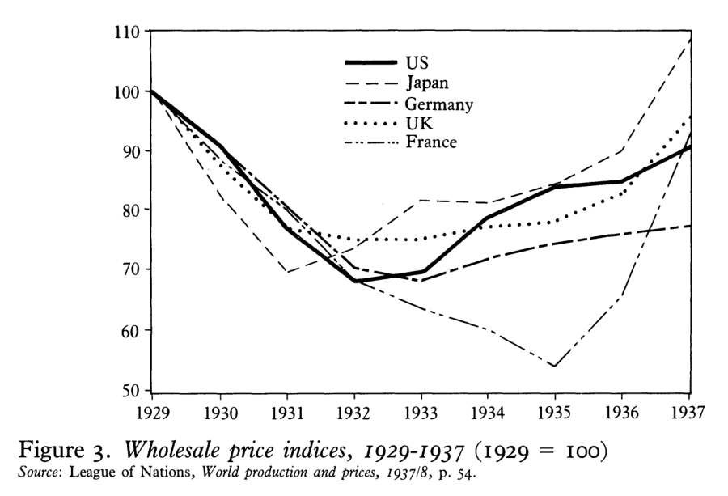
Between 1929 and 1932, prices collapsed by more than 30% in the U.S.! That’s the inevitable result of far less money chasing about the same amount of goods. Note that France saw massive deflation all the way through 1935. France stayed on the gold standard until 1936.
Now look at what happened to wages as the Great Depression set in (Figure 4).
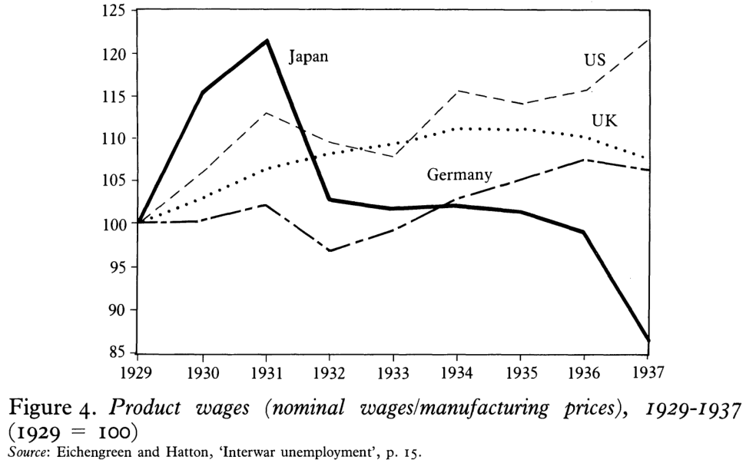
Wages adjusted for deflation rose in all these economies in the first two years of the recession. That’s the last thing you want to happen to wages in a recession. You want wages to fall in a recession so that employers will start wanting to hire again. Check out what happens in the U.S. The U.S. sees real wages rise 20% from 1929 to 1937! No wonder the U.S. had the worst depression of all the major economies: workers couldn’t get jobs at these elevated wages.
Because fewer people were working, industrial production fell (Figure 5). The U.S. had the sharpest decline of these five economies and the second-slowest recovery (after France). Note that Japan left the gold standard early and immediately inflated (depreciated) its currency, and it didn’t even have a significant recession. Britain and Germany went off the gold standard in 1931, depreciated their currencies, and immediately started to recover. The U.S. didn’t go off the gold standard until 1933, and that greatly delayed its recovery.
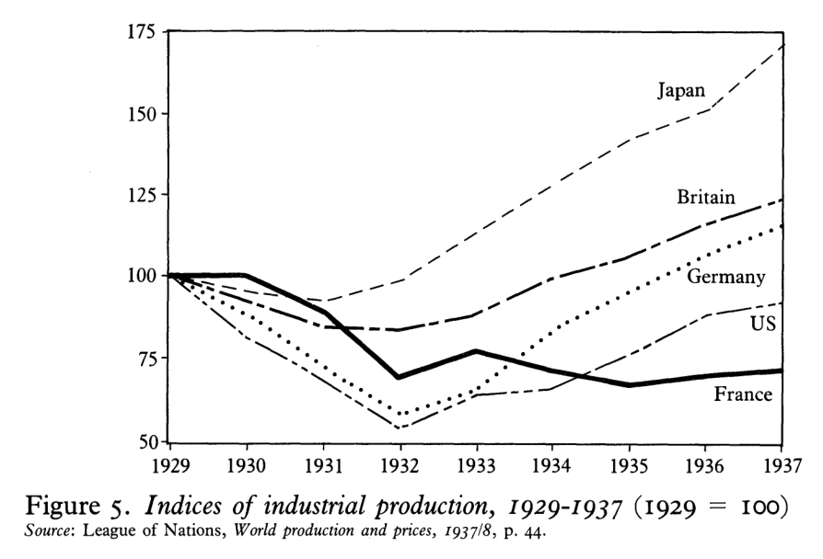
Countries that got off the gold standard earlier recovered more quickly (Table 2). Countries that allowed their currencies to float freely in international markets, where their exchange rates were set by supply and demand, did better than exchange-control countries that tightly regulated people’s ability to convert their money.
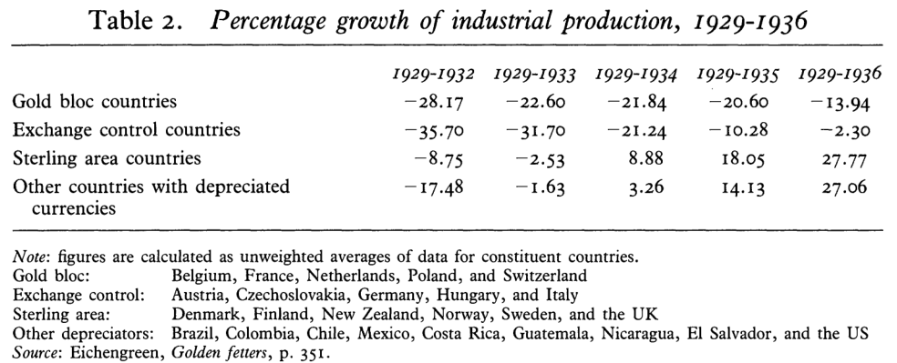
Getting off the gold standard allowed central banks to increase the money supply, causing inflation, reducing real wages, and encouraging hiring (Figure 8). U.S. money supply collapsed between 1929 and early 1933, then started rising again after FDR took the U.S. off the gold standard. By 1937, the U.S. had had the most rapid increase in the money supply of these four economies.
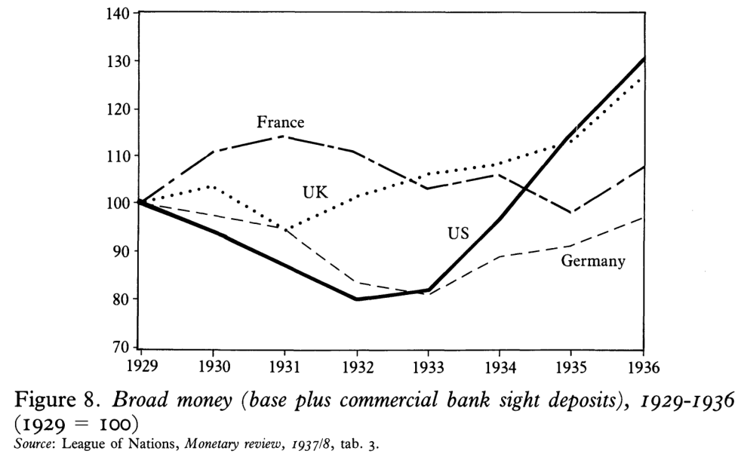
Part of the reason the U.S. had such a huge collapse in money supply in 1931 and 1932 was that the Federal Reserve allowed many banks to fail when they suffered runs. Most of us have seen the movie “It’s a Wonderful Life” in which Jimmy Stewart’s character persuades bank customers to take a small share of their deposited money at once and come back for more later. The bank was profitable, but it didn’t have on hand most of the deposited funds, because it had loaned them out.
Well, prior to the Federal Reserve, banks had done something similar. It was called “suspension of payments,” and it allowed solvent banks to deter runs. The Federal Reserve banned the practice and then allowed solvent banks to fail simply due to illiquidity (not having the required funds on hand). When a bank failed, all the deposits in it disappeared. The money supply fell.
Now, if going off the gold standard helped Japan, Britain, and Germany so much, and staying on the gold standard until 1936 hurt France so much, why was the U.S. recovery from 1933 to 1937 so weak? Let’s think back to that chart showing U.S. real wages climbing year after year during the Depression. There’s a good reason for that. FDR’s New Deal programs were explicitly intended to keep wages high. Back then, they thought this would “stimulate” the economy. How wrong they were. The National Industrial Recovery Act (invalidated by the Supreme Court in 1935) and the National Labor Relations Act that was enacted in 1935 forced large companies to keep prices and wages high. That ended up being a fundamentally wrongheaded policy choice, and it kept the U.S. economy in the doldrums even as other economies made their recovery. By 1938, the Federal Reserve was foolishly tightening monetary policy again, and the U.S. experienced the second-worst year of the Great Depression. The U.S. economy didn’t really emerge from depression until 1946.
So what caused the Great Depression? Bad U.S. monetary policy and a badly designed international gold standard that spread recession from country to country.
GÖdel’s Theory of Incompleteness
Giving a mathematically precise statement of Godel's Incompleteness Theorem would only obscure its important intuitive content from almost anyone who is not a specialist in mathematical logic. So instead, I will rephrase and simplify it in the language of computers.
Imagine that we have access to a very powerful computer called Oracle. As do the computers with which we are familiar, Oracle asks that the user "inputs" instructions that follow precise rules and it supplies the "output" or answer in a way that also follows these rules. The same input will always produce the same output. The input and output are written as integers (or whole numbers) and Oracle performs only the usual operations of addition, subtraction, multiplication and division (when possible). Unlike ordinary computers, there are no concerns regarding efficiency or time. Oracle will carry out properly given instructions no matter how long it takes and it will stop only when they are executed--even if it takes more than a million years.
Let's consider a simple example. Remember that a positive integer (let's call it N) that is bigger than 1 is called a prime number if it is not divisible by any positive integer besides 1 and N. How would you ask Oracle to decide if N is prime? Tell it to divide N by every integer between 1 and N-1 and to stop when the division comes out evenly or it reaches N-1. (Actually, you can stop if it reaches the square root of N. If there have been no even divisions of N at that point, then N is prime.)
What Godel's theorem says is that there are properly posed questions involving only the arithmetic of integers that Oracle cannot answer. In other words, there are statements that--although inputted properly--Oracle cannot evaluate to decide if they are true or false. Such assertions are called undecidable, and are very complicated. And if you were to bring one to Dr. Godel, he would explain to you that such assertions will always exist.
Even if you were given an "improved" model of Oracle, call it OracleT, in which a particular undecidable statement, UD, is decreed true, another undecidable statement would be generated to take its place. More puzzling yet, you might also be given another "improved" model of Oracle, call it OracleF, in which UD would be decreed false. Regardless, this model too would generate other undecidable statements, and might yield results that differed from OracleT's, but were equally valid.
Do you find this shocking and close to paradoxical? It was even more shocking to the mathematical world in 1931, when Godel unveiled his incompleteness theorem. Godel did not phrase his result in the language of computers. He worked in a definite logical system and mathematicians hoped that his result depended on the peculiarities of that system. But in the next decade or so, a number of mathematicians--including Stephen C. Kleene, Emil Post, J.B. Rosser and Alan Turing--showed that it did not.
Research on the consequences of this great theorem continues to this day. Anyone with Internet access using a search engine like Alta Vista can find several hundred articles of highly varying quality on Godel's Theorem. Among the best things to read, though, is Godel's Proof by Ernest Nagel and James R. Newman, published in 1958 and released in paperback by New York University Press in 1983.
There cannot be separate objects or entities that have all their properties in common. That is, entities x and y are identical if every predicate possessed by x is also possessed by y and vice versa; to suppose two things indiscernible is to suppose the same thing under two names.
Gödel, Escher, Bach: An Eternal Golden Braid, also known as GEB, is a 1979 book by Douglas Hofstadter. The tagline "a metaphorical fugue on minds and machines in the spirit of Lewis Carroll" was used by the publisher to describe the book.^{[1]}
By exploring common themes in the lives and works of logician Kurt Gödel, artist M. C. Escher and composer Johann Sebastian Bach, the book expounds concepts fundamental to mathematics, symmetry, and intelligence. Through illustration and analysis, the book discusses how self-reference and formal rules allow systems to acquire meaning despite being made of "meaningless" elements. It also discusses what it means to communicate, how knowledge can be represented and stored, the methods and limitations of symbolic representation, and even the fundamental notion of "meaning" itself.
In response to confusion over the book's theme, Hofstadter has emphasized that Gödel, Escher, Bach is not about the relationships of mathematics, art, and music, but rather about how cognition emerges from hidden neurological mechanisms. At one point in the book, he presents an analogy about how the individual neurons of the brain coordinate to create a unified sense of a coherent mind by comparing it to the social organization displayed in a colony of ants

The Deep State Battle Plan Against Trump
Contributed by Stephen Lendman
After the most unprecedented denigration of a presidential candidate in US history, the worst may be yet to come, beginning today with Trump’s inauguration as America’s 45th president.
Pro-Hillary dark forces call him illegitimate. Media scoundrels beat on him relentlessly. Whatever he does or says or doesn’t do or doesn’t say is criticized.
Nothing in memory resembles what’s gone on since mid-2015. The problem isn’t Trump. It’s America’s debauched system – fantasy democracy.
Leaders like Obama govern by the script handed them, doing the bidding of powerful dark forces running the country. Trump’s anti-establishment sounding rhetoric scares them, especially talk of getting along with Vladimir Putin – anathema in neocon infested Washington.
Days before his inauguration, a disgraceful Huffington Post article contemptuously headlined “Hillary Clinton is the Legitimate President,” saying:
“The evidence is clear. Hillary Clinton is the rightful president-elect, and courts must use the broad discretionary powers with which they are vested to enjoin an illegitimate president from taking office.”
Shocking stuff, here in America, not in some faraway tinpot dictatorship.
The evidence is very clear. Trump won convincingly. Hillary lost whining, whimpering, simpering and groaning, drunkenly shouting like an alley cat in the rain that it was her turn as a woman to claim the nation’s highest office.
Her defeat let humanity dodge a possible nuclear bullet. Huffpo saying US courts should intervene on her behalf is seditious or treasonous – despicably promoting coup d’etat action to prevent an elected US president from taking office.
Huffpo: “Every major intelligence agency in the country has reached the same conclusion: Russian hackers engaged in cyber attacks with the express purpose of helping Donald Trump win the election. They altered Podesta’s emails. They coerced Comey to slander her.
“They operated at the directive of Russian President Vladimir Putin, apparently motivated by his hatred for Clinton.”
Fact: This is what passes for mainstream news and information – utter rubbish, knowing, or should know, not a shred of evidence suggests Russian US election hacking. The whole dirty story was fabricated – a disgraceful scheme to delegitimize Trump and prevent normalizing ties with Russia. Promoting the notion of Hillary as America’s legitimate president is scandalous, stuff commonplace in banana republics or despotic monarchies.
It’ll likely continue after Trump enters office – instead of focusing solely on how he governs, judging him by what he does or doesn’t do for good or ill. A rough ride awaits him. Fidel Castro’s advice to Hugo Chavez before his death applies to Trump, saying “(t)ake care what you eat, what they give you to eat. They inject you with I don’t know what.”
Watch your back is also sound advice, including carefully vetting security personnel assigned for protection.
Threatening dark forces make survival Trump’s top priority.
France’s Marine Le Pen Speaks of Unique Currency
A unique currency is an instrument capable of destroying the EU economy, and countries should be able to leave the euro if they want, leader of the French National Front (FN) Marine Le Pen said at a gathering of Europe’s right-wing parties in Germany.
“I don't say every country has to leave the euro... But we have to leave the possibility if a country wants to leave,” she said, and the audience welcomed the words with loud applause, according to Reuters. She added that a “unique currency” is an instrument “to destroy the economy.”
Speaking at a meeting in Koblenz, Germany described as an “EU counter-summit,” she predicted Brexit would trigger a domino effect.
“The key factor that is going to set in course all the dominoes of Europe is Brexit. A sovereign people chose... to decide its destiny itself,” Le Pen said.
“We are experiencing the end of one world and the birth of another. It’s a return to the nation states.”
According to Le Pen, 2017 will be “the year of the awakening of people of continental Europe.”
“We can transform this ideological victory to a political victory and put an end to this ultra-liberal, anti-democratic world where non-elected people … decide for others without even facing opposition to their interests,” she told reporters after the conference.
Le Pen called the EU “a force of sterilization,” adding that “everyone sees that this migration policy is a daily disaster.”
She particularly attacked the German Chancellor Angela Merkel, who she said “did colossal damage to the French and German people” and “contributed to absolutely uncontrolled immigration, which no one can handle any more” referring to Merkel’s so called ‘open door’ migration policy.
Le Pen also said the policy of austerity advocated by the EU “has created poverty” and has led to the “suffering” of many German and French people.
The right-leaning gathering comes a day after Donald Trump was sworn in as US president, and the right-wing Dutch MP Geert Wilders was quick to seize the initiative, “Yesterday, a new America. Today, hello Koblenz, a new Europe!” Wilders said.
“The people of the west are awakening. They are throwing off the yoke of political correctness. This year will be the year of the people... the year of liberation, the year of the patriotic spring,” he added.
Wilders once again called for stopping the steady migrant inflow from the Middle East and North Africa in general and Muslims in particular, “We should stop migration from Islamic countries. We have too many Muslim migrants; we are unable to integrate people, who are already here.”
He also added that those migrants, who “abide by the laws and our constitution and our values, are welcome to stay” but those, who “commit crimes, start implementing Sharia law and commit terrorist acts” should not only face punishment but should also be “denaturalized” and “sent packing out of the country immediately” after serving jail terms for their crimes.
Wilders also said that “tolerant” attitudes towards “Islamization” would only lead to more instability and a higher terrorist threat. He said the surge of violent incidents and terrorist attacks in Germany in 2016, which he described as “the black summer,” is “the result of a politically correct attitude towards Islamization.”
AfD co-chair Frauke Petry once against criticized the migrant policy of Germany, saying that Berlin calls for tolerance, “while hundreds of thousands, millions, of mostly illiterate young men from a far and partly violent culture invade our continent.”
In the meantime, around 3,000 activists protesting against the summit of the right wing parties have gathered outside the venue of the ‘Freedom for Europe’ congress in Koblenz, AFP reported, citing organizers.
“Koblenz stays colourful – No room for rightwing populism,” banners held by demonstrators read.
One protester carried a banner with the words: “If you sleep through democracy, you wake up in a dictatorship.”
Founded as a European Parliament political bloc for parties with similar ideals, ENF says its core mission is to unite people opposing “supranational bodies and/or European institutions.” Its board includes Le Pen, Alternative for Germany Party (AfD) member Marcus Pretzell, and Geert Wilders.
“Our plan is to build a Europe that respects the inalienable right of the European peoples to self-determination, to form a grouping of countries cooperating freely with each other,” ENF said in a statement.
The EU /Euro is a system designed to enslave Europe into a system where the people have no voice , just as Trump declared Washington DC reaps all the rewards while the people starve.
Associated Propaganda and the Women’s March on DC
Associated Propaganda reported today that in a global exclamation of defiance and solidarity, more than 1 million people rallied at women's marches in the nation's capital and cities around the world Saturday. Most real news outlets counted a little more than a couple hundred thousand in DC, and there are no clear reports of the size of the protests in other countries. We do know the count in Saudi Arabia, Iran, and in Somalia. It was zero. The high priestesses of the church of billion dollar butchery gathered in what many are saying was one of the most vulgar and unprintable public displays in DC history. Their message to President Donald Trump, and to the rest of America? Very clear and very simple. And very frightening.
"Welcome to your first day, we will not go away!" they screamed. We demand to kill our babies and to allow Planned Parenthood to sell the body parts to cosmetic companies for wealthy women to preserve their youth. That’s it. That’s all they want. They use code words like freedom of choice, and women’s health care, and reproductive rights, but it all means the same thing. They have killed over 40 million babies in the US alone, and there are 50 million women missing from India, but they want more. Millions and millions more babies must die. The plumbing will run red with the blood of these children, and it will cry for judgment far louder than the victims of Baal, or Allah or the long list of other fake gods.
The one scream that wasn’t heard was from the babies torn to pieces and dumped in a cold steel pan. Because they cannot yet breathe air. The rest of the article is pure propaganda, and I am not going to read it out loud. Let them get their own distributorship.
Soros has funded, or has close relationships with, at least 56 of the march’s “partners,” including “key partners” Planned Parenthood, which opposes Trump’s anti-abortion policy, and the National Resource Defense Council, which opposes Trump’s environmental policies. The other Soros ties with “Women’s March” organizations include the partisan MoveOn.org (which was fiercely pro-Clinton), the National Action Network (which has a former executive director lauded by Obama senior advisor Valerie Jarrett as “a leader of tomorrow” as a march co-chair and another official as “the head of logistics”). Other Soros grantees who are “partners” in the march are the American Civil Liberties Union, Center for Constitutional Rights, Amnesty International and Human Rights Watch. March organizers and the organizations identified here haven’t yet returned queries for comment.
Linda Sarsour, one of the organizers behind Saturday’s Women’s March, being held in Washington, D.C., was recently spotted at a large Muslim convention in Chicago posing for pictures with an accused financier for Hamas, the terrorist group.
Sarsour, the head of the Arab American Association of New York and an Obama White House “Champion of Change,” was speaking at last month’s 15th annual convention of the Muslim American Society and Islamic Circle of North America.
While there, she posed for a picture with Salah Sarsour, a member of the Islamic Society of Milwaukee and former Hamas operative who was jailed in Israel in the 1990s because of his alleged work for the terrorist group.
The “Women’s March,” unfortunately, has taken a stand on the side of partisan politics that has obfuscated the issues of Islamic extremism over the eight years of the Obama administration. “Women’s March” partners include the Council on American-Islamic Relations, which has not only deflected on issues of Islamic extremism post-9/11, but opposes Muslim reforms that would allow women to be prayer leaders and pray in the front of mosques, without wearing headscarves as symbols of chastity. Partners also include the Southern Poverty Law Center (SPLC), which wrongly designated Maajid Nawaz, a Muslim reformer, an “anti-Muslim extremist” in a biased report released before the election. The SPLC confirmed to me that Soros funded its “anti-Muslim extremists” report targeting Nawaz. (Ironically, CAIR also opposes abortions, but its leader still has a key speaking role.)
Earlier, at least 33 of the 100 “women of color,” who initially protested the Trump election in street protests, worked at organizations that receive Soros funding, in part for “black-brown” activism. Of course, Soros is an “ideological philanthropist,” whose interests align with many of these groups, but he is also a significant political donor. In Davos, he told reporters that Trump is a “would-be dictator.”
A spokeswoman for Soros’s Open Society Foundations, said in a statement, “There have been many false reports about George Soros and the Open Society Foundations funding protests in the wake of the U.S. presidential elections. There is no truth to these reports.” Their propaganda continues: “We support a wide range of organizations — including those that support women and minorities who have historically been denied equal rights, many of whom are concerned about what policy changes may lie ahead. We are proud of their work. We of course support the right of all Americans to peaceably assemble and petition their government—a vital, and constitutionally safeguarded, pillar of a functioning democracy.”
These peaceful, Soros-funded protests sport hundreds of professionally printed signs, and clothing with slogans “Kill Trump, Not my President, etc. These protests were not “spontaneous,” as reported by some media outlets. They were planned for months, marketed, transportation was chartered, hotels booked, and permits obtained, The “Women’s March” is an extension of strategic identity politics that is carefully crafted at very high levels to fracture America today, from campuses to communities, to movies, to music, and of course public demonstrations. With the march, “women” have been unwittingly appropriated for a clearly anti-Trump day. The patriot would say they have been courted to act un-American in an American way.
One Difference Between Fascism and the Trump Train
A name you will no doubt here often is Sean Spicer. We have also seen more signs with the word Fascist, spelled correctly and incorrectly, that we have seen since the election of Roosevelt. At least that was an administration that openly chose Fascism as a counter to the threat of Communism. It was ironic, since it was a Soviet Spy who launched the campaign from right inside the White House. Harry Hopkins was the lead agent, working right alongside Roosevelt, to implement the completely Fascist Agency Government.
It is precisely that government with which Trump has gone to war. So what makes him different? How can you fight a Fascist government with 24 million employees that controls nearly a billion acres of American land. How do you battle an organization that is 84 years old, wields three private armies inside the United States, the ATF, the BLM, and the DHS? How do you tell the people what is going on, if all six of the world’s media moguls that control 100% of all TV, radio, and nationally syndicated news?
You put them on notice. That’s how. Where was the first place Trump visited to make a speech after he was inaugurated? Langley. He spoke to the hundreds of lead administrators who voted for him and support his fight to save the Republic. Second, he called press conference and made an announcement through his press secretary, Sean Spicer.
“There’s been a lot of talk in the media about holding President Trump accountable. Well, I’m here to tell you that it goes two ways. We’re going to hold the press accountable as well. The American people deserve better,” Spicer said. “And as long as he serves as the messenger of this incredible movement, he will take this message directly to the American people where his focus will always be.”
Here is the difference. This is why and how you can tell which is Fascism and which is the truth. In Fascism, global corporations run government as a protection racket, crushing competitors, like small businesses, and controlling all media outlets, education, entertainment—such as movies, TV shows, and documentaries—litigation, and of course legislation. The Republic cannot exist without a free press. Filtering, editing, blocking, or falsifying the truth is what the media moguls do. That is why Sean Spicer put them on notice. Trump will come directly to the people without the actors, who play the role of journalists, turning it into a lie.
Look for a resurgence in the Republic for which we stand. Get used to personal responsibility. Get ready for opportunity without the fear of global corporations starving you out, blocking you from financing, or killing you. Yes, just ask the family of Lavoy Finicum to tell you about how their unarmed activist father was ambushed and murdered in cold blood by the BLM mercenaries under the orders of Kate Brown, the unindicted coconspirator in the murder and Democrat governor of Oregon. Yes, she is openly gay and has a well-publicized hatred of the alpha male.
The Global Effort to Patent Food
In order to get developmental assistance, Tanzania amended its legislation, which should give commercial investors faster and better access to agricultural land as well as a very strong protection of intellectual property rights.
‘If you buy seeds from Syngenta or Monsanto under the new legislation, they will retain the intellectual property rights. If you save seeds from your first harvest, you can use them only on your own piece of land for non-commercial purposes. You’re not allowed to share them with your neighbors or with your sister-in-law in a different village, and you cannot sell them for sure. But that’s the entire foundation of the seed system in Africa’, says Michael Farrelly.
Under the new law, Tanzanian farmers risk a prison sentence of at least 12 years or a fine of over €205,300, or both, if they sell seeds that are not certified.
‘That’s an amount that a Tanzanian farmer cannot even start to imagine. The average wage is still less than 2 US dollars a day’, says Janet Maro, head of Sustainable Agriculture Tanzania (SAT).

Under pressure of the G8
Tanzania applied the legislation concerning intellectual property rights on seeds as a condition for receiving development assistance through the New Alliance for Food Security and Nutrition (NAFSN). The NAFSN was launched in 2012 by the G8 with the goal to help 50 million people out of poverty and hunger in the ten African partner countries through a public-private partnership. The initiative receives the support of the EU, the US, the UK, the World Bank and the Bill & Melinda Gates Foundation.
Companies that invest in the NAFSN are expected to pay attention to small-scale farmers and women in their projects, but sometimes little of that is noticed. As a result, the NAFSN receives a lot of criticism from NGOs and civil-society movements. Even the European Parliament issued a very critical report in May this year to urge the European Commission to take action.
‘In practice, it means that the fifty million people that the New Alliance wants to help can escape poverty and hunger only if they buy seeds every year from the companies that are standing behind the G8.’
With the changes in the legislation, Tanzania became the first least-developed country to join the UPOV 91-convention. All countries that are members of the World Trade Organization must include intellectual property rights on seeds in their legislation, but the least-developed countries are exempt from recognizing any form of intellectual property rights until 2021. After that, the issues would be reviewed.
‘In practice, it means that the fifty million people that the New Alliance wants to help can escape from poverty and hunger only if they buy seeds every year from the companies that are standing behind de G8,” says Michael Farrelly.
‘As a result, the farmers’ seed system will collapse, because they can’t sell their own seeds”, according to Janet Maro. ‘Multinationals will provide our country with seeds and all the farmers will have to buy them from them. That means that we will lose biodiversity, because it is impossible for them to investigate and patent all the seeds we need. We’re going to end up with fewer types of seeds.’
‘I have seeds of my family, because my great-grandmother used them. She gave them to my grandmother, who gave them to my mother and my mother then gave them to me. I’ve planted them here in the demonstration garden in Morogoro and that’s why very rare plants now grow here’, says Janet Maro. ‘Local farmers find it hard to understand the idea that you can patent and own a seed. Seed should simply be something that is easily available”, says Janet Maro.

Ownership for investments
‘Intellectual property rights ensure that farmers have better access to technology’, claims Kinyua M’Mbijjewe, head of Corporate Affairs in Africa for Syngenta. Syngenta is a Swiss company that produces seeds and agrochemicals alongside Yara, one of the two largest players in the private sector in the NAFSN.
‘A company that wants to invest wants to be sure that its technology is protected. African farmers have been sharing, bartering and trading their seeds as a form of tradition. For farmers who want to continue to do so, it is important that they have that choice.’ Kinyua M’Mbijjewe claims not to be aware that the Tanzanian legislation no longer allows that freedom of choice. This is strange, since Syngenta is one of the companies that is part of the leadership council of the NAFSN, meaning that they negotiate directly with the partners about the changes in legislation which must be met in exchange for aid.
Nevertheless, according to the Tanzanian Government, the legislation never intended to penalize small-scale farmers, only to protect their property rights – that is, if they patent their own seeds.
‘Small-scale farmers do not have the means to get a patent for their seeds.’
‘But who’s going to sell non-certified seeds? Small-scale farmers do not have the means to get a patent for their seeds’, says Janet Maro.
“The government is working on a revision of the seed legislation. We hope that they will add an exception for small-scale farmers and will expand the Quality Declared Seed System,” says Michael Farrelly.
The Quality Declared Seed System gives quality guarantee for seed. It is a kind of compromise, because quality is cheaper and easier to obtain than a patent.
Currently, a farmer is allowed to sell recognized seeds in only three surrounding villages, but the government says it wants to expand this at the district level with the new legislation. ‘That way, the seeds could be sold in seventy villages, which is economically viable,” says Farrelly.

Removal of trade barriers
An additional problem is that the seeds of foreign companies are not always adapted to the local climate. ‘What works in Utrecht doesn’t necessarily work in Zanzibar,’ says Michael Farrelly. Tanzania alone has five different climate zones. ‘Even the region of Morogoro has different climate zones,” says Janet Maro.
‘Africa’s trade barriers have not pushed forward the farmers and the economy.’
Yet soon it will be easier for seeds from different regions to enter the country, and other African countries are on the way to follow Tanzania’s example. In 2015, eighteen African countries signed the Arusha Protocol for the protection of new plant varieties.
The purpose is that all countries would try to work on eliminating the trade barriers and incorporate intellectual property rights on seeds in their legislation, in order to achieve a harmonized regional system. Among others, the Community Plant Variety Office, an EU agency for the protection of plant varieties as intellectual property, invariably takes part in all meetings related to the Protocol.
Syngenta believes that these measures will help advance Africa: ‘We are pleased that it is finally going in the right direction after years of negotiations,’ says Kinyua M’Mbijjewe. ‘The EU has a harmonized policy regarding the seeds that are allowed to be brought into another country. In Africa this doesn’t exist. You could not bring seeds from Kenya over the border to Tanzania, an area with the same climate zone. Africa’s trade barriers have not pushed forward the farmers and the economy.’

More intensive farming?
In order to feed the world population by 2050, the World Bank and FAO (the UN food agency) state that food production must increase by half. A figurative war is fought regarding the approach to increase production, but there will likely be many victims among the small-scale farmers.
According to the business world, Africa needs more agricultural inputs: fertilizers, hybrid seeds, pesticides… But is the commercial approach best suited to help the poorest segment of the population?
‘The small-scale farmers are not our target.’
All the development initiatives of the NAFSN in Tanzania focus exclusively on the most fertile part of the country. The Southern Agricultural Growth Corridor of Tanzania (SAGCOT) covers much of the southern half of the country. Fertile soil easily attracts investors. But what about the farmers who are located in less-than-ideal regions? Or what about the statement by the World Bank (2008 report) that input subsidies for fertilizer in Zambia were beneficial mainly for relatively rich farmers rather than for the small-scale farmers whom the subsidies were meant to benefit? Another essential fact: this type of intensive farming is one of the biggest causes of global warming.
Syngenta itself has admitted that it is logical that they, as a company, have little concern for the less successful farmers. ‘We are a commercial company and therefore we invest in Africa. We believe that Africa is done with development aid and that it is now all about trade,” concludes Kinyua M’Mbijjewe. ‘The small-scale farmers are not our target. We focus on small-scale farmers trying to grow businesses and we are happy to work with NGOs that have a commercial approach. Farmers who merely try to survive or operate in an unfavorable climate are left out.’

Agro-ecological alternative
Many farmer organizations and FAO have more faith in ecological methods. Particularly the smaller-scale farmers would benefit from it, because they usually cannot afford the expensive inputs for conventional agriculture.
Janet Maro, on the other hand, works in challenging rural areas. Together with SAT, she trains small-scale farmers in agro-ecological farming methods. SAT teaches farmers to do farming with what is available in their surroundings.
‘After our training, there were many farmers with good results who questioned why they should still go into town to buy expensive synthetic fertilizer.’
‘Our training center is located in the dry areas of Vianze, which most people would claim to be impossible to farm,’ says Janet Maro. ‘If we can do it there, we can do it anywhere. We plant additional trees that hold back the water when it rains, so that it is incorporated into the soil, and we have an irrigation system with water bottles, so we consume less water.’
‘We teach small-scale farmers how to make compost with the plants they cut in their fields. We also teach them to do mixed cropping and to make extracts from plants that grow in their surroundings in order to control crop pests and diseases. The most common pest, for example, is the aphid. You can make an extract of Lantana camara, a shrub that grows in almost every village in Tanzania, to control the aphids,’ says Janet Maro.
‘We also trained farmers in a region where they were given government subsidies to purchase fertilizer. After our training, there were many farmers with good results who questioned why they should still go into town to buy expensive synthetic fertilizer, as they can have a good harvest and can fight pests with resources that are available in their own fields. Those farmers returned their vouchers for subsidized fertilizer to the government. The government has now also come knocking on our door, asking us to train farmers.’

Choosing between grandmother and industry
‘Doing nothing and thinking that you can continue with what your grandmother grew, is a guaranteed catastrophe’, says Kinyua M’Mbijjewe from Syngenta. ‘The reason we have hunger in Africa is that there are insufficient agricultural inputs.’
‘Doing nothing and thinking that you can continue with what your grandmother grew, is a guaranteed catastrophe.’
Abel Lyimo, the CEO of the Tanzanian Rural Urban Development Initiatives, a NGO that focusses on the development of small-scale farmers through the private sector, thinks the same: ‘Tanzania is one of the countries with the lowest use of farm inputs and the lowest productivity in the world. There is a link between proper use of inputs and productivity. Use only half, and you’ll produce only half.’
Janet Maro contradicts that. ‘In the Mlali Region, there were projects in which they gave the farmers parcels of land to grow tomatoes. It went really well for a while and they produced a huge quantity of tomatoes, but this year things went wrong. The price of a bucket of tomatoes ranged between two and three Euros. Nowadays, because of the overproduction, you have to consider yourself lucky if you get 40 cents. Now, the farmers can no longer afford those expensive fertilizers and chemicals.’
‘And I haven’t even started to mention the environmental damage and the deterioration in soil fertility that these projects cause. The government has asked us to train farmers because the quality and quantity of the water from the Mzinga and Ruvu Rivers have considerably worsened because of the government’s agricultural projects. They want to save the situation before it is too late and have seen that the projects of SAT have a much better impact on the environment.’
Even the United Nation’s former Special Rapporteur for the Right for Food, Olivier De Schutter, stresses the importance of more research and investment in agro-ecological methods in a report in 2011.
According to FAO figures, more than 80 percent of the food in Asia and Sub-Saharan Africa is produced by small-scale farmers. If they cannot afford commercial inputs, they can still make progress with agro-ecological methods. The methods are not immediately patentable and therefore the industry treats them shabbily. An unfortunate consequence of this is that insufficient research is being done into such methods.
The Globalist Effort to Control all Money
Contributor: Rory Hall
The global elite are meeting this week in DAVOS for the annual World Economic Forum. Apparently, we, the citizens of the world, aren’t smart enough to determine our own economic future and the global elite have taken it upon themselves to meet annually in order to determine what is in our best interest.
This year there seems to be a different agenda. The global thieves, I mean elite, seem to be concerned that the “little people” are none too happy with the fate that was determined for them by these globalist. There is concern we may be onto their schemes, lies and theft. As Ray Dalio was meeting with one the main global thieves, Christine Lagarde, Director of the IMF, Mr. Dalio voiced his concern about the people having ideas that don’t necessarily fit with the global agenda.
“Populism is not just the belief that there is a wealth gap … But it’s also a sense that they don’t represent me. It’s a matter of nationalism, it’s a matter of getting greater control. It’s a matter of increased polarity – the left becomes more left, the right becomes more right – and that particular dynamic, I would say that this is the first year where populism is the most important issue globally,” he said at a Bloomberg hosted panel at the World Economic Forum in Davos.
****
“I would say before it used to be central banks, central banks don’t matter as much, now the number one issue economically – and as a market participant – is how populism manifests itself over the next year or two,” Dalio later added. Source
Mr Dalio is both right and wrong. He is correct in that the people are done with non-representatives. He is incorrect in that central banks are no longer a concern – central banks are very much a concern.
As a responsible citizen of the United States I feel compelled to do what I do – deliver news and information about what is happening in our communities and nation. If people would actually read the Constitution and Bill of Rights and attempt to understand what they are reading our nation would have a much better chance at uniting instead of continually being divided by these criminals in Washington DC and banking scum on Wall Street. The number one source of most all the problems we are facing today, from the smallest to the greatest, has roots on Wall Street that run through Washington DC and into our living rooms and bedrooms. If citizens of this once proud nation would better understand their roles, along with their responsibilities, we would be in a much different place today.
Having a better understanding of the media’s role would be helpful as well. If you listen to the dying corporate media one could determine that only big corporations and a select few are responsible, and the actual guardians, of current affairs and news of the day. Nothing could be further from the truth. The dying corporate media was comprised in the mid 1950’s, or earlier, by the CIA through Operation Mockingbird. This program allowed the infiltration of the CIA into news rooms and Editors desk of both large and small broadcast and print news companies, not only in the U.S. but around the world. Remember, Brian Williams?
What has happened over the past sixty plus years is the American people have become less informed with each passing day. The news has morphed into entertainment, celebrity and sports highlights with current affairs, national and global affairs given the smallest window of time possible. Most of the more important news items going unreported and still others having a “media blackout” placed on them to intentionally keep the American people ignorant of vital information.
With the American people feeling left out, uninformed and attempting to gathering together information that is relevant to their lives, communities and nation, internet news sources, such as The Daily Coin, have been recently gained a major foothold in news reporting space. The dying corporate media/CIA have retaliated and labeled us as propagandist, fake and various other adjectives to discredit our efforts. All of this has been a complete disaster for the dying the corporate media/CIA and the federal government that has supported and pushed this idea. Independent media presents the information that is no longer available through legacy formats; e.g. television, magazines and other printed sources.
Now we see a wave of citizens around the world standing up and demanding changes in their country. These changes begin with the non-representatives that were “elected” to represent the people. The citizens understand they have been sold-down-the-river by the people in parliament, congress and other so-called representative bodies within government. The citizens have come to learn these people could care less about them, their needs and the needs of their communities.
As the citizens have become better educated, through independent media, a lot seem to be going through the “5 Stages of Grief“. It appears, based on reports from around the world, that most of the citizens are either coming out of the “depression” or “acceptance” stage. Once a person comes to accept what is happening there is usually a period of action. This seems to be confirmed with what has happened with brexit and the U.S. Presidential election that sees Donald Trump being elected. This is to say nothing of what is happening across Europe, France being the most prominent, with citizens looking for their respective nation state to leave the European Union.
There is currently an attempt to pigeon hole the citizens with the term “populist” or “nationalist”. This is another attempt at divide and conquer. The fact of the matter is this – the citizens that are speaking out and standing up are simply demanding their rights as human beings be honored. The right to speak their mind without having someone tell them what to think. The right to protect their nation from an onslaught of illegal immigrants that have the potential to eradicate their national heritage. The right to protect themselves from a tyrannical government or gang of hooligans. The basic human right to not be treated as slave to the state. The right to the truth about their community and nation. The right to not be disappeared because the state has deemed you an enemy of the state for pointing out the lies, deceit and propaganda they produce and foist upon the citizens.
These are but a few of the issues that seem to be at the top of the list for most people. It’s not that difficult and it’s not some “grand conspiracy” that people simply want their lives back. What it boils down to is this – don’t steal my wealth, don’t steal my resources, don’t abuse my family or myself, do what you say you are going to do and don’t lie to cover-up your shortcomings. From my perspective it really is that simple. Are we asking too much for the people that we “elect” to listen to our needs and act accordingly?
The Antarctic: Meetings at the Bottom of the World
The Antarctic is not on the way to anywhere. In fact, it is out of synch with the rest of the planet in many ways. That is why it is most curious that representatives of the most powerful nations on Earth have been sent there in recent months. Even the penguins were curious. They waddled up for a closer look at the new visitor, who wore a parka and rubber boots along with his traditional black robes.
A visit to an Antarctic research station Wednesday by the leader of the Russian Orthodox Church might seem like an extravagant detour for the 69-year-old Patriarch Kirill. After all, he had just wrapped up a busy Latin American trip that included historic talks with Pope Francis in Cuba.
But take a closer look at Kirill, and the polar swing begins to make more sense. Kirill has played a role – at various times and various ways – as an influential and reliable voice for Kremlin policies, including domestic crackdowns on dissident and military flexing in places such as Ukraine. think of Kirill’s sojourn in the Antarctic as both a once-in-a-lifetime photo op (it was splashed across Russian media) and some boots on the frozen ground for the Kremlin.
Russia has expanded its presence in Antarctica in recent years and has also expanded claims over the Arctic, part of an ambitious push to secure resources and plant the flag in some of the world’s most remote regions.
Russian state-run television on Thursday emphasized how hard Kirill had worked to get to the Russian research enclave on Waterloo Island, a three-hour flight from Punta Arenas in southern Chile. He also donned a life vest for a boat trip to a penguin rookery on nearby Ardley Island.
"Antarctica is the only place free from weapons, military activity or research into new means of human destruction,” he told a handful of Russian scientists, explorers and others at the Bellingshausen Station research outpost, according to the Interfax news agency.
“This is an example of ideal humankind and proof that people can live so, without borders or arms or hostile competition, that they can cooperate and feel like members of one family," he added.
Yet Russia appeared to stake out a stronger strategic interest in the region last month with the arrival of an oceanographic research ship, the Admiral Vladimirsky, on a mission backed by Russia’s navy. The vessel reached Antarctic waters six months after Russia unveiled an updated maritime doctrine. It emphasized the Arctic as another front to counter NATO influence and expand Russian naval presence in potential new shipping lanes opened by receding sea ice.
Last week, Russia presented its claim on a wide swath of Arctic Ocean seabed to the United Nations. The Russian Ministry of Defense recently released footage of armed soldiers training on sleighs pulled by reindeer.
The Antarctic was not overlooked in the new policies, which included improvements on Russia’s Antarctic research stations and the construction of new polar research vessels, the Russian news agency RIA Novosti reported.
“Seeing that in the last few years there have been many new developments with regard to Antarctica, this has become a very important region for Russia,” Russian Deputy Prime Minister Dmitry Rogozin said in July.
Much of the Antarctic attention involved long-range strategy rather than current gains. The continent holds vast mineral deposits, although a treaty currently bans mining them. The continent is also overseen by agreements that ban any permanent military presence, although some nations have made territorial claims.
USA
SCOTT BASE, Antarctica — A group of hikers in red parkas approached a half-dozen seals resting on floating sea ice. The leader of the entourage — Secretary of State John Kerry — raised his arms and ordered everyone to halt.
As an ethereal silence descended, Mr. Kerry cocked his head in the stillness of one of the world’s last truly wild places.
In that moment, the frozen landscape seemed timeless, but it is actually in grave peril, as Mr. Kerry had been told by scientists only minutes before. The ice across large parts of West Antarctica may be starting to disintegrate because of global warming, and if it goes, the world’s coastal cities face destruction, too.
The presence of Mr. Kerry, the highest-ranking United States government official ever to visit Antarctica, lifted the morale of scientists working to understand the icebound continent. Yet the visit, at the end of last week, was shadowed by anxiety.
In his nearly four years as secretary of state, Mr. Kerry has hurled himself into conservation issues, making them a central focus of American diplomacy and winning a string of ambitious deals to limit global warming and protect the oceans.
Mr. Kerry and the aides traveling with him to Antarctica, many of them young liberal Democrats, were not expecting Mr. Trump to win. The trip began a day before the election, and Mr. Kerry had confidently predicted a Hillary Clinton victory.
He was flying over the South Pacific toward New Zealand the next day when the results began to come in. His aides rushed around the plane, shocked at some of the states Mrs. Clinton was losing.
The results were not definitive until he was in his hotel room that night in Christchurch. In an interview the next evening, and in a series of chats on the trip, Mr. Kerry trod carefully, declining to offer any direct criticism of Mr. Trump.
He and his aides plan to welcome the Trump appointees who will soon run the State Department, hoping to build relationships with them and, possibly, persuade them to keep some of Mr. Kerry’s diplomatic deals.
But Mr. Kerry also made clear that when he leaves office Jan. 20, he will rejoin the political struggle over climate change, speaking publicly on the issue and perhaps campaigning against members of Congress who dispute the validity of climate science.
“I’m ready to continue to fight,” Mr. Kerry said. “We’ve made too much progress.”
On Wednesday, in Marrakesh, Morocco, Mr. Kerry is expected to urge delegates at a United Nations climate conference to redouble their efforts to limit emissions.
China
China's plans to open a fifth base in Antarctica are proceeding on schedule, after Beijing opened its fourth base last year. The bases, unlike Russia's holdovers from the Soviet Union, are brand new and reflect the country's growing international ambitions and power, the Times reports.
Beijing claims that its bases are for scientific research. However, it also admits that its push for Antarctic influence plays into future operations aimed at ensuring access to resources, including plentiful fishing waters and mineral and hydrocarbon wealth.
A current ban on commercial drilling of resources in Antarctica is due to expire in 2048, unless the Protocol on Environmental Protection is re-ratified by consensus. If the accord does expire, Antarctica could become the next major source of hydrocarbons on earth. The region is believed to have an approximate 200 billion barrels of oil, in addition to being the largest single repository of fresh water on the planet.
China's current investments could place it in an unrivaled position to take advantage of any resources on the continent in 2048.
"China's exploration of the continent is like playing chess. It's important to have a position in the global game," Guo Peiqing, a law professor at the Ocean University of China told The Guardian. "We don't know when play will happen, but it's necessary to have a foothold."
The History
What do you get when you mix ancient pyramids discovered in Antarctica, with a map of Antarctica thatâ€™s been around since long before Christ that depicts Antarctica under the ice sheet to perfection, with tales of mythical giants who carved out giant caverns millennia ago all the way to the Island of Malta allegedly using modern technology, and then fuze what weâ€™ve heard about the ancient past with what is known about the more recent obsession of Hitlerâ€™s Naziâ€™s with the Antarctic during World War II, and why not include The United States Navy Antarctic Developments Program and Operation Highjump that put nearly 5000 U.S. military personnel along with every resource available to the Navyâ€™s disposal in the hands of Admiral Richard Byrd, the Operations Leader of the U.S. Naval mission into the Antarctic.Â
WWW.UNSILENTMAJORITYNEWS.COM

Itâ€™s got the making of an INSANELY awesome story donâ€™t you think? Think about that for a moment and let it sink in. Every resource in the ENTIRE U.S. Navy was made readily available for Admiral Byrdâ€™s teamâ€™s useâ€¦ in the Antarcticâ€¦ IMMEDIATELY after World War II. The continental U.S. was left naked defensively for whatever the heck Admiral Byrdâ€™s team found in Antarctic, but what could it have been? We havenâ€™t even started yet!Â Many of you may think you know this story. Heck, I did a piece on a VERY similar story not long agoÂ titled, What the U.S. Government Found, Then Covered Up, in Antarctica Will Blow Your Mind, but this elevator goes ALL the way to the bottom floorâ€¦ This might very well go back to the days of Atlantis!!!!
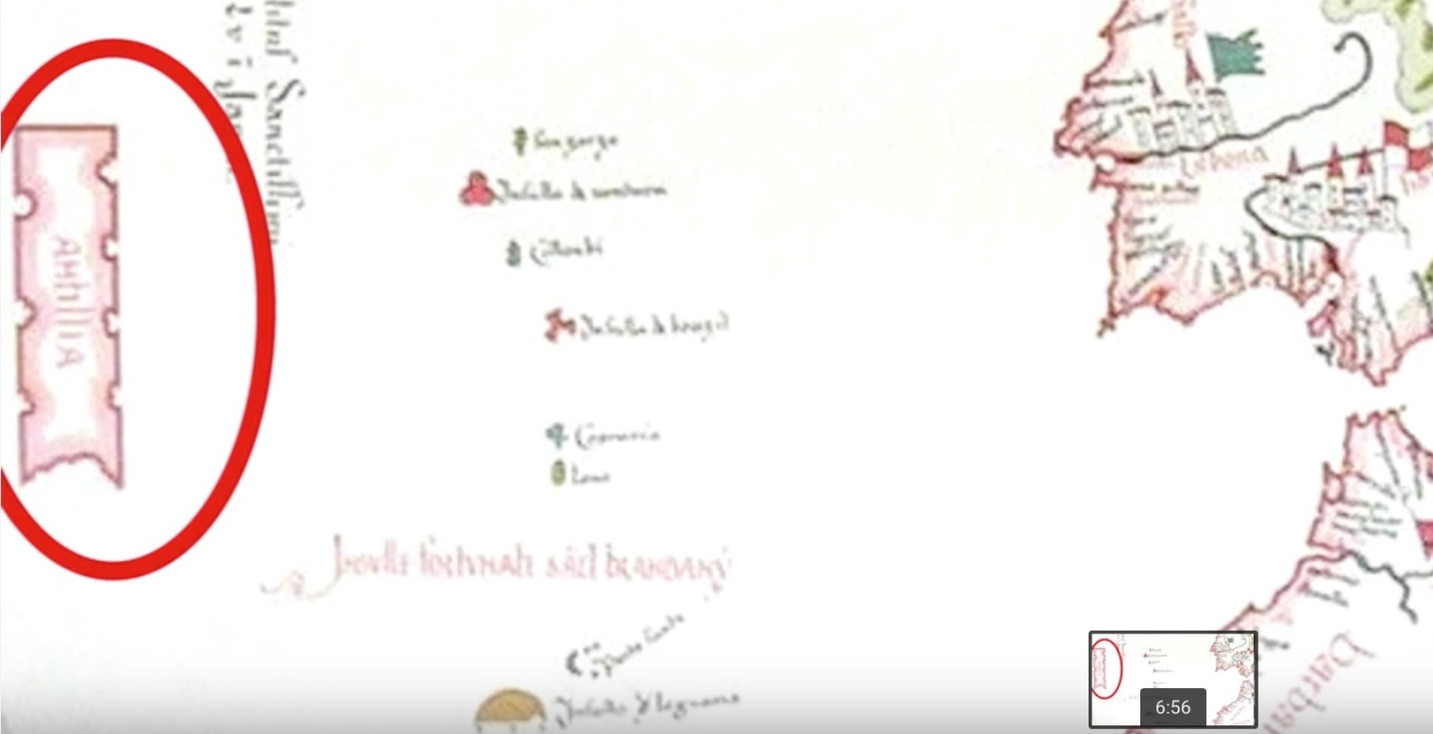
The body of land in the map labeled Antilla and circled in red is said to have been the actual Atlantis, but today it is deep under the oceanâ€™s surface. When you stop and consider thatÂ One of the Oldest Maps On EarthÂ shows the antarctic continent back when it did not have ice, things begin to get VERY strange. You see,Â itâ€™s been over 30 million years by most estimates since the continent was not covered in ice, and since modern man wasnâ€™t around until millions of years later, that begs the question: WHERE DID THE MAP COME FROM? First, the map is real. Even Einstein examined it. That has never been in question. SOâ€¦ where does that leave us? Needless to say, modern â€œscienceâ€ or â€œacademiaâ€ donâ€™t say a word, because they know their explanations are nonsensical.Â
1. Were there flying machines with ground penetrating radar 2000 years ago?
2. Was there an ancient civilization here before mankind, as SO MANY have proposed? Regardless of whether the civilization was the biblical Nephilim, OR some other worldly civilization, where did they come from, where did they go, or are they still here perhaps?
What gives the culprits away, I think, it that the same lies cross national boundaries. Who has the power if not government (or sovereign states) to push such a command and control agenda? To date, the only organization that I can think of with the power to perpetrate the lie, and do so across national boundaries, is the Illuminati, or New World Order. That means at this point itâ€™s time to begin asking yourself, What If Everything You Were Ever Taught Was A Lie?Â Find out why I believe The Truth Movement and Illuminati May Hold Answers For Humanityâ€™s Future.
Now, the people of Atlantis were said to be giants. This becomes ANOTHER example in a long line of examples that could prove the existence of theÂ Mighty Nephilim Giants the Book of Genesis Chapter 6Â talks about? Were the giants as the Bible describes, or were they ancient aliens? You listen to the story of the Nephilim and see if they could be mistaken for alien by early man?Â Nephilim were said to beÂ the offspring of the angels cast out of heaven by God, and possessed knowledge we couldnâ€™t even dream of today. That might explain their intimate knowledge of the stars??? Then again, were the Giants from the stars the way the ancient Sumerian texts say? There is also evidence suggesting that a creature or being of some type was able to travel the globe and interact with different ancient civilizations because the same pictures show up around the world in ancient writings! Regardless, Atlantis was said to be so advanced, The King and Queen were rumored to live in a giant palace with running hot and cold water.

