Jihad Report
Dec 09, 2017 -
Dec 15, 2017
Attacks | 30
Killed | 146
Injured | 99
Suicide Blasts | 5
Countries | 10

ATL Goes Dark for No Reason
A power outage at the world's busiest airport left thousands of passengers stranded in dark terminals and in planes sitting on the tarmac, as a ground stop for Atlanta's Hartsfield-Jackson International disrupted air travel across the United States.
The outage affected all airport operations. Georgia Power said the cause of the outage is not yet determined, though it may have involved a fire that caused extensive damage in a Georgia Power underground electrical facility. The fire impacted substations serving the airport. The utility said it expected power to be restored by midnight.
Incoming and outgoing flights at the airport were halted while crews worked to restore power. Atlanta is the heart of the US air transport system, and the disruption led to hundreds of flight delays and cancellations across the country.
No storms.
No equipment failures
No reason they can find
Cyber attack the most likely reason.
Type and a shadow of EMP attack

Here are the latest developments:
- More than 600 flights to and from Atlanta have been canceled, including 350 departures, according to Flightradar24.
- Southwest, American and United airlines canceled operations in and out of Atlanta for the rest of Sunday.
- More than 450 Delta mainline and regional flights have been canceled.
- Flights headed to Atlanta are being held on the ground at their departure airport.
- Inbound flights to Atlanta are being diverted, US Customs and Border Protection said.

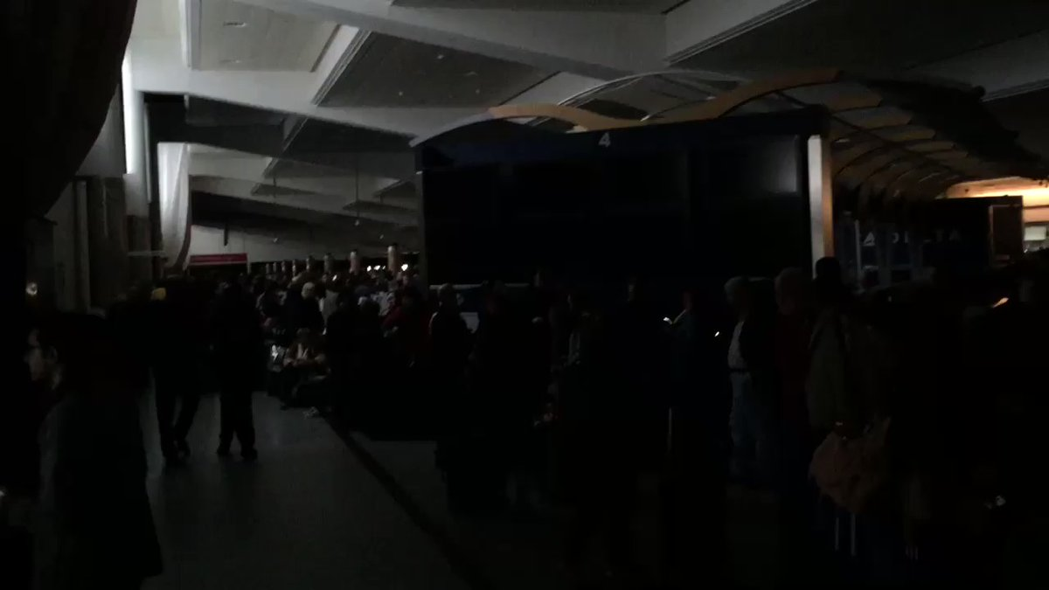

Mehtap Colak
✔@Mehtap_Colak
What You can't see here is hundreds of people waiting at a completely dark terminal
4:24 PM - Dec 17, 2017 · Hartsfield-Jackson Atlanta International Airport (ATL)

2121 Replies

7777 Retweets

6464 likes
Twitter Ads info and privacy
The outage cut power in the terminals, leaving passengers stranded in the dark as they stood in line at gates and security checkpoints. Brittny Dettro said she was waiting to board a flight from Atlanta to Milwaukee when the power went out in Terminal B. She shot this image at 1:10 p.m. ET.
People used flashlights on their phones to see where they were going, said passenger Heather Kerwin, an Atlanta resident bound for New York.
"There were a few emergency lights on, but it was really dark -- felt totally apocalyptic," she said. "I decided to get the hell out of there."
Some passengers told CNN that airport and airline staff offered no updates as hours passed, leaving people scanning their phones and tablets for information. Stores stopped serving food and passengers were evacuated to alleviate crowding.
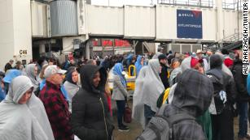
The outage left passengers sitting in planes on the tarmac for hours.
Jodi Green's Delta flight from the Bahamas landed at 1:15 p.m. ET Sunday. As of 7 p.m. she was still on the plane with no end in sight.
The ground stop led Southwest Airlines to cancel all operations in and out of Atlanta for the rest of the day, spokesman Brian Parrish said. Customers are being offered re-bookings without fare differences, he said.
United and American Airlines also suspended operations to and from Atlanta for the rest of Sunday. Delta, which has its headquarters and largest hub in Atlanta, canceled more than 450 Delta mainline and regional flights as a result of the ground stop, the airline said in a statement.
Meanwhile, Atlanta Police urged people to stay away from the airport.
"We have no injuries, no one is harmed, everyone is safe, everything is orderly," Sgt. Warren Pickard said. "What we need the public to understand right away is that we need everyone to refrain from coming to the airport."

Norks Readying Next Blast
North Korea appears to be pressing ahead with its nuclear programme. Satellite images recently detected hectic activity at the North Korean nuclear test site, Punggye-ri.
Experts say that after North Korea's last nuclear test, minor tremors were detected near Mt Mantap, located close to the nuclear site. However, Pyongyang is now engaged in additional tunnel work at the site.

According to experts at 38North, a US-based think tank, the fresh activities were detected at the West Portal of the site – indicating that the site may be undergoing an expansion. Meanwhile, the North Portal, where the previous five tests were conducted, appears to have been temporarily abandoned.
"At the West Portal, there has been a consistently high level of activity since North Korea's last nuclear test. This includes a routine presence of vehicles and personnel around the portal, movement of mining carts from the portal to the adjacent spoil pile and signs of fresh spoil being dumped onto the pile," 38North experts said in a blog. "These activities suggest that tunnel excavation is underway at the West Portal, as the North Koreans expand the site's potential for future nuclear testing."
Ryan Barenklau, CEO and founder of Strategic Sentinel, a Washington-based nonpartisan geostrategic consulting agency, told IBTimes UK, "The tunneling is occurring at the West Portal and activity near that area has been relatively high for the last month. They are most likely digging deeper and expanding the complex underneath so they can continue their normal operations."
"The complex is probably unstable seeing how many tremors have been recording, forcing new tunnels to be created. The West Portal area will probably be where the next nuclear tests will be conducted if there are anymore to come."
Breanklau added that it might be a while before North Korea conducts its next nuclear test. "The last two tests were conducted one year apart. These mining operations take time and there is no telling just how badly the mountain has been damaged due to the previous tests."

Over the weekend, Strategic Sentinel tweeted that Pyongyang Radio had broadcast secret coded messages over its 6400kHz radio station. Such transmissions have previously been observed preceding major weapons tests by North Korea.
However, it remains unclear if the continuing activities at Punggye-ri and the sudden influx of coded messages being transmitted indicate that North Korea might be ready to conduct yet another major weapons test.
"Pyongyang likes to send out coded messages on the weekend, especially Saturday morning US time, and does this regularly. December 9th was one of those weekend messages," Barenklau told IBTimes UK.
"Rarely, Pyongyang will start to send them out at random times multiple times per week. That is usually indicative of a large provocation or diplomatic move, but not always. Again, we really don't know for sure what they are doing with those messages. We don't necessarily care to try and understand the messages themselves. We look for how often and when.
The Uranium One Blood Trail
Senator John Barrasso (R-WY) is turning up the heat on the Uranium One investigation, demanding documents from both the Energy Department and the Nuclear Regulatory Commission (NRC) in a Monday letter to both entities. Barrasso wants to find out if he was intentionally misled by the Obama administration about Uranium One being able to export yellowcake uranium out of the United States after the company was acquired by Russia.
Barrasso writes: “Prior to the approval of the sale [of Uranium One], I wrote to then-President Barack Obama registering my strong concerns regarding Russian control over American uranium production facilities and Russia's ability to ship U.S. uranium overseas. I also requested immediate notification should ARMZ file for a license to export U.S. uranium. Based on information that has recently come to light, I now believe the response I received, and the process by which I received it, were both misleading.
On March 21, 2011, former NRC Chairman Greg Jaczko responded to my letter on behalf of then-President Obama stating:
‘At this time, neither Uranium One Inc. nor ARMZ holds a specific NRC export license. In order to export uranium from the United States, Uranium One, Inc. or
ARMZ would need to apply for and obtain a specific NRC license authorizing the export of uranium for use in reactor fuel’
The NRC staff made a similar statement in their recommendation to approve the transfer control of Uranium One to ARMZ, stating: "before the licensee may export uranium to a foreign country, they must first comply with the NRC's regulations and seek a specific license for such purpose."
Recent reporting by The Hill uncovered that Uranium One was able to export uranium without obtaining a specific export license. Beginning in 2012, Uranium One exported U.S. uranium by ‘piggy-backing’ as a supplier on an export license held by the shipping company, RSB Logistic Services Inc.
Indeed, as The Hill 's John Solomon and Alison Spann reported last month - when congress reviewed the Uranium One deal back in 2010, assurances that US uranium would not leave the country was a key sticking point. As such, repeated assurances were provided that such exports would never occur.
“No uranium produced at either facility may be exported,” the NRC declared in a November 2010 press release that announced that ARMZ, a subsidiary of the Russian-owned Rosatom, had been approved to take ownership of the Uranium One mining firm and its American assets.
A year later, the nuclear regulator repeated the assurance in a letter to Sen. John Barrasso, a Wyoming Republican in whose state Uranium One operated mines.
“Neither Uranium One Inc. nor AMRZ holds a specific NRC export license. In order to export uranium from the United States, Uranium One Inc. or ARMZ would need to apply for an obtain a specific NRC license authorizing the exports of uranium for use in reactor fuel,” then-NRC Chairman Gregory Jaczko wrote Barrasso.
The NRC never issued an export license to the Russian firm, a fact so engrained in the narrative of the Uranium One controversy that it showed up in The Washington Post’s official fact-checker site this week. “We have noted repeatedly that extracted uranium could not be exported by Russia without a license, which Rosatom does not have,” The Post reported on Monday, linking to the 2011 Barrasso letter.
The FISA Affair
Everyone knew that sooner or later, a special court set up to approve warrants allowing the tapping of conversations of Americans having conversation with foreigners would be used for nefarious purposes. That is to say, once the barriers between intelligence agencies was removed by Barack Obama, just 17 days before Trump’s inauguration, the fox was let into the henhouse. Well, no sooner did the executive order’s ink dry, but the feathers and the blood started flying.
It turned out to be very close to what I said would happen way back in November. Over the past 10 days we've learned a lot about FBI agent Peter Strzok, a man who very likely would have lived the remainder of his life in relative obscurity as an FBI counterintelligence agent but for his sudden dismissal from Special Counsel Mueller's "Russian Collusion" investigation.
As we noted on December 2nd (see: Mueller's Top FBI Agent Probing Clinton Emails, Russian-Collusion "Removed" After Anti-Trump Texts Found), Strzok's life became far more complicated when it was revealed that his dismissal from Mueller's team was linked to the discovery of multiple "anti-Trump text messages" shared with a colleague...a colleague with whom he happened to be having an extramarital affair.
Of course, like most twisted Washington D.C. scandals, his overt political bias and anti-Trump text messages were only the tip of the iceberg as it was subsequently discovered that Strzok not only held a leading role in the Hillary email investigation but potentially single-handedly saved her from prosecution by making the now-infamous change in Comey's final statement to describe her email abuses as "extremely careless" rather than the original language of "grossly negligent."
Of course, as we noted a month ago (see: First Comey Memo Concluded Hillary Was "Grossly Negligent," Punishable By Jail), the change in language was significant since federal law states that "gross negligence" in handling the nation’s intelligence can be punished criminally with prison time or fines whereas "extreme carelessness" has no such legal definition and/or ramifications.
All that said, while ill-advised, sending anti-Trump texts to your mistress is certainly not illegal and probably doesn't violate any FBI statutes that would require dismissal from an ongoing investigation...if we're wrong on that then we would highly encourage Mueller to look at the text messages of the remainder of his team because we're almost certain he would have to replace everyone.
So, that brings us back to the key question surrounding Peter Strzok...why exactly was he fired from the Trump investigation?
As it turns out, Representative Jim Jordan (R-OH) has an interesting theory on that question which he shared during his questioning of FBI Director Chris Wray last week. To summarize, Jordan's theory is that Strzok received the controversial "Trump Dossier" from the Clinton campaign then went to the FISA courts where he passed it off as a legitimate piece of intelligence in an effort to obtain the warrants necessary to effectively spy on the Trump campaign.
"Here's what I think Director Wray. I think Peter Strzok, head of counter intelligence at the FBI, Peter Strzok the guy who ran the Clinton investigation and did all the interviews, Peter Strzok, the guy who was running the Russia investigation at the FBI, Peter Strzok, Mr. 'Super Agent' at the FBI, I think he's the guy who took the application to the FISA court...and if that happened...if you have the FBI working with the Democrats' campaign, taking opposition research, dressing it all up and turning it into an intelligence document and taking it to the FISA court so they can spy on the other campaign...if that happened...that's as wrong as it gets."
Of course, Director Wray could clear up any confusion on this topic by simply releasing the FISA application but that would just be too simple now wouldn't it?
The Last Jedi
Carrie Fisher’s death one year ago is made even more tragic by the fact that she’s the actual star of the new “Star Wars: The Last Jedi.” Her General Leia Organa is all over this Rian Johnson movie, which soars and aims for operatic drama that is (luckily) punctuated by a number of Fisher’s one liners and wise cracks.
What a surprise! Fisher wise cracked her way through the original three “Star Wars” movies, then “Shampoo” and movies like “Soap Dish.” She had a whole hugely successful second career as a humorist and novelist, took herself to Broadway with the hilariously self-effacing “Wishful Drinking,” and became a much sought after script doctor.
And now, in what would be her last grand gesture, she is the noble leader of the Resistance, wise and wonderful, taking her band of rebels into battle of in act one of “The Last Jedi” and then commanding them with reason and good humor in act three. For this alone, Johnson should be commended. General Leia rules. Best Supporting Actress? You bet.
So do a lot of other characters in the 8th installment of a 40 year old franchise. Fisher is joined by her original “Star Wars” buddy Mark Hamill, who used to be the cute kid, the poster boy Luke Skywalker who learned from his elders. Now Luke is the elder, and Hamill– whose credits beyond “Star Wars” didn’t give his resume much gravity (the surfing movie “Big Wednesday” was about it)–rises to the occasion as an Obi-Wan for the ages. Luke Skywalker has become a sage and shows that pop stars can age with dignity.
There are some surprises in “The Last Jedi.” Newcomers Laura Dern and Benicio del Toro prove to smart additions to the cast. Dern, in particular, is kind of magnificent. del Toro echoes Han Solo from the original “Star Wars,” the rogue you shouldn’t trust.
And then there are the returnees from “The Force Awakens,” the future of “Star Wars” to come after this: Daisy Ridley, John Boyega, Oscar Isaac, Adam Driver. Clocking in at a massive two and a half hours or more, “The Last Jedi” gives all of them ample room to stake their claims in the franchise’s future as the older generation waves goodbye.
Ridley’s Rey is the yin to Driver’s Ben Solo/Kylo Ren’s yang, but Boyega’s Finn is every bit their equal. Less defined is Isaac’s Poe Dameron, who wanders into a muddled part of this movie: Poe’s brashness gets in his own way when he makes a serious misjudgement about Dern’s Resistance leader. There’s an abruot edit where it seems like a plot change was made, but we’re so far in that it doesn’t matter.
(Maybe it’s me, but my major problem with the new “Star Wars” plot is understanding why Ben Solo went bad and became Kylo Ren. (He’s that angry with his parents?) His act of violence in “The Force Awakens” still doesn’t make sense, makes him irredeemable. That’s my take. A similar act in this movie doesn’t help his cause. I suppose in Episode 9, Rey will have to choose between him and Finn, the good guy. May the force be with her.)
“Star Wars” debuted forty years ago in 1977. I was 20 years old. I didn’t know I was signing up for four decades. What an amazing contribution George Lucas has made to the culture of my lifetime. With “The Last Jedi,” you feel like closure has been reached for fans of my generation. There will be more “Star Wars” adventures, I’m sure, but for me, I’m happy to end here with a kind of Gotterdammerung. When the film ends, and the memorial card to Carrie Fisher appears, I felt a sufficiency. Our work here is done.
Gold Digger’s Hell
Do you remember my monologue about narcissists? Well, there is a special type that men should avoid at all costs. The beautiful woman that uses her femininity to get you to give her the break she’s looking for. If you don’t provide it, you may be opening yourself up for gold digger’s hellfire.
There are three women, paid big dollars by an organization called Brave New Films. It just happens to be owned by George Soros. An interesting reality about the current parade of Soros funded Trump Accusers is that their claims were independently researched pre-election and many appear ridden with holes.
Prior to the 2016 election, GotNews published the following bombshell report, exposing Rachel Crooks for having a family friend calling her an outright liar. Crooks was a Hillary donor and many question if her claims against President Trump are politically motivated. The New York Times’ Trump accuser Rachel Crooks is lying about Donald Trump allegedly kissing her on the mouth without permission, according to a family friend.
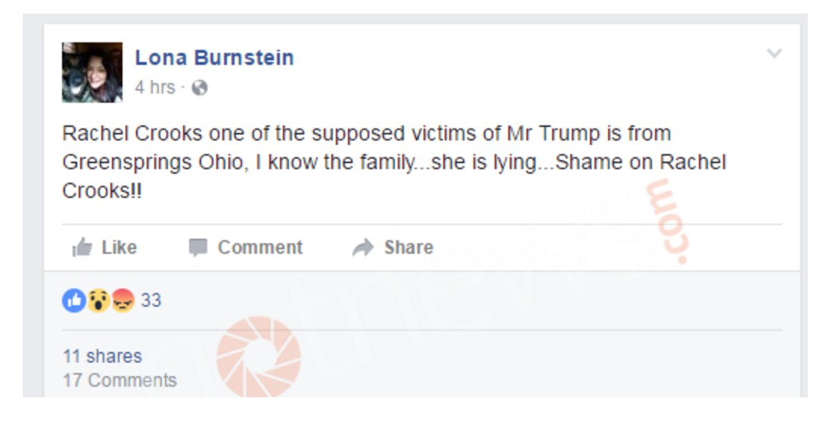
Lona Burnstein from Columbus, Ohio, says she knows Crooks’ family. Burnstein’s cousin was married to Crook’s uncle. Burnstein was commenting on Rachel Crooks’ Facebook profile before it was locked down.
Burnstein says Rachel Crooks is a “big baby.”
Donald Trump “was being nice to her and told her he would contact her for a modeling career and he never did… end of story.”
Burnstein says of Crooks: “I remember them talking about her meeting him… and her story today doesn’t match the story she told 11 years ago!! She’s definitely lying!”
When Muhammad Meets the Wall
This weekend, Antifa tried to crash a “Build The Wall” rally in San Diego, California. The leftists felt powerful until they regretted it at one point.
The supporters of President Donald Trump unleashed their worst nightmare.
It has been a year since Donald Trump got in office, and since then, he started making great strides to protect our country from illegal immigrants who invade our borders, destroy our cities and commit crimes against the American people. Prototypes for the wall are being built and tested and the DACA program ends on March 5, 2018.
According to our source, Mad World News, a Texas border agent was killed by an illegal immigrant last month, and recently, a San Francisco jury acquitted the illegal alien who murdered Kate Steinle.
“Big Rally at the San Diego Border (Otay Mesa) in support of the new border wall and the U.S. Border Patrol. This rally is dedicated to Kate Steinle and also Border Patrol Agent Rogelio Martinez, who was murdered by an illegal alien last month near the Texas border.
Rally sponsored by San Diegans for Secure Borders, Unite America First, Frontline America, San Diego Patriots, Latinos for Trump, Make America Great PAC, and other pro-border security groups.”
Scheduled speakers at the rally included Congressman Duncan Hunter and Angel Mom Agnes Gibboney, whose son was murdered by an illegal alien.
“The border fence that we have here in San Diego is the only border fence in the entire country,” said Rep. Hunter. “You had crime reduced by 50 percent overnight and drugs reduced in San Diego by over 90 percent. Fences make good neighbors. Period,” he continued.
“You don’t have national security unless you have border security. It”s very simple… Yemenis, Iraqis, Pakistanis, Chinese, name your former Soviet satellite states, they all come in through Mexico,” added the Congressman. ”They don’t come in on cruise ships, they don’t come in through the airports, they come across the border here and that’s what the wall stops and that’s why we need the wall,” he rightfully pointed out.
“I’ll tell you, Trump is doing what he said he would do and he’s being undermined by his own Department of Justice, he’s being undermined by his own FBI, he’s being undermined by his own Border Patrol managers that are still the same guys that Obama put into place, but he’s fighting all of that, and he’s doing what he said he was going to do,” said Rep. Hunter.” CBS8 reported.
Alien Ship or Asteroid?
Today, scientists led by Stephen Hawking are using high-tech scanners to discover if a huge, cigar-shaped 'comet' is in fact, an alien probe.
Now, one astronomer claims that the space rock, named Oumuamua, could be an alien spacecraft with broken engines that is tumbling through our solar system.
Dr Jason Wright from Penn State University suggests that a broken alien spacecraft would move in exactly the same way as the interstellar comet.
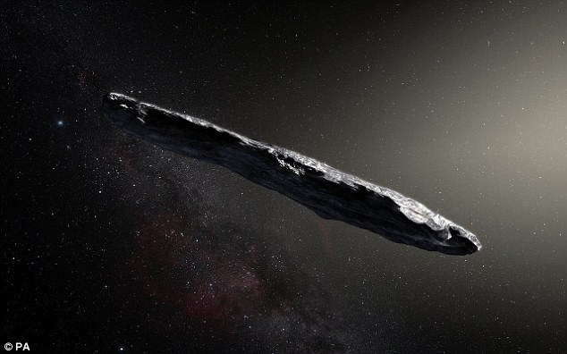
Last month, a mysterious cigar-shaped asteroid sailed past Earth, marking the first time an interstellar object has been seen in the solar system

OUMUAMUA
A cigar-shaped comet named 'Oumuamua sailed past Earth last month and is the first interstellar object seen in the solar system.
It was first spotted by a telescope in Hawaii on 18 October, and was observed 34 separate times in the following week.
Travelling at 44 kilometres per second (27 miles per second), the comet is headed away from the Earth and Sun on its way out of the solar system. The comet is up to one-quarter mile (400 meters) long and highly-elongated - perhaps 10 times as long as it is wide.
That aspect ratio is greater than that of any asteroid or comet observed in our solar system to date. But the comet's slightly red hue — specifically pale pink — and varying brightness are remarkably similar to objects in our own solar system.
Oumuamua is about a quarter of a mile long, 260ft wide and currently travelling at 196,000mph. Rather than moving through space like other space rocks, astronomers believe that it is 'tumbling' through our solar system.
Writing in his blog, Dr Wright, an associate professor of astronomy and astrophysics at Penn State University, says: 'Such derelict craft would, if they are not travelling so fast that they escape the Galaxy, eventually 'thermalize' with the stars and end up drifting around like any other interstellar comet or asteroid.
'In fact, since they (presumably) no longer have attitude control, one would expect that they would eventually begin to tumble, and if they are very rigid that tumbling might distinguish them from ordinary interstellar asteroids… and in fact, just because their propulsion is broken doesn't mean that their radio transmitters would be broken.'
Dr Wright suggests that the object could be a 'Von Neumann probe' - a theoretical self-replicating spacecraft that visits star systems.
He added: 'Such a discovery would imply that there are lots of these things in the solar system at any given moment (even if they are deliberately targeting the sun, they are hard to spot and we'll miss most of them), and so lots of opportunities to study them.'
Dr Wright previously suggested the mysterious dimming of star KIC 8462852 – also known as Tabby’s Star – could be caused by an alien megastructure called a Dyson Sphere.
His latest comments come ahead of a project later today in which scientists will use high-tech scanners to discover if Oumuamua was sent by an alien civilisation.
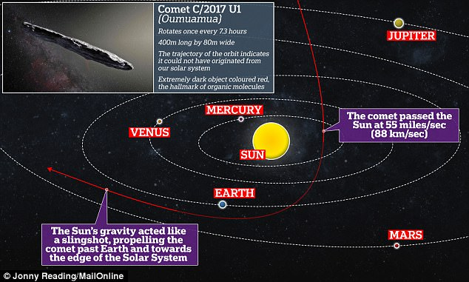
The cigar-shaped object, named 'Oumuamua by its discoverers, sailed past Earth last month and is the first interstellar object seen in the solar system

WHO IS DR JASON WRIGHT?
Dr Wright is an associate professor of astronomy and astrophysics at Penn State University.
Dr Wright achieved global fame after suggesting that the dimming of star KIC 8462852, also known as Tabby’s Star, could be caused by an alien megastructure called a Dyson Sphere.
This is a hypothetical structure that could be used by an advanced alien race to harness the energy of a star. First proposed by theoretical physicist Freeman Dyson in 1960, the sphere would be a swarm of satellites that surrounds a star.
They could be an enclosed shell, or spacecraft spread out to gather its energy - known as a Dyson swarm. If such structures do exist, they would emit huge amounts of noticeable infrared radiation back on Earth.
But as of yet, such a structure has not been detected. The team of scientists, called Breakthrough Listen, will use the world's largest directable radio telescope, at Green Bank in West Virginia, to follow it for ten hours today at 3pm ET (8pm GMT).
They are listening for electromagnetic signals, no stronger than those emitted by a mobile phone, that cannot be produced by natural celestial bodies. If they find them, it would be proof that extraterrestrial forces really could be at play.
For the moment, they are trying to contain their excitement. But the name they have given this bizarre object betrays their optimism. Oumuamua is a Hawaiian term meaning 'a messenger from afar arriving first'.
Most intriguingly, it is the wrong shape for an asteroid — they are typically round.
Professor Hawking and his colleagues at Breakthrough Listen report: 'Researchers working on long-distance space transportation have previously suggested that a cigar or needle shape is the most likely architecture for an interstellar spacecraft, since this would minimise friction and damage from interstellar gas and dust.'
Scientists led by Stephen Hawking, pictured, are today using high-tech scanners to discover if a huge, cigar-shaped space object currently hurtling through our solar system was sent by an alien civilisation
Another oddity is that Oumuamua is flying very 'cleanly', without emitting the usual cloud of space dust that astronomers observe around asteroids.
Experts say this suggests it is made of something dense: probably rock, but possibly metal.
It was first detected on October 19 by a long-running research programme called Pan-STARRS, which uses powerful telescopes to photograph and monitor the night sky at the University of Hawaii.

WHERE DID IT COME FROM?
Most comets follow ellipse-shaped orbits around the sun.
But this comet appears to orbit at an angle, and doesn't circle the sun.
Its orbital path suggests it entered our solar system from the direction of the constellation Lyra, looped around the sun, and will never return.
But others have suggested that the comet did come from Earth, but interacted with Jupiter or another planet, which changed its orbit.
Its amazing speed has led some experts to conclude it is the first such object to have come towards us from outside our solar system.
Analysts also say its faintly red colour indicates it has been subjected to interstellar cosmic radiation which is harsher than we experience in our solar system.
The fact that it doesn't seem to have engines or show signs of propulsion may wreck the interplanetary-spacecraft theory.
If a radio signal does come back from the object, Professor Avi Loeb, Professor of Astronomy at Harvard University, suggests that we will need to proceed with caution.
Speaking to MailOnline, he said: 'My recommendation, as in any dialogue, is that we first listen and do our best to understand what we are hearing.
'Once we figure this out, we can decide how to respond.
'Overall, I am an optimist. I believe that a very intelligent civilisation will be peaceful, and we could save ourselves millions or billions of years by learning from it.
'But there is also the possibility that such a civilisation will have hostile intentions and risk our existence, so we should deliberate carefully in any future contact with them.'
Moon Initiative

President Donald Trump has signed a directive for the National Aeronautics and Space Administration (NASA) to join the brewing space race once again.
Trump has directed acting NASA administrator Robert M. Lightfoot Jr. to “lead an innovative space exploration program to send American astronauts back to the moon, and eventually Mars,” and “perhaps someday to many worlds beyond.” The directive “will refocus America’s space program on human exploration and discovery,” and “marks an important step” in America’s return to our lunar satellite.
“This time, we will not only plant our flag and leave our footprint” but establish a plan for “long term exploration and use.” This decision comes after recommendations from the National Space Council, according to Deputy White House Press Secretary Hogan Gidley.
On Monday, Gidley asserted that the president’s directive “will change our nation’s human spaceflight policy to help America become the driving force for the space industry, gain new knowledge from the cosmos, and spur incredible technology.”
During his 2016 presidential campaign, Trump promised that “under a Trump administration, Florida and America will lead the way into the stars” and that NASA would be freed to “refocus on space exploration.” Vice President Mike Pence echoed these sentiments, calling the moon “a stepping-stone, a training ground, a venue to strengthen our commercial and international partnerships as we refocus America’s space program toward human space exploration.”
Pentagon’s UFO Program
The truth is finally out there, after the Pentagon admitted it ran a secret UFO investigation programme for five years until 2012.
The Department of Defense’s own “X-Files” operation, known by the less catchy title of the Advanced Aviation Threat Identification Program, was closed after a change in funding priorities, it said.
But the remarkable revelation has raised more questions than answers, including whether the programme has been completely shut down, or just covered up further.
While the Pentagon claims it ended five years ago, it said it continued to take seriously “all threats and potential threats to our people”.
The military intelligence official Luis Elizondo, who ran the programme on the fifth floor of the Pentagon’s C Ring, according to the New York Times, which broke the story, told the paper it was only the government funding that had dried up. He said activities continued under the direction of his successor, whom he declined to name.
Either way the revelation is likely to provide some satisfaction to UFO enthusiasts, often dismissed as conspiracy theorists.
Nick Pope, who used to run the British government’s UFO project, said: “The take-home message here is that there’s probably something out there, but we don’t know what it is. It’s an extraordinary revelation, not least because it directly contradicts the many specific denials that the US government has issued previously when asked about this subject, and their involvement in it.
“It precisely reflects my own experience of this intriguing but frustrating subject with the British government. Like our US colleagues, we too denied – even to parliament – that we were undertaking secret studies into the UFO phenomenon and consistently downplayed the true extent of our interest and activity at the Ministry of Defence.”

Astronomers to check interstellar body for signs of alien technology

Read more
The New York Times said the project, parts of which remain classified, received $22m (£18.7m) each year, hidden away in US Department of Defense (DoD) budgets worth hundreds of billions of dollars.
It said its initial funding came largely at the request of the former Senate leader Harry Reid, the Nevada Democrat long known for his enthusiasm for space phenomena. He was quoted as saying: “I’m not embarrassed or ashamed or sorry I got this thing going. I think it’s one of the good things I did in my congressional service. I’ve done something that no one has done before.”
Last year, John Podesta, chair of Hillary Clinton’s presidential campaign, declared that he had convinced her to explore declassifying any government documentsrelated to UFOs should she win the election.
Bill Clinton previously said that, during his time in the White House, he had tried to find out if there were any secret “X-Files”, concluding: “If so, they eluded me.”
ADVERTISEMENT
In the UK, 209 files and approximately 52,000 pages of information on UFOs were released during a five-year rolling disclosure programme that concluded in 2013, containing details of about 6,000 separate observations reported to the British authorities since 1984.
In 2009, the Ministry of Defence closed down its hotline for UFO sightings, stating: “In over 50 years, no UFO report has revealed any evidence of a potential threat to the United Kingdom.”
Responding to the revelations about its activities, the Pentagon spokeswoman Laura Ochoas told Reuters: “The Advanced Aviation Threat Identification Program ended in the 2012 timeframe. It was determined that there were other, higher priority issues that merited funding and it was in the best interest of the DoD to make a change.”
She added: “The DoD takes seriously all threats and potential threats to our people, our assets, and our mission and takes action whenever credible information is developed.”
Pope said: “This isn’t quite the ‘spaceship in a hangar’ smoking gun the UFO lobby was hoping for, but it’s as close as those of us who have looked at this subject from within government will ever go to saying: ‘Yes, this is real.’”

Voter Fraud Uncovered in Alabama Senate Race!
By Gary Maher -
December 13, 2017
0
2959
Judge Roy Moore is calling for all the votes to be counted in the Alabama Senate election, refusing to concede the race to Doug Jones even as the mainstream media declares a premature victory.
Moore is down 1.7 points and only needs to come within a half-point to spark a statewide recount. Absentee ballots from military service members have still not been counted. Mobile County, a heavily pro-Jones county, tabulated its votes later than the pro-Moore counties, and eventually gave Jones the lead.
The Alabama Supreme Court shot down a lower court ruling Tuesday requiring counties to preserve their digital voting records. Thus, the Supreme Court is allowing counties to destroy their voter records. The Moore legal team will need to jump on this development fast to protect those records.
Evidence of voter fraud exists in the election.

Hillary's Entire "Hit List" Just Went Public. You'll Never Guess Who's #1
Health Sciences Institute

Ads by Revcontent
Find Out More >

13,726
Democratic activists made a last-minute push to get out the vote against Roy Moore in Alabama by encouraging “African-Americans in Mississippi” to vote in the wrong state.
Sources on the ground in Alabama confirm that these tactics are real, and they have been used by supporters of Democrat Doug Jones.
Big League Politics received evidence of a Reddit call for “African-Americans in Mississippi” to “make a short trip to Alabama on December 12.” That Reddit thread is still active.
Similar calls have been made on Reddit for African-Americans in other nearby states, including Georgia and Tennessee.
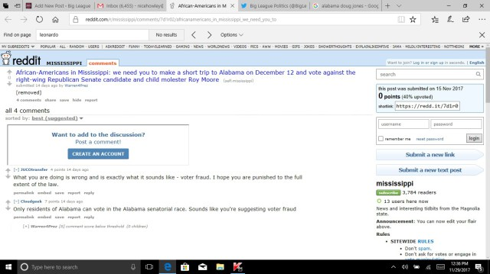
There was also a concerted effort underway to register felons to vote in the Alabama special election.
AL.com reports:
“Thousands of felons across Alabama have registered to vote in recent weeks, according to Pastor Kenneth Glasgow, who is heading up a statewide effort to get felons to the voting booth.
Glasgow’s goal is to get as many felons as possible signed up to vote before the end of the day Monday, the deadline to be able to cast a ballot in Alabama’s Dec. 12 U.S. Senate special election…
For generations, most Alabamians convicted of a felony were barred from ever voting in the state again, but the Definition of Moral Turpitude Act, a new law passed by the state Legislature and signed by Gov. Kay Ivey in May, cleared the way for thousands of felons to restore their voting rights.”
Strange Booms
Something is shaking the southeast and has been for quite some time.
Carolina Beach resident Jody Smith was enjoying a Saturday morning with her son Roman when she felt and heard a 'boom.' Her son walked to her and asked, "Mommy, what was that?" Smith didn't know how to respond.
Many people in her neighborhood ran outside in hopes of finding the source of the noise.
"It feels like a Mack truck driving by and it just shakes your whole house," said neighbor Paula Powell.
"It's a shaking feeling," Smith added. "More than thunder and more than a truck going by. Initially that is what it sounded like but it turned into something more than that and I guess more movement. I went to Facebook and I asked, 'Did anyone else just feel a small earthquake?' And within minutes people were posting from all over town saying, 'I felt it in Mayfaire,' 'I felt it in Pine Valley.'"
Dozens posted on her wall and thousands have reported the noises up and down the coast on various websites from Georgia to Virginia. With speculative explanations ranging from the ordinary, like military aircraft to the outrageous like ghosts and aliens.
"I don't think it's ghosts, and I don't think it's aliens," said Geophysicist Dr. David Hill with the United States Geological Service in Menlo Park, California. "I think it's likely to be small earthquakes."
For nearly 50 years, Hill has studied just that across the globe, publishing more than 75 papers.
Hill said an earthquake produces audible sound by making the "ground around the person listening seem like they are in a big woofer."
"The ground is vibrating and that sound is transmitted up into the atmosphere and you hear a low rumbling sound," said Hill.
But on the east coast at the University of North Carolina Chapel Hill, another prominent Geophysicist says earthquakes have nothing to do with it.
"There are earthquakes occurring all around the world that we are recording here in North Carolina," said Dr. Johnathan Lees. "If we had a local earthquake it would be impossible for us not to record that."
Lees is also a life long student and teacher of sounds produced by the earth. The professor at UNC says of all the loud booms heard, recorded and studied there has never been any direct relationship discovered between any seismic activity.
"It's just very unlikely that we could have humans observe this and not have our very sensitive instruments making these observations," said Lees.
But Hill strongly disagrees saying, "Magnitude twos and smaller could produce an audible sound that and shaking that wouldn't be recorded on the seismic stations."
Lees thinks the sounds are something more secretive like military activity. There are a number of aircraft and submarine testing and bombing ranges off the coast stretching from Florida to New Jersey, with more than a dozen off the Carolina coastline. And supersonic flight can certainly make a boom.
But no military instillation is taking credit for the booms, and no exercises were scheduled at the time.
"We know that these things were reported long before people were flying around at the speed of sound," Hill pointed out.
In fact the term Seneca Guns, which is often used to describe these sounds comes from a James Fenimore Cooper story explaining the same phenomenon published in 1851, 50 years before man even learned to fly.
None the less, if it was an earthquake that rattled Smith's house there is no seismic evidence. Perhaps because of the lack of seismometers in the eastern half of the Carolinas.
"It just doesn't make sense how nothing could show up," said Smith as she plays with her son Roman. "How could nothing at all show up if all these people definitely felt and heard something that wasn't thunder that wasn't a plane and wasn't a truck driving by the house?"
Smith asks questions that even the most experienced scientists can't agree on an answer. Both Geophysicist, however, say you could eliminate some theories by installing a seismometer and sensitive microphones along the Carolina coastline.
But, since the booms do little more than rattle windows finding someone to foot the$10,000 to $20,000 bill in our current economy will likely keep the public guessing as to what is causing the mysterious booms.
Leaving folks like Smith to wonder and think, "it's just bizarre."
Putin Thanks Trump for Stopping Terror Attack
Russian President Vladimir Putin telephoned U.S. President Donald Trump Sunday to thank him for a CIA tip that helped thwart a series of bombings in St. Petersburg, the Kremlin said.
During the call, the two leaders' second in three days, Putin expressed gratitude for the CIA information. The Kremlin said it allowed Russia's top domestic security agency to track down a group of suspects that planned to bomb Kazan Cathedral and other crowded sites this weekend.
Related SearchesCIA HeadquartersTrump PutinVladimir Putin
"The information received from the CIA proved sufficient to find and detain the criminal suspects," the Kremlin said.
It added that Putin asked Trump to convey gratitude to the CIA and assured him that "if the Russian intelligence agencies receive information about potential terror threats against the United States and its citizens, they will immediately hand it over to their U.S. counterparts via their communications channels."
The CIA's tip to Russia comes even as Russia-U.S. ties have plunged to their lowest level since the Cold War era — first over Russia's annexation of Crimea and support for pro-Russia separatists in Ukraine, more recently over allegations that Moscow interfered in the U.S. presidential election to help Trump.
While Russian officials have said the two countries were continuing to exchange a terror-related intelligence, Sunday's statement from the Kremlin was Russia's first public assertion that information from the United States helped prevent an attack.
The conversation was the second between the Russian and U.S. presidents since Thursday, when Trump thanked Putin for his remarks "acknowledging America's strong economic performance," according to the White House.
During the first call, they also discussed during ways to work together to address North Korea's nuclear and ballistic weapons program, the White House said.
The Federal Security Service, or FSB, announced Friday that seven suspected followers of the Islamic State group had been arrested for allegedly planning to carry out terror attacks in St. Petersburg this weekend.
The agency said the suspects were plotting a suicide bombing in a church and a series of other explosions in the city's busiest areas this coming weekend on IS orders. It said a search of a St. Petersburg apartment found explosives, automatic weapons and extremist literature.
Russian news reports said that Kazan Cathedral, a landmark 19th century Russian Orthodox church on St. Petersburg's central Nevsky Prospect, was the prime target.
If the suspects succeeded in bombing the cathedral, it would have been the first major attack on a Russian Orthodox Church by Islamic terrorists, who have blown up apartment buildings, passenger planes and transport facilities in Russia.
In April, a suicide bombing in the St. Petersburg's subway left 16 dead and wounded more than 50.
Russian TV stations have aired footage daily since Friday of the suspects in the foiled attacks being apprehended and questioned. One segment showed FSB operatives outside a St. Petersburg apartment building detaining a suspect, who appeared later saying he was told to prepare homemade bombs rigged with shrapnel.
"My job was to make explosives, put it in bottles and attach pieces of shrapnel," the suspect, identified by Russian media as 18-year old Yevgeny Yefimov, said in the footage released by the FSB.
Several other suspects came from mostly Muslim regions in Russia's volatile North Caucasus, and one man was from the ex-Soviet nation of Tajikistan that borders Afghanistan.
The TV reports included footage of a metal container, which the suspects used as a laboratory for making explosives, according to the FSB. Another video showed operatives breaking the doors and raiding an apartment used by other suspects.
Last week, the FSB said it also arrested several IS-linked suspects in Moscow, where they allegedly were plotting a series of suicide bombings to coincide with New Year's celebrations.
The latest calls between Putin and Trump came after the Russian leader praised his U.S. counterpart during a marathon news conference on Thursday.
Putin hailed Trump's achievements, saying that global markets have demonstrated investors' confidence in Trump's economic policies. He said he hoped the U.S. president would be able to follow through on his campaign promises to improve ties with Russia despite pressure from his political foes at home.
During the news conference, Putin also reaffirmed his multiple denials of meddling in the 2016 U.S. presidential election and argued that the U.S. is only hurting itself with investigations of alleged collusion between Trump and Russia. The allegations were "invented" by Trump's foes to undermine his legitimacy, Putin said.
Alexei Chepa, a deputy head of the foreign affairs committee in the lower house of Russia's parliament, hailed the CIA tip as a "step toward cooperation."
"The more such actions we have, the better it will be for both our countries," Chepa told the state RIA Novosti news agency
The Swamp Enema is Working
Congress’ human resources scandal is about to break wide-open and over a dozen members of the House of Representatives will likely resign within the next 72 hours.
I anticipate we will see the resignation of more than a dozen House members over sex-harassment and secret settlements. Mark my words, the House is going to be rocked in the coming 72 hours. Tick Tock.
Last week news broke that Rep. Gregory Meeks (D-NY) had made a settlement with a former congressional aide that he fired after she reported being sexually assaulted at the business of a major campaign donor. The first congressmen to go down in the post-Weinstein era of sexual misconduct was Michigan Democrat Rep. John Conyers, who eventually resigned after accusations against him snowballed. Other notable politicians on Capitol Hill caught up in sexual misconduct cases:
Democrat Rep. Alee L. Hastings (FL) — The Treasury paid $220,000 to settle allegations against him made by a former congressional staffer that claimed he “touched her, made unwanted sexual advances, and threatened her job.”
Republican Rep. Blake Farenthold (TX) — The congressmen announced on Thursday that he was "retiring" after former staffers accused him of making "sexually graphic jokes" and berating his aides. He previously settled a sexual harassment claim made by an employee in 2014.
Democrat Rep. Ruben Kihuen (NV) — Multiple women have accused the Pelosi-backed congressman of sexual harassment.
Democrat Sen. Al Franken (MN) — Franken announced that he would resign last week after multiple women accused him of sexual assault. Franken has still not resigned despite his promise to do so.
Republican Rep. Trent Franks (AZ) — Resigned after he reportedly made women uncomfortable by asking them to be a surrogate mother.
My former colleagues in the Intelligence Community have told me that the "dirt" on some of these people is so scurrilous, they can't imagine how they ever got elected in the first place.
The Swamp is being drained!
Abbas Appeals to UN to Annul Trump’s Declaration
Palestinian Authority chairman Mahmoud Abbas has signaled plans to have the U.N. Security Council “annul” President Trump’s recognition of Jerusalem as Israel’s capital, but according to an international law expert, the proposal is “fantasy.”
Abbas said in Istanbul Wednesday that under the U.N.’s founding charter it is possible for a resolution to be brought to a vote before the U.N. Security Council (UNSC), which the U.S. would not be able to veto.
The U.S. would instead be compelled to abstain, on the grounds that it is a party to the dispute in question.
In a joint release with Turkish President Recep Tayyip Erdogan and Organization of Islamic Cooperation (OIC) secretary-general Yusuf Al-Othaimeen, Abbas said that “according to the United Nations Charter Palestinians can request a vote on an issue that the U.S. cannot vote on.”
“We will go to the Security Council to annul the announcement of U.S. President Donald Trump recognition in Jerusalem as the capital of Israel,” the official P.A. news agency Wafa quoted him as saying.
Abbas appeared to base his reasoning on article 27 of the U.N. Charter, which says:
“Decisions of the Security Council on all other matters shall be made by an affirmative vote of nine members including the concurring votes of the permanent members; provided that, in decisions under Chapter VI, and under paragraph 3 of Article 52, a party to a dispute shall abstain from voting” (emphasis added).
(Chapter VI deals with the peaceful settlement of disputes, and article 62, paragraph 3 refers to cases where the Security Council encourages the peaceful settlement of local disputes through regional initiatives.)
According to international law scholar Eugene Kontorovich, Abbas is simply wrong.
“There is no way this could be put to a vote of the UNSC that the U.S. would not veto,” he said in response to queries. “Nor can the U.N. veto recognition decisions of countries, which are purely sovereign political acts.”
“This is all fantasy. It shows that Abbas always believes there is no reason to deal with his current interlocutors because he can get a better deal from the U.N.”
Kontorovich, who is professor of law at Northwestern University’s School of Law, and head of international law at the Kohelet Policy Forum in Jerusalem, said Abbas’ proposal did underline the importance of who occupies the Oval Office.
“While Abbas’ plan is unrealistic now, all it takes is a different president in the White House to make it real, by not vetoing such a resolution and then saying while he is unhappy about it, the UN has ‘tied his hands’ and he must annul the recognition.”
Kontorovich said it was quite possible a future Democratic president would do that, noting that President Obama in fact did in his last weeks in office.
(He was referring to UNSC resolution 2234, which was adopted on December 23 last year after the Obama administration chose not to exercise its veto. The measure declares eastern Jerusalem, including Judaism’s most sacred site, to be “occupied Palestinian territory” and calls Israeli presence there “a flagrant violation under international law.”)
“Using the UNSC to tie Americans hands is a technique favored by the internationalist left – the prior administration did it with the Iran deal too – and we have not seen the last of it,” Kontorovich said.
Abbas made the comments in Istanbul, where he attended an OIC “extraordinary summit,” convened by Erdogan in reaction to Trump’s December 6 announcement.
Representatives of the 57 mostly Muslim-majority members slammed Trump’s decision and called on all countries to respond by recognizing east Jerusalem as the “capital of the State of Palestine.”
A sovereign Palestinian state does not currently exist, but Abbas also announced plans to seek from the UNSC and General Assembly support for “full membership of the state of Palestine.”

When the Sun Gets Quiet
As the sun gets successively more blank with each day, due to lack of sunspots, it is also dimming. According to data from NASA’s Spaceweather, so far in 2017, 96 days (27%) of the days observing the sun have been without sunspots. Here is the view today from the NASA Solar Dynamics Observatory satellite:
Solar Dynamics Observatory HMI Continuum image more at WUWT’s solar reference page: https://wattsupwiththat.com/reference-pages/solar/
Today at Cape Canaveral, SpaceX launched a new sensor to the International Space Station named TSIS-1. Its mission: to measure the dimming of the sun’s irradiance. It will replace the aging SORCE spacecraft. NASA SDO reports that as the sunspot cycle plunges toward its 11-year minimum, NASA satellites are tracking a decline in total solar irradiance (TSI).
Across the entire electromagnetic spectrum, the sun’s output has dropped nearly 0.1% compared to the Solar Maximum of 2012-2014. This plot shows the TSI since 1978 as observed from nine previous satellites:
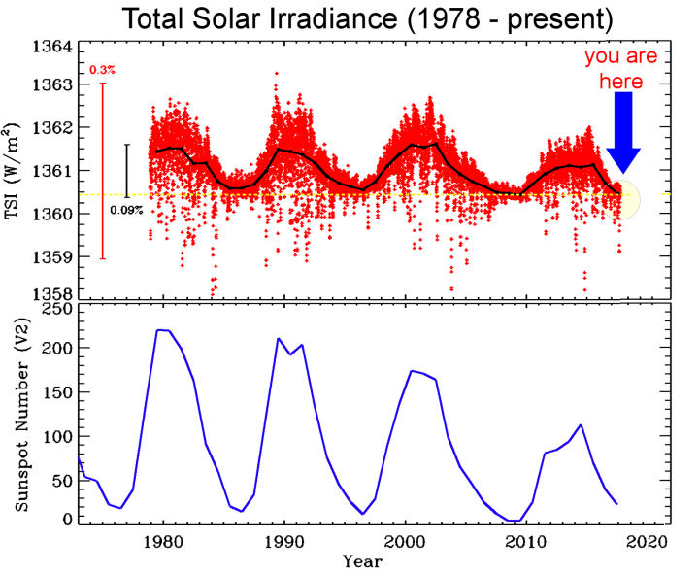
In the top plot, we drew the daily average of measured points in red (so there are a lot of points, 14187 to be precise). On the left is a red vertical bar showing a 0.3% change in TSI. The black curve is the average of TSI over each year. The dashed horizontal line shows the minimum value of year-averaged TSI data. The vertical black bar shows the 0.09% variation we see in that average. The bottom plot shows the annual sunspot number from the SIDC in Belgium in blue. Source: NASA Solar Dynamics Observatory Mission Blog.
What do we learn from these plots? First, TSI does change! That’s why we stopped calling it the solar constant. Second, as the sunspot number increases, so does TSI. But the converse is also true. As the sunspot number decreases so does TSI. We have watched this happen for four sunspot cycles. This waxing and waning of TSI with sunspot number is understood as a combination of dark sunspots reducing TSI below the dashed line and long-lived magnetic features increasing TSI. SORCE has even observed flares in TSI.
Third, the horizontal dashed line is not an average, it is drawn at the lowest value in the year-averaged TSI data (that happened in 2009). When there are no sunspots the Sun’s brightness should be that of the hot, glowing object we always imagined it to be. We would expect TSI to be the same at every solar minimum. There is much discussion over whether the value of TSI at solar minimum is getting smaller with time, but it is not getting larger.
These data show us that the Sun is not getting brighter with time. The brightness does follow the sunspot cycle, but the level of solar activity has been decreasing the last 35 years. The value at minimum may be decreasing as well, although that is far more difficult to prove. Perhaps the upcoming solar minimum in 2020 will help answer that question.
The rise and fall of the sun’s luminosity is a natural part of the solar cycle. A change of 0.1% may not sound like much, but the sun deposits a lot of energy on the Earth, approximately 1,361 watts per square meter. Summed over the globe, a 0.1% variation in this quantity exceeds all of our planet’s other energy sources (such as natural radioactivity in Earth’s core) combined. A 2013 report issued by the National Research Council (NRC), “The Effects of Solar Variability on Earth’s Climate,” spells out some of the ways the cyclic change in TSI can affect the chemistry of Earth’s upper atmosphere and possibly alter regional weather patterns, especially in the Pacific.
NASA’s current flagship satellite for measuring TSI, the Solar Radiation and Climate Experiment (SORCE), is now more than six years beyond its prime-mission lifetime. TSIS-1 will take over for SORCE, extending the record of TSI measurements with unprecedented precision. It’s five-year mission will overlap a deep Solar Minimum expected in 2019-2020. TSIS-1 will therefore be able to observe the continued decline in the sun’s luminosity followed by a rebound as the next solar cycle picks up steam. Installing and checking out TSIS-1 will take some time; the first science data are expected in Feb. 2018.
In other news, as the magnetic activity of the sun decreases, influx of Galactic Cosmic Rays (GCR’s) increase as has been observed by balloon measurements over California:
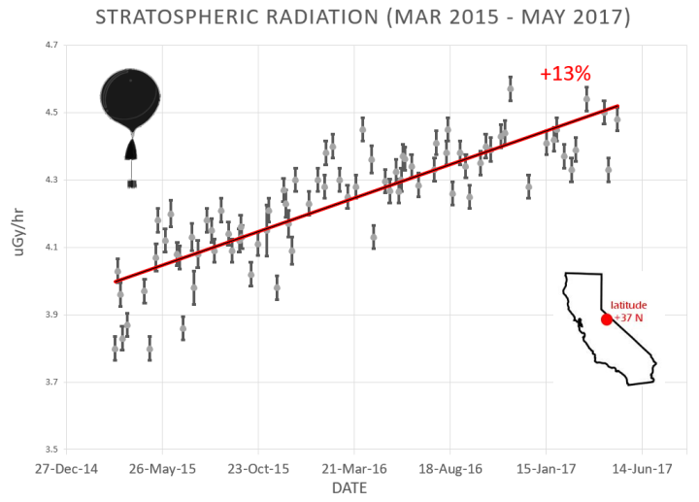
Why are cosmic rays intensifying? The main reason is the sun. Solar storm clouds such as coronal mass ejections (CMEs) sweep aside cosmic rays when they pass by Earth. During Solar Maximum, CMEs are abundant and cosmic rays are held at bay. Now, however, the solar cycle is swinging toward Solar Minimum, allowing cosmic rays to return. Another reason could be the weakening of Earth’s magnetic field, which helps protect us from deep-space radiation.
The radiation sensors onboard our helium balloons detect X-rays and gamma-rays in the energy range 10 keV to 20 MeV. These energies span the range of medical X-ray machines and airport security scanners.
The data points in the graph above correspond to the peak of the Reneger-Pfotzer maximum, which lies about 67,000 feet above central California. When cosmic rays crash into Earth’s atmosphere, they produce a spray of secondary particles that is most intense at the entrance to the stratosphere. Physicists Eric Reneger and Georg Pfotzer discovered the maximum using balloons in the 1930s and it is what we are measuring today.

US Weapons found in Isis Positions

The monitor group Conflict Armament Research (CAR) hasissued a report based on three years of documentation that shows weapons procured by the U.S. military in 2015 fell into the hands of the Islamic State (ISIS/ISIL) within weeks.
The weapons were discovered in the terrorist group’s arsenals and on the battlefield, according to NBC.
NBC reported that researchers identified weapons supplied by other geopolitical players, as well:
CAR used serial numbers or key markings on the weapons to trace them back to their origin and try to piece together how they were obtained by the militants.
Some of the weapons found on the front lines after ISIS was driven out also include Chinese-manufactured machine guns laced with amphetamines, drones modified in sophisticated terrorist factories and even a rifle made in Nazi Germany. CAR found that one anti-tank missile sold to the U.S. Army made its way to ISIS in just 59 days.
“This is extremely short,” Damien Spleeters, a CAR researcher focused on Iraq and Syria, told NBC News in Iraq, referring to the amount of time between the arrival of the weapons and their discovery in enemy hands. “It means that there are not many intermediaries in this chain of custody.”
advertisement
The U.S. supplied the weapons to two different groups; one fighting the Assad regime in Syria and another to the rebel group the Syrian Democratic Forces.
CAR also reported at some of the weapons could have been stolen or purchased illegally.
NBC reported that there is photographic evidence showing a Syrian opposition group called Jaysh al-Nasr in possession of anti-tank weapons bearing an identical lot number and a similar serial number to the item seized in Iraq.
That suggests, CAR states in the report, that they “were part of the same supply chain.”
NBC asked Eric Pahon, a spokesman for the Department of Defense, about the CAR report.
“Any alleged misuse or diversion of U.S. support will be taken seriously and lead to the possible curtailment of support, if verified,” Pahon said, adding that he had not seen the report.
Charles Lister, a senior fellow at the Middle East Institute in Washington, D.C., called Jaysh al Nasr “one of the most significant groups” receiving weaponry support according to NBC.
NBC reported:
The weapons recovered from ISIS and documented in the report come from a wide range of manufacturers and sources. Many were looted from Iraqi and Syrian government stockpiles as ISIS rampaged across both countries. By early 2015, the group controlled around 35,000 square miles of territory—an area about the size of Indiana. But CAR says the introduction of new weapons into the Syrian conflict significantly improved the “quantity and quality of weapons available” to ISIS.
Breitbart News reported in May that the U.S. Army had lost track of more than $1 billion worth of weapons and other equipment sent to anti-Islamic State (ISIS/ISIL) allies in Iraq, including an Iran-allied group of Shiite fighters.
According to a declassified government audit of the Iraqi Train and Equip Fund, hundreds of Humvees and mortars and tens of thousands of rifles remain unaccounted for largely because a central database for keeping track of U.S. taxpayer-funded military equipment does not exist.
“This audit provides a worrying insight into the U.S. Army’s flawed—and potentially dangerous—system for controlling millions of dollars’ worth of arms transfers to a hugely volatile region,” Patrick Wilcken, an arms control and human rights researcher for Amnesty International, which procured the release of the government audit, said in a statement.
“It makes for especially sobering reading given the long history of leakage of U.S. arms to multiple armed groups committing atrocities in Iraq, including the armed group calling itself the Islamic State,” Wilcken said. “The need for post-delivery checks is vital. Any fragilities along the transfer chain greatly increase the risks of weapons going astray in a region where armed groups had wrought havoc and caused immense human suffering.”
Russia May Sever Transatlantic Cables?
The headlines could hardly be scarier and more apocalyptic. In a speech delivered by the head of Britain's military last week, the world learned that Russian President Putin could bring about global financial collapse and return civilization to a communications dark ages by a mere snip-snip of underwater transatlantic internet cables!
Air Chief Marshal Sir Stuart Peach warned Russia could in an instant end 97% of global communications capabilities and disrupt trillions in daily financial transactions, ushering in a "catastrophic" economic collapse, as the roughly 200 international undersea network cables are under imminent threat. Peach said that Russia's modernized Navy constitutes a “new risk to our way of life.”
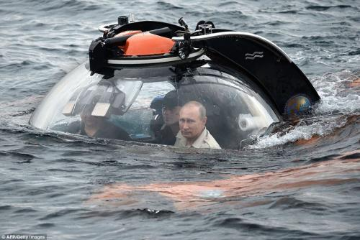
Putin engaging in undersea collusion with Trump. Image source: AFP/Getty
The speech from a lone British military chief generated endless fear-inducing headlines and thousands of lines of anxiety and panic-driven commentary, a mere sampling of which is below...
RELATED VIDEO
Leaders Create Leaders S3 EP5: Create Your Own Opportunities | ft. Chris Stamp
X
- Russia could cut off internet to NATO countries, British military chief warns (NBC)
- Russian Navy 'could cut underwater cables and devastate UK economy' warns UK Armed Forces chief (IBT)
- UK defense chief says Russia poses risk to undersea cables (AP)
- Top British Officer: Russia May Be Able To Cut Undersea Cables (NPR)
- How Russia could use drones armed with explosives to destroy vital underwater cables linking Britain's phone and internet to rest of the world (UK Mirror)
- Russia's naval updates threaten undersea comms network, says top British military officer (Defense News)
- Russian Ships Could Cause 'Catastrophe' for West by Cutting Transatlantic Internet Cables (Newsweek)
- Could Russia cut undersea communication cables? (BBC)
- Russia could cut off internet to Nato countries, British military chief warns (The Guardian)
- Russia 'could cut UK's undersea internet cables', defence chief warns (The Independent)
- Russia 'could CRIPPLE Britain by cutting undefended undersea internet cables' (The Sun)
- Senior British Officer: Russia Could Cut Undersea Cables (Newsmax)
- Top UK military official says NATO must protect underwater cables from possible attacks by Russia (EuroNews)
- Russian navy ship Yantar can sever internet cables (Sunday Times)
Meanwhile, Defense News included in its coverage the following casual and passing reference:
“In addition to new ships and submarines, Russia continues to perfect unconventional capabilities and information warfare. Therefore, we must continue to develop our maritime forces with our allies to match Russian fleet modernization,” said Peach, who will give up his job as Britain’s top military commander next year to become chairman of the NATO Military Committee.
So NATO's future military chief needs to increase those budgets before sliding into his new position you say? His speech also emphasized how member countries need to ensure their own fleet modernization keeps pace with the oh-so-scary 'Russian threat'. Budgets, budgets, budgets people! Cause the Russians are coming!
But we've seen those headlines before - they are essentially the same as a barrage of stories that came out in 2015, also based on military officials speculating and ruminating on all the possible scariest Russian threats.
Oops! Though it sounds like a fresh new Russian threat the media had yet to tap into, it turns out the British commander is merely channeling these old headlines, most from October 2015 after a New York Times story ran which relied on the usual "anonymous officials". Well, perhaps it just sounds more legit the second time around when delivered through a British accent?

aLleluia@DumbJam
RUSSIA COULD CUT UNDERWATER INTERNET CABLES. If my aunt had balls, she’d be my uncle. #mediahysteria #whatif
4:51 AM - Dec 16, 2017

22 Replies

33 Retweets

77 likes
Twitter Ads info and privacy
The 2015 NYT story cited the Russian underwater cable threat as "raising concerns among some American military and intelligence officials that the Russians might be planning to attack those lines in times of tension or conflict." Below is a small sampling of the headlines generated from that more than two year old reporting originally based on "some American military and intelligence officials":
- Russian Ships Near Data Cables Are Too Close for U.S. Comfort (NYT, Oct. 2015)
- Why Is Russia Interested in Undersea Internet Cables (VOA News, Nov. 2015)
- Fears over Russian submarine and spy ship patrols near vital undersea internet cables (Daily Mail/Reuters, Oct. 2015)
- How Bad Would It Be If The Russians Started Cutting Undersea Cables? Try Trillions In Damage (Forbes, Nov. 2015)
- We Asked an Expert What Would Happen if Russia Cut the Pipeline to the Internet (Vice News, Oct. 2015)
- US fears Russia could sever undersea internet cables (The Verge, Oct. 2015)
- Russia, the Internet and a new way to wage war? (CNN, Oct. 2015)
- US fears that Russia is plotting to sever its undersea internet cables (The Inquirer, Oct. 2015)
- Russia possibly mapping underwater internet cables in Mediterranean (Washington Times, Oct. 2016)
- Undersea Cables: How Russia Targets the West’s Soft Underbelly (Oct. 2015)
- In Case Of Nuclear War, Cut Internet Cables (Oct. 2015)
Naturally, Congress should impose new sanctions on Russia, banning all bolt and wire cutters from being shipped to the country... Before it's too late

