Easter story
(Matthew 21:12-17; Mark 11:15-19; Luke 19:45-48)
12After this he went down to Capernaum, he, and his mother, and his brethren, and his disciples: and they continued there not many days.
13And the Jews' passover was at hand, and Jesus went up to Jerusalem, 14And found in the temple those that sold oxen and sheep and doves, and the changers of money sitting: 15And when he had made a scourge of small cords, he drove them all out of the temple, and the sheep, and the oxen; and poured out the changers' money, and overthrew the tables; 16And said unto them that sold doves, Take these things hence; make not my Father's house an house of merchandise. 17And his disciples remembered that it was written, The zeal of thine house hath eaten me up. 18Then answered the Jews and said unto him, What sign shewest thou unto us, seeing that thou doest these things? 19Jesus answered and said unto them, Destroy this temple, and in three days I will raise it up. 20Then said the Jews, Forty and six years was this temple in building, and wilt thou rear it up in three days? 21But he spake of the temple of his body. 22When therefore he was risen from the dead, his disciples remembered that he had said this unto them; and they believed the scripture, and the word which Jesus had said.
23Now when he was in Jerusalem at the passover, in the feast day, many believed in his name, when they saw the miracles which he did. 24But Jesus did not commit himself unto them, because he knew all men, 25And needed not that any should testify of man: for he knew what was in man.
(Mark 11:1-19;
- And when they came nigh to Jerusalem, unto Bethphage and Bethany, at the mount of Olives, he sendeth forth two of his disciples,
- 2And saith unto them, Go your way into the village over against you: and as soon as ye be entered into it, ye shall find a colt tied, whereon never man sat; loose him, and bring him.
- 3And if any man say unto you, Why do ye this? say ye that the Lord hath need of him; and straightway he will send him hither.
- 4And they went their way, and found the colt tied by the door without in a place where two ways met; and they loose him.
- 5And certain of them that stood there said unto them, What do ye, loosing the colt?
- 6And they said unto them even as Jesus had commanded: and they let them go.
- 7And they brought the colt to Jesus, and cast their garments on him; and he sat upon him.
- 8And many spread their garments in the way: and others cut down branches off the trees, and strawed them in the way.
- 9And they that went before, and they that followed, cried, saying, Hosanna; Blessed is he that cometh in the name of the Lord:
- 10Blessed be the kingdom of our father David, that cometh in the name of the Lord: Hosanna in the highest.
- 11And Jesus entered into Jerusalem, and into the temple: and when he had looked round about upon all things, and now the eventide was come, he went out unto Bethany with the twelve.
- 12And Jesus went into the temple of God, and cast out all them that sold and bought in the temple, and overthrew the tables of the moneychangers, and the seats of them that sold doves,
- 13And said unto them, It is written, My house shall be called the house of prayer; but ye have made it a den of thieves.
- 14And the blind and the lame came to him in the temple; and he healed them.
- 15And when the chief priests and scribes saw the wonderful things that he did, and the children crying in the temple, and saying, Hosanna to the Son of David; they were sore displeased,
- 16And said unto him, Hearest thou what these say? And Jesus saith unto them, Yea; have ye never read, Out of the mouth of babes and sucklings thou hast perfected praise?
- 17And he left them, and went out of the city into Bethany; and he lodged there.

- Father, forgive them, for they know not what they do. Luke 23:34. ...
- Today you will be with me in paradise. Luke 23:43. ...
- Behold your son: behold your mother. ...
- My God, my God, why have you forsaken me? ...
- I thirst. ...
- It is finished. ...
- Father, into your hands I commit my spirit.
John: 20
1The first day of the week cometh Mary Magdalene early, when it was yet dark, unto the sepulchre, and seeth the stone taken away from the sepulchre. 2Then she runneth, and cometh to Simon Peter, and to the other disciple, whom Jesus loved, and saith unto them, They have taken away the Lord out of the sepulchre, and we know not where they have laid him. 3Peter therefore went forth, and that other disciple, and came to the sepulchre. 4So they ran both together: and the other disciple did outrun Peter, and came first to the sepulchre. 5And he stooping down, and looking in, saw the linen clothes lying; yet went he not in. 6Then cometh Simon Peter following him, and went into the sepulchre, and seeth the linen clothes lie, 7And the napkin, that was about his head, not lying with the linen clothes, but wrapped together in a place by itself. 8Then went in also that other disciple, which came first to the sepulchre, and he saw, and believed. 9For as yet they knew not the scripture, that he must rise again from the dead.
(Mark 16:9-11)
10Then the disciples went away again unto their own home.
11But Mary stood without at the sepulchre weeping: and as she wept, she stooped down, and looked into the sepulchre, 12And seeth two angels in white sitting, the one at the head, and the other at the feet, where the body of Jesus had lain. 13And they say unto her, Woman, why weepest thou? She saith unto them, Because they have taken away my Lord, and I know not where they have laid him. 14And when she had thus said, she turned herself back, and saw Jesus standing, and knew not that it was Jesus. 15Jesus saith unto her, Woman, why weepest thou? whom seekest thou? She, supposing him to be the gardener, saith unto him, Sir, if thou have borne him hence, tell me where thou hast laid him, and I will take him away. 16Jesus saith unto her, Mary. She turned herself, and saith unto him, Rabboni; which is to say, Master. 17Jesus saith unto her, Touch me not; for I am not yet ascended to my Father: but go to my brethren, and say unto them, I ascend unto my Father, and your Father; and to my God, and your God. 18Mary Magdalene came and told the disciples that she had seen the Lord, and that he had spoken these things unto her.
Jesus Appears to the Disciples
(Luke 24:36-43; 1 John 1:1-4)
19Then the same day at evening, being the first day of the week, when the doors were shut where the disciples were assembled for fear of the Jews, came Jesus and stood in the midst, and saith unto them, Peace be unto you. 20And when he had so said, he shewed unto them his hands and his side. Then were the disciples glad, when they saw the Lord. 21Then said Jesus to them again, Peace be unto you: as my Father hath sent me, even so send I you. 22And when he had said this, he breathed on them, and saith unto them, Receive ye the Holy Ghost: 23Whosoever sins ye remit, they are remitted unto them; and whosoever sins ye retain, they are retained.

April 4, 2017
Atlanta Attorney Assassinated After Filing Request For I-85 Bridge Explosion Documents
By: Sorcha Faal, and as reported to her Western Subscribers
A grim new Foreign Intelligence Service (SVR) report circulating in the Kremlin today says that Trinh Huynh, one of the most knowledgeable construction attorneys in Atlanta, Georgia, was gunned down in broad daylight yesterday just minutes after she filed legal requests at a Federal Courthouse for all US and State of Georgia documents relating to the believed to be Islamic State (IS/ISIS/ISIL/Daesh) terror bombing of the I-85 bridge—with Atlanta street sweeper, and eyewitness, Toney Booker telling local police about this assassination: “She was crossing the road, and he draws out his gun and shoots her three times. She drops, and he takes off running.”—and whose “military bearing” assassin was captured on video surveillance recordings running away from the crime scene. [Note: Some words and/or phrases appearing in quotes in this report are English language approximations of Russian words/phrases having no exact counterpart.]
According to this report, Trinh Huynh was a Vietnamese-American attorney with The Gibson Law Firm, LLC, who specialized in contractor litigation and was a graduate of Princeton University and received her law degree from Emory University School of Law—where she was awarded the Emory Order of Advocates, the State Bar of Georgia Prizes for Labor and Employment Law and was a member of the Emory Moot Courty Society and the Lamar Inn of Court—and who prior to joining Gibson was an associate in the Government Contracts and Construction Practice Group at Powell Goldstein LLP and, most recently, was a senior associate in the Government Contracts and Construction Practice Group at Alston & Bird LLP, where she was an active member of the Georgia Asian Pacific American Bar Association.
So knowledgeable, in fact, was Trinh Huynh in her construction field of expertise, this report continues, she authored many works on the subject too—including her 2009 book titled “The ABCs of Federal Government Contracting” and her, likewise, 2009 publication and course titled “Construction Recordkeeping and Documentation Requirements for Government Contracts” (Co-Presenter, Lorman Education Services seminar).
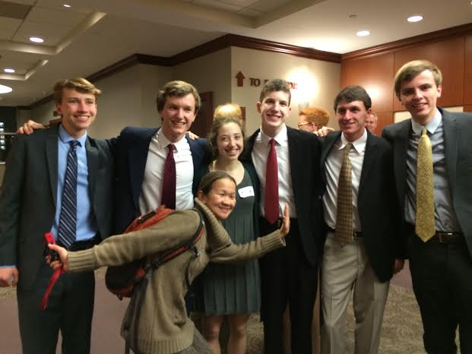
Assassinated Atlanta attorney Trinh Huynh (center, with arms outstretched) with student litigators she was coaching.
As an in-house attorney, also, for United Parcel Service (UPS), the world's largest package delivery company headquartered in Atlanta, this report details, Trinh Huynh, yesterday, appeared at the US District Court for the Northern District of Georgia where she filed legal papers for UPS asserting a force majeure claim due to the destruction of the I-85 bridge—that is a common clause in contracts that essentially frees both parties from liability or obligation when an extraordinary event or circumstance beyond the control of the parties, such as a war, strike, riot, crime, or an event described by the legal term “act of God” occurs.
Along with Trinh Huynh filing her force majeure claim for UPS, this report notes, her further legal filings contained what SVR analysts say were “common and natural” legal requests for all US Federal and State of Georgia documents relating to the I-85 bridge explosion—but that within 30 minutes of her making these filings, she was assassinated with all of the legal documents she filed then “disappearing-becoming non-existent”.
As to why Trinh Huynh had to be assassinated, this report continues, is due to the longstanding policy of American “Deep State” intelligence operatives currently at war with President Donald Trump of using what are called “message killings” in order to strike fear into anyone interfering with their objectives—and that in this particular instance involves keeping the knowledge of this Islamic State terror attack away from the Trump administration as it supports Trump’s warnings of how great a threat these terrorists are to the US.
Georgian resident Bobby Barnhart was 60 yards away from the I-85 bridge when he heard several explosions and a slow rumbling before it collapsed stating: “It was a big sound. You could feel the vibrations”
With the SVR having previously detailed the evidence that Islamic State terrorists, who had infiltrated themselves into Georgia from Syria, blew up the I-85 bridge in Atlanta (31 March: “Catastrophe Strikes Atlanta After ISIS Terrorists Blow Up Main I-85 Bridge”), and how after this terror attack US “Deep State” operatives are furiously working to cover-up all the true facts of (2 April: “Massive Cover-Up Of Islamic Terror I-85 Bridge Explosion In Atlanta Now Underway”), this new report chilling reveals that Deputy Director of the Federal Bureau of Investigation, Andrew McCabe, has personally taken charge of this investigation.
Critical to note about FBI Deputy Director McCabe, this report explains, is that he was appointed by FBI Director James Comey to be this intelligence agencies #2 official shortly after President Trump took office—but who stunningly failed to list on his financial disclosure forms, for 2015, that his wife, Dr. Jill McCabe, received nearly $600,000 from Hillary Clinton operatives—and that the powerful United States Senator Charles Grassley is now demanding an explanation for as McCabe is now being linked to the “Deep State” operation to smear President Trump with “fake news” Russian allegations.
With 700-feet of the I-85 bridge now having to be replaced due to this Islamic State terror attack, and the State of Georgia Department of Transportation breaking with the “Deep State” and revealing that only non-combustible materials were stored underneath it, this report concludes, the assassination of Trinh Huynh leaves only Atlanta City Councilman Clarence Terrell “C. T.” Martin calling for true facts behind this terror attack to be known—but whom SVR analysts estimate has, most likely, less than two weeks before he too is “neutralized”, like all of the other great American truth seekers that have gone before him.

Scientists Have Peered into a Black Hole and Taken a Photo of Its Event Horizon for the Very First Time
Hannah Osborne,Newsweek Thu, Apr 13 5:09 AM PDT
- Comments
- Sign in to like
- Reblog on Tumblr
- Share
- Tweet
- Email
The first attempt to peer inside a black hole and take an image of its event horizon—the point of no return—appears to have been a success, with no major problems during the 10-day observation period. The mass of data collected is now being sent to two supercomputers in the US and Germany, and scientists expect to find out if they have the very first picture of a black hole in early 2018.
The Event Horizon Telescope is a hugely ambitious project. It links telescopes around the globe to create one Earth-sized telescope — these are connected virtually so it effectively has a diameter of the entire planet. This technique is not new, but this is the first time it has been done on such a large scale. The level of detail it provides is like being able to count the stitches on a baseball from 8,000 miles away.
Black holes are not hard to see. The material they accumulate is extremely hot, so very bright. The problem is the resolution of images returned—right now, they appear like a bright blur. The Event Horizon Telescope should be able to provide a clear image showing the ring surrounding a black hole and its shadow.
Trending: United Passenger David Dao Plans to Sue Over Dragging Incident
Researchers targeted two black holes. The first, Sagittarius A*, is the black hole that sits at the center of the Milky Way. The other, Messier 87, is a supermassive black hole in an elliptical galaxy 53 million light years away.
Vincent Fish, a research scientists at MIT Haystack, Massachusetts who is working on the project, tells Newsweek that the image returned should show the flow of material going in and out of the black hole. “What we expect to see is an asymmetric image where you have a circular dark region. That’s the black hole shadow. And there might be a bright ring at the edge of that—which is the photon ring [a spherical region of space where gravity is so strong photons are forced to travel in orbits]. Then around it you will see one side is bright and the other side is faint, so kind of like a crescent.
“The reason for the crescent is that material near the black hole is moving at a few tenths of the speed of light. Special relativity tells you when particles emit photons—when they shine light at you—if the particles are moving towards you, it looks very bright, if they’re moving away from you, then it gets very dim. That produces this asymmetry.”
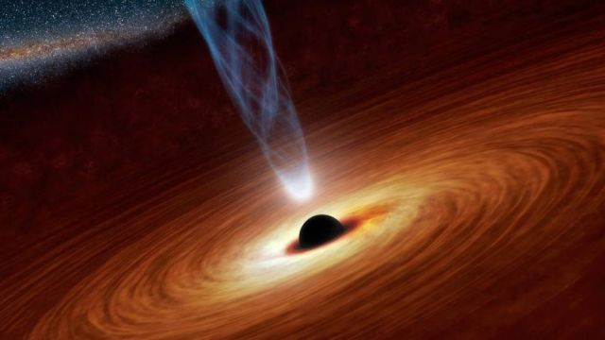Artist impression of a black hole. NASA/JPL-Caltech

Processing the data
Around one petabyte of data has been collected. To put that into perspective, a petabyte of MP3 songs would play continuously for more than 2,000 years without repeating. Scientists are collecting and distributing the data between two research institutes: One at MIT Haystack, the other at the Max Planck Institute for Radio Astronomy in Bonn, Germany.
Don't miss: Brussels And Hungary Clash Over Education, Refugees
The data, recorded on hard disks, will be plugged into two correlators (or supercomputers). This will remove any time delays caused by the different global positioning of each telescope. “We plug it into the correlator and we look at each baseline to see if we detected anything. With the array we have, we should have plenty of sensitivity. If things went well, we should have clear detections on most of the baselines at least, but we won’t know for certain until the data get back here,” Fish says.
Data will come back in two waves. Most will be returned in the coming weeks, but what has been collected at the South Pole telescope will be unavailable for another six months— planes cannot land there because of winter, so at the moment, the data is “stranded,” Fish explains.
Without this data, scientists cannot be sure of success. “I don’t think we’ll have the complete dataset until January next year. We’ll have partial datasets in a couple of months and we’ll look at the incomplete datasets just so we get a head start on data reduction and calibration so we know what issues there are and how to mitigate them,” he says.
“We’ll have a pretty good idea of whether it’s been a success—how strongly we’ve detected sources—but for imaging the baselines to the South Pole are very important. So I think the imaging part can’t really start in earnest until next year.”
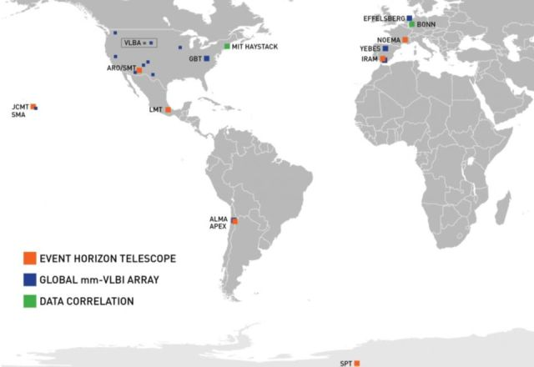A map showing the locations of the telescopes used in the Event Horizon Telescope project. MIT Haystack Observatory
Most popular: Former Trump Campaign Chairman Paul Manafort Got $13 Million In Loans From Trump-tied Businesses

What does it all mean?
Black holes are effectively laboratories for extreme physics. Gravitational forces are so strong that nothing, not even light, can escape. An event horizon is the point of no return—it will drag in anything passing it. At the center of a black hole is what is known as a singularity: a one dimensional point that is unimaginably small, but contains a huge mass. At the singularity, spacetime curves infinitely and the laws of physics cease to exist.
“If you talk to people who study black holes, general relativity, thermodynamics and quantum mechanics, they will tell you one of these theories has to give at a black hole,” Fish explains. An example of this is the information paradox. Put simply, quantum mechanics says information cannot truly be destroyed, so details of anything that is sucked into a black hole must remain in some way or form. General relativity, on the other hand, says nothing can survive a black hole.
“We have these assumptions about how the universe works, these well-tested theories, but at a black hole something is wrong and we don’t know what it is,” Fish says.
From the initial image returned, scientists should be able to test relativity. “If you know the mass of the black hole—and for Sagittarius A* we know that well—and if you know the distance of the black hole, which again we know well, then relativity predicts you will see that shadow and ring and that the ring will have a certain diameter and it will be near circular. That’s a test of relativity. If the shape isn’t circular or the wrong size, then relativity has made a prediction that has failed. That’s the first thing we’ll look at.”
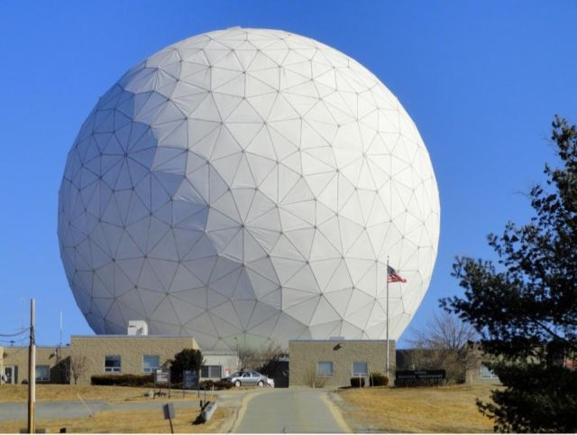MIT Haystack Observatory, where one of the two supercomputers that will be used to process the data is housed. MIT Haystack Observatory
In the longer term, astrophysicists will be able to start studying exactly how material is sucked into a black hole and how it gets launched out into a jet. “It’ll give us a better understanding of whether general relativity is an accurate description of the spacetime around a black hole,” Fish says, adding it will be the first time we are able to test general relativity at the most extreme limits. “For general relativity, we’ve been assuming it’s correct. There have been some tests of relativity in the weak field limit going back to 1919 with [Arthur] Eddington and the solar eclipse. But we haven’t really been able to do any tests in the strong field limit. And there’s really no stronger field than a black hole.”
Astronomy research professor Gopal Narayanan, who led the efforts on the Event Horizon Telescope at the Large Millimeter Telescope in Mexico, said in a statement emailed to Newsweek: “[An event horizon] is the best lab we have to study the extreme physics out there. These are the observations that will help us to sort through all the wild theories about black holes. And there are many wild theories. With data from this project, we will understand things about black holes that we have never understood before.”

A dark matter 'bridge' holding galaxies together has been captured for the first time
Researchers at the University of Waterloo used a technique known as weak gravitational lensing to create a composite image of the bridge

By Victoria Woollaston

Thursday 13 April 2017
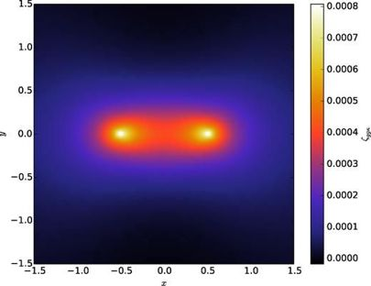
University of Waterloo
The first image of a dark matter "bridge", believed to form the links between galaxies, has been captured by astrophysicists in Canada.
Researchers at the University of Waterloo used a technique known as weak gravitational lensing to create a composite image of the bridge. Gravitational lensing is an effect that causes the images of distant galaxies to warp slightly under the influence of an unseen mass, such as a planet, a black hole, or in this case, dark matter.
Universe's dark matter skeleton spotted for the first time

Universe's dark matter skeleton spotted for the first time

- Filaments
- 06 Jul 2012
Their composite image was made up of a combination of combined lensing images taken of more than 23,000 galaxy pairs, spotted 4.5 billion light-years away. This effect was measured from a multi-year sky survey at the Canada-France-Hawaii Telescope.

READ NEXT
- This is the most detailed 'map' of dark matter ever seen

This is the most detailed 'map' of dark matter ever seen

By Abigail Beall
These results show that the dark matter filament bridge is strongest between systems less than 40 million light years apart, and confirms predictions that galaxies across the Universe are tied together through a cosmic web of the elusive substance.
Dark matter is a mysterious element said to make up around 84 per cent of the Universe. It's known as "dark" because it doesn't shine, absorb or reflect light, which has traditionally made it largely undetectable, except through gravity and gravitational lensing. Evidence for the existence of this form of matter comes, among other things, from the astrophysical observation of galaxies, which rotate far too rapidly to be held together only by the gravitational pull of the visible matter.
Astrophysics has long proposed the Universe's web of stars and galaxies is supported by a "cosmic scaffolding" made up of fine threads of this invisible dark matter. These threadlike strands formed just after the Big Bang when denser portions of the Universe drew in dark matter until it collapsed and formed flat disks, which featured fine filaments of dark matter at their joins. At the cross-section of these filaments, galaxies formed.

READ NEXT
- Ligo's next trick? Finally hunting down dark matter

Ligo's next trick? Finally hunting down dark matter

By Abigail Beall
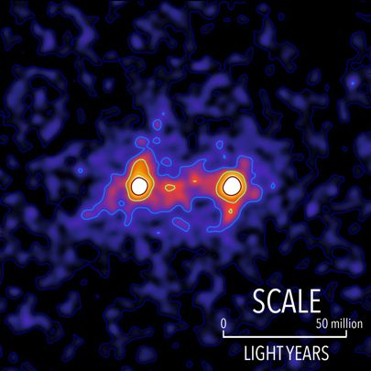
University of Waterloo
"For decades, researchers have been predicting the existence of dark matter filaments between galaxies that act like a web-like superstructure connecting galaxies together," said Mike Hudson, a professor of astronomy at the University of Waterloo in the journal Monthly Notices of the Royal Astronomical Society. "This image moves us beyond predictions to something we can see and measure."
"By using this technique, we're not only able to see that these dark matter filaments in the Universe exist, we're able to see the extent to which these filaments connect galaxies together," said co-author Seth Epps.

What is dark matter?

Dark matter is an invisible form of matter which, until now, has only revealed itself through its gravitational effects.
Evidence for the existence of this form of matter comes, among other things, from the astrophysical observation of galaxies, which rotate far too rapidly to be held together only by the gravitational pull of the visible matter.
High-precision measurements using the European satellite Planck show that almost 85 percent of the entire mass of the universe consists of dark matter.
All the stars, planets, nebulae and other objects in space that are made of conventional matter account for no more than 15 percent of the mass of the universe.
The unknown form of matter can either consist of comparatively few, but very heavy particles, or of a large number of light ones.
One of the possible candidates for dark matter is a particle called the axion, first proposed in 1977. It appears in some extensions of the Standard Model of particle physics. Astronomers believe that if axions make up dark matter, they could be detected through gravitational waves. This is because axions accelerated by a black hole would give off gravitational waves, just as electrons give off electromagnetic waves.
What are gravitational waves? WIRED explains Einstein's theory
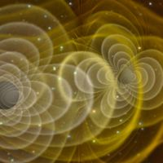

What are gravitational waves? WIRED explains Einstein's theory

- Science
- 13 Feb 2017
As a result, instruments like Ligo – and the upcoming Advanced Ligo (Ligo) –
may be able to see gravitational waves (GWs) from thousands of black hole (BH) mergers which would mark the beginning of a new precision tool for physics.
Physicists have a general idea about what the dark matter particle looks like but are struggling to build a clear picture. They can track the distribution of dark matter throughout the galaxy by examining how galaxies move, but can't pinpoint its exact location or design.
Earlier this year, Priyamvada Natarajan, a professor of astrophysics at Yale University, and her team brought the search for dark matter a step forward by creating the most detailed map of dark matter ever created. The map looks like an alien landscape, with uneven peaks and troughs scattered throughout. There are gentle mounds, on top of which sharp peaks arise, like the inside of a cave covered in stalactites.
The Easter Moon
Likely you have already heard this from a friend, or perhaps you've even made this observation yourself: "Easter is coming late this year."
Have you ever wondered how the date of Easter is actually set? It is all based on the moon.
The day to be observed as Easter was fixed by a great council of Christian churches, called the First Council of Nicaea, which met at Nicaea (now İznik, in the province of Bursa, Turkey) in A.D. 325. Under the Nicaean rule, Easter is celebrated on the first Sunday following the fourteenth day of a particular new moon — the one that begins on or after the vernal equinox. [2017 Full Moon Calendar]
Put another way, Easter falls on the Sunday that follows the first full moon occurring on or the day after the March equinox. If the full moon occurs on a Sunday, however, then Easter is observed the following Sunday.
This year, the fourteenth day of this particular new moon was on April 11 (Eastern Daylight Time), which was a Tuesday. So the following Sunday, April 16, is designated as Easter.
When the Council of Nicaea met, Easter was already the most important festival of the church calendar, and it was the custom of thousands of Christians to make long pilgrimages to Jerusalem and other shrines to celebrate the Resurrection. The rule of the Council of Nicaea was established to make it certain that the pilgrims would always have the light of a full moon to guide them on their way at night.
Unfortunately, sometimes there is confusion about how to properly set the date for when Easter should fall in our current Gregorian calendar.

Calendar discontinuities
For astronomers, the moment of a "full" moon comes when our natural satellite is directly opposite from the sun in our sky. But there is also an "ecclesiastical" full moon. The latter, which originated with the Christian Church, was determined from ecclesiastical tables (epacts and "Golden Numbers"). And the church's date does not necessarily coincide with the date of the "astronomical" full moon, which is solely based on astronomical calculations.
And then there is the problem involving the vernal equinox. Ecclesiastical rules also state that the vernal equinox always occurs March 21, even though from the years 2008 through 2101 it will actually occur no later than March 20 at European longitudes.
As a result, we occasionally end up with discrepancies. From the years 1583 to 2582, for example, there are 78 years in which the date of "astronomical Easter" differs from that of the traditional, "ecclesiastical Easter."
Perhaps the most noteworthy is the dating for Easter in 2038. In that year, astronomically speaking, Easter should fall on March 28: The equinox falls on March 20, with a full moon the next day. However, according to the church's rules, Easter will occur on its latest possible date — April 25.
Conversely, Easter can come as early as March 22. That last happened in 1818, but it will not happen again until the year 2285, although as recently as 2008, we came within a day of that extreme: Easter occurred in that year on March 23. So, there are 35 dates on which Easter can fall.
From the years 2000 to 2999, Easter falls on March 22 just five times. In the same 1,000-year time frame, the latest Easter date of April 25 comes up twice as many times: 10. During this same time period, the date that comes up the most (41 times) for celebrating Easter is April 16, which also just happens to be this year.
Since the beginning of the 20th century, people have been circulating a proposal to choose a fixed date for Easter, rather than having a movable one. In 1963, the Second Vatican Council said that it would agree if a consensus on that date were reached among Christian churches — and the second Sunday in April has been put forward as the most likely date. That happens to work out quite well this year. [Best Night Sky Events of April 2017 (Stargazing Maps)]

Wild swings of the weather pendulum
Because Easter is a movable feast, and its placement in the calendar occurs during a time when the weather in temperate latitudes is transitioning from winter to spring weather conditions, the actual weather that can occur on Easter can vary quite a bit. We are accustomed to associating cold and snow with Christmastime, and hot and sultry weather with Independence Day. And yet, Easter weather can reflect the very same characteristics of both extremes.
Take, for example, Easter 1970 in the Greater New York area. In that year, Easter Sunday fell on March 29, and that was the day that a late-season snowstorm blanketed New York City with 4 inches of snow, while to the north, Westchester and Putnam counties received as much as 9 to 12 inches. Six years later, in 1976, Easter Sunday occurred on April 18, right in the middle of a three-day stretch of what is now known in weather annals as New York's Great Easter Heat Wave. Temperatures each day reached to above 90 degrees, but Easter was the hottest day. Not only was it the hottest Easter on record in Gotham, but it was also the very first (and only) time that New York had the highest temperature in the nation: In Central Park the thermometer hit a blistering 96 degrees!
That was probably the first time you could have fried an Easter egg on a New York sidewalk.
The NASA Concept Contest
How would you like to be paid $125,000 to come up with a new space program? Well, by friends down at NASA's Jet Propulsion Laboratory in Pasadena, California are advancing for a new round of research funded by the agency.
In total, the space agency is investing in 22 early-stage technology proposals that have the potential to transform future human and robotic exploration missions, introduce new exploration capabilities, and significantly improve current approaches to building and operating aerospace systems.
The 2017 NASA Innovative Advanced Concepts (NIAC) portfolio of Phase I concepts covers a wide range of innovations selected for their potential to revolutionize future space exploration. Phase I awards are valued at approximately $125,000, for nine months, to support initial definition and analysis of their concepts. If these basic feasibility studies are successful, awardees can apply for Phase II awards.
"The NIAC program engages researchers and innovators in the scientific and engineering communities, including agency civil servants," said Steve Jurczyk, associate administrator of NASA's Space Technology Mission Directorate. "The program gives fellows the opportunity and funding to explore visionary aerospace concepts that we appraise and potentially fold into our early stage technology portfolio."
The selected 2017 Phase I proposals are:
• A Synthetic Biology Architecture to Detoxify and Enrich Mars Soil for Agriculture, Adam Arkin, University of California, Berkeley
• A Breakthrough Propulsion Architecture for Interstellar Precursor Missions, John Brophy, NASA's Jet Propulsion Laboratory (JPL) in Pasadena, California
• Evacuated Airship for Mars Missions, John-Paul Clarke, Georgia Institute of Technology in Atlanta
• Mach Effects for In Space Propulsion: Interstellar Mission, Heidi Fearn, Space Studies Institute in Mojave, California
• Pluto Hop, Skip, and Jump, Benjamin Goldman, Global Aerospace Corporation in Irwindale, California
• Turbolift, Jason Gruber, Innovative Medical Solutions Group in Tampa, Florida
• Phobos L1 Operational Tether Experiment, Kevin Kempton, NASA's Langley Research Center in Hampton, Virginia
• Gradient Field Imploding Liner Fusion Propulsion System, Michael LaPointe, NASA's Marshall Space Flight Center in Huntsville, Alabama
• Massively Expanded NEA Accessibility via Microwave-Sintered Aerobrakes, John Lewis, Deep Space Industries, Inc., in Moffett Field, California
• Dismantling Rubble Pile Asteroids with Area-of-Effect Soft-bots, Jay McMahon, University of Colorado, Boulder
• Continuous Electrode Inertial Electrostatic Confinement Fusion, Raymond Sedwick, University of Maryland, College Park
• Sutter: Breakthrough Telescope Innovation for Asteroid Survey Missions to Start a Gold Rush in Space, Joel Sercel, TransAstra in Lake View Terrace, California
• Direct Multipixel Imaging and Spectroscopy of an Exoplanet with a Solar Gravity Lens Mission, Slava Turyshev, JPL
• Solar Surfing, Robert Youngquist, NASA's Kennedy Space Center in Florida
• A Direct Probe of Dark Energy Interactions with a Solar System Laboratory, Nan Yu, JPL
"The 2017 NIAC Phase I competition has resulted in an excellent set of studies. All of the final candidates were outstanding," said Jason Derleth, NIAC program executive. "We look forward to seeing how each new study will expand how we explore the universe."
Phase II studies allow awardees time to refine their designs and explore aspects of implementing the new technology. This year's Phase II portfolio addresses a range of leading-edge concepts, including: a Venus probe using in-situ power and propulsion to study the Venusian atmosphere, and novel orbital imaging data derived from stellar echo techniques -- measurement of the variation in a star's light caused by reflections off of distant worlds -- to detect exoplanets, which are planets outside our solar system.
Awards under Phase II of the NIAC program can be worth as much as $500,000, for two-year studies, and allow proposers to further develop Phase I concepts that successfully demonstrated initial feasibility and benefit.
The selected 2017 Phase II proposals are:
• Venus Interior Probe Using In-situ Power and Propulsion, Ratnakumar Bugga, JPL
• Remote Laser Evaporative Molecular Absorption Spectroscopy Sensor System, Gary Hughes, California Polytechnic State University in San Luis Obispo
• Brane Craft Phase II, Siegfried Janson, The Aerospace Corporation in El Segundo, California
• Stellar Echo Imaging of Exoplanets, Chris Mann, Nanohmics, Inc., Austin, Texas
• Automaton Rover for Extreme Environments, Jonathan Sauder, JPL
• Optical Mining of Asteroids, Moons, and Planets to Enable Sustainable Human Exploration and Space Industrialization, Joel Sercel, TransAstra Corp.
• Fusion-Enabled Pluto Orbiter and Lander, Stephanie Thomas, Princeton Satellite Systems, Inc., Plainsboro, New Jersey
"Phase II studies can accomplish a great deal in their two years with NIAC. It is always wonderful to see how our Fellows plan to excel," said Derleth. "The 2017 NIAC Phase II studies are exciting, and it is wonderful to be able to welcome these innovators back in to the program. Hopefully, they will all go on to do what NIAC does best -- change the possible."
NASA selected these projects through a peer-review process that evaluated innovativeness and technical viability. All projects are still in the early stages of development, most requiring 10 or more years of concept maturation and technology development before use on a NASA mission.
NIAC partners with forward-thinking scientists, engineers, and citizen inventors from across the nation to help maintain America's leadership in air and space. NIAC is funded by NASA's Space Technology Mission Directorate, which is responsible for developing the cross-cutting, pioneering, new technologies and capabilities needed by the agency to achieve its current and future missions.

Ben Carson Uncovers MASSIVE HUD FRAUD Under the Obama Administration

Liberals called President Trump’s selection to run HUD “unqualified.” That’s right. For Leftists, a brain surgeon wasn’t qualified to understand housing.
Worse yet, we now learn that Obama’s HUD was completely inept.
The inspector general (IG) for the Department of Housing and Urban Development (HUD) revealed this week that for three straight years, Obama’s HUD staff cooked the books. These morons wouldn’t know a balance sheet from a fitted sheet.
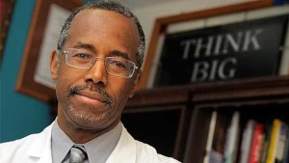HUD’s books are in such bad shape that the IG can’t complete an audit on their second try.
Here’s what happened on the first try:
According to the IG report, after the first review, Obama staffers had to correct a whopping $520 billion in bookkeeping errors.
When the IG remained unable to issue an opinion for fiscal years 2015 or 2016, he gave Obama staffers a three-month extension. Thus, their reprieve allowed them to fix $3.4 billion in 2015 errors and $516.4 billion in 2016 errors.
After HUD’s re-submission of paperwork, 11 material weaknesses, seven significant deficiencies, and five instances of failure to comply with laws and regulations remained unresolved.
The continued problems “were due to an inability to establish a compliant control environment, implement adequate financial accounting systems, retain key financial staff, and identify appropriate accounting principles and policies,” the IG said.

If the Obama team hired qualified staff, the unresolved issues below would already be resolved:
- HUD lawyers repeatedly refusing to sign a management letter listing all HUD litigation
- HUD’s improper accounting methods
- Failure to correctly measure assets and liabilities
- Discrepancies between general ledger and sub-ledger accounts
- Lack of sufficient support for an audit of $4.2 billion in loan assets from Ginnie Mae’s financial statements.
The Fix was simple. Obama’s HUD needed to “comply with generally accepted accounting principles.”

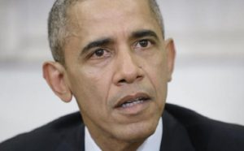Yet, Obama’s HUD lackey, Brian Sullivan said otherwise.
In December 2016 he claimed:
“HUD does apply generally accepted accounting standards,” despite the IG report that we do not.
Ironically, Senate Democrats rushed to condemn Dr. Ben Carson, the former neurosurgeon who President Trump tapped to be his new HUD Secretary. Further, Senate Minority Leader Chuck Schumer (D-NY) argued:
“I have serious concerns about Dr. Carson’s lack of expertise and experience in dealing with housing issues. Someone who is as anti-government as him is a strange fit for Housing secretary, to say the least,” Schumer said in a statement.
And House Minority Leader Nancy Pelosi (D-CA) called Carson a “disconcerting and disturbingly unqualified choice.”
As we say of Leftists, they accuse you of what they are.
Dr. Ben Carson is undoubtedly qualified to run HUD or anything else in the government. Now the distinguished doctor must clean up billions of dollars in sloppy accounting left undone by his predecessors.
However, the real question may be, “Where’s the money?”
Regardless, you can bet that Dr. Carson and President Trump will follow the money.
Chinese Parts in NK Rockets?

China seems to be having second thoughts about indulging the deranged Kim regime in North Korea for so long, but it will not be easy for Beijing to downplay the amount of assistance it has given Pyongyang’s nuclear missile program over the years.
The Washington Post writes of a North Korean booster rocket falling into South Korean waters after a major satellite launch last year, and the South Koreans discovering that many of its key components were purchased from Chinese businesses.
U.N. officials sought comment from these Chinese firms after preparing a report on the rocket configuration but “received only silence.” That is not surprising since the U.N. report found that “sensitive software and other items specifically banned for export to North Korea under U.N. Security Council sanctions” were sold by the Chinese as well, and some of the shipments occurred within the last 18 months.
Analyst Joshua Pollack of the James Martin Center for Nonproliferation Studies suggested the Chinese government might be inadvertently allowing these shipments because it is unwilling, or unable, to police the huge number of companies exporting these sensitive goods, using sophisticated tactics to keep their activities hidden. He added that if they are trying to police the exports, endemic corruption in the Chinese system might be holding investigators at bay. It really should come as no surprise to analysts. Chinese chips and circuits are packed into every aircraft, naval vessel, and electronic weapons system in America as well. Oh, and yes the firmware has a back door, with a Chinese lock for which only they have the key. When they are facing down any weapon, they can simply turn it off with a simple code. You always wondered why our highest tech drones can not only be easily spotted, but flown harmlessly to the ground behind enemy lines at will. Drones and cruise missiles are useless against the Chinese or the Koreans. End of game.
Those excuses seem difficult to square with the shrill insistence of Chinese officials on impossible standards of proof before they will investigate allegations of North Korea sanctions-busting. Also, the North Koreans took considerable pains to destroy the evidence by planting explosives all over their test rocket.
The conclusions from the U.N. report were mixed, with some optimism expressed that China has been cracking down on illicit shipments to North Korea over the past few months but also complaints that China could do a great deal more to cut off Pyongyang’s access to missile technology.
On the one hand, China’s ban on North Korean coal seems like a serious blow to the North Korean economy, and China appears to be serious about maintaining the ban. But on the other hand, Chinese officials boasted this week that overall trade with North Korea increased by 37 percent in the first quarter of 2017. It is not enough to balance the billion-dollar loss North Korea will experience from China’s ban on coal imports, but it will ease the pain of that loss somewhat.
It is unclear whether China would be willing to use the other high-powered economic weapon in its arsenal and ban exports of Chinese oil to North Korea, effectively devastating their economy (and possibly triggering one of China’s worst fears, a flood of North Korean refugees). The Chinese gave North Korea a little taste of oil shortage back in 2003, passed off as “technical problems” with shipping, and it seemed to concentrate Pyongyang’s mind wonderfully.
North Korea’s belligerence might force the issue, on both Chinese economic sanctions and China’s willingness to indulge Pyongyang’s missile program. On Friday, mixed with its customary threats to unleash “nuclear thunderbolts” against the United States, North Korea sneered through one of its “think tanks” that “somebody” was cooperating with the U.S. in a “naive and foolish” attempt to collapse the North Korean system. The somebody in question is widely interpreted to be China, making it one of the worst insults the Kim regime has thrown at its Chinese patrons.
More than anything else, that calculation changed when the North Koreans began their final lap toward nuclear-tipped ICBMs, and the U.S. responded by deploying the THAAD anti-missile system in South Korea. China and Russia hate the way THAAD’s powerful radars allow it to peer into Chinese territory, and they dislike the thought of pouring resources into offensive systems that might be able to overwhelm advanced missile defense.
Also, China may have calculated it could pull its junk yard dog, North Korea back before it developed nuclear-tipped long-range missiles. That doesn’t even factor in the danger of EMP attacks against the free world. High-altitude nuclear detonations designed to scramble electronics don’t require much in the way of precision guidance, and they don’t need re-entry technology at all, which is one of the biggest challenges to producing regular nuclear missiles. The very same type of satellite launch vehicle China helped North Korea build is just about good enough to put an EMP weapon over the United States or Europe, with potentially catastrophic results. It’s a threat Western planners simply cannot ignore. It is also a threat against which any Western planner has no plan.
No one needs to invade the US. Who would could possibly fight street by street against the most well-armed people the world has ever known? And make zero mistake here. Without that fight, there will be no invasion of America. But, as I said, if all you want to do it take liberty out of the human equation, which seems to have been the goal for 240 years, then all you have to do right now is turn out the lights for a while. The Muslim Brotherhood, formed in 1928 with the sole purpose of destroying freedom and liberty globally, and led by the charismatic Barack Obama, has been preparing America for more than ten years for this. Once the lights go out, and the police go home, or wander around without orders, all hell is going to break loose. Take a look around. They have had a dozen dry runs in the past 6 years alone. It’s a powder keg of epic proportions.
If war re-commences with North Korea, the US will very likely suffer major attacks HERE – inside our own land. These attacks may come from submarines off our coast, cyber-attacks to utilities, acts of sabotage by Sleeper Cells. Our electric, water and communications systems are all vulnerable. Are you prepared? Here’s how and why you need to take action for yourself and your family.
North Korea has no chance over a long-term of defeating the US. But over the short term, they can do an awful lot of very serious damage to us; damage that would affect YOU and YOUR FAMILY. It’s time to prepare. RIGHT NOW!
In any conflict with North Korea, they will seek to use “asymmetrical” warfare. It won’t be tit-for-tat it will be unusual attacks.
For instance, over the past decade or so, North Korea has successfully launched two orbiting satellites. Both orbit the United States mainland and Alaska every 100 minutes or so. Track them yourself HERE and HERE
Both satellites are in orbit 450 kilometers above the planet, which converts to about 300 or so miles.
The strange thing about BOTH these satellites is that they do not transmit anything. Nothing at all. No radio or TV signals. No data streams. No radar.
So what are they up there for?
Some feel that each satellite is a low yield nuclear bomb with a radio receiver, waiting for the signal to detonate over the United States.
What if this is true; what could such a device actually accomplish?
Well, first of all, if it is a nuke, we would not feel any blast and would not suffer any radiation. It’s too far up to affect us in those ways.
But it’s altitude of about 300 miles is the PERFECT altitude to send an Electro-Magnetic Pulse (EMP) into the Stratosphere. The massive and sudden release of the blast would react with the earth’s atmosphere and cause a sudden “surge” (pulse) of MAGNETISM.
Human bodies would not be affected at all by magnetic fields, we live with them all the days of our lives.
Electronics, however, are another story.
First, a little High School Physics:
Do you know how electricity is generated? “The free flow of electrons.”
And how do power companies make the electrons flow freely? Magnetic fields!
In a power plant or even in your automobile alternator, there are coils of wire around a center stem. On that center stem is a . . . . magnet.
As the magnet turns inside (by a steam source in a power plant or a drive belt on your engine), the magnetic fields coming off the magnet cause electrons in the nearby wire to move. THAT is electricity.
Now think about your house, your car, all the electronic gizmos you have. They ALL have wires, right?
Well, if a nuclear bomb explodes up in space, and reacts with our atmosphere as it is well-known to do, the magnetic pulse that comes down to the ground will cause the electrons inside wires to flow. Put simply, the pulse from the nuke will cause anything metallic, to generate electric! A lot of electric. The graphic below from the US Army show the VOLTS along the right column:

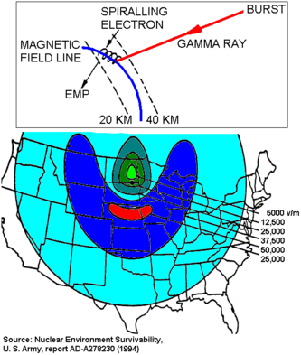

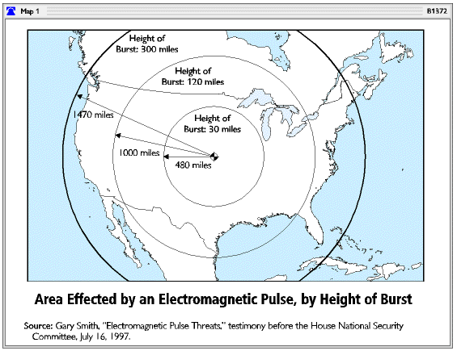

In fact, depending upon how close or how far from the detonation you are, the voltage would be from 5,000 to 50,000 VOLTS per meter of metal wire !!!!!!
Every wire in your house, all the plugs on your appliances, all the extension cords you have, all the circuits in all your electronic gizmos would ALL suffer those types of instant voltage surges – and be fried. Dead.
Cars may not work because their electronic ignitions MAY get fried too.
But that's the least of our worries . . .

Our Power Grid
Now, think about the United States Power Grid. All the wires you see on all the telephone poles everywhere. ALL OF THEM would surge with voltage as well!
On many of those telephone poles are “transformers” which step-down the voltage from the power plant, to a level we can use in our homes. ALL of those transformers would be wrecked, with many, many of them flat-out exploding.

The Big-Government Alliance
This week we saw the attacks by Soros-funded statists continue to escalate.
We expect those attacks to grow as we pass in more and more states. As Mark Levin said on his radio program on Thursday, “Wait until you see what happens when we get to 20 states!”
But the big development this week is something even more sinister. According to Fred Wertheimer, the President of Democracy 21 (another Soros-funded organization), in a COS attack piece published by The Huffington Post,
"But there is also a national coalition working to prevent a constitutional convention. Groups providing leadership for the coalition effort include the Center for Budget and Policy Priorities, Common Cause, AFSCME and Democracy 21.
The coalition has been joined in some states by local conservative organizations, including... the Eagle Forum…"
That’s right…there is now a coalition of radical progressive Soros groups, powerful statist Unions, and duped organizations on the right working to undermine an Article V Convention of States.
They are the new American Anti-Constitutionalists. Instead of using Article V of the Constitution to restore the Constitution back to its original meaning, they are working to preserve big, centralized government.
Instead of working for a return to the original Constitution and Bill of Rights known and loved by conservatives across the country, some allegedly conservative groups are spending time, money and donor resources, preserving the “Annotated Constitution,” which is literally over 2,000 pages as “interpreted” over centuries by the Supreme Court.
The “Annotated Constitution” includes the decision upholding Obamacare and the Obergfell marriage decision, among many other SCOTUS decisions that expanded federal power and overreach.
Why would any conservative want to protect those things? The answer is, “no real conservative would.”
So whose Constitution will you defend, George Soros’s or our Founding Fathers’?
This week, we are standing up and asking for your help, to fight back against Soros and his progressive elitists, who like the “new” version of the Constitution created by Congress and the Courts.
And sadly, we also need your help to fight back against the fringe groups on the right who, according to the Huffington Post, are now working in a coalition with radical leftists to preserve the status quo.
This unholy alliance is colluding to dupe conservative state legislators with their lobbyists and fake media. The question for your state legislator is, “Do you stand with Soros and big government, or the constitutional solution to restore limited government, provided by the Framers?”
So why are the attacks escalating now? The radical leftists learned some hard lessons in the last electoral cycle.
“Brexit could never happen,” said the elitists. And then it did.
“Trump will never be President,” the leftists scoffed. And then they stared, mouths agape, as he took the oath.
So now, the limited government they once deemed as “impossible,” they now see as probable. With ten states under our belts, the pathway to 34 to call a convention is more clear every day.
Together, We the People can make the final push to victory.
Americans Have Stopped Moving
Americans are stuck. Locked into our jobs, rooted where we live, frozen at our income levels. More than at any previous point in our history, we’ve stopped moving — whether moving up the income ladder or packing up a truck and finding another home. We’ve grown ossified, rigid.
The flip side is that we’re stable. If we weren’t so content, we’d be more willing to gamble, to shake things up, to start a new firm or join one. Maybe we’re fine where we are. But maybe this period of stasis cannot last. Maybe it even portends a period of massive disruption.
In “The Complacent Class: The Self-Defeating Quest for the American Dream,” economist Tyler Cowen presents an X-ray of societal sclerosis. This isn’t merely another exercise in nostalgia, a sentimental yearning for a bygone era (when, for instance, crime and pollution were higher, people were highly likely to marry someone who lived within five blocks and you would buy an album containing 10 lousy songs because you liked one track). Something has changed in the American character and in the American economy, and the two seem to be reinforcing each other.
For instance, parts of the country (New York City, Silicon Valley, Texas) are doing extremely well, yet able-bodied adults sit idle in other areas. Why don’t the unemployed, and the large numbers who have dropped out of the labor force, move to the boom towns? Wouldn’t it be better to drive an Uber in Brooklyn than to get by on welfare in West Virginia?
Yet labor mobility is in a funk. Especially after WWII, millions of Americans with limited resources — southern blacks — moved hundreds of miles from home to take up industrial jobs in the north. At the peak, more than 30 percent of southern-born blacks moved north, from 1920 through the 1960s. Even when technological limitations made long-distance travel extremely onerous, in the late 19 century, we were willing to travel in search of opportunity. In the second half of the 1800s, more than two-thirds of US men over 30 had moved away from their hometowns, and more than a third of those moves were for more than 100 miles.
Modal Trigger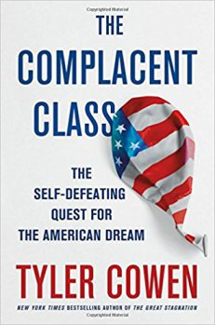
Nowadays, moving from one state to another has dropped 51 percent from its average in the postwar years, and that number has been decreasing for more than 30 years. Black Americans, once especially adventurous, are now especially immobile. A survey of blacks born between 1952 and 1982 found that 69 percent had remained in the same county and 82 percent stayed in the same state where they were born.
This is especially troubling in context: Studies show major benefits for the children of poor people who move to better-off neighborhoods via, for instance, a program called Moving to Opportunity. If a poor child from a bad neighborhood moved to a middle-class neighborhood at age 8, his expected lifetime income would be $302,000 higher than if he stayed put. Still, the bias toward inertia is so strong that 52 percent of impoverished black families told about Moving to Opportunity declined offers to participate.
One reason people don’t move where the jobs are is because of real-estate prices — which in turn are kept at high levels by regulatory restrictions and NIMBY-ism. In New York City in the 1950s a typical apartment rented for $60 a month, or $530 today if you adjust for inflation. Two researchers found that if you reduced regulations for building new homes in places like New York and San Francisco to the median level, the resulting expanded workforce would increase US GDP by $1.7 trillion. That won’t happen, though: More homes would diminish the property values of existing homeowners.
When we lose the ability to pay for stuff, the poorest and least powerful will be the first and worst hurt.
That locked-in syndrome is a factor in economic stagnation, too: A recent Wells Fargo survey found that white-collar office productivity growth was zero. As the economy was supposedly recovering from the financial crisis, from 2009 to 2014, American median wages fell 4 percent. Men’s median incomes today are actually below 1969 levels. Had we retained our pre-1973 rates of productivity growth, the typical household would earn about $30,000 a year more than it does.
Despite all the hype attached to a few tech companies, far fewer companies are being formed than in the 1980s, and fewer Americans are working for startups. Such new companies are linked with rapid job creation. We’re coming close, Cowen says, to realizing the 1950s cliche (not really true then) of everyone clinging to a job at a handful of huge, soul-crushing companies.
So where is all this heading? “Ultimately peace and stability must be paid for,” writes Cowen. Sluggish growth, diminished productivity, unwillingness to move to a better job and fewer entrepreneurs taking risks to create fortunes adds up to less tax revenue. When we lose the ability to pay for stuff, the poorest and least powerful will be the first and worst hurt. They won’t like it.
The social, economic and political disruption represented by the ascent of President Trump is one of the early warning signs, Cowen says, that the tectonic plates of our society are rumbling. When they start to move, a lot of complacency will be destroyed in the quake
The War Over Free Speech
The battle between the CIA and WikiLeaks is intensifying.
CIA Director Mike Pompeo used his first major public remarks on Thursday to skewer WikiLeaks as a “non-state hostile intelligence service” willing to work with Russia and other foreign actors to promote their interests.
He blasted Julian Assange as a “fraud” interested in his own fame, seeking to undermine efforts by the WikiLeaks founder to be viewed as a legitimate ally of civil libertarians.
“It is time to call out WikiLeaks for what it really is, a non-state hostile intelligence service often abetted by state actors like Russia,” Pompeo said.
“Assange is a narcissist who has created nothing of value,” the former Republican congressman charged. “He relies on the dirty work of others to make himself famous. He is a fraud—a coward hiding behind a screen.”
WikiLeaks was quick to respond, sending out a series of messages on Twitter claiming that Pompeo vowed to “silence” the organization over its purported disclosures of CIA hacking tools and using his remarks to promote an op-ed written by Assange in the Washington Post.
In the op-ed, Assange wrote that WikiLeaks had the same mission as news outlets such as the Post and The New York Times.
The organization also mocked Pompeo by sending out a since-deleted tweet he wrote last July, when the former Kansas lawmaker cited stolen Democratic National Committee emails released by WikiLeaks as proof that the presidential nomination had been “fixed” for Hillary Clinton.
Pompeo’s speech was a wide departure from President Trump’s praise of WikiLeaks on the campaign trail. Trump and his administration have taken a much more hostile approach to WikiLeaks since taking office.
U.S. national security experts welcomed Pompeo’s comments as a signal that the new director was taking a hard line on an organization that has leaked information damaging to American interests.
“I think what [Pompeo] did was putting him on notice, which I think is exactly the right thing to do,” James Carafano, a national security expert at the conservative Heritage Foundation, said. “I think he’s throwing down the gauntlet.”
But the speech was not warmly embraced by all. Journalist Glenn Greenwald, who published documents leaked by Edward Snowden, slammed Pompeo for his remarks, accusing him of "explicitly" threatening free speech and press freedoms.
"WikiLeaks now has few friends in Washington," Greenwald wrote in The Intercept. "But the level of affection for WikiLeaks should have no bearing on how one responds to these press freedom threats from Donald Trump’s CIA Director. Criminalizing the publication of classified documents is wrong in itself, and has the obvious potential to spread far beyond their initial target."
WikiLeaks for weeks has needled the CIA by releasing troves of leaked documents allegedly revealing the agency’s hacking programs.
The releases, called “Vault 7,” contain documents describing hacking techniques used by the CIA, such as tools to breach mobile devices and hack into smart televisions, as well as other internal communications.
Hours after Pompeo’s speech, WikiLeaks leaked yet another trove of documents that claimed to reveal information about a top-secret CIA hacking program called Hive.
Experts have largely described the contents of the periodic document releases as unsurprising, and evidence that the CIA is doing its job. Nevertheless, they have renewed the debate around privacy and intelligence community spying and also raised questions about the source of the leaks.
“Obviously, this hurts when other people know where you have been, what you have been thinking,” said former CIA Director Michael Hayden, who said that the documents show no abuse of the agency’s powers.
“There is the danger that even though these things might reflect appropriate activities that Americans don’t object to, the fact that you can’t keep the tools secret, the fact that you can’t keep the data you collect from other prying eyes, that creates a real big, strong argument for, ‘then I don’t want you doing it in the first place,’” Hayden said.
Some note that the leaks underscore the persisting problem of insider threats, which has been a major cause for concern since the leaks by former NSA contractor Edward Snowden and former soldier Chelsea Manning.
Pompeo acknowledged Thursday that the agency needs to strengthen its own systems to prevent leaks.
Adam Klein, a senior fellow at the Center for a New American Security, said that a major concern about WikiLeaks is that the organization provides an “outlet” for insider threats and encourages them.
“Insider threats are our intelligence agencies’ biggest security threat,” Klein told The Hill.
WikiLeaks has appeared to target CIA interns as potential sources of information. “CIA advertises internships. Whistleblowing opportunity?” the organized wrote on Twitter in mid-March.
“To the extent that there’s any news here, it’s that we have not gotten a handle on insider threats,” Klein said of the latest releases, noting that Congress should be concerned about the CIA leaks.
“I think it’s good news, frankly, that the CIA us thinking creatively about collecting information from foreign intelligence targets in the digital age,” Klein said.
The CIA has not confirmed the authenticity of any of the documents released, which Pompeo mentioned briefly on Thursday.
“As a policy, we at CIA do not comment on the accuracy of purported intelligence documents posted online,” Pompeo said. “In keeping with that policy, I will not specifically comment on the authenticity or provenance of recent disclosures.”
“But the false narratives that increasingly define our public discourse cannot be ignored,” he said.

