Jihad Report
Jun 03, 2017 -
Jun 09, 2017
Attacks | 41
Killed | 324
Injured | 403
Suicide Blasts | 8
Countries | 18
The Sleeping Sun
Over the last three and a half years the Sun has gone from solar maximum through a bounded decline to the current stage of the trail to minimum. Solar minimum is likely to be still three years away. Solar Cycle 24 is sitting at the lower bound of activity for solar cycles back to 1964, the start of Solar Cycle 19. From here to minimum though, it looks like Solar Cycle 24 will have much lower volatility than the solar cycles that preceded it. According to Svensmark’s theory, the neutron flux, with its effect on cloud cover and thus the Earth’s albedo, is one of the bigger climate drivers. For Solar Cycle 24, the neutron flux duly turned around and starting rising again in 2015, one year after solar maximum. It is a safe bet that the neutron flux is heading for a record high at solar minimum (+ one year) relative to the instrumental record. The last weak solar cycle was Solar Cycle 20 which caused the 1970s Cooling Period. From the same stage in that cycle the neutron count flattened out to minimum. That could happen for Solar Cycle 24 but it is more likely to keep rising to minimum as 23 did and thus we can expect a count, at the end, of over 7,000. If we conflate the F10.7 flux and the Oulu neutron count inverted, that shows they tracked each other closely up to 2004. Something changed in 2004 and since then the neutron count has been higher relative to its previously established correlation with the F10.7 flux.
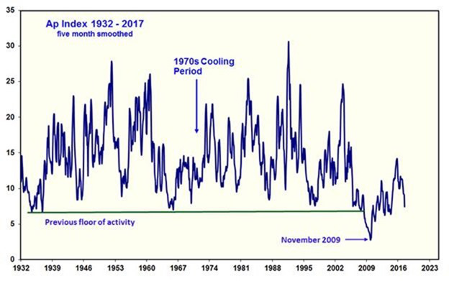
Figure 6: Ap Index 1932 – 2017
Figure 6 shows that what changed in 2004 was the magnetic output of the Sun, shown in this instance by the Ap Index. Prior to that, there seemed to be a floor of activity at solar minima, just as the floor of activity for the F10.7 flux is 64. Three years to minimum and the Sun is now back to that level.
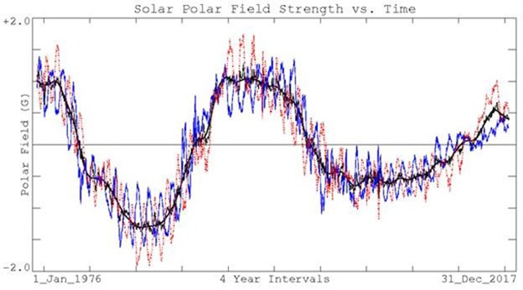
Figure 7: Solar Polar Field Strength 1976 – 2017
The best predictor of the amplitude of the next solar cycle is the strength of the solar polar magnetic fields at solar minimum. Figure 7, from the Wilcox Solar Observatory, shows that the solar polar magnetic fields at minimum have been weakening with each successive cycle.
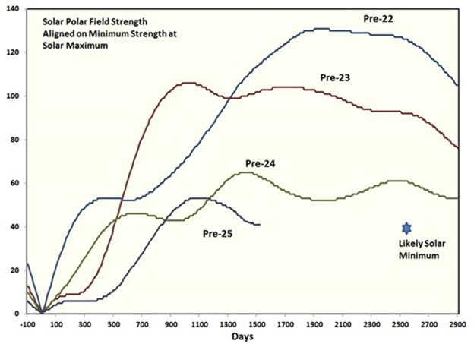
Figure 8: Solar Polar Field Strength aligned on minimum strength at solar maximum
Solar Cycle 25 started from the blocks looking like it was going to be very weak and fulfill the prophecies of those predicting a Maunder-like experience for the 2020s. Then after a couple of years it caught up with Solar Cycle 24. Looking back over the previous three cycles, the solar polar field strength at this stage, three years before minimum, has been close to the value at minimum. On that assumption, Solar Cycle 25’s amplitude is likely to be two thirds of that of Solar Cycle 24, and thus 60. Further climatic cooling is therefore in store.
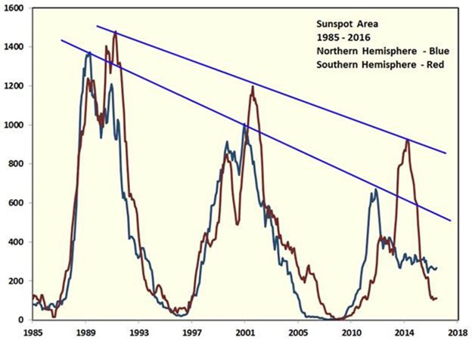
Figure 9: Sunspot Area 1985 – 2016
NASA has deigned to give us another nine months of sunspot area data by hemisphere, up to September 2016. The strong asymmetry between the northern and southern hemispheres continues. The fact that the hemispheric peaks of the last three cycles align indicate that there is a multi-decadal force operating in the vertical dimension. The chance that two sets of three points line up exactly by themselves is infinitesimal.
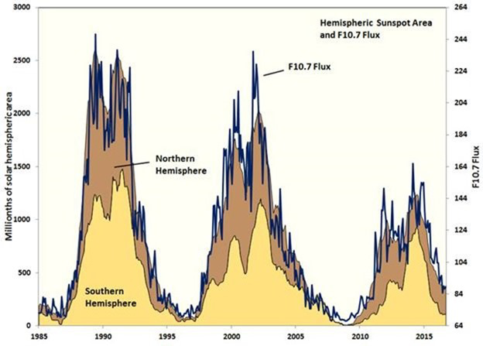
Figure 10: Hemispheric Sunspot Area and F10.7 Flux
As shown by Figure 10, total sunspot area tracks the F10.7 flux closely.
Daytime and Nightime Temperatures Converging
A cursory review of articles about the upper atmosphere reveals many theories about the role of CO2 on temperatures aloft. By “Upper Atmosphere” we mean the region above the surface and below 100,000 feet. Actually, in this article, we will only concern ourselves with the region from 850 millibars to 100 millibars, which is about 5,000 feet to 55,000 feet.
In the early days of Global Warming, the theories predicted that the upper atmosphere would heat due to increases in CO2. Well, that didn’t happen. One recent article by NASA says that the Thermosphere (above 100,000 ft) has cooled in recent years due to decreased solar activity and a reduction in ultraviolet light. That certainly seems reasonable. Another article stated that if the lower atmosphere warms, the upper atmosphere must cool, which makes no sense to me.
Other articles posit that as CO2 increases the level at which radiation escapes to space also increases and the upper atmosphere warms. That also made no sense to me.
I decided to take a look at temperatures aloft and reasoned that the difference between day and night temperatures in the upper atmosphere might reveal whether the nighttime atmosphere is cooling faster or slower than in previous years. If cooling slower the temperature curves at 00z and 12z would tend to converge and if cooling faster the curves would diverge. Simple, right?
Upper air data was obtained from NOAA at https://ruc.noaa.gov/raobs/ for the period 1970 through 2016. The NOAA site houses balloon data in different formats but only the standard levels of 850, 700, 500, 400, 300, 250, 200, 150, and 100mb data were used. It was felt that the best way to test the hypothesis was to use data from an upper air station where moisture levels were low in the belief that a lot of moisture would cloud the results.
Initially, Tucson was selected for its dry climate and where the 00z and 12z observation times coincided with the time of maximum and minimum temperatures at 5 pm and 5 am at that location. After downloading the data as yearly files, a computer program averaged all 00z and 12z observations for each mandatory level.
The results from plotting Tucson average yearly 0000z and 1200z temperatures at different heights were unexpected, to say the least.
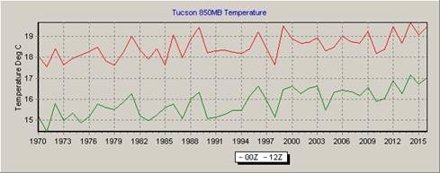
Figure 1. Tucson 850mb (about 5,000 ft.) temperature graph.
As expected, the 12z curve (green) shows that the air cooled during the night on average about three degrees through 1995 and then narrowed to only two degrees through 2016. Both curves are trending upward and beginning in the mid-90s the curves tend to converge, which may support the Global Warming theories since CO2 cools slower than air. However, that would mean that Global Warming did not start until the mid-90s, which is an unlikely scenario.
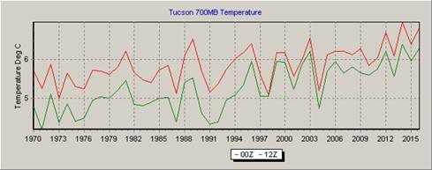
Figure 2. At 700mb (10,000 feet) the temperature continues to increase as the convergence of the curves becomes more pronounced beginning in 1996.
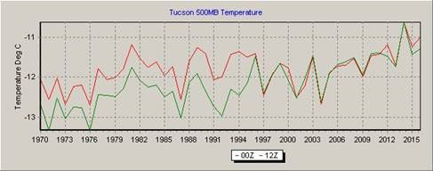
Figure 3. At 500mb (18,000 feet) the curves became virtually the same beginning in 1996.
The question must be asked, “What happened in 1996?” El Nino was in 1997 and 1998. When this graph was created, my initial reaction was that there was a serious error in the data or the extraction program. I have been unable to find such an error.
The strangeness continues with the following charts.
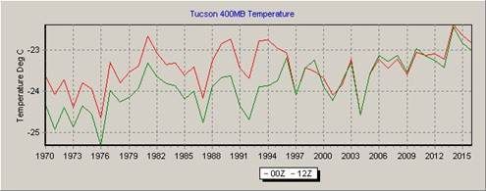
Figure 4. At 400mb(24,000 ft).
We are now above 90% of the moisture, and any changes in the divergence of the two curves must be due to external forces. It is unreasonable to think that a steadily rising CO2 would suddenly make itself known in this way. The following charts are included to show that the converging curves are present at all upper levels.
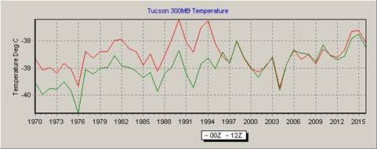
Figure 5. 300mb.
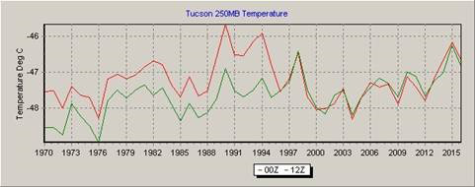
Figure 6. 250mb.
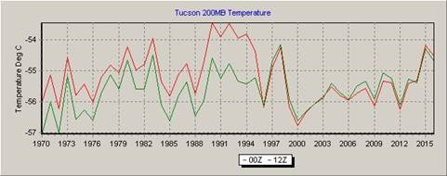
Figure 7. 200mb.
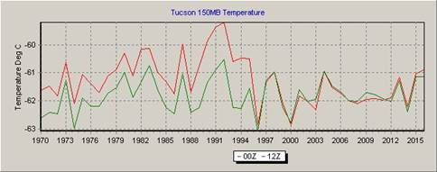
Figure 6. 150mb.
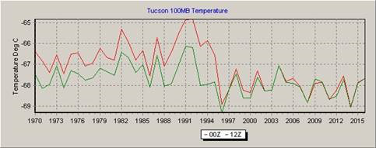
Figure 7. 100mb.
As can be seen in the preceding charts something happened in 1996 that affected the atmosphere beginning at 850mb and increased in severity as we go aloft, culminating in a rather large drop in temperature at 100mb. There are two things about the preceding charts: 1. the temperature, after convergence, on each chart from 300mb and higher, cool until the curve is flat at 100mb and 2. There is little change in the curves before 1996.
The NASA article said that the Thermosphere has cooled due to a reduction in ultraviolet light from a quite sun. Perhaps it is affecting lower levels also.
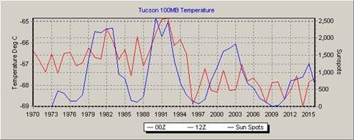
Figure 8. Tucson 100mb temperature and sunspots offset by three years.
If we plot the 100mb Tucson temperatures with a three-year delay of sunspots, the graph above is the result. The correlation between sunspots and the 00Z temperature is .44.
Normally we tend to think that conditions in the lower atmosphere affect the upper atmosphere, but the charts indicate that it is the other way around and the upper atmosphere is affecting the lower levels, and that is why the biggest change is not at 850mb but at 100mb where significant cooling has taken place.
To check for errors the daily data for the years 1995 and 1996 were plotted as shown below. In these two examples, there are less than 365 observations because of missing data at the 100mb level.
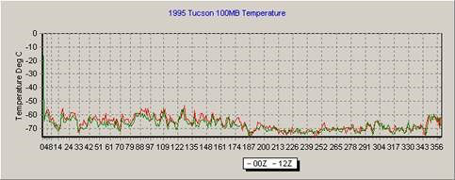
Figure 9. 1995 Daily Temperature for Tucson.
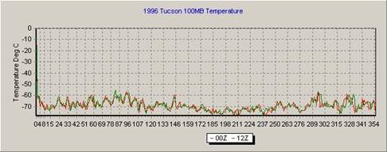
Figure 10. 1996 Daily Temperature for Tucson.
This error check does show that the temperature does indeed cool in the first half of 1996 as compared to 1995.
As stated earlier, Tucson was chosen because it was dry and the observation times were ideal. But to me the temperatures changes were very unusual and to investigate further, I obtained rawinsonde data for Anchorage, Alaska, and the charts are shown below. While not as dramatic as the temperature changes for Tucson, the Anchorage charts also show a rather abrupt change in temperature, but not in 1996 but 1999. Again the biggest change was with temperatures at 100mb.
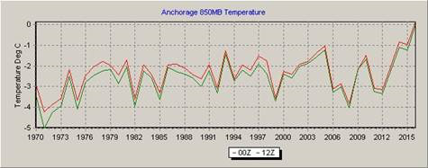
Figure 11. Anchorage 850mb.
Note how the two curves on Anchorage’s 850mb chart are much closer than the same chart for Tucson. I believe this is due to much greater water vapor in the air over Anchorage compared to Tucson. Also, the times of observation are at 3 am and 3 pm, which is not ideal but not bad either.
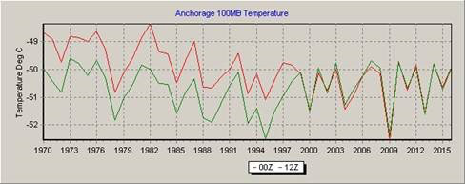
Figure 11. Anchorage 100mb.
While the 100mb data for Anchorage is cooler in later years, it does not have the pronounced cooling as seen in the Tucson chart and convergence occurs in 1999 as opposed to 1996 for Tucson. Anchorage charts for levels between 850mb and 100mb are not shown but are available if anyone is interested in them.
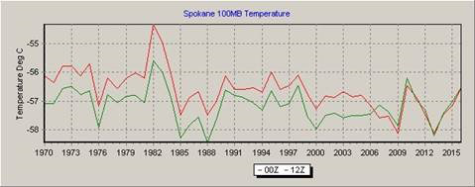
Figure 11. Spokane 100mb Temperature.
Only the 100mb chart is shown for Spokane. Note cooling in later years and the convergence started in 2006.
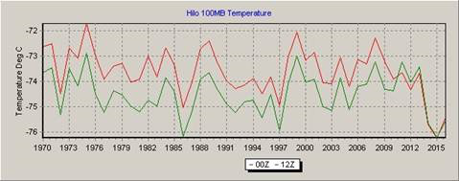
Figure 12. Hilo, Hawaii 100mb.
And here is Hilo Hawaii where the temperatures converged in 2011.
So now we have Tucson temperature aloft curves converging in 1996, Anchorage’s in 1999, Spokane’s in 2006, and Hilo’s in 2011.
· Tucson’s 100mb temperatures are increasing until about 1990, drop sharply until they converged in 1996 and then remain constant.
· Anchorage’s 100mb temperatures drop until about 1996, increase slightly and converge in 1999 and almost constant after that.
· Spokane’s 100mb temperature is decreasing after 1982 and then converging in 2006 and remaining constant after that.
· Hilo’s 100mb temperature curve is rather constant until it converges in 2011 and drops sharply in 2014.
These graphs raise many questions and provide few answers. Whatever the cause of cooling temperatures at the 100mb level, it is not directly related to steadily increasing CO2. It is apparent that the phenomenon is worldwide and it starts at the higher levels.
As a further check, El Paso data was used as shown in the following graph.
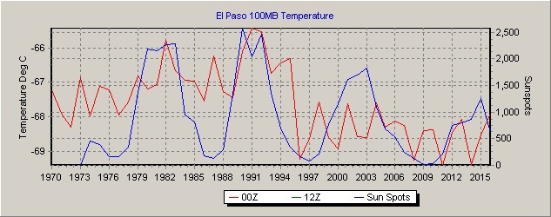
The plots for El Paso were almost identical to Tucson’s and also has a correlation of 0.44.
The following conclusions are pure speculation.
The sun is the main driving force for changes in temperature at high altitudes, less so for high latitude locations. It is clear that the sun is changing the temperature at high altitudes, but what about the convergence of night and day temperatures?
Occam’s Razor says that the simplest answer is usually correct, which means that the sun is causing both. And indeed the answer is simple. Consider that normally the radiation from the sun passes through the atmosphere without heating it and all the heat in the upper air comes from below as long wave radiation. But if ultraviolet radiation is heating the upper atmosphere, we have a different kettle of fish. Since prior to the sun becoming quiet the upper atmosphere was being heated during the day, that extra heat would be dissipated at night, but without that heating, the night temperature stays the same as the day temperature.
300,000 Teachers are Sent “Alternative Climate Change” Perspective
A conservative think tank has sent teachers across the country thousands of books and DVDs that claim there is no scientific consensus on climate change, Buzzfeed News reports.
The Heartland Institute sent over 300,000 teachers a 135-page book titled "Why Scientists Disagree About Global Warming," and an 11-minute DVD titled "History of Climate Change in Greenland."
Heartland spokesperson Jim Lakely told BuzzFeed News that "the intent was to make sure teachers were aware that there was alternative scientific research.
"There's been a positive response to the mailings for sure," he added, saying that members of the institute visited some classrooms in the spring after receiving requests from schools. "We have some invitations pending for the next school year when it begins."
In a letter to Secretary of Education Betsy DeVos, Democratic Sens. Sheldon Whitehouse of Rhode Island, Brian Schatz of Hawaii, and Elizabeth Warren and Ed Markey of Massachusetts objected to her statement of support for President Donald Trump's decision to withdraw from the Paris climate agreement, and calling on her to distance her department from the Heartland Institute, which they say "has disseminated 'alternative facts' and fake science at the behest of its industry funders for decades."

They note that the Heartland Institute previously "teamed up with Phillip Morris to challenge facts about the health risks of tobacco. The tobacco industry's conduct is found to be fraudulent. Using the same strategies, with funding from the Koch family foundation, ExxonMobil, and other fossil fuel interests, the Heartland Institute now seeks to undermine the scientific consensus about climate change."
The Heartland Institute has had to respond to scandalous assaults in their integrity in a section called a "reply to critics" on its website, where it quotes legal counsel: "There have been numerous false and malicious claims that The Heartland Institute is a front for the energy industry and is funded by 'the Koch brothers.' These statements are often made with full and advanced knowledge they are untrue; in some cases they are made without such knowledge. With this notice, the reader is informed he/she will have no defense of 'innocent mistake' made because of lack of knowledge and may have legal liability for defamation." This is very typical of the lack of factual defense that the globalist fascists have for their effort to use something as unreliable as weather prediction science as the basis for global governance and the establishment of an international transfer of wealth. Oh, by the way, there would be handling charges for moving all that wealth around the world. Your wealth. Just remember that, when you think about defending the climate change crackheads.
Florida Sheriff Coaches Armed Citizens

Florida’s Brevard County Sheriff Wayne Ivey is urging law-abiding Americans to arm up, get familiar with their firearm, and be ready to make terrorists worry about defending their own lives, for a change.
Ivey made these comments in a video he posted to Facebook in reaction to the horrendous attacks on unarmed, law-abiding Londoners. Looking at terror attacks around the world, Ivey observed:
Terrorists and active shooters are using every weapon available to target citizens. Guns, knives, trucks, hammers, and even explosives have all become the weapon of choice for murderers who only have one goal–killing innocent and law-abiding citizens. It seems that almost everyday we hear of another attack taking place at a concert, tourist destination, church, business, or anywhere else in the world where they can strike fear in the hearts of citizens.
He urged Americans to take their safety seriously and to determine to be “the first line of defense” against a terror attack. He stressed, “Let me be perfectly clear, doing nothing or just hoping it won’t happen to you is not going to save your life.”
Ivey mentioned that officials in other parts of the world are teaching citizens that the best thing they can do is “run, hide, tell,” and he rejects that paradigm, citing the fact that “this is war” and you win a war by fighting — not by running.
He points out that “terrorists and active shooters know that our citizens have been coached to run and hide, and then patiently await help.” He said attackers “count on” Americans to respond this way, then added, “What they don’t count on is being attacked themselves.” Ivey says it is time to be prepared to counterattack; to be armed and ready to make the terrorists fight to defend their own lives for a change, should they strike.
Ivey said:
No matter who you are or what your position is on guns, there is no denying the fact that the only thing that stops a bad guy with a gun–or a knife–is an armed and well-prepared citizen or law enforcement officer. There is no doubt that as soon as 911 is called law enforcement is on the way, however, until they arrive it is up to you and those with you to neutralize or eliminate the threat.
Article V Convention: Threshold is Coming
As the U.S. national debt climbs ever closer to $20 trillion, many Americans are wondering if there is any way to curb federal spending. One former senator has a plan.
“Ask yourself why we’re not fixing Social Security. Why are we not fixing Medicare’s unfunded liabilities? Why do we continue to have $400 billion in waste, fraud, and duplication every year, or $145 billion in improper payment?” asked former Sen. Tom Coburn, R-Okla., in a recent interview on MSNBC’s “Morning Joe.”
According to Coburn, millennials will be the ones hit hardest by the out-of-control deficit accumulated in the United States.
“The average millennial is going to have to pay back $1.7 million over the next 50 years,” he stated. “That’s over thirty thousand bucks a year, and they already have a declining median income. People don’t know how much a billion is. If you make $40,000 a year, you have to work 25 years to make a million dollars. To make a billion, you have to work 25,000 years. Now we know what a billion is . . . and that’s just pocket change to career politicians.”
Coburn posited that the problem is that a class of career politicians have sprung up in Washington, taking power for themselves that the founders never intended for them to have.
“I left Washington because I didn’t see we could fix it there, and our founders gave us this opportunity for state legislatures to re-exert their authority to restore the Constitution to its original intent,” said Coburn. “How do we muzzle the alligators in the swamp? By reducing their authority back to what it was originally intended to be.”
Sen. Coburn proposes to do this by using one of the two methods of amending the U.S. Constitution laid out in Article V of that document — the Convention of States. Coburn made an argument for a convention in his newest book, “Smashing the DC Monopoly: Using Article V to Restore Freedom and Stop America’s Runaway Government.”
For an Article V Convention to occur, two-thirds of the state legislatures must pass an application for Congress to call one. Twelve states out of the 34 necessary have submitted such an application. All the state applications must deal with the same topics, and the 12 currently submitted call for amendments limiting the scope of the federal government, imposing a balanced budget on Congress, and giving term limits to Washington politicians.
“We can actually rebalance more power back to the people,” Coburn stated concerning these applications. “Bringing the power back to where the people actually have an input in it will actually solve some of the problems that are facing our country.”
At an Article V Convention, states would send delegates chosen however they saw fit, who would discuss the issues laid out in the submitted applications. Proposed amendments would go back to the state legislatures for ratification, and they would not become part of the Constitution until three-fourths of the states had ratified them.
“What Americans want is problems solved, and they don’t want to hear why you can’t, they want to see it done,” said Coburn. “Here’s a solution that’s as big as the problems we have.”
Coburn claims that 85 percent of the American people across the political spectrum support a balanced budget amendment, and believes that bringing the states together in an Article V Convention would bring the power closer to the people of each state, who have more ready access to members of their state legislatures than those in Washington, D.C.
A strong central government was the most frightening necessity facing the founding fathers. They knew the States needed a way to regulate commerce, and a way to commonly defend the nation. They also knew that such a government would one day be staffed by corrupt individuals and thus led in a direction of self awareness and self-will. This self-willed government would write for itself unlimited power and financial need and enslave the people. They knew that it would one day stop governing and would start ruling the nation, and one day the world. They also knew there was only one way to stop it. That is why Article V was written, just two days before the end of the Convention of 1787.
The day has come, Earth explorers, when that Article must be implemented. The States must unite and must stand up to amend the Constitution so as to stop the Federal government from continuing to claim powers it does not and should never have. No government should. There are six amendments outlined in the book Alienated Nation. They are as follows:
- A balanced budget amendment. Require a super-majority of States to raise the debt ceiling.
- Define and clarify the Commerce clause to prevent the Federal government from forcing people to buy services they do not want or need.
- Remove the authority of the agencies, department, bureaus, and administrations from writing laws and taxes.
- Establish term limits for the Congress and the Senate
- Repeal the 16th Amendment, returning the nation to the Constitutional taxing method.
- Requiring the sunset of all existing federal taxes and a super-majority vote to replace them with new, fairer taxes.
- I proposed a 7th which would not allow the President to command any State militia without a formal declaration of war by Congress.
The Lights Out Protocol

North Korea Dreams of Turning Out the Lights
Pyongyang doesn’t need a perfect missile. Detonating a nuke above Seoul—or L.A.—would sow chaos.

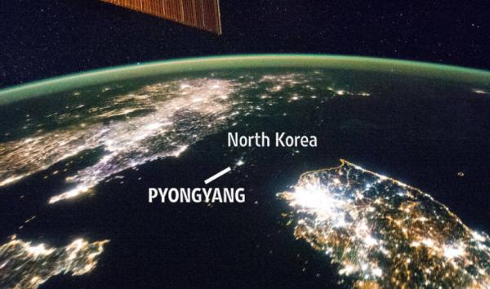

In 2001 Congress established a commission to study the danger of an electromagnetic pulse generated by the detonation of a high-altitude nuclear weapon. It concluded that while there would be no blast effects on the ground, critical electricity-dependent infrastructure could be rendered inoperable. The commission’s chairman, William R. Graham, has noted that several Russian generals told the commissioners in 2004 that the designs for a “super EMP nuclear weapon” had been transferred to North Korea.

Pyongyang, the Russian generals reported, was probably only a few years away from developing super EMP capability. According to Peter Vincent Pry, staff director of the congressional EMP commission, a recent North Korean medium-range missile test that was widely reported to have exploded midflight could in fact have been deliberately detonated at an altitude of 40 miles.

Was it a dry run for an EMP attack? Detonation at that altitude of a nuclear warhead with a yield of 10 to 20 kilotons—similar to those tested by North Korea—would produce major EMP effects and inflict catastrophic damage to unhardened electronics across hundreds of miles of surface territory. It is a myth that large yield nuclear weapons of hundreds of kilotons are required to produce such effects.

Although some analysts have dismissed the possibility of a successful North Korean EMP attack—either on South Korea or the United States—several factors could make it a more appealing first-strike strategy for Kim Jong Un’s nuclear scientists than a direct, missile-delivered nuclear strike. For one thing, accuracy is not a concern; the North Koreans simply need to get near their target to sow chaos. Nor would they need to worry about developing a reliable re-entry vehicle for their ballistic missiles.

Conventional wisdom aside, a North Korean EMP attack on the U.S. may also not be far-fetched. “North Korea could make an EMP attack against the United States by launching a short-range missile off a freighter or submarine or by lofting a warhead to 30 kilometers burst height by balloon,” wrote Mr. Graham earlier this month on the security blog 38 North. “Even a balloon-lofted warhead detonated at 30 kilometers altitude could blackout the Eastern Grid that supports most of the population and generates 75 percent of US electricity. Moreover, an EMP attack could be made by a North Korean satellite.” Two North Korean satellites currently orbit the earth on trajectories that take them over the U.S.

This is not mere theory. In 1962 the United States detonated a 1.4-megaton nuclear warhead over the South Pacific, 900 miles southwest of Hawaii. Designated “Starfish Prime,” the blast destroyed hundreds of street lights in Honolulu, caused electrical surges on airplanes in the area, and damaged at least six satellites. Only Hawaii’s undeveloped electric power-transmission infrastructure prevented a prolonged blackout. It was the era of vacuum-tube electronics. We are living in the digital age.
Some conclusions
Lots of actors in addition to North Korea have this capability. And we can’t stop it. Preventing a nuke-laden plane or balloon from detonating miles above a populated area is hard to the point of impossibility.
Banking and brokerage networks would be shut down – possibly for a long while – by such an attack, which means no access to ATM machines or credit card readers. People without ready cash would be stuck without access to life’s necessities. Meanwhile cars, which have in recent years become rolling computer networks, won’t run, making it hard to get to distant supplies.
The fiat currency of a system shut down in this way might or might not hold its value. This is uncharted financial territory so it’s not certain that cash under the mattress will be of use. And forget about cryptocurrencies in this scenario. Virtual money evaporates when the network on which it circulates goes down.
The solution?
Start upgrading to hardened electronics as part of a basic prepping program. That’s beyond the technical scope of this article, but Google it and you’ll find plenty of resources. And hold precious metals in small enough denominations to use as currency. One of history’s lessons is that gold and silver remain valuable whatever else is going on. If we’re destined to spend a few months back in the Middle Ages, spendable money will make the experience a lot more manageable
The DOJ is About to Make an Announcement
In a letter to Sen. Richard Shelby, Sessions explained that he would skip an appearance before a Senate subcommittee chaired by Sheldy where he was supposed to discuss the Justice Department budget to instead testify before the intelligence committee. The AG said it’s clear that, in the wake of Comey's testimony, the Russian investigation would become the focus of questioning, according to the AP. Deputy AG Rod Rosenstein will appear before Shelby's subcommittee in his stead, Sessions said.
I previously accepted an invitation to testify on behalf of the Department of Justice before the House and Senate Appropriations Subcommittees about the Department's FY18 budget, which funds the Department's efforts in several important areas such as combatting the opioid crisis and violent crime. Some members have publicly stated their intention to focus their questions on issues related to the investigation into Russian interference in the 2016 election, from which I have recused, and for which the Deputy Attorney General appointed a Special Counsel.
In light of reports regarding Mr. Comey's recent testimony before the Senate Select Committee on Intelligence, it is important that I have an opportunity to address these matters in the appropriate forum. The Senate Intelligence Committee is the most appropriate forum for such matters, as it has been conducting an investigation and has access to relevant, classified information. Therefore, I am pleased to accept the invitation to appear before members of that committee on June Therefore, I am pleased to accept the invitation to appear before members of that committee on June 13th.
Accordingly, Deputy Attorney General Rosenstein, who has operational and budget responsibilities for the Department, will appear before the Senate and House Appropriations Subcommittees on Tuesday.
I firmly believe in the mission of the Department of Justice, and I believe that appropriations hearings are an important way for both Congress and the American people to learn about the vital work that dedicated Department employees do every single day to ensure the fair administration of justice. I appreciate your commitment to our efforts.
Comey Chameleon allegedly told members of the intelligence committee that the FBI had been investigating the possibility that there was a third undisclosed meeting between Sessions and Russian ambassador Sergey Kislyak that allegedly took place at Washington's Mayflower Hotel in April 2016. This is only a rumor right now, but remember that the globalists have been dealt a death blow by the Comey Chameleon this last week. They are not giving up. They are regrouping behind their freshest general, Robert Mueller.
Sessions recused himself in March from a federal investigation into contacts between Russia and President Donald Trump’s campaign after acknowledging that he had met with Kislyak twice, despite telling Senators at his confirmation hearing in January that he had not met with any Russians during the campaign. This did not make Trump happy, but most people think he did the right thing, and that it only delayed the inevitable; the firing of James Comey. Within a few days of the appointment of the confirmation of Deputy Attorney General Rosenstein, Trump followed through with his intention to drain the swamp of one of its most notorious and powerful agents; the infamous James Comey, aka Comey Chameleon. He had been openly and actively working for the Clinton Crime Syndicate for decades, funneling billions in cash and contracts to Clinton associates for millions in kickbacks.
The Justice Department has said that while Sessions was at the Mayflower, for a speech by Trump, there were no meetings or private encounters. Sessions presence at the event was similar to someone saying you met with Trump when all you really did was attend one of his rallies. Comey said during his testimony that the FBI had expected Sessions to recuse himself weeks before he actually did, but declined to elaborate on these claims in the open session, the New York Times noted. The question we are asking here, is how did Comey know Sessions would recuse himself, the DAY BEFORE the Russian meeting was leaked to the public? The question no one asked Comey Chameleon was if the leak to his Columbia Law Professor henchman was the first time he had manipulated the public discourse with leaked, partial, inside information?
Comey Chameleon said during testimony before the Senate Intelligence Committee this week that Loretta Lynch, the attorney general during the FBI's investigation into Democratic presidential nominee Hillary Clinton's private email server, had asked him to refer to the inquiry as a "matter" instead of an "investigation."
He recalled the request giving him "a queasy feeling." It also echoed language the Clinton campaign itself was using.
"That was one of the bricks in the load that led me to conclude I have to step away from the department if we're to close this case credibly," Comey said. In other words, his collusion with the Clinton Crime Syndicate was being exposed. He knew he would be hung out to dry, just like all the Clinton solders are, when they have outlived their usefulness.
After hearing Comey's Thursday remarks, Jed Shugerman, a law professor at Fordham University, said he could no longer "stand by my earlier criticism that the GOP was asking about Clinton email to distract from the Trump questions. They may have intended to change the subject, but they found a real subject to investigate further," he added in an email to Business Insider.
The professor called the apparent pressuring of Comey to use "matter" instead of "investigation" a "huge mistake" and "a partisan intrusion" on Lynch's part. The fact that Comey would leak this to the committee, unsolicited, means Lynch was being thrown under the bus as well. In other words, Comey Chameleon was saying to the world, “If I go down, you go down.” Of course, the next step is to go after the titular head of the Crime Syndicate. Bill Clinton himself waited for hours in the Phoenix heat with his private jet idling and Secret Service agents standing at the bottom of the air stairs to keep the press away. He waited for Miss Step and Fetch to land and taxi up to the general aviation hangar and VIP lounge at Phoenix Airport. He had a special message for her. He ordered her to refer to the Clinton Crime Syndicate investigation by the FBI as a matter. She did just that. Shortly thereafter, Seth Rich and 8 other people were ruthlessly murdered, including 6 Russian high-level ambassadors and diplomats who had intimate knowledge of Clinton’s multi-billion dollar dealings with Russia. The investigation went suddenly cold.
It did change the course of history by making Comey realize that Lynch was a solder in the Clinton Crime Syndicate as well. Comey instantly changed how he handled the investigation into the Clinton Crime Syndicate. He was afraid. People were dying all around him. No one, not even the DC police, would anything to stop them.

It is unclear whether the upcoming intelligence committee hearing will be open or closed, but I will be watching.
The Wall
The Trump administration will not release the names of companies selected to work on prototypes of a border wall slated for construction next month in San Diego.
Federal procurement rules — which can be used to prevent the leak of proprietary materials or avoid conflicts among vendors — require the roughly 20 businesses selected to remain secret, U.S. Customs and Border Protection spokesman Carlos Diaz said Monday.
Border Protection has used the same rules as a reason not to release the exact number of companies that applied to build border wall prototypes between the United States and Mexico or copies of bids.
Bidders who advance in the selection process are expected to be notified this week and will be asked to submit more detailed proposals. From that group, companies will be chosen to build four to eight prototypes. Border Protection has previously stated the prototypes will be built in the Otay Mesa neighborhood of San Diego in June.
While President Donald Trump’s push to get border wall funding in this year’s budget was unsuccessful, Congress had already approved $20 million to pay for prototypes and other border security in the early days of his presidency.
The federal government will not confirm any companies that have been selected, but Scottsdale, Arizona-based DarkPulse Technologies says it is one of the businesses picked to work on the prototypes.
DarkPulse CEO Dennis O’Leary said it has begun work on a more detailed proposal that includes pricing, more details on its designs and subcontracting plans. His design, shared with the San Diego Union-Tribune in April, features a wall made of ballistic concrete that can withstand more than 12 hours of tampering and has sensors to alert Border Protection of any tunneling.
Some of the companies that bid on the proposed wall were subject to criticism and protests. Now that his company is moving ahead, O’Leary said he’ll likely be adding extra security for any prototype construction and he’s ready for criticism.
“I take morality and politics out of it,” he said. “I’m addressing the mission at hand. I’m for secure borders. I’m not against any particular group. I’m not against immigration.”
O’Leary and his design were featured on Fox & Friends in March in which he expressed the need for technology to detect tunneling. The TV show is a favorite of President Trump.
He said Border Protection has planned a trip to his company’s Arizona shop to view its work so far. DarkPulse has roughly 50 employees and has been open since 2010.
Prototypes must be 30 feet tall, can’t be climbed and constructed to prevent digging below the wall for at least 6 feet. Roughly 460 companies replied to requests for proposals to build the wall prototypes, including 23 in San Diego County.
It might be a "smart wall" filed with fiber optic cables designed to detect anyone trying to climb over or tunnel underneath it. Or it could resemble a medieval castle, with a notched top and turrets. It could be made of solar panels, or even be a work of art.
These are among the ideas submitted to the Department of Homeland Security, which is considering bids to build a barrier of some kind between Mexico and the United States.
This round of bids is actually to build a prototype for a wall, the first step in President Donald Trump's much repeated promise to build a border wall. Next, DHS will narrow down the list and request a handful of prototypes. The department declined to say how many proposals were submitted, but several candidates shared their plans with CNNMoney.
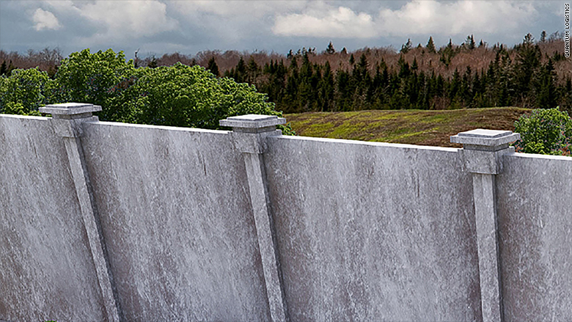Quantum Logistics takes a traditional approach.
One of the more straightforward proposals comes from Quantum Logistics, which has built security walls for the U.S. military in Iraq and Afghanistan. Its pitch is to build a relatively simple wall with concrete slabs that are reinforced with steel bars. It would look something like the sound barriers along some U.S. highways.
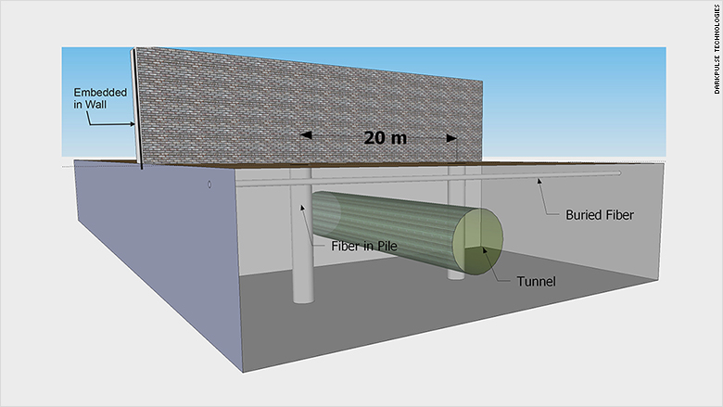The plan from DarkPulse Technologies shows how it could detect a tunnel.
DarkPulse Technologies wants to build a wall that has fiber optics embedded, in order detect attempts to tunnel underneath, climb over or breach the wall. DHS guidelines call for all wall submissions to go at least six feet underground to deter tunneling. But CEO Dennis O'Leary said that's just not enough, and points out that some existing border tunnels are as much as 80 feet underground.
"A six-foot foundation -- a couple of guys with a shovel can easily defeat that," he said.
Crisis Resolution Security Services was inspired by the Great Wall of China.
The proposal from Crisis Resolution Security Services of Clarence, Illinois is inspired by the Great Wall of China and other ancient walls. It calls for a 30 foot dirt berm leading up to the wall's base, with a 26-foot wall on top of that. It will also have a four-foot safety rail along the top, so tourists can walk or even drive on the top of the wall.
"The wall will become a symbol of the defense of the American nation and culture, just as [the Roman Empire's] monumental wall defended the limits of the Western civilization," said the proposal.
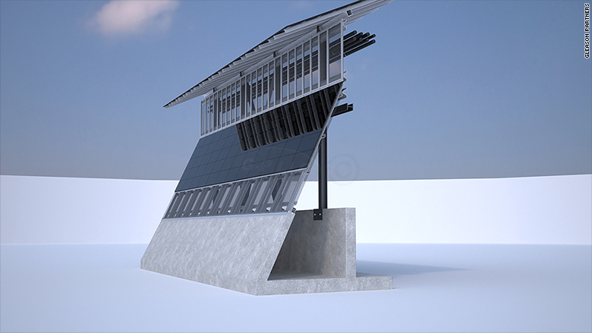A solar border wall from Gleason Partners. Another solar wall from Advanced Warning Systems.
Two proposals call for a wall that's covered on the southern side with solar panels, and has panels on the top that an be tilted during the day to capture the greatest amount of sunlight. Both suggest selling the electricity that the solar panels generate to offset the cost of the wall.
"Talking with young people, some of Spanish descent, they say if the wall is going to be built, they want it to be green," said Thomas Gleason, whose firm authored one of the bids.
Another solar wall proposal comes from a company called Advanced Warning Systems.
One proposal calls for a hyperloop rather than a barrier along the border.
Some of the proposals submitted to DHS are more like political statements than practical suggestions for a barrier.
A group called Otra Nation, which is a collective of engineers, architects and designers, calls for the whole border area to be run jointly by both nations. Instead of erecting any kind of barrier, its plan calls for an elevated high-speed hyperloop that would stretch the length of the current border. The only trouble is that no one will travel from Al to New York via El Paso.
During and before the Obama administration, US policymakers concluded that a US-Mexico border wall would not be feasible. The border is, after all, 1,954 miles long. That is more than the driving distance between Washington, DC, and Denver, Colorado. And, while more than 700 miles of border fence exists (about the driving distance between Washington, DC, and Chicago), the fenced border remains porous with drug cartels and people smugglers constructing tunnels under the border, cutting holes through the fence, or simply climbing over it.
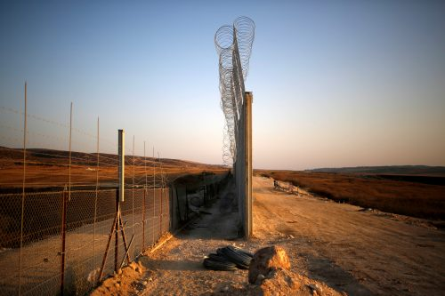
An Israeli barrier with the West Bank is seen while still under construction near Havat Ela in southern Israel July 20, 2016. Picture taken July 20, 2016. REUTERS/Amir Cohen.
So, is it a foregone conclusion that a US-Mexico border wall would be a multi-billion dollar folly?
The answer to this is no. Walls do have a history of doing their job and, indeed, they are the tried-and-true go-to strategy almost everywhere that security or illegal migration is a concern. A border wall isn’t analogous to the Berlin Wall nor should it be seen in the same light. After all, there’s a huge difference between a system designed to keep people in—a lock on the door—and a system designed to keep people out—the door itself. So, let’s consider the precedent of walls and systems designed to maintain security and keep illegal immigrants and terrorists out while allowing legal immigrants and visitors in:
Consider first buildings like the White House, where a decorative fence predated the wrought iron fence installed by President Ulysses Grant to control New Year’s crowds. President Franklin Roosevelt began restricting access to White House grounds to appointment-holders only during World War II as a further security measure. But the White House is a building and different than a national border, even if the logic remains the same. Is there a precedent with border walls working along much longer distances?
Here, again, the answer is yes. Consider the following:
Jerusalem might have developed that technology for Israel’s own security, but it could just as easily be replicated to detect, interdict, and destroy tunnels under the US border.
Israel-West Bank: The border wall — actually much more a security fence — was constructed in the wake of the 2001-2002 terror campaign in Israel. Almost immediately, the number of successful terror attacks in the Jewish state dropped by 90%. Indeed, it is Israel to which the Trump administration and wall proponents might turn to resolve one of the main arguments about duplicating the system along the US-Mexican border. After all, Israel has developed anti-tunnel radar and other technology to stymie Hamas (and Hezbollah) terrorist who might try to tunnel. Jerusalem might have developed that technology for Israel’s own security, but it could just as easily be replicated to detect, interdict, and destroy tunnels under the US border.
Morocco-Algeria: Morocco fought a bloody insurgency and terrorist campaign sponsored by Algeria’s and Cuba’s Cold War proxy, the Polisario Front. The Polisario became ineffective, however, after Morocco built its famous 1,700-mile system of sand berms, fences, mine fields, and ditches.
Cyprus: It was the United Nations which built a wall dividing Cyprus between the northern Turkish portion and the remaining Greek section after Turkey invaded and occupied parts of the island nation in 1974. To cite international law as opposed to walls is, therefore, nonsense since the United Nations created the precedent.
India-Pakistan: India and Pakistan fought wars in 1947, 1965, 1971, and 1999, that collectively killed millions of people. The two sides have had a more than three decade-long standoff on the Siachen glacier and several skirmishes elsewhere along the disputed border. Because Pakistani terror groups regularly try to infiltrate and wreak havoc in India, India constructed a border fence and wall system to keep Pakistanis out. That’s a good thing, because nowhere else in the world could a simple border incident so quickly escalate into nuclear war.
Turkey-Syria: Throughout the 1990s, Turkey faced an escalating challenge from the Kurdistan Workers Party (PKK), a group leading a Kurdish insurgency against the Turkish Army. Indeed, Syria only seriously cracked down on the PKK when Turkey credibly threatened war. Turkey subsequently reinforced the border with fences, mine fields, and no-man’s land, and it worked. The next 15 years was largely quiet. It was only when Turkey’s leader Recep Tayyip Erdogan removed many of the defenses and turned a blind eye to border security that the terrorism problem in Syria—and its subsequent blowback inside Turkey itself—grew so great.
There are other walls out there, of course: Saudi Arabia has just built a wall along its disputed border with Yemen to keep Yemeni-based terrorists out of the Saudi Kingdom. India has a long-standing border fence with Bangladesh to prevent illegal immigration. Hungary is building a fence to protect its borders. Greece maintains a heavily protected border with Turkey. Spain fortifies its enclaves in Africa.
Simply put, if the goal is to protect national security and curtail illegal immigration, the record is clear: walls work.

Taxpayers Subsidizing Purchases Made on Amazon

Amazon is now offering subscriptions to their Prime membership at a discount of 45 percent to customers that are receiving government assistance.
Recode reports that e-commerce giant Amazon announced on Tuesday a 45 percent discount on Prime memberships for low-income shoppers, bringing the monthly fee from $10.99 to $5.99. The discount is applied to shoppers that possess an Electronic Benefits Transfer card and they must requalify for the discount every year for up to four years.
Access to Amazon Prime gives shoppers a number of perks, notably free two-day shipping on millions of items and access to Amazon’s video and entertainment library at no extra charge. The $10.99 per month price point for Prime was previously only available on a one-off payment of $99, but was made available on a monthly payment plan last year. Since this change, Prime usage growth has been strongest amongst homes that make less than $50,000 annually, according to an R.W. Baird study.
The Prime discount for customers with an EBT card comes shortly after an announcement from Amazon earlier this year which stated that they would be accepting food stamps in exchange for grocery items starting this summer. Amazon charges a grocery delivery fee on top of their Prime membership; it’s unclear whether or not a discount will also be applied to grocery deliveries.
Amazon’s Prime feature is one of the most profitable programs that the website offers as Prime users tend to spend more and shop more than regular Amazon shoppers. CEO Jeff Bezos has publicly stated that he wants to improve the Prime program to the point where it becomes irresponsible not to use it.
There is a Congressional movement to do one of two things. Either return the program to the SNAP script booklets with coupons, which would be expensive to launch again. Or, restrict the use of the SNAP cards to be used in walk-in groceries only. I heard the same “cheaper by Amazon” kind of talk when they were talking about approving the SNAP cards for use at fast food and sitdown restaurants. That was not approved either. This is additional purchase power working families do not have. Only the selectively subsidized residents, not necessarily citizens, are given from your paycheck by the agency government. The SNAP card user doesn’t have to show up for work, and now they don’t have to show up to shop for food. The taxpayer is not going to stand for subsidizing the world’s largest corporation with their tax dollars.
Obama’s ‘Race’ to the Top Program Stopped by DOE
Testifying in front of Congress on President Donald Trump’s new budget for education, Secretary of Education Betsy DeVos said Tuesday that she will not follow the footsteps of Obama’s “Race to the Top” grant program.
James Lankford (R-Ok) asked Devos whether the $1 billion increase in Title I funds she proposed, dedicated to “furthering options for children to unlock success,” will be different from Race to the Top, a grant announced in 2009 by Former President Barack Obama and Former Secretary of Education Arne Duncan.
According to the website of the U.S. Department of Education, Title I provides financial assistance to local educational agencies and schools highly attended by children from low-come families to ensure that every child meet state standards.
“There was a concern in this dais that [the program] was really a requirement from the government that, if you want these dollars, then you’ll have to do these curricula.” Lankford said. “Do it our way and, if you don’t do it our way, you can’t get the dollars that came out of your state to come back to your state.”
But according to DeVos, her proposal will allow individual states more flexibility on educational procedures.
“It’s only if states want to, and local education agencies and authorities want to, attempt an experiment to allow students to attend other public schools in their region,” she said. “It is, no way, going to be mandated from the top that this has to happen or how it has to happen.”
The increase, Devos said, will serve as a financial aid if the students choose to utilize it. That is the framework around which states or local districts would be able to opt into or adopt, she said. Lankford asked if the proposal would give instructions to those states or those entities on how to do curriculum, how to do teacher evaluations, how to do testing requirements.
“Not at all,” DeVos replied. “No, we’ve seen that movie; we’re not going to do that one again.”
A report by the Education Department on American’s schools under Race to the Top reveals that although the program was voluntary, 46 states and the District of Columbia coincidentally applied.
The administration used the money to encourage – majority of people would say coerce – states to embrace these race-specific education policies, which covered restrictions on charter schools, colleges and career-ready standards and sensitivity evaluations of teachers using student test scores as the indicator of whether a teacher was doing a good job or not.
The Origin of Lower Adam
The bones of ancient hunters unearthed in Morocco are the oldest known specimens of the human species, potentially pushing back the clock on the origin of modern Homo sapiens, scientists announced Wednesday.
Found among stone tools and the ashes of ancient campfires, the remains date from about 300,000 years ago, a time when the Sahara was green and several early human species roamed the world, the scientists said. That makes them about 100,000 years older than any other fossils of Homo sapiens—the species to which all people today belong.
“These dates were a big wow,” said anthropologist Jean-Jacques Hublin at the Max Planck Institute for Evolutionary Biology in Leipzig, Germany. He led an international team of scientists who reported the discovery Wednesday in Nature. “This material represents the very roots of our species—the very oldest Homo sapiens found in Africa or anywhere.”
Until now, most researchers believed that modern humankind emerged gradually from a population centered in East Africa around 200,000 years ago. Previous discoveries of early Homo sapiens fossils have been concentrated at sites in Ethiopia.
The fossil discovery at Jebel Irhoud near Marrakesh in North Africa, however, suggests that early humans had already spread across most of Africa by then.
“What’s really neat about this discovery is that you now have evidence of modern Homo sapiens across Africa, about as far from sites in East Africa as you can get,” said anthropologist Bernard Wood at George Washington University’s Center for the Advanced Study of Human Paleobiology, who wasn’t involved in the find.
As early experiments in the human form, these ancestors had quite modern-looking facial features, but relatively primitive skulls, suggesting that the cognitive capacities of modern brains had yet to take shape, the scientists said.
Their faces were likely so contemporary in appearance that they might pass unnoticed on a crowded city sidewalk, although they might need to wear a hat to disguise their skull’s elongated shape, Dr. Hublin said.
Such combinations of traits, though, blur the differences that distinguish one human ancestor from another, making it hard for scholars to classify species accurately. In fact, several early human species, such as Neanderthals, were so closely related to Homo sapiens that they could all interbreed, modern genetic evidence shows.
But several independent experts said they agreed that the fossils most likely belonged to Homo sapiens.
“It has a modern face and a primitive brain case,” said John Fleagle, an expert on primate evolution at Stony Brook School of Medicine, who wasn’t part of the research group. “You would expect it to have a few primitive characteristics even if it is on the main line of our lineage. It shows what is probably an earlier stage of our species.”
The scientists found bones of three adults, a teenager and a child mixed in with sharpened flint tools and the butchered bones of gazelles and zebra, suggesting that a hunting party had camped there. Fires had scorched the tools and that proved key to determining the age of the find.
The researchers tested the tools using a technique called thermoluminescence dating, which reveals how much time has elapsed since an object has been heated. By that measure, they calculated that the tools were 315,000 years old, plus or minus 34,000 years.
They also dated tooth enamel from a fossil jaw using electron spin resonance, which can measure the residual radiation that has built up since a material formed. That yielded an age of 286,000 years, plus or minus 32,000 years, the scientists said.
“It leads us to conclude that 300,000 years old is the best age for these fossils,” said Daniel Richter at the Max Planck Institute, who conducted the dating studies.
Single Payer Insurance the Path to Euthanasia
The movie Soylent Green was not too far different than the methods insurance giants will use to mitigate their losses under the single payer plan. A Nevada physician says insurance companies in states where assisted suicide is legal have refused to cover expensive, life-saving treatments for his patients but have offered to help them end their lives instead. One of the fastest growing service industries in health care now is the development of painless, beautiful experiences for people who want to leave this life on a schedule. Before you forget the woman you love, the kids you parented, your favorite songs or the PIN code to your smartphone, you can schedule a graduation exit with your friends. Pick the best music, the best movie, the best meal, and even the best family reunion while you get ready to take the great American dirt nap. Even Charlotn Heston didn’t think it was such a bad idea until he learned that the government was making food out of the people’s recently occupied bodies.
Brian Callister, associate professor of internal medicine at the University of Nevada, said he tried to transfer two patients to California and Oregon for procedures not performed at his hospital. Representatives from two different insurance companies denied those transfer requests by phone. Dr. Callister said. “And in both cases, the insurance medical director said to me, ‘Brian, we’re not going to cover that procedure or the transfer, but would you consider assisted suicide?’”
The phone calls took place last year within the span of a month, Dr. Callister said. He said he did nothing to prompt the suggestion in either case. The patients were not terminal, but “would have become terminal without the procedures. It was estimated by the equivalent of a “Death panel,” that their chance for cure — cure, not just adding time — of about 50 percent in one case and 70 percent in the other case, was too low to waste the money on these patients.
The allegation comes as more than a dozen states are actively considering legislation to legalize physician-assisted suicide, including Nevada, where Dr. Callister testified against the proposed bill on Monday. In February, Washington became the sixth U.S. jurisdiction to enact such a law, joining California, Colorado, Oregon, Vermont and Washington state. The Montana Supreme Court has ruled that helping terminally ill patients to end their lives does not violate state law. As part of a campaign to curb the trend, the Patient’s Rights Action Fund on Wednesday released a video featuring Dr. Callister.
“As much as most insurance companies try to come across as your best friend, they want to do whatever the least-costly thing is,” Dr. Callister says in the video. “It’s a lot cheaper to grab a couple of drugs and kill you, than it is to provide life-sustaining therapy. Simple as that.”
The anti-assisted suicide group plans to release other videos, including one of Stephanie Packer, a terminally ill Californian who said she was denied coverage and offered life-ending pills after the state enacted its law in 2015.
Before airing the video, the Patient’s Rights Action Fund said it consulted a lawyer who advised against naming the insurance companies involved, citing the Health Insurance Portability and Accountability Act (HIPAA), a federal privacy law.
Dr. Callister said, because he makes such transfer requests infrequently, the attorney said naming the insurance companies could lead to the identification of the patients.
“It’s a low-enough number that naming the insurance companies would potentially make the individual patients identifiable, and therefore a violation of HIPAA,” Dr. Callister said. “I would love to name the insurance companies, but it is what it is.”
He also said he was unable to obtain waivers from either patient to authorize the disclosures. Cathryn Donaldson is the director of communications for America’s Health Insurance Plans, an advocacy group that represents insurance providers. She said in a statement that aid-in-dying laws do not change the behavior of insurance companies. Obviously that is not the truth, because insurance companies are all about the return on investment, and when it comes to life insurance or health insurance, the goal is to find the right set of circumstances so that they get to keep all the premiums without paying out a dime. Anyone who disagrees with that better have some facts to back it up, because I have mine.
Health coverage providers absolutely deny life-sustaining care in states that have physician-assisted suicide. It is the health care provider who often steps forward to save the life of a patient who cannot afford the treatment on the same day. They get paid later, or sometimes not at all in the form of money. Sometimes it is the form of experience and testing of new drugs or techniques.
What’s more, the American Medical Association, the nation’s largest association of doctors, has long opposed physician-assisted suicide. The AMA is the smallest and weakest of all the medical associations. They are routinely overruled by the insurance companies.
Kat West, national director of policy and programs at Compassion & Choices, which works to enact aid-in-dying legislation, said she’s “skeptical” of Dr. Callister’s story. She said “the names of the insurance companies he talked to are absolutely not covered” under HIPAA.
“I’m not a HIPAA lawyer, but that sounds really — it sounds like someone who does not want to share information,” said Ms. West, who testified in favor of the Nevada aid-in-dying legislation on Monday. “That’s what it sounds like to me.”
She said “there’s no evidence” to support Dr. Callister’s claim, and “he needs to come forward and provide evidence” if he wants to make such an allegation.
But Dr. Callister said it’s no coincidence the insurance agents stumped for assisted suicide over the phone.
“Now was this in writing? Of course not,” he said. “This was on the phone. They’re too smart to put that in writing.”
There have been several cases of insurance companies offering assisted suicide to patients in writing. In 2008, Barbara Wagner received a letter from her state’s Medicaid program declining to cover a lung cancer drug that would have cost $4,000 per month. The Oregon Health Plan, however, did offer to pay for the 64-year-old to procure assisted suicide drugs, priced at $50.
Anne Sommers, board chair of disability rights group Not Dead Yet, said insurance providers are motivated by profit, and helping patients end their lives is cheap. She said insurance companies encouraging assisted suicide is an inevitable consequence of the practice’s legalization.
“If you asked a series of economists, and didn’t tell them you were talking about [assisted suicide], they would laugh you out of the room,” Ms. Sommers said. “Of course it’s going to have an effect. It’s only when politics becomes involved that people find a way to torture the facts to come up with the answer they want.”
Compassion & Choices’ Ms. West pointed to a 1998 study in The New England Journal of Medicine titled “What are the potential cost savings from legalizing physician-assisted suicide?” that predicted insurance companies would hardly alter their behavior in response to assisted suicide laws.
She said her advocacy group wants terminally ill patients to “get the best care possible” and would be “appalled” if there were evidence to support Dr. Callister’s claims. Due to privacy laws and the fact that insurance companies rarely offer reasons for denying coverage, Ms. Sommers said it’s difficult to collect data either for or against the claim.
“This is a very convenient thing for Compassion & Choices to say, that this is all anecdotal, that there are lots of reasons people are denied treatment,” she said. “But physician-assisted suicide will always be the cheapest option.” Even proponents of aid in dying have argued that economic pressure will help to normalize the practice.
In his 1998 book “Freedom to Die,” Derek Humphry, who founded the Hemlock Society, which evolved into Compassion & Choices, wrote that “economics, not the quest for broadened individual liberties or increased autonomy, will drive assisted suicide to the plateau of acceptable practice.”
Of course, when it comes his turn to die, he will be driving the other way. That’s the way it works.

