Jihad Report
Sep 02, 2017 -
Sep 08, 2017 The Week of the Hadj
Attacks | 33
Killed | 196
Injured | 84
Suicide Blasts | 5
Countries | 12
Fraulein Schultz: The end in Near
For months now various media outlets have speculated on whether Debbie Wasserman Schultz (DWS) and her now-indicted IT staffer may have colluded to conceal evidence potentially linked to the infamous 'DNC hacks.' While Schultz and the DNC have maintained that the hacks were orchestrated by Russians from a remote location, others have argued that the stolen documents must have been taken by an insider with direct access to DNC servers. Meanwhile, the mystery surrounding the ongoing controversy has only been amplified by the DNC's rather curious refusal to allow the FBI access to their servers after the supposed 'attacks.'
But, according to a new report from The Daily Caller, even if Awan was originally acting to protect/extort DWS, that may have all changed on April 6, 2017 when he seemingly led U.S. Capitol Police directly to her laptop.
A laptop that Rep. Debbie Wasserman Schultz has frantically fought to keep prosecutors from examining may have been planted for police to find by her since-indicted staffer, Imran Awan, along with a letter to the U.S. Attorney.

U.S. Capitol Police found the laptop after midnight April 6, 2017, in a tiny room that formerly served as a phone booth in the Rayburn House Office Building, according to a Capitol Police report reviewed by The Daily Caller News Foundation’s Investigative Group. Alongside the laptop were a Pakistani ID card, copies of Awan’s driver’s license and congressional ID badge, and letters to the U.S. attorney. Police also found notes in a composition notebook marked “attorney-client privilege.”

The laptop had the username “RepDWS,” even though the Florida Democrat and former Democratic National Committee chairman previously said it was Awan’s computer and that she had never even seen it.

The laptop was found on the second floor of the Rayburn building — a place Awan would have had no reason to go because Wasserman Schultz’s office is in the Longworth building and the other members who employed him had fired him.

Of course, DWS's story on the now-infamous laptop has 'evolved' over the months...originally it was apparently her laptop back when she decided to threaten the U.S. Capitol Police Chief but later, after he stood his ground, DWS backtracked saying she had never seen the laptop and it never belonged to her.
Wasserman Schultz used a televised May 18, 2017 congressional hearing on the Capitol Police budget to threaten “consequences” if Chief Matthew Verderosa did not give her the laptop. “If a member loses equipment, it should be given back,” she said.

Verderosa told her the laptop couldn’t be returned because it was tied to a criminal suspect. Wasserman Schultz reiterated that, while Awan was a suspect, the computer should be returned because it is “a member’s … if the member is not under investigation.”

She changed her story two months later, claiming it was Awan’s laptop — bought with taxpayer funds from her office — and she had never seen it. She said she only sought to protect Awan’s rights. “This was not my laptop,” she said August 3. “I have never seen that laptop. I don’t know what’s on the laptop.”
Sponsored By SmartAsset

This One Free Tool is Disrupting the Multi-Billion Dollar Retirement Industry
Finding a financial advisor who you could trust used to be difficult, but not anymore. SmartAsset's Financial Advisor Matching tool will find the best advisor for you, based on your financial profile. Learn more about how easy it is - here.
For those who missed DWS threatening the cops for a laptop that apparently didn't even belong to her...it's good entertainment.

Of course, for a conniving person like Awan who has been accused of multiple counts of federal bank fraud, making the simple mistake of accidentally leaving critical evidence out in the open for all to see would seem unlikely.
The circumstances of the laptop’s appearance described in the police report suggest Wasserman Schultz was trying to keep the police from reviewing a laptop that Awan himself may have wanted them to find. The former phone booth room where police found the items is small, and there was no obvious reason to enter it.

Leaving important items there accidentally would seem extremely unlikely, according to Rep. Louie Gohmert, a Texas Republican, former prosecutor, and member of the House Judiciary Committee.

"Imran Awan is a calculating person who made great efforts to cover his tracks, both electronically and physically,” Gohmert told TheDCNF. “Placing that laptop with his personal documents, which may well incriminate him, those he worked for, or both, in the dead of night in a House office building, was a deliberate act by a cunning suspect, and it needs to be investigated.”
And then there is the simple question of why DWS has gone through the trouble of hiring lawyers to fight for a laptop that never belonged to her and could provide valuable evidence against a man who has been charged with a federal crime?
Even though the laptop was allegedly used only by an IT aide who worked for numerous members, Wasserman Schultz has hired an outside counsel, William Pittard, to argue that the laptop not be examined. Pittard argued that the speech and debate clause — which only protects a member’s information directly related to legislative duties — should prevent prosecutors from examining the laptop’s contents, TheDCNF has learned. Pittard did not respond to requests for comment.

Pittard, a partner with KaiserDillon, is the former acting general counsel of the House. Hiring an outside counsel to argue the speech and debate clause on behalf of Wasserman Schultz is highly unusual, because the general counsel of the House offers opinions on speech and debate issues for free.
So, what say you? Giant 'nothing burger' or are the walls closing in on DWS?
The Dark Arts Pointed at America
TENS of thousands of witches around the world join forces every month to cast a “binding” spell on Donald Trump, Hollywood witch Vicky Adams has revealed.
Vicky, who runs a renowned occult store in tinseltown, says the spell aims to stop the US President from reaping “harm and destruction” across the globe.
Witch Vicky Adams says thousands of witches around the world join forces every month to cast a ‘binding’ spell on Donald Trump
She says she has been inundated with people wanting to learn the spell and buy ingredients
Leading Hollywood witch Vicky Adams shows off her occult store and says thousands are casting spells against Donald Trump
Vicky said huge numbers of people are turning to witchcraft and black magic to help them deal with modern problems
She says her shop has been inundated with people desperate to learn the spell and buy the ingredients - which include an orange candle to signify the President’s trademark fake tanned skin.
The 49-year-old says the spell, which started in February, has now become a global phenomenon.
Witches cast 'magic spell' on President Trump outside Trump Tower in New York
Witches gathered outside Trump Tower in March to cast spells
The occultists used tarot cards to put a curse on the US president
Witches around the world were invited to join in by casting spells

To do the spell, Vicky advises people to get some Tarot cards, an orange candle, an unflattering photo of Trump, some sage and a feather
Dozens of witches were seen performing rituals outside Trump Tower earlier this year - just one week before a blaze inside the building.
As well as casting spells on the controversial President, Vicky said huge numbers of people are turning to witchcraft and black magic to help them deal with everything from boosting their love life - to cursing or exacting revenge on their enemies.
Even celebrities come in to her store, Panpipes Magickal Marketplace, looking for spells to help them land big movie roles.
Singer Lana Del Rey jumped on the Trump spell craze and tweeted instructions to her followers in February.
Vicky, 49, from Los Angeles, told SunOnline: “The Donald Trump spell is not a hex or a curse - it’s binding Trump and any of his abetters to prevent them from causing harm and destruction to people, animals, the environment, everything.

Even celebrities come in to her store, Panpipes Magickal Marketplace, looking for spells to help them land big movie roles
“It’s not just within the US - it’s global at this point.
“Not everybody agrees with the spell even within the Pagan community - some people think there will be Karmic repercussions.
“I’ve been assisting people with setting up their tools - people have been coming in here seeking guidance especially when it first came out earlier this year.
“It takes place every waning moon, once a month - the next one is September 18th.
“There are probably tens of thousands of witches who take part - it’s hard to know exactly - but certainly a great amount of witches are coming together every month to do this spell.
Photo John Chapple / www.JohnChapple.com
17
Vicky runs a renowned occult store in tinseltown
“It’s not unheard of for witches to do things like this - in fact it’s been done before decades back.
“In England there was a famous case where British witches helped stop the invasion of the Germans into the British Isles.
“They created a thought-form and everybody contributed to the spell and helped to stop the Nazi invasion.”
To do the Trump spell, Vicky advises people to get some Tarot cards, an orange candle, an unflattering photo of Trump, some sage and a feather.
She says: “It involves the use of the tower card from the Tarot deck to represent his downfall - but that might as simple as they want his phone to break so he can’t tweet at 3am in the morning anymore.
“You need an orange candle to represent him - you can guess why. Some people use little baby carrots.
“You need some sage and a feather. Some people have added their own components so they might add a figure candle.
“And you also need the most unflattering photo of Donald Trump that you can find. There are variations - some people might do a physical binding where they physically bind a picture of Trump with string or something.
“There’s also words or a prayer that you recite which calls for a hindrance or absolute cessation of Trump and anyone who aids and abets him from causing harm to man, beast and land.
“It’s a form of sympathetic magic and it’s a very powerful thing."
The spell comes amid global outrage surrounding many of President Trump's policy decisions since he's been in the White House.
Photo John Chapple / www.JohnChapple.com
17
The magic store is filled with special sex candles and figurines
He's come under fire for his policy on building a wall between the US and Mexico and more recently for cancelling the Obama era DACA program, threatening the future of thousands of young immigrants in the US.
“The spell is not as negative as it might sound - nobody is calling for President Trump's death or anything - it’s more along the lines of stopping congress passing his legislation," she explained.
“It’s not binding him in every aspect of his life - just in his role as president - because lots of people perceive his actions as being very harmful and contrary to the wishes of the people of America.”
Vicky has people from all walks of life coming into her Los Angeles store to buy occult supplies such as pentagrams, herbs, gargoyles, crystals, cauldrons - and even daggers.
She estimates there are thousands of witches' covens just in LA alone - with new ones popping up every day.
Photo John Chapple / www.JohnChapple.com
17
A raven ornament can be found on the shelves of the occult store
“It’s a lot more common than people might think - you might be living next door to a witch and have no idea because we're not stereotypical with the pointy hats and the warty noses - the people who come in the shop reflect that,” she said.
“I have lawyers, doctors, policemen, nurses, housewives, students - everyone comes in here. I also have Christo-witches who are practicing Christians and witches. I have Satanists and people who work with demonology - I do not discriminate against anybody.
“I get well-known celebrities and actors coming in - and not so well-known ones. Pretty much everyone is looking for love, success, happiness, protection."
Vicky claims that Paganism is rapidly growing in popularity.
“You can see it reflected in so many TV shows and movies that are centred around witchcraft," she said.
"Just scrolling through Instagram it’s witch, witch witch, it’s become fashionable. It wasn't 20 years ago but it is now.
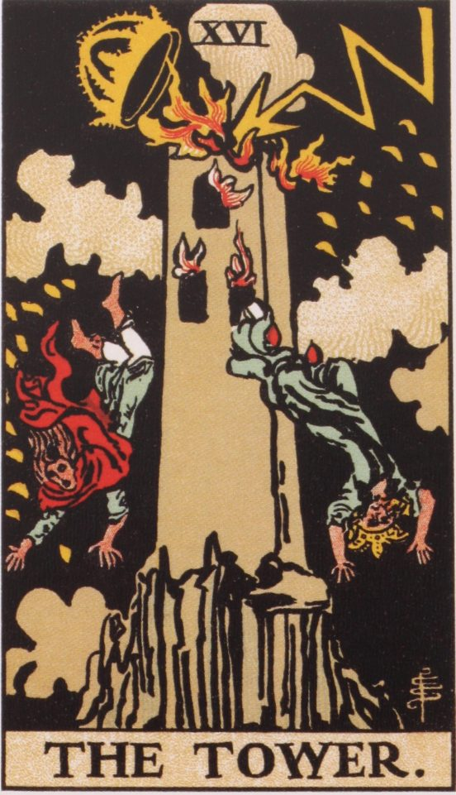
Alamy
17
The spell uses the tower card from the Tarot deck
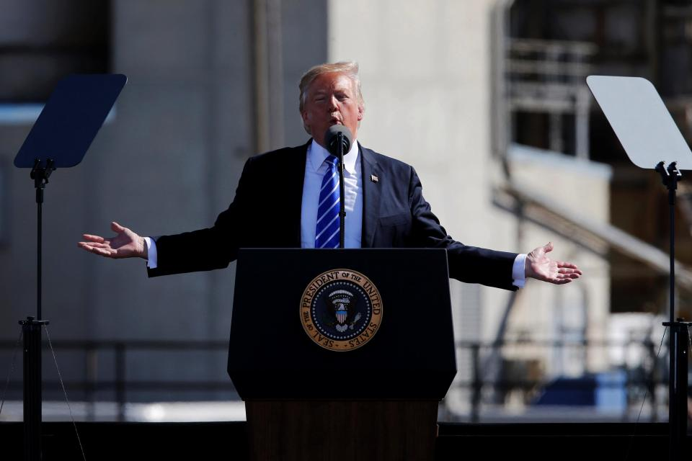
Reuters
17
The spell comes amid global outrage surrounding many of President Trump's policy decisions since he's been in the White House
“I think it's growing in popularity because people are very dissatisfied with organised religion. A lot of us come from Christian backgrounds and we’re fed up of the limitations placed on us - particularly women. Paganism is all-embracing - it accepts all and there’s no judgement.”
Vicky, who practices black and white magic including Voodoo and ritual magic, says she can help people exorcise demonic spirits from their homes, improve their sex life, get a job or improve their finances.
She also has clients coming in with darker objectives - such as to curse or hex an enemy.
“Hexes and curses are real you are using a very powerful force - you are using the planetary influence of Saturn or Mars,” she explains.
“Any powerful emotion is also going to make a spell more powerful.
Photo John Chapple / www.JohnChapple.com
17
Many of the requests she gets relate to customer’s love life - and as well as herbs and oils to carry out love spells
“A curse can make somebody ill or bring absolute devastation and destruction to someone on their family or their ancestors. It can make you lose all your worldly possessions.
“It can make you lose your health - it can cause death - it can cause a loss of everyone you love.
“I’m not one to curse someone it’s not really my style but I’m not going to condemn someone for doing it either.
“I don’t agree with it but it’s their choice and something they're going to have to answer to at the end of the day.
“If someone comes in wanting to do something negative I won’t try to talk them out of it but I will advise them of possible consequences.
Photo John Chapple / www.JohnChapple.com
17
She also has clients coming in with darker objectives - such as to curse or hex an enemy
Photo John Chapple / www.JohnChapple.com
17
Many of the requests she gets relate to customer’s love life - and as well as herbs and oils to carry out love spells
17
To cast the spell witches need a dodgy photo of Trump, an orange candle (or baby carrot) and tarot cards
“You have to feel justified in your actions otherwise you will be your own undoing.”
Many of the requests she gets relate to customer’s love life - and as well as herbs and oils to carry out love spells she also sells special sex candles - which she claims can make people impotent - or stop them from cheating.
“Yes I have candles shaped like men and women's genitals - the black ones are for hexes to make a scorned lover impotent," she explains.
“The red is to make somebody more potent or to bind someone to you sexually so they don’t stray. Blue and white are more healing.
“The black female candle can lower someone’s sex drive or give them a skin disease or something.
“You can do spells to make somebody fall in love with you but that’s one of the spells I think has a great potential to backfire.
“Everybody has their own free will but if you insist on bending somebody’s will and you persistently work on them you can make them fall in love with you.
“But it’s a very ego-driven conquest so when you get the person, chances are you don’t want them anymore but it’s too late because you’ve created a stalker or possible psychopath somebody dangerous who will kill you because they are so obsessed with you. You have created a monster.
“I don’t advise that - I’ve seen people get cancer, start to lose their status in society even become incarcerated - it starts to turn inwardly.
“I don’t tell people what to do - but I do advise them of the consequences.”
Little Kim and the Globalist Plan
All day Saturday, South Korea braced for a possible new missile test by North Korea as the provocative northern neighbor marked its founding anniversary, just days after its sixth and largest nuclear test rattled global financial markets and further escalated tensions in the region. Throughout the week, South Korean officials warned the North could launch another intercontinental ballistic missile, in defiance of U.N. sanctions and to further provoke the US. As Reuters reports, Pyongyang marks its founding anniversary each year with a big display of pageantry and military hardware. Last year, North Korea conducted its fifth nuclear test on the Sept. 9 anniversary.
Ultimately, September 9 came and went, and North Korea did nothing, perhaps signalling its eagerness to de-escalate. Or perhaps not, and Kim is simply looking to surprise his adversaries with the ICBM launch date. Experts have said the rogue, isolated regime is close to its goal of developing a powerful nuclear weapon capable of reaching the United States, something Trump has vowed to prevent.
Celebrating its founding anniversary, a front-page editorial of the Saturday edition of North Korea’s official Rodong Sinmun said the country should make “more high-tech Juche weapons to continuously bring about big historical events such as a miraculous victory of July 28.”. The July date refers to the intercontinental ballistic missile test (Juche is North Korea’s homegrown ideology of self-reliance that is a mix of Marxism and extreme nationalism preached by state founder Kim Il Sung, the current leader’s grandfather).
* * *
Meanwhile, South Korean nuclear experts, checking for contamination, said on Friday they had found minute traces of radioactive xenon gas but that it was too early to link it to Sunday’s explosion. The Nuclear Safety and Security Commission (NSSC) said it had been conducting tests on land, air and water samples since shortly after the North Korean nuclear test on Sunday. There was no chance the xenon “will have an impact on South Korea’s territory or population”, the agency said.
What is more concerning, however, is a Friday report on NBC, according to which Trump is readying a package of diplomatic and military moves against North Korea, including cyberattacks and increased surveillance and intelligence operations, after the nation's sixth and largest nuclear test.
Trump's top national security advisers walked him through a range of options over lunch in the White House on Sunday, just hours after North Korea's latest test, officials said.
According to NBC, Trump is also seriously considering adopting diplomatically risky sanctions on Chinese banks doing business with Pyongyang and upgrading missile defense systems in the region, administration officials said. In addition, the administration is not ruling out moving tactical nuclear weapons to South Korea should Seoul request them, a White House official said, though many consider such a move a nonstarter. It would break with nearly three decades of U.S. policy of denuclearizing the Korean Peninsula.
U.S. officials have also made the case to China that if Beijing doesn't take stronger steps against North Korea, such as cutting off oil exports, South Korea and Japan are likely to pursue their own nuclear weapons programs and the U.S. won't stop them, the official said. "It's more a message for China than North Korea," the official said.
The U.S. has adopted sanctions aimed at Chinese entities that conduct business with North Korea, but has so far held back on broadly targeting China's banking system. China has told U.S. officials it would protest such a move diplomatically and retaliate, according to the senior administration official.
So what happened on Sunday? According to NBC, Trump's national security advisers presented him with U.S. military options, including pre-emptive strikes, and nuclear capabilities should America be called on to abide by its treaty obligations in the region, White House and defense officials said.
The president's advisers have made the case, however, that military strikes on North Korea could have serious repercussions, senior defense officials said, and the most glaring among these is that China has told administration officials that if the U.S. strikes North Korea first, Beijing would back Pyongyang, a senior military official told NBC.

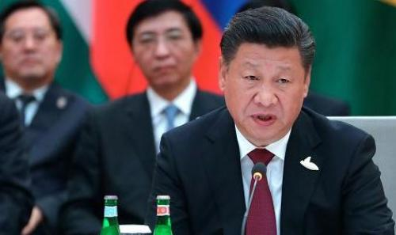
This is not the first time China has warned the US not to escalate: on August 11, Beijing, through the state-owned media, cautioned the US president on Friday that it would intervene (militarily) on North Korea’s behalf if the US and South Korea launch a preemptive strike to “overthrow the North Korean regime,” according to a statement in the influential state-run newspaper Global Times.
"If the U.S. and South Korea carry out strikes and try to overthrow the North Korean regime and change the political pattern of the Korean Peninsula, China will prevent them from doing so," it said.
At the same time, the Chinese regime made it clear that its preferred outcome would be a continuation of the status quo, warning Kim Jong Un, or perhaps Trump, that it would "remain neutral if North Korea were to strike first."
As we said almost one month ago:
"not surprisingly, analysts have compared the standoff between the two nuclear powers (the North is a recent, if untested, member of this club) to a modern day Cuban Missile crisis. "This situation is beginning to develop into this generation's Cuban Missile crisis moment," ING's chief Asia economist Robert Carnell said in a research note. "While the U.S. president insists on ramping up the war of words, there is a decreasing chance of any diplomatic solution."
Since then, the potential risks, mutual threats and near-hostilities have grown exponentially. China - which is by far North Korea’s biggest trading partner, accounting for 92% of two-way trade last year, and also provides hundreds of thousands of tonnes of oil and fuel to the impoverished regime - has only dug in deeper, explaining repeatedly that it wants a peaceful de-escalation and that it would not side with the US in case of a military conflict.
* * *
What happens next? Well, on one hand, after today's lack of launch, there is hope that things will indeed de-escalate. A headline that just hit from Yonhap may accelerate this:
- SOUTH KOREA SEES NO SIGNS OF IMMINENT ADDITIONAL PROVOCATIONS BY NORTH KOREA THAT COULD LEAD TO ANOTHER MISSILE OR NUCLEAR TEST: YONHAP
On the other hand, what the US does next may be a sufficient provocation to force Kim to lob another ICBM. Earlier today, Reuters reported that the USS Ronald Reagan aircraft carrier left its home port in Japan for a routine autumn patrol of the Western Pacific, a Navy spokeswoman said. That area included "waters between Japan and the Korean peninsula." North Korea vehemently objects to military exercises on or near the peninsula, and China and Russia have suggested the United States and South Korea halt their exercises to lower tension.
Another imminent escalation is due on Monday.
That's when the United States told the U.N. Security Council that it intends to call a meeting to vote on a draft resolution establishing additional sanctions. U.S. ambassador to the United Nations Nikki Haley said last Monday that she intended to call for a vote on Sept. 11 and then the United States circulated a draft resolution to the 15-member council on Wednesday.
The United States wants the Security Council to impose an oil embargo on North Korea, ban its exports of textiles and the hiring of North Korean laborers abroad, and to subject Kim Jong Un to an asset freeze and travel ban, according to a draft resolution seen by Reuters on Wednesday.
It was not immediately clear how North Korean allies China and Russia would vote, but a senior U.S. official on Friday night expressed scepticism that either nation would accept anything more stringent than a ban on imports of North Korean textiles. Chinese officials have privately expressed fears that imposing an oil embargo could risk triggering massive instability in its neighbor.
Meanwhile, tensions are also growing between China and South Korea. The two countries have been at loggerheads over South Korea’s decision to deploy the U.S. THAAD anti-missile system, which has a powerful radar that can probe deep into China. Shares in South Korean automaker Hyundai Motor and key suppliers slid on Friday on worries over its position in China after highly critical Chinese state newspaper comments. Recently Hyundai auto sales in China have crashed as local suppliers and potential customers have shied away from the company due to nationalistic prerogatives. The military section of China’s Global Times newspaper on Thursday referred to THAAD as “a malignant tumor”.
The good news, for markets, is that this Saturday's widely anticipated ICBM launch from North Korea did not take place; the bad news is that said launch was at best delayed, and if and when it comes, the US will have to choose: do nothing again, and appears increasingly weak on the global diplomatic arena, or retaliate, and risk dragging China into the conflict, potentially precipitating the appearance of mushroom clouds around the globe.

Is Little Kim Really Saying the Things The Press Reports?
Does Little Kim speak English? Reportedly, yes. Then, why do we never hear him actually say anything the press reports he says? North Korea openly has been threatening the rest of the world, and specifically the United States, for years. The rhetoric has intensified in recent months as the rogue Communist nation has repeatedly conducted bomb tests and missile launches in violation of international agreements.
President Donald Trump, following a Barack Obama tenure in which the danger surged but was unaddressed, repeatedly has warned that Kim Jong-un needs to fall into line and behave, even suggesting military action has not been ruled out.
But a report that has appeared in Politico talks about the situation’s difficulties.
Jacqueline Klimas explains, “U.S. efforts to penetrate reclusive North Korea have been so confounding for so long that the military likely doesn’t have enough accurate intelligence to take out its nuclear and missile facilities even if President Donald Trump ordered it.”
Trump himself seemed to note a certain level of uncertainty, explaining at a White House news conference about action against North Korea, “Is it inevitable? Nothing’s inevitable.”
“Because the so called Hermit Kingdom has long been one of the most impenetrable intelligence targets – the top U.S. spy earlier this year called it ‘one of the hardest, if not the hardest’ – there is low confidence airstrikes or other means of attack would successfully thwart its nuclear and missile ambitions without leaving significant elements of its arsenal for Pyongyang to retaliate with,” the report said.
Klimas cited the comment from Douglas Pall, of the Carnegie Endowment for International Peace, “You don’t want to stir the hornet’s nest and the hornets are still there when you’re done. If you’re giving options to the president … one of the very first things we have to say is we can strike what we can see, but we don’t know what we can’t see.”
He continued, “Generally speaking, I don’t think it’s overstating to say we’re still groping in the dark.”
The reported noted different spy agencies often reach differing conclusions about North Korea because of “the difficulty collecting and interpreting intelligence on North Korea.”

The Real Equifax Problem
For nearly 5 decades, three corporations have risen to the position of absolute power in the financial industry. They are private corporations that have one purpose, and one purpose only. That is to protect the banks by making sure everyone carries the maximum healthy amount of debt. They have developed a magical scoring system that includes everyone with a social security number. If you remain debt free for more than 24 months, you are severely penalized. If you remain debt free for more than 5 years, you will never qualify to borrow money again as long as you live. That means, no car loan, no home loan, and no credit card for renting a car.
They have also pressured companies to stop allowing people to pay with debit cards, so the only choice left for millions is to do business in cash. In an economy where cash in king; however, using it exclusively will reduce your credit to the equivalent of a junk bond, and maybe even put you on an FBI watch list, or worse.
Now, the only way these private corporations can do this is to have unfettered access to all your private information, with or without your permission. Another day, another massive data breach. Except this one involves Equifax, one of the credit-monitoring companies you might expect to be ultrasensitive to the importance of safeguarding your personal information from hackers.
Instead, the company revealed on Thursday, the personal data of 143 million U.S. consumers in its care — nearly half the country — was potentially compromised. The data now at large includes names, Social Security numbers, birthdates, addresses and driver’s license numbers, all of which can be used fraudulently to validate the identity of someone trying to open a bank or credit account in another person’s name.
In some cases, Equifax says, the security questions and answers used on some websites to verify users’ identity may also have been exposed. Having that information in hand would allow hackers to change their targets’ passwords and other account settings.
The fact that the breached entity (Equifax) is offering to sign consumers up for its own identity protection services strikes me as pretty rich. — Security expert Brian Krebs
This isn’t the largest data breach ever — that crown belongs to Yahoo, which allowed account information for 500 million people to be hacked. But it has several elements that make it much worse than the usual. The breadth of the hacked information is one. Another is the signal it sends that firms like Equifax are much more concerned about collecting personal information than protecting it.
Here are three others:
— Equifax waited six weeks to disclose the breach. The firm says it discovered the breach, which it reports began in mid-May, on July 29. That’s six weeks that consumers could have been victimized without their knowledge and therefore left without the ability to take countermeasures. Equifax hasn’t explained the delay.
— Three Equifax executives sold shares after the discovery of the breach and before its public disclosure, according to Bloomberg. They collected $1.8 million from the sales, which weren’t part of any prearranged option-exercise programs. The sales were made on Aug. 1 and 2, the third and fourth days after the breach was discovered. An Equifax spokeswoman says the executives were unaware of the breach at the time of their sales, but that’s hardly comforting: One was John Gamble, the firm’s chief financial officer. If the firm’s No. 2 executive wasn’t immediately informed about a catastrophic security breach, why not?
In any case, the executives’ timing was exquisite. Gamble sold 6,500 shares for $145.60, or about $946,400. As of midday Friday, following the firm’s disclosure, the shares are trading at a bit over $123, down about 13% on the day.
— Equifax already is trying to take advantage of the victims of its own breach. The firm set up a website allowing individuals to check if their information was potentially compromised, but it requires users to plug in their last name and last six digits of their Social Security numbers. That raises the question of why anyone would trust Equifax with even a partial Social Security number at this stage.
The site also invites users to sign up for Equifax’s “TrustedID Premier” credit monitoring service. As a recompense to the victims, the firm is offering this service free for a year. But be warned: Not only is that woefully inadequate, since hackers can exploit stolen personal data for many years, but it gives Equifax a lucrative database of possible customers to be sold continuing subscriptions for the service after the year is expired — at a price currently set at $19.95 a month. In fact, enrollment in the service typically requires customers to provide Equifax with a credit card number, which the firm uses to automatically bill them after the free trial is over.
“The fact that the breached entity (Equifax) is offering to sign consumers up for its own identity protection services strikes me as pretty rich,” security expert Brian Krebs observed on his website.
Even worse, the TrustedID terms of service state that enrollees give up their right to sue Equifax and prevents them from filing or joining a class action in the case of any dispute — they’ll have to go to arbitration as individuals, which almost always places consumers at a disadvantage. It isn’t clear how those restrictions apply to preexisting data breaches, but judges have held in other cases that arbitration clauses may have retroactive effect. People should be very, very cautious about signing up with Equifax’s service.
The most important lesson in the Equifax breach is an old one: Consumers whose information is held by Equifax are not its customers or clients — they’re the product, and their personal information merely raw material to be exploited by the firm for its own profit. Equifax and its two major competitors in the credit-monitoring game, Experian and TransUnion, make their money by compiling detailed files on individuals and selling them to credit card firms, banks and marketers. In short, they don’t care about you, except so far as you’re an entry in their databases.
Equifax Chief Executive Rick Smith tried hard to demonstrate that he does care, with little success. In a video on the firm’s website, he called the breach “a disappointing event for our company,” sounding a bit like Mr. Spock after he’s told that a catastrophic attack on the Enterprise is underway.
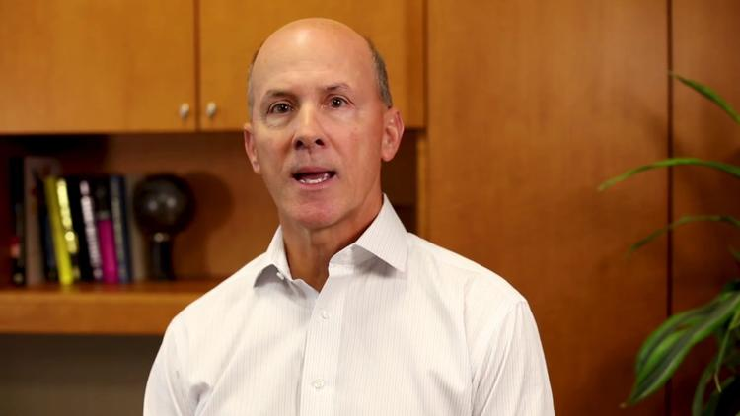
Equifax Chairman and CEO Rick Smith tries to explain away his firm's massive data breach
Smith further stated, “We pride ourselves on being a leader in managing and protecting data.” But the evidence contradicts that claim. Just last May, Krebs reported that thieves were able to access W-2 tax data of employees at client companies of Equifax’s payroll service subsidiary TALX, thanks to lax security. That breach lasted almost a year, starting in April 2016. The firm has suffered a string of other breaches, too.
The credit bureaus have “shown themselves to be terrible stewards of very sensitive data, and are long overdue for more oversight from regulators and lawmakers,” Krebs wrote.
But lawmakers at the state and federal level have been inexcusably lax about regulating these data firms and any others holding sensitive consumer information. Only eight states — Connecticut, Florida, Maine, New Mexico, Ohio, Rhode Island, Tennessee and Vermont — impose a firm deadline on how quickly companies must inform consumers of a breach, usually 30 to 90 days after its discovery. (California requires “timely” notification, whatever that means, except for medical information, which carries a 15-day notification deadline.)
In Europe, starting next May, the deadline will be 72 hours after a breach is discovered. That seems adequate.
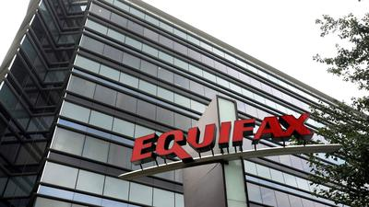
In the meantime, what can consumers do? Krebs and other security experts recommend going beyond signing up for account monitoring services, and placing a security freeze on your credit lines. This can be done through Equifax and the other agencies, though there may be a fee. The freeze prevents anyone from opening a new credit or loan account in your name. That includes you, however, which means you have to lift the freeze when you wish to open a new account yourself, and reimpose it (possibly incurring another fee) afterward. That’s an inconvenience, but a worthwhile one to protect your credit, the experts say.
The real action needs to take place in Congress. If there were harsh federal penalties for the kind of sloppiness that seems to be demonstrated by Equifax — life-threatening penalties for the companies — it would be a good bet that they’d get their act together. After every major breach, lawmakers talk about taking action, but seldom go further than holding a hearing or two. If that happens this time, it won’t be long until the next monster breach.
The real legislation should be to make it illegal to “classify” any citizen based on financial history older than 24 months. Anyone can lose a job and get rehired. Anyone can get sick, and then wrestle to pay off a doctor. But once that debt is paid, the “score” should go back to normal. Less than 3% of people have been working the same job for more than 5 years. The Credit Bureau has the power and authority to ruin anyone for up to 7 years with rotten credit,
Satellite Cleanup, or Eve of a New Space War

Think of the latest idea of collecting space junk as something akin to a hungry tiger pouncing on its prey. Aerospace Corporation says its Brane Craft will wrap itself around debris orbiting Earth and drag it back down through the atmosphere, causing it to burn up and never again threaten satellites or astronauts.
The project recently received a second round of funding from the NASA Innovative Advanced Concepts program, which funds far-out ideas that remain years away from launch — if they get there at all.
The Brane Craft is a yard across, flexible, and less than half the thickness of a human hair. This makes it difficult to protect the spacecraft's electronics from radiation, or even micrometeorites.
"It has to be bullet-proof, because a 5-micron diameter particle can penetrate the main structural sheet, which is only 10 microns thick," Siegfried Janson, principal investigator and a senior scientist at Aerospace Corporation, said.
So the company, based in El Segundo, California, has designed the spacecraft to be resilient. If one solar cell is whacked by a micrometeorite, only that cell will fail. Same goes for the craft’s microprocessor and digital electronics — if one fails, others will keep working. Even the propellant tank, which is sandwiched between two thin sheets, is split into multiple segments. In the case of a micrometeorite strike or an electrical short, other segments are designed to remain operable.
Radiation is another challenge as the spacecraft is thin and most commercial electronics cannot withstand the harsh conditions of space. The NIAC grant allows the company to investigate how to improve radiation tolerance during the short deployments that the company has proposed for the craft.
Aerospace Corporation aims to make the craft efficient and low cost. The thin spacecraft is not only lightweight, which reduces fuel consumption, but is easy to stack in a launcher and deploy in a swarm of dozens of bots, each on a track to a different rogue piece of debris. Brane Crafts will be powered by ultrathin solar cells as well as a little bit of propellant. The company plans to launch the craft frequently, with many Branes deployed at the same time, helping to reduce costs.
After each Brane envelops a piece of space junk, it will navigate back to towards Earth, acting like a near-space incinerator as it and the junk burn up in the atmosphere.
We've known about orbital debris for decades, but with each launch the problem becomes more urgent. There are at least 500,000 pieces of debris circling Earth. And that doesn't include tiny, yet dangerous, pieces of junk like paint flecks, which can cause a lot of damage when smacking into a spacecraft at upwards of 17,500 miles per hour.
NASA revises occasionally the orbit of the International Space Station to avoid space debris. Spacecraft often collide with the detritus of previous space missions, causing dings and damage. In 2009, the operational Iridium 33 and dead Kosmos-2251 satellites were destroyed after smacking into one another, which caused a swarm of space debris that is still swirling around Earth.
Beyond helping to take out the garbage, Brane Craft technology could help to lessen the weight of other communication satellites.
The NIAC grant provides two years of funding for laboratory demonstrations of the thin film. The investigators plan to outline how to develop the technology and which fabrication technologies hold the most promise.
"We're also looking at how we can get government or other companies interested in this to take this to the next level," Janson said, pointing out that readiness for space would likely take a few million dollars.
But once Brane gets going, if enough spacecraft are deployed, the concept should be able to pull down most objects of 0.9 kilograms (2 pounds) or less within a few years, he said.

More Reasons to Buy Taco Bell
Police say three employees of a Cleveland Taco Bell opened fire on two armed burrito banditos, killing one.
Police have said two masked robbers entered the restaurant early Wednesday and ordered three employees to lie on the floor. Police say three other employees pulled out handguns and opened fire, shooting one of the suspects six times. The other suspect ran off.
The Cuyahoga County Medical Examiner’s Office on Thursday said the man killed was 24-year-old De’Carlo Jackson.
Investigators say Jackson was found with a loaded gun in his hand. He was taken to a hospital and pronounced dead.
No one has been arrested. The employees who opened fire are said to be two 19-year-old men and a 23-year-old man. This is what I call gun control; being able to hit your target. Another great report of bad guys being stopped by armed good guys. This kind of gives new meaning to Fire sauce.
A Taco Bell spokeswoman told Cleveland.com the company is “shocked” by the shooting and is offering counseling to employees.
When Earth Strikes Back
Several people wrote me this week asking if I thought judgment was coming to America. ‘For What?’ you might ask. We systematically finance and legally provide and promote as a people the killing of more than a million babies a year. We enslave our people with debt, force them to be vaccinated, provide free propagandized federal education K-12, we have expunged God from every aspect of life, except perhaps your local church, and even then the sermon can be subpoenaed into court. We teach kindergarten kids about trangenderism and homosexuality. Our most famous actors and actresses, yes there is a difference, call for the assassination of our president with impunity. We apparently allow Democrats to sell our most valuable national secrets to our enemies for campaign money, and we do absolutely nothing about it.
Then, we wonder why our enemies have been sent against us. We wonder why the Earth itself is having this allergic reaction. And even more insane, it seems we ridicule the few people who gather together to ask for forgiveness for all of our tolerance and all of our silence in the face of this evil and to repent. We make fun of a few hundred people who want to apply their faith to healing this open sore. And, yes, it could even come down to people going potty in the wrong bathroom. Let’s gather the light together, and pull away from the darkness, so that the darkness comprehendeth it not. This is the Grand Division.
Well, let me tell you. The faith of a righteous man or woman availeth much. The faith of a hundred, is mighty indeed. Well, tonight I would like to apply the faith and consciousness of a few thousand or maybe a million. Faith is a powerful thing, and even in the mass of a mustard seed, when applied at exactly the right moment, over and over again, it can make a steel beam ripple and rock like a jump rope. It can remove mountains. And in the case of tonight’s effort, it can remove a storm of epic proportions.
So, let’s get started.
- The first opening breaths.
- The cleansing of negativity.
- The formation of the ball of light
- The pulse.
- The 18th breath when we think of this moment for the next 24 hours.
- The coordinated goal of evaporating the storm by stopping its rotation.
The End of the US Debt Ceiling

Of all the absurd Washington pantomimes none has been as reliably entertaining and maddening as the annual debates to raise the debt ceiling. Although the outcome was always a foregone conclusion (the ceiling would be raised), the excitement came when fiscal conservatives bemoaned the perils of runaway debt and “attempted” to exact spending restrictions through threats “to shut down the government,” (which often led to news coverage of tourists being turned away from national parks.) On the other side of the aisle Democrats would rail that the ceiling must be raised “because America always pays her bills.” Lost was the irony that “paying” bills with borrowed money was fiscally responsible, and that raising the ceiling actually enabled America to continue to avoid paying its bills. After these amateur theatrics, the ceiling would be lifted and Washington would go on as if nothing happened. But at least the performance threw occasional light on the nation’s debt problems.
But this week the news dropped that President Trump had made a “gentleman’s agreement” with Senate Minority Leader Chuck Schumer to permanently scrap the “debt ceiling” so that government borrowing can occur perpetually without the need to air the nation’s fiscal dirty laundry. Given how much the national debt has exploded in recent decades, and how reluctant Congress has been to address the problem, it should be no surprise that the proposal has finally been made. The only shock is that it happening when the Republicans control the White House and both houses of Congress.
The news came just a day after the President stunned the Republican party by abruptly siding with Congressional Democrats over the best way to deal with current debt ceiling negotiations. These developments should make it clear, as I described in the weeks after Trump moved into the White House, that budget deficits during the Trump administration will be far larger than just about anyone predicted. In fact, the self-proclaimed “King of Debt” is reaching for his crown and the coronation profoundly affect the fate of the U.S. dollar and the American economy.
Trump came to the White House with essentially no history of stated aversion to government spending and debt accumulation. Instead, he won the votes of Republicans and some independents by staking out extreme positions on immigration, terrorism, and economic nationalism, and by thumbing his nose at a political establishment much deserving of ridicule. Unlike almost all other Republicans, he had nothing to say about fiscal prudence, limited government, entitlement reform, spending cuts, or balanced budgets. In fact, he very rarely criticized government for being too large, but simply for being too stupid.
But as a businessman Trump had made his successes by borrowing, and then by borrowing even bigger when his ventures fell deeply into the red. There really should have been no doubt that he would bring those instincts with him into the Oval Office.
Republicans who thought otherwise have no one but themselves to blame for what the future holds.
The debt ceiling came into existence just a few years after the Federal Reserve was created in 1913. At the time that the bank was established many politicians, and certainly many citizens, were concerned that it could potentially lend unlimited funds to the government, a capacity that could short-circuit constitutional checks and balances and lead to the development of a Federal behemoth. As a result, the Fed’s original charter prevented the bank from buying or owning obligations of the U.S. Treasury. This provision allayed the fears of unlimited borrowing and it helped Congress approve the Act.
But just a few years later the United States entered the First World War. The massive expenses associated with quickly waging war on an unprecedented scale was too much for the government’s ability to tax or borrow directly from the public. Instead Congress changed the charter to allow the Fed to buy debt from the government. But to prevent this power from being absolute, Congress set limits. This “debt ceiling” has been with us ever since. But since it has been raised so many times in the past 100 years (every time the issue has come up), the intent of the law has been essentially neutered and now appears to be an archaic vestige with no real purpose; the fiscal equivalent of an appendix.
But in reality it is much more than that. For years Republicans have paid mountains of lip service to the need for a Balanced Budget Amendment as the only way to force government to live within its means. But the existence of the Debt Ceiling had given them that power all along. Like Dorothy in the Wizard of Oz, all conservatives had to do was click their heels together three times and not vote to raise the debt ceiling. And just like that our budgets would have had to be balanced. But Republicans just like to talk about balanced budgets. They never really wanted to actually balance them.
But even the possibility helped. One of the primary reasons that annual government deficits declined by two thirds between 2010 and 2015 (from $1.4 trillion to $450 billion) was because the Republican-controlled Congress was able to get the Obama administration to agree to the so-called “sequester” which capped the level of growth in a variety of Federal programs, including social programs and the military. Absent the leverage provided by the debt ceiling, sequester never would have seen the light of day. It is clear however that most of those negotiations were political in nature: Republicans beating on a Democrat president with any club they could find. But the end result was good for the country. Now that a “Republican” is on the other end of Pennsylvania Avenue, no clubs are being sought.
In fact, voting to raise the debt ceiling was always politically embarrassing for Republicans. To provide cover the measures were usually pared with some other politically popular legislation. In many cases some Republicans would be given the nod from leadership to vote no, as they could cast their votes against it knowing it would pass anyway. But eliminating the ceiling makes it that much easier for Republicans to campaign one way and govern another.
But the potential failure to raise the debt ceiling has never been the problem. It’s the debt that’s the problem, and the ceiling is a tool to solve the problem that vote-seeking politicians are afraid to actually use. If we eliminate the only tool, the problem will never be fixed. If the debt ceiling were to be cut out like an unneeded appendix, we should expect that America’s foray into debt creation, which has already been fantastical, to journey even farther into the looking glass. America’s funded national debt is already just a few clicks below $20 Trillion. If we were able to amass that much debt with a ceiling, even one that could be raised, imagine how much more debt will be run up with no ceiling at all!
In the end we may be able to repeal our self-imposed debt ceiling, but our creditors may not care.
When we drop even the pretense of a theoretic limit to our profligacy, our lenders may decide its time to impose a lending ceiling of their own. That is a ceiling we have no power to raise, and it could force our leaders to finally make some very unpopular choices. Massive cuts to government spending, including to current Social Security and Medicare benefits, huge middle class tax hikes, or an actual default on the national debt. Since neither of these alternatives is politically viable, I believe the coward’s way out will be a massive QE program where the Fed buys the bonds our creditors no longer want. This could be the worst possible choice for the U.S. economy, and investors should be prepared.
It could produce a dollar and sovereign debt crisis that will dwarf the financial crisis of 2008 with respect to its impact on the American economy. It could make hurricane Irma look like a summer shower.
The Real Debt Picture
A number of people have argued over the past few days that Hurricane Harvey will NOT boost the US housing market. As if any such argument would or should be required. Hurricane Irma will not provide any such boost either. News about the ‘resurrection’ of New Orleans post-Katrina has pretty much dried up, but we know scores of people there never returned, in most cases because they couldn’t afford to.
And Katrina took place 12 years ago, well before the financial crisis. How do you think this will play out today? Houston is a rich city, but that doesn’t mean it’s full of rich people only. Most homeowners in the city and its surroundings have no flood insurance; they can’t afford it. But they still lost everything. So how will they rebuild?
Sure, the US has a National Flood Insurance Program, but who’s covered by it? Besides, the Program was already $24 billion in debt by 2014 largely due to hurricanes Katrina and Sandy. With total costs of Harvey estimated at $200 billion or more, and Irma threating to cause far more damage than that, where’s the money going to come from?
It took an actual fight just to push the first few billion dollars in emergency aid for Houston through Congress, with four Texan senators voting against of all people. Who then will vote for half a trillion or so in aid? And even if they do, where would it come from?
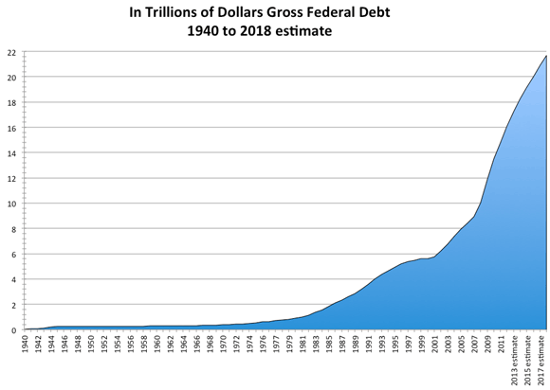
Trump’s plans for an infrastructure fund were never going to be an easy sell in Washington, and every single penny he might have gotten for it would now have to go towards repairing existing roads and bridges, not updating them -necessary as that may be-, let alone new construction.
Towns, cities, states, they’re all maxed out as things are, with hugely underfunded pension obligations and crumbling infrastructure of their own. They’re going to come calling on the feds, but Washington is hitting its debt ceiling. All the numbers are stacked against any serious efforts at rebuilding whatever Harvey and Irma have blown to pieces or drowned.
As for individual Americans, two-thirds of them don’t have enough money to pay for a $500 emergency, let alone to rebuild a home.
Most will have a very hard time lending from banks as well, because A) they’re already neck-deep in debt, and B) because the banks will get whacked too by Harvey and Irma. For one thing, people won’t pay the mortgage on a home they can’t afford to repair. Companies will go under. You get the picture.
There are thousands of graphs that tell the story of how American debt, government, financial and non-financial, household, has gutted the country. Let’s stick with some recent ones provided by Lance Roberts. Here’s how Americans have maintained the illusion of their standard of living. Lance’s comment:
This is why during the 80’s and 90’s, as the ease of credit permeated its way through the system, the standard of living seemingly rose in America even while economic growth rate slowed along with incomes.

Therefore, as the gap between the “desired” living standard and disposable income expanded it led to a decrease in the personal savings rates and increase in leverage. It is a simple function of math.

But the following chart shows why this has likely come to the inevitable conclusion, and why tax cuts and reforms are unlikely to spur higher rates of economic growth.
There’s no meat left on that bone. There isn’t even a bone left. There’s only a debt-ridden mirage of a bone. If you’re looking to define the country in bumper-sticker terms, that’s it. A debt-ridden mirage. Which can only wait until it’s relieved of its suffering. Irma may well do that.
A second graph shows the relentless and pitiless consequences of building your society, your lives, your nation, on debt.
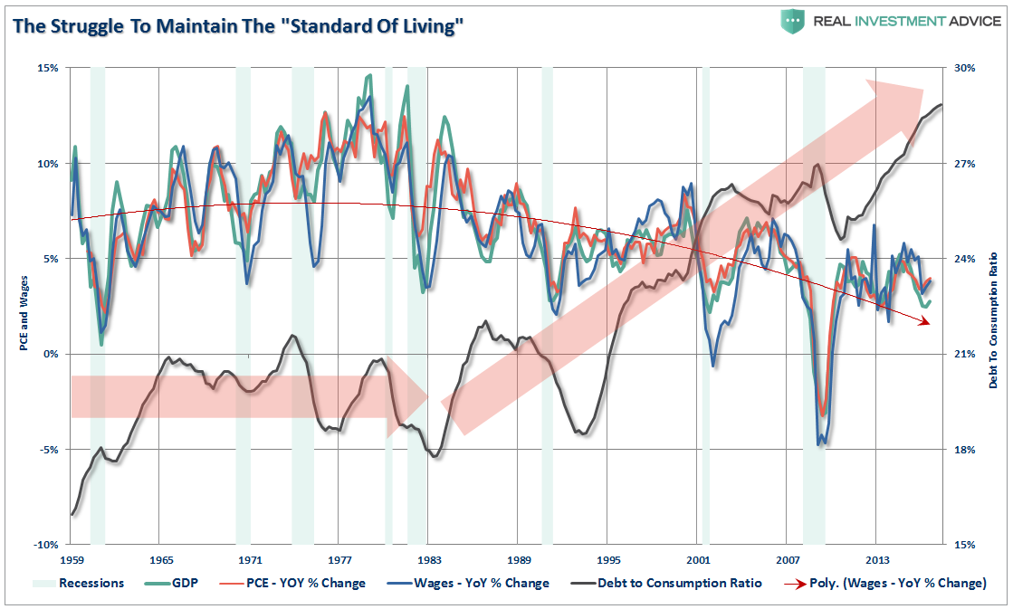
It may not look all that dramatic, but look again. Those are long-term trendlines, and they can’t just simply be reversed. And as debt grows, the economy deteriorates. It’s a double trendline, it’s as self-reinforcing as the way a hurricane forms.
Back to Harvey and Irma.
Even with so many people uninsured, the insurance industry will still take a major hit on what actually is insured. The re-insurance field, Munich RE, Swiss RE et al, is also in deep trouble. Expect premiums to go through the ceiling. As your roof blows off.
We can go on listing all the reasons why, but fact is America is in no position to rebuild. Which is a direct consequence of the fact that the entire nation has been built on credit for decades now. Which in turn makes it extremely vulnerable and fragile. Please do understand that mechanism. Every single inch of the country is in debt. America has been able to build on debt, but it can’t rebuild on it too, precisely because of that.
There is no resilience and no redundancy left, there is no way to shift sufficient funds from one place to the other (the funds don’t exist). And the grand credit experiment is on its last legs, even with ultra low rates. Washington either can’t or won’t -depending on what affiliation representatives have- add another trillion+ dollars to its tally, state capitals are already reeling from their debt levels, and individuals, since they have much less access to creative accounting than politicians, can just forget about it all.
Not that all of this is necessarily bad: why would people be encouraged to build or buy homes in flood- and hurricane prone areas in the first place? Why is that government policy? Why is it accepted? Yes, developers and banks love it, because it makes them a quick buck, and then some, and the Fed loves it because it keeps adding to the money supply, but it has turned America into a de facto debt colony.
The DOJ Takes Another Pass
In what amounts to another act of inexcusable negligence by the Department of Justice, former IRS bureaucrat Lois Lerner – the woman who President Barack Obama put in charge of weaponizing the agency as a tool to suppress Tea Party groups – has escaped being charged for her role in the wide-ranging conspiracy, which involved at least five other employees.
The decision is the culmination of five years of lawsuits brought by conservative groups against Lerner and the IRS, which successfully forced the agency to release the names of 426 nonprofit groups that were systematically targeted for additional scrutiny. The scandal was first disclosed to the public in 2012, but evidence obtained by conservative groups revealed that Lerner and another high-ranking IRS official knew about it years before.
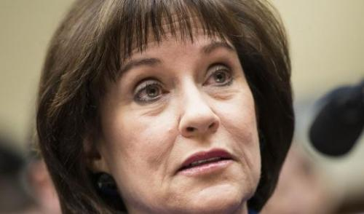
Predictably, conservatives are outraged by the decision – a rage that’s compounded by the DOJ’s reluctance to investigate former FBI Director James Comey and former Attorney General Loretta Lynch for possibly colluding to quash the investigation into Hillary Clinton’s mishandling of classified information, though Congress has nominally launched an investigation into the latter.
In the following statement, Judicial Watch President Tom Fitton asked that Trump intervene and order a complete review of the scandal:
“I have zero confidence that the Justice Department did an adequate review of the IRS scandal. In fact, we’re still fighting the Justice Department and the IRS for records about this very scandal. Today’s decision comes as no surprise considering that the FBI collaborated with the IRS and is unlikely to investigate or prosecute itself.

President Trump should order a complete review of the whole issue. Meanwhile, we await accountability for IRS Commissioner Koskinen, who still serves and should be drummed out of office.”
In a news release about the decision, Judicial Watch recounted how litigation forced the IRS first to say that emails belonging to Lerner were supposedly missing and later declare to the court that the emails were on IRS back-up systems, exposing a proliferation of “record-keeping problems” at the agency.
Here’s a timeline of civil actions and disclosures related to the scandal:
“In June 2014, the IRS claimed to have “lost” responsive emails belonging to Lerner and other IRS officials.

In July 2014 Judge Emmett Sullivan ordered the IRS to submit to the court a written declaration under oath about what happened to Lerner’s “lost” emails. The sworn declarations proved to be less than forthcoming.

In August 2014, Department of Justice attorneys for the IRS finally admitted Judicial Watch that Lerner’s emails, indeed all government computer records, are backed up by the federal government in case of a government-wide catastrophe. The IRS’ attorneys also disclosed that Treasury Inspector General for Tax Administration (TIGTA) was looking at several of these backup tapes.

In November 2014, the IRS told the court it had failed to search any of the IRS standard computer systems for the “missing” emails of Lerner and other IRS officials.

On February 26, 2015, TIGTA officials testified to the House Oversight and Government Reform Committee that it had received 744 backup tapes containing emails sent and received by Lerner. This testimony showed that the IRS had falsely represented to both Congress, Judge Sullivan, and Judicial Watch that Lerner’s emails were irretrievably lost. The testimony also revealed that IRS officials responsible for responding to the document requests never asked for the backup tapes and that 424 backup tapes containing Lerner’s emails had been destroyed during the pendency of Judicial Watch’s lawsuit and Congressional investigations.

In June 2015, Judicial Watch forced the IRS to admit in a court filing that it was in possession of 6,400 “newly discovered” Lerner emails. Judge Emmet Sullivan ordered the IRS to provide answers on the status of the Lerner emails the IRS had previously declared lost. Judicial Watch raised questions about the IRS’ handling of the missing emails issue in a court filing, demanding answers about Lerner’s emails that had been recovered from the backup tapes.

In July 2015, U.S District Court Judge Emmet Sullivan threatened to hold John Koskinen, the commissioner of the Internal Revenue Service, and Justice Department attorneys in contempt of court after the IRS failed to produce status reports and recovered Lerner emails, as he had ordered on July 1, 2015.”
According to the Washington Examiner, after being asked by Republicans in April to take a "fresh look" at the case against Lerner, the Trump administration responded Friday that it had reviewed the case and decided against it.
Some Republicans in Congress openly questioned Attorney General Jeff Sessions’s judgment:
"[T]he Department determined that reopening the criminal investigation would not be appropriate based on the available evidence," Assistant Attorney General Stephen Boyd wrote in a letter to Kevin Brady, the chairman of the House Ways and Means Committee.
Boyd added that the department had "carefully reviewed" its original 2015 decision not to prosecute, and had new attorneys independently review the investigation. He said that to convict Lerner, it would be necessary to prove that she intentionally discriminated against the groups based on their political views.
"I assure you that the Department has carefully studied the law, given the evidence the utmost consideration, and thoroughly reviewed the prior investigation from an objective perspective," he wrote.

In his response, Ways and Means Chairman Brady called it a "terrible decision" that suggested political appointees were not being held accountable under the law.

"I have the utmost respect for Attorney General [Jeff] Sessions, but I'm troubled by his Department's lack of action to fully respond to our request and deliver accountability," the Texas lawmaker said in a statement.

Peter Roskam, chairman of the House’s tax subcommittee, also criticized the decision, calling it "a miscarriage of justice."
Lawmakers had previously suggested that the Obama Department of Justice had declined to prosecute Lerner in 2015 because it was taking political cues from Obama. In 2014, their committee had voted to refer Lerner to the Justice
Department for prosecution for her role in the targeting scandal. Now Obama is gone, but the DOJ continues to protect his henchmen. The DOJ’s excuse – used many times recently - that proving intent would be too difficult, seems flimsy.

