Jihad Report
Aug 26, 2017 -
Sep 01, 2017
Attacks | 36
Killed | 150
Injured | 153
Suicide Blasts | 7
Countries | 15
Ancient Lost Languages Discovered in Egyptian Monastery
Ancient works hidden underneath monastery scriptures have been uncovered using imaging technology that pieced together words originally scrubbed off. The team found a series of lost texts using a method that allows scientists to restore ancient documents that were written over long ago to save on expensive parchment.
The discoveries at Saint Catherine's monastery on the Sinai peninsula, Egypt, signal a 'new golden age of discovery', the scientists behind the research said. Other lost ancient texts could be revealed using the new technique, which involves taking pictures of parchment from several angles and using different parts of the light spectrum.
Among several new texts discovered by researchers from the Early Manuscripts Electronic Library in California were documents written in rare languages. These include Caucasian Albanian, which had only been known from scattered stone inscriptions until now.
Three ancient Greek medical texts that were previously unknown to scholars were also revealed, as well as the earliest copies of some texts from famed Greek physician Hippocrates. The findings were announced at the headquarters of the Ministry of Antiquities in Cairo last week.
More details on the content of these finds are expected as scientists study the texts more closely.
Saint Catherine's monastery is the oldest continually operating library in the world, having been in use for 1,500 years. Parchment was once extremely valuable, meaning it was often reused.
'At some point the material the manuscript was on became more valuable than what was written on it,' Michael Phelps, from the Early Manuscripts Electronic Library in California.
'So it was deemed worthy of being recycled.'
Monks commonly wrote copies of the Bible on top of old texts, meaning many ancient texts have been lost. But the researchers say that long lost documents, such as those written by ancient philosopher Aristotle, could now be rediscovered on texts in libraries across the world using their technique. They used photographs taken from a number of angles and using different parts of the light spectrum to reveal traces of ink left by early scribes before the text was washed off.
Images of the parchment are then combined using computer algorithms to highlight the text beneath.
The Arming of ISIS by the CIA
A months-long investigation which tracked and exposed a massive covert weapons shipment network to terror groups in Syria via diplomatic flights originating in the Caucuses and Eastern Europe under the watch of the CIA and other intelligence agencies has resulted in the interrogation and firing of the Bulgarian journalist who first broke the story. This comes as the original report is finally breaking into mainstream international coverage.
Investigative reporter Dilyana Gaytandzhieva authored a bombshell report for Trud Newspaper, based in Sofia, Bulgaria, which found that an Azerbaijan state airline company was regularly transporting tons of weaponry to Saudi Arabia, United Arab Emirates (UAE), and Turkey under diplomatic cover as part of the CIA covert program to supply anti-Assad fighters in Syria. Those weapons, Gaytandzhieva found, ended up in the hands of ISIS and al-Qaeda terrorists in Iraq and Syria.
While it's long been understood that the US-Gulf-NATO coalition arming rebels inside Syria facilitated the rapid rise of the Islamic State as the group had steady access to a "jihadi Wal-Mart" of weapons (in the words of one former spy and British diplomat), the Trud Newspaper report is the first to provide exhaustive documentation detailing the precise logistical chain of the weapons as they flowed from their country of origin to the battlefield in Syria and Iraq. Gaytandzhieva even traveled to Aleppo where she filmed and examined labeled weapons shipping containers held in underground jihadist storehouses.
The Bulgaria-based journalist obtained and published dozens of secret internal memos which were leaked to her by an anonymous source as part of the report. The leaked documents appear to be internal communications between the Bulgarian government and Azerbaijan's Embassy in Sofia detailing flight plans for Silk Way Airlines, which was essentially operating an "off the books" weapons transport service (not subject to inspections or tax under diplomatic cover) for the US Special Operations Command (USSOCOM), Saudi Arabia, Israel, Germany, Denmark, and Sweden. Silk Way Airlines has been the subject of other recent investigations involving weapons supplies for the Saudi war on Yemen. In addition, the military monitoring site Balkan Insight has exposed similar weapons cargo flights in and out of neighboring Serbia.
But perhaps the more explosive finding involves private American companies contracting with the US government to help train and equip militants in Syria. An investigative series by Buzzfeed - the first of which was published in 2015 - named military contractor Purple Shovel LLC as the recipient of two no-bid contracts totaling more $50 million as part of the US train and equip program for Syria. Gaytandzhieva's report definitively links Purple Shovel and other private American military contractors to the Azerbaijan Silk Way Airlines shipments.
One leaked memo includes a cargo manifest for multiple tons of anti-tank grenades purchased in Bulgaria by Purple Shovel which were ostensibly designated for the official consignee - the Ministry of Defense of Ajerbaijan - but which never made it to Ajerbaijan. The documents, however, reveal that the military cargo was offloaded at Turkey's Incirlik air base, which is one of the US and NATO's main command centers for covert operations in Syria.
Though Gaytandzhieva's report is months old and began through a series of smaller investigations, it gained little traction in Western or international press, even though it was promoted on social media and discussed among some of the world's foremost experts on Syria and the Middle East. However, on Sunday Qatar-based Al Jazeera featured the story while reporting the shocking news that Gaytandzhieva had been interrogated by Bulgarian authorities before being fired from her newspaper:
Gaytandzhieva said on Thursday in a tweet that she was fired from her job at Trud after she was interrogated by the Bulgarian national security which tried to find out her sources.
She said she first got suspicious of the weapons transferred to Syria when she found Bulgarian-made weapons at the hands "terrorists" in Aleppo while reporting on the Syrian war there.
She said that she then traced those weapons to its Bulgarian manufacturer only to find out that those weapons were legally exported to Saudi Arabia, which in turn supplied it to CIA operatives in Syria.
Fusion Breakthrough
For years nuclear fusion was the stuff of sci-fi books and movies, but technology has brought it, like so many other things, closer to reality. So close, in fact, that there are plans to build the first nuclear fusion reactor by 2025 - a reactor that could yield a lot more energy than is fed into it and provide vast amounts of clean, sustainable energy. An international team of scientists is working on the biggest project in nuclear fusion in France, to build the largest magnetic fusion machine - a tokamak - and test the commercial-scale viability of this clean energy source. The ITER project is based on the pretty simple premise that the larger the vessel in which fusion reactions occur, the more of them occur, generating more energy.
The ITER tokamak will be ten times larger than the largest existing such device, capable, as per plans, to produce 500 MW of fusion power. To compare, the record so far, set by European tokamak JET (the largest existing one), is 16 MW, from input of 24 MW. The goal of the ITER team is to produce these 500 MW from an input of just 50 MW. Recently, a team of researchers from the MIT published a paper that suggests this achievement is realistic.
The MIT team tweaked the “recipe” for nuclear fusion in such a way that the output of power was ten times greater than with the original composition, which consists of 95 percent deuterium ions and 5 percent hydrogen ions, forming plasma heated to incredibly high temperatures in the tokamak from the movement of the ions. The tokamak produces magnetic fields that keep the superhot plasma inside and keep it moving - and hot - but controlling it for ever-longer periods of time and making it move faster to produce more energy has been a challenge. Now, the MIT scientists may have found the secret ingredient in an isotope of helium, helium-3.
The team, from the Plasma Science and Fusion Center of the MIT, added trace amounts - 1 percent - of helium-3 to the traditional combination and tested the new combination at the Alcator C-Mod tokamak. The results showed that the hydrogen-deuterium-helium plasma got wrigglier and hotter, producing 10 times more energy than before. The amount of energy produced after the addition of helium, the researchers explained, increased output by an order of magnitude, bringing it into the realm of megaelectronvolts.
One of the scientists involved in the project, John C. Wright, explains,
“These higher energy ranges are in the same range as activated fusion products. To be able to create such energetic ions in a non-activated device — not doing a huge amount of fusion — is beneficial, because we can study how ions with energies comparable to fusion reaction products behave, how well they would be confined.”
The test results were so exciting that another team, the one working with the JET in the UK, decided to replicate them. The replication confirmed the results, raising hopes that a fully functional nuclear fusion reactor may indeed be on the horizon. This horizon is still far, or near, depending on your perspective. According to the head of the Alcator C-Mod project, Earl Marmar, we could see fusion reactors in the 2030s. The main problem: keeping the process going.

Why Little Kim is a Threat to Global Security
North Korea launched another medium-range missile on Monday, this one right over Japan. Despite Defense Secretary Jim Mattis’ threats to shoot down missiles aimed at Guam and President Donald Trump’s Pyongyang-aimed bluster, the United States and Japan let it fly. Why?
After the test, Trump on Tuesday said that “all options are on the table,” as every president has said for decades. But the Pentagon is still reluctant to use some of the most obvious options, such as shooting down a missile above the earth’s atmosphere with another missile fired from a ship.
The United States has 33 Aegis warships (three more are slated to arrive next year) that can launch an interceptor to hit a mid- or intermediate-range missile like the Hwasong-12 that North Korea sent over Hokkaido. Sixteen of those warships are currently in the Pacific.
Bottom of Form
Pacific Command, in Honolulu did not respond to questions about why they didn’t attempt to down Monday’s missile. The command did issue a statement: “North American Aerospace Defense Command, NORAD, determined the missile launch from North Korea did not pose a threat to North America,”
Mattis said earlier this month that any North Korean missile headed toward U.S. land, including Guam and other territories, would be shot down and considered war against the United States. But, he added, if the missile were tracking to land in the sea, it would be the president’s call what to do about it.
Tom Karako, senior fellow and missile defense expert with the Center for Strategic and International Studies, said that if the missile launched Monday were really a threat to the United States or even Japan “then presumably we may well have attempted to engage it.”
But what are the costs and what are the benefits in attempting such an intercept? Anti-missile interceptors like the ones on U.S. warships are designed to hit enemy missiles as they reach peak altitude — in the case of the Hwasong-12, that’s above 3,500 kilometers. The United States has demonstrated that it can intercept mid-range and slightly higher intermediate-range missile. But the test record includes embarrassing and recent failures.
Between January 2002 and August 14 of this year, the Defense Department attempted 37 intercepts of a mid-range missile and hit the target 29 times with an SM-3. There are many reasons for this, but the biggest, according to the Pentagon’s Office of the Director of Operational Testing and Engineering, is that realistic testing of interceptors is very expensive and requires a lot of lead time and support.
Update: On Wednesday morning, MDA conducted another successful intercept test using an SM-6 aboard a warship against a medium-range ballistic missile target. “The USS John Paul Jones detected and tracked a target missile launched from the Pacific Missile Range Facility on Kauai, Hawaii with its onboard AN/SPY-1 radar,” the agency said in a press statement.
In February, MDA showed that their newest version of the standard missile, the SM-3 IIA, could hit a mid-range missile. But a second test in June was a failure. The Navy later attributed that to human error. But 50 percent is not a good record for the most advanced intermediate-range interceptor in the U.S. arsenal.
Advertisement
The Obama administration pushed hard for a ship-based defense against mid-range North Korean missiles aimed at Japan or Guam but found that the military has much better chance of hitting missiles that don’t fly so high.
Shooting down an enemy missile aimed at U.S. territory may be good defense, but shooting down a missile test aimed at the sea would be an act of war. Or so argued North Korea.
“Taking a shot at a North Korean missile is not something the U.S. military would do lightly or without a directive to do so,” said Karako. “if we are going to shoot at something, we will do it like we mean it. But there has to be a good reason to do it. That reason might be if there is an actual threat to the U.S., its forces, or our allies. Or it might be if the U.S. or Japan adopts a policy to intercept certain types of missiles or those on certain kinds of trajectory. But that would have to be a deliberate policy choice.”
The highest probability of success would be to hit the enemy missile closer to the ground, during the so-called boost phase. That’s what MDA is aiming for in the future with laser-armed drones. In July, the agency put out a request for information for a high-altitude long endurance aircraft. Read that to mean a drone that can fly above 63,000 feet for a long time. According to the request, the drone should have enough power for a 140-kw laser. But that program won’t even begin testing until 2023. Until then, and likely even after, every time a missile heads toward Japan, Guam, or anywhere else, military leaders will have to decide whether attempting to shoot down North Korean missiles is worth the costs of possibly missing — or starting a war.
Weekend Update – The Hydrogen Signature
North Korea said it conducted a sixth and significantly larger nuclear test Sunday, stepping up pressure on President Donald Trump in what is shaping up to be his biggest foreign policy crisis.
In a televised statement, North Korea described the underground explosion, which triggered a large earthquake, as a “perfect success in the test of a hydrogen bomb for an ICBM.” Pyongyang said “the creditability of the operation of the nuclear warhead is fully guaranteed.”
The test came just hours after leader Kim Jong Un showed off what he described as a hydrogen bomb capable of being mounted on an intercontinental ballistic missile.
The explosion at the nuclear test site at Punggye-ri in North Korea’s mountainous northeast triggered an initial magnitude-6.3 earthquake, followed by a magnitude-4.1 temblor that was possibly caused by a structural collapse, according to the U.S. Geological Survey.
While it was unclear what set off the second quake, satellite imagery has captured evidence of tunneling activity at the nuclear test site in recent months. Any structural collapse might have been related to that.
Estimates of the size of Sunday’s initial earthquake varied among different agencies, but the USGS said it had a magnitude of 6.3. According to the logarithmic scale used to measure earthquakes, a 6.3 quake would be 10 times bigger than the one triggered by the North’s previous nuclear test in September 2016, which the USGS said had a magnitude of 5.3.
The latest nuclear test was estimated to have a yield of as high as 100 kilotons—about 10 times the power of the North’s previous test and roughly five times that of the atomic bomb that the U.S. dropped on Nagasaki, Japan, in 1945, according to Kim Young-woo, a South Korean lawmaker who is chairman of the legislature’s defense committee and received a briefing from military authorities.
A spokesman for the defense ministry declined to comment.
Norsar, a Norwegian nonprofit foundation with a focus on seismology, estimated the explosive yield at 120 kilotons, based on a 5.8-magnitude assessment of the explosion.
South Korea’s national security adviser, Chung Eui-yong, said after a 90-minute emergency meeting of the National Security Council that Seoul would consider the possible deployment of what he described as the “most powerful strategic assets that the U.S. possesses,” without elaborating, according to a statement from the presidential Blue House.
The phrase “strategic assets” typically refers to stealth bombers, aircraft carriers or possibly nuclear weapons. The U.S. withdrew the last of its nuclear weapons from South Korea in 1991.
Mr. Chung, who also spoke by phone with Lt. Gen. H.R. McMaster, his counterpart at the White House, said that Moon Jae-in, the South Korean president, had called for the “strongest punitive measures” against Pyongyang. That includes diplomatic measures and a new United Nations Security Council resolution to “completely isolate North Korea.”
In Sunday morning tweets, Mr. Trump said North Korea’s “words and actions continue to be very hostile and dangerous to the United States.” He added: “North Korea is a rogue nation which has become a great threat and embarrassment to China, which is trying to help but with little success.” He also added: “South Korea is finding, as I have told them, that their talk of appeasement with North Korea will not work, they only understand one thing!”
“The national security team is monitoring this closely,” White House Press Secretary Sarah Sanders said Sunday morning. “The president and his national security team will have a meeting to discuss further later today. We will provide updates as necessary.”
While North Korea has made steady advances in both its nuclear and missile programs over the course of decades, Mr. Kim has greatly accelerated the pace of testing as the isolated country nears the ability to deliver a nuclear-tipped missile to the continental U.S.
Just this year, it has conducted a string of successful missile tests that have extended the proven range of its arsenal and introduced new capabilities that allow Pyongyang to fire missiles more quickly and with less warning. In July, it test-fired two ICBMs that experts say they believe are capable of reaching many parts of the U.S. mainland.
“The Kim regime made the strategic decision to develop a nuclear armed ICBM that can strike the United States,” said Leif-Eric Easley, a professor of international studies at Ewha Womans University in Seoul. “It is in a sprint to deploy that capability, because it wants the world to recognize it before returning to diplomatic talks, and before sanctions become unbearable.”
However, analysts have been divided on whether North Korea could shrink a nuclear warhead to fit on the tip of a missile. Many also remain skeptical about whether a North Korean warhead can survive the strain of re-entry into the Earth’s atmosphere.
In an earlier statement Sunday, which followed a meeting between Mr. Kim and his top nuclear scientists, North Korea claimed it had already mastered the ability to mount a hydrogen bomb atop a long-range missile.

Related
- Electromagnetic Pulse: North Korea’s Latest Threat Against U.S.
- North Korea’s Relentless March to Nuclear Prowess
- North Korea Says It Has Developed Advanced Hydrogen Bomb
- North Korea Conducts Fifth Nuclear Test (Sept. 9, 2016)
- North Korea Says It Successfully Conducted Hydrogen-Bomb Test (Jan. 6, 2016)
Mr. Kim was quoted as saying all of the components of its hydrogen bomb were homemade, insulating the nuclear-weapons program from sanctions and “enabling the country to produce powerful nuclear weapons, as many as it wants.” The bomb’s explosive power has a range up to hundreds of kilotons, the North Korean report said.
The claims couldn’t be immediately verified and the report didn’t specify the date of Mr. Kim’s visit. North Korea conducted a pair of nuclear tests last year, including one a year ago this week, that Pyongyang claimed involved hydrogen bombs.
North Korea’s September 2016 test had an estimated yield of about 10 kilotons, higher than in any of its previous four tests but likely too low to have come from a hydrogen bomb.
The Threat From North Korea’s Missiles
In photos published by North Korean state media before Sunday’s nuclear test, Mr. Kim gestured toward a bulbous silver device that appeared capable of holding the two nuclear devices that would be necessary for a thermonuclear blast.
A hydrogen bomb—technically known as a thermonuclear weapon—typically uses a smaller, primary atomic explosion to ignite a secondary, much larger blast. The first stage is based on nuclear fission—the splitting of atoms—and the second on nuclear fusion, which combines atoms, smashing them together and unleashing more energy. Additional stages can be added to increase its destructive force.
That makes the H-bomb more powerful than early nuclear weapons that typically used a single-stage blast based only on nuclear fission. Those weapons are known as “pure fission” devices and are thought to have been used in all of North Korea’s first three nuclear tests, which it said involved atomic bombs.
Sunday’s nuclear test came just before Chinese President Xi Jinping was set to give a speech at a summit of the five so-called Brics countries, including Brazil, Russia, India and South Africa, being held in the southern Chinese coastal city of Xiamen.
China’s environmental ministry posted online Sunday evening that it has initiated emergency protocol for possible radiation from North Korea at 11:46 a.m. local time (11:46 p.m. EDT), and is currently monitoring radiation on the northeast border.
Zhao Tong, a fellow at the Carnegie-Tsinghua Center for Global Policy in Beijing, said North Korea may have chosen to conduct the nuclear test ahead of China’s leadership reshuffle set for next month, knowing Beijing will emphasize stability before the critical meeting.
“It appears North Korea wants to complete the final step toward perfect nuclear deterrence before the 19th party congress because China wants to prioritize stability ahead of it,” he said. The twice-a-decade Communist Party gathering is expected to start Oct. 18 in Beijing.
If North Korea has achieved the capability to test a thermonuclear weapon, it gives it a more “credible nuclear deterrence,” as it no longer needs very accurate missiles to hit its targets, he said. “That’s a real concern.”
China’s Foreign Ministry condemned the latest North Korean nuclear test in a statement, vowing to “comprehensively implement” U.N. Security Council resolutions on Pyongyang.

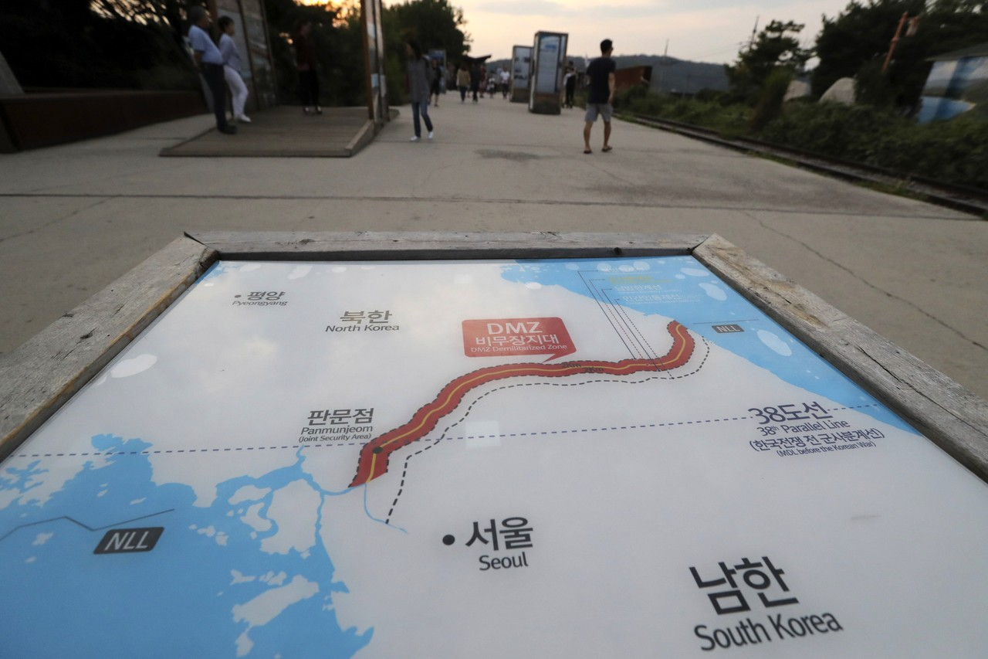
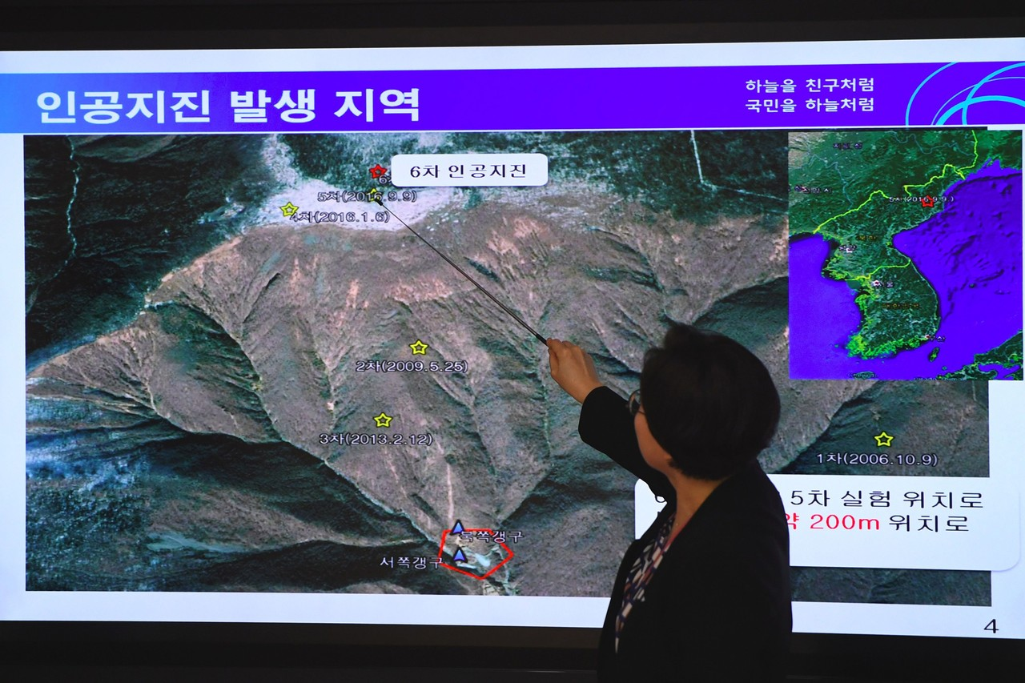
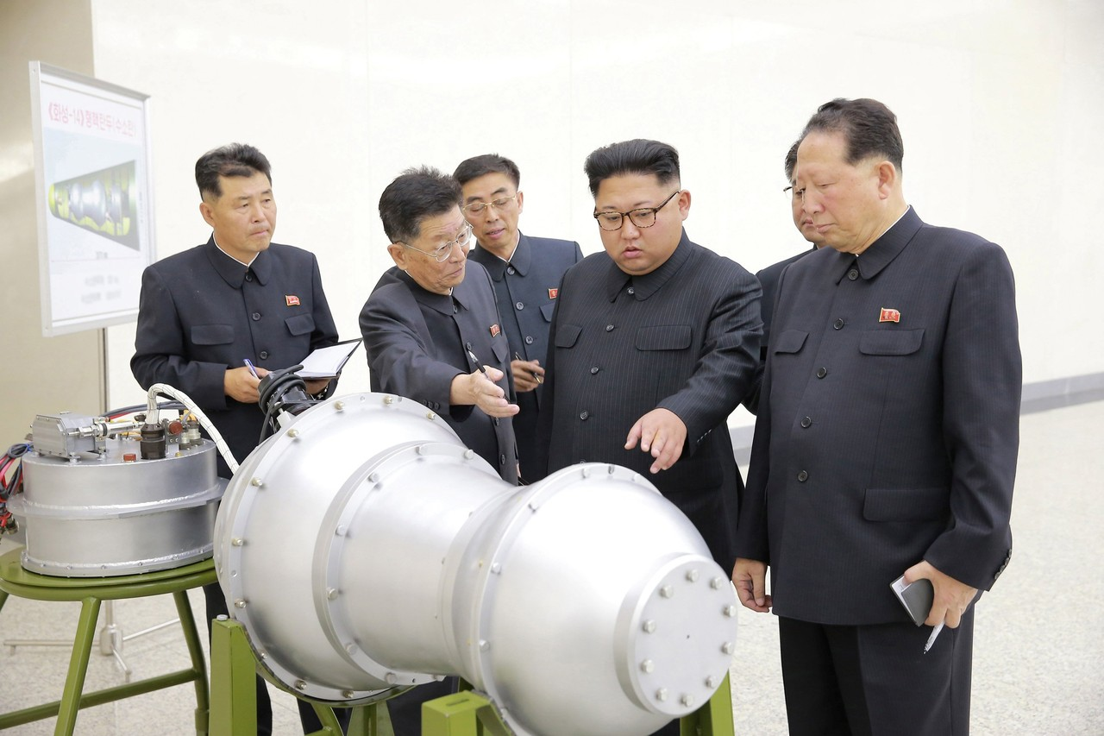
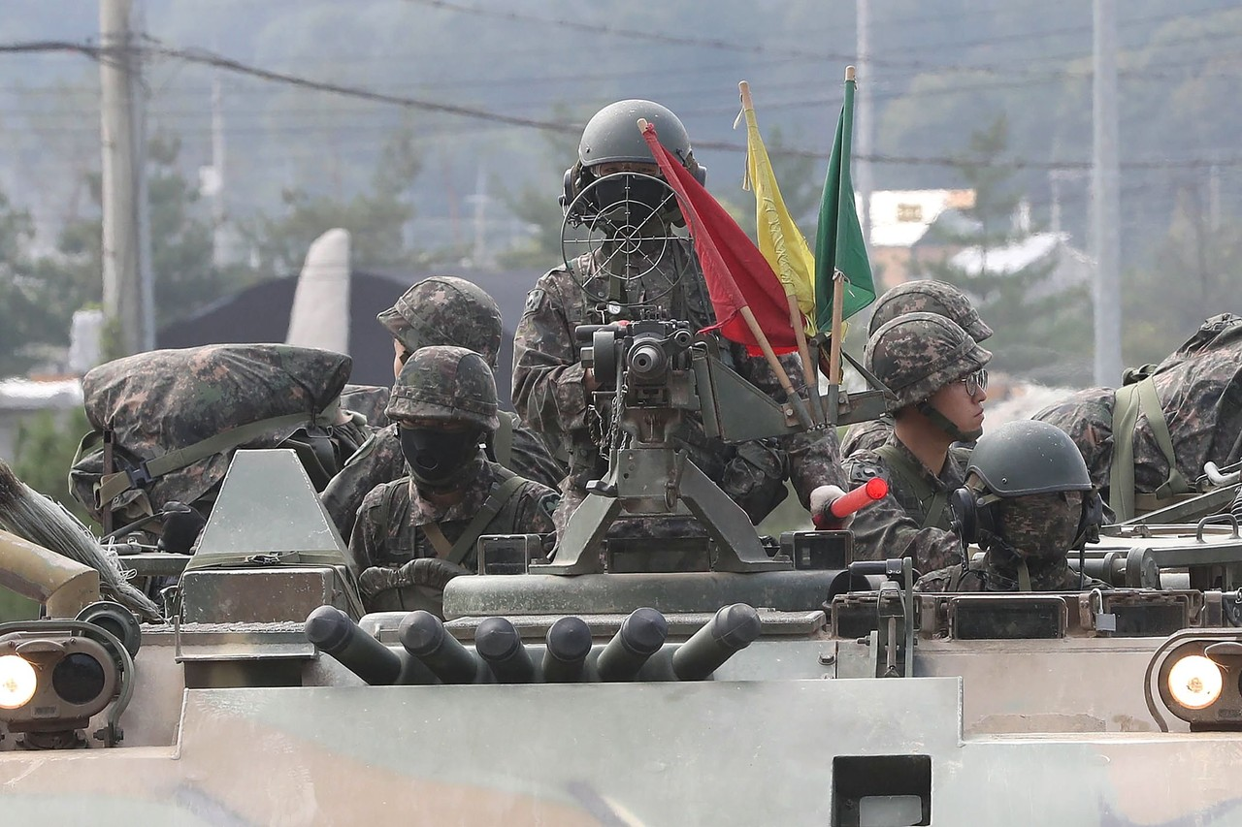
Lee Mi-Seon, a director of South Korea’s National Earthquake and Volcano Center, shows a map of a North Korean location during a briefing about the ‘artificial earthquake’ in North Korea, at the Korea Meteorological Administration in Seoul on Sunday. The ‘artificial quake’ in North Korea on Sunday, thought to be its sixth nuclear test, was five to six times more powerful than the tremor from Pyongyang's fifth test, the weather agency said.
Jung yeon-Je/Agence France-Presse/Getty Image
1 of 7
•••••

“We strongly urge the DPRK to face up to the firm will of the international society on the issue of denuclearization on the Korean Peninsula” and to return to “the track of dialogue,” the ministry said, referring to North Korea by the initials of its official name, the Democratic People’s Republic of Korea.
Japanese Prime Minister Shinzo Abe said his country would work together with the U.S., South Korea, China and Russia on a response to the nuclear test.
“We can never accept it. We will need to make a strong protest,” Mr. Abe said.
In North Korea’s statement before the nuclear test, Mr. Kim also threatened to detonate a nuclear device at a high altitude above the U.S. The detonation could emit a brief but powerful electromagnetic signal capable of disrupting swaths of the U.S. electrical grid, experts say.
Fears of such an electromagnetic pulse, or EMP, attack by North Korea have circulated for years among some U.S. policy makers, though others have openly dismissed the possibility that Pyongyang could launch such a strike.
The EMP Aspect
The dynamics of the standoff between the US and North Korea have shifted dramatically in the past week.
First, the North started with an unexpectedly sharp provocation - launching a missile over the Japanese island of Hokkaido - before following that up with its sixth nuclear test. Also, judging by the size the earthquake detected in the country’s mountainous North on Sunday morning, North Korea may have been telling the truth when it said it conducted what it described as its first hydrogen bomb test.
And while the North bragged about the weapon’s “great destructive power” in a TV broadcast, what caught analysts’ attention was a mention of a different tactic: detonating an H-bomb at high altitude to create an electromagnetic pulse that could knock out parts of the US electrical grid.
“North Korea’s threats against the U.S. now include a tactic long discussed by some experts: an electromagnetic pulse, or EMP, triggered by a nuclear weapon that would aim to shut down the U.S. electricity grid.

North Korea’s state news agency made a rare reference to the tactic in a Sunday morning release in which the country said it was able to load a hydrogen bomb onto a long-range missile. The bomb, North Korea said, ‘is a multifunctional thermonuclear nuke with great destructive power which can be detonated even at high altitudes for super-powerful EMP attack.’”
Unlike a conventional nuke, an EMP blast - think Oceans' 11 - is not directly lethal, and serves mostly to knock out key infrastructure (useful when robbing a casino).
However, it would probably lead to an unknown number of indirect deaths as hospitals and essential infrastructure lose power.
“The idea of an EMP attack is to detonate a nuclear weapon tens or hundreds of miles above the earth with the aim of knocking out power in much of the U.S. Unlike the U.S. atomic bombs dropped over Hiroshima and Nagasaki in 1945, such a weapon wouldn’t directly destroy buildings or kill people. Instead, electromagnetic waves from the nuclear explosion would generate pulses to overwhelm the electric grid and electronic devices in the same way a lightning surge can destroy equipment.”
In the worst possible scenario, regional power grids could be offline for months, potentially costing many deaths as people would eventually start running out of necessities like food and medicine. Lawmakers and the US military have been aware of the EMP threat for many years, according to WSJ. IN a 2008 report commissioned by Congress, the authors warned that an EMP attack would lead to “widespread and long-lasting disruption and damage to the critical infrastructures that underpin the fabric of US society.”
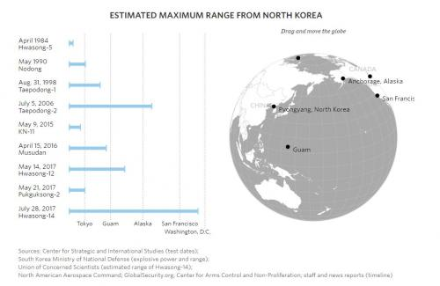
In a report published last month, the Hill noted that the North could choose to carry out an EMP attack on Japan or South Korea as a more politically acceptable act of aggression. Such an attack could help the North accomplish its three most-important political goals, the Hill said.
“North Korea has nuclear-armed missiles and satellites potentially capable of electromagnetic pulse (EMP) attack. EMP is considered by many the most politically acceptable use of a nuclear weapon, because the high-altitude detonation (above 30 kilometers) produces no blast, thermal, or radioactive fallout effects harmful to people.

EMP itself is harmless to people, destroying only electronics. But by destroying electric grids and other life-sustaining critical infrastructures, the indirect effects of EMP can kill far more people in the long-run than nuclear blasting a city. In this scenario, North Korea makes an EMP attack on Japan and South Korea to achieve its three most important foreign policy goals: reunification with South Korea, revenge upon Japan for World War II, and recognition of North Korea as a world power.”
Scientists first discovered a hydrogen bomb’s ancillary EMP capabilities after testing one in the Pacific in the early 1960s.
“When the U.S. tested a hydrogen bomb in the Pacific in 1962, it resulted in lights burning out in Honolulu, nearly 1,000 miles from the test site. Naturally occurring electromagnetic events on the sun can also disrupt power systems.

A 1989 blackout in Quebec that came days after powerful explosions on the sun expelled a cloud of charged particles that struck earth’s magnetic field.”
Some experts who spoke with WSJ said it would be impossible to guarantee success during an EMP attack, since the weapon would need to detonate with near perfect accuracy.
“Skeptics generally acknowledge that an EMP attack would be possible in theory, but they say the danger is exaggerated because it would be difficult for an enemy such as North Korea to calibrate the attack to deliver maximum damage to the U.S. electrical grid. If it a North Korean bomb exploded away from its target location, it might knock out only a few devices or parts of the grid.”
The North Korea said its hydrogen bomb had explosive power of tens of kilotons to hundreds of kilotons – so of course if it landed to close, or the attack was mishandled in other ways, what was meant to be an EMP attack would result in a nuclear strike. At least one expert said using an EMP attack would make little sense when the North could cause much more destruction with a nuclear ground attack.
“Others say that even if North Korea had the technical capability to deliver a damaging electromagnetic pulse, it wouldn’t make strategic sense to use it because Pyongyang could wreak more destruction with a traditional nuclear attack directed at a large city.

A rogue state would prefer a “spectacular and direct ground burst in preference to a unreliable and uncertain EMP strike. A weapon of mass destruction is preferable to a weapon of mass disruption,” wrote physicist Yousaf M. Butt in a 2010 analysis.”
Luckily, if US military authorities truly fear an attack, there are some long-term steps the US could take to minimize the effectiveness of an electromagnetic pulse attack. Defenses could be bolstered inexpensively by designing electrical-grid components to withstand sudden pulses, just as the grid already is protected against lightning strikes. The US could also build backup systems that could step in for the principal electrical grids in an emergency.
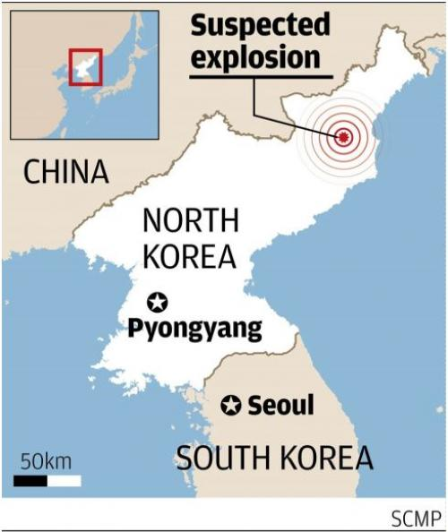
If the North’s latest nuclear test, conducted early Sunday, didn’t involve a hydrogen bomb, the weapon used was at least close to it according to US officials. It was the North’s first nuclear test since late last year, and also the first since tensions between Kim Jong Un and President Donald Trump began escalating shortly after his inauguration. China, Japan, South Korea and the US have already condemned the attack, with China and South Korea threatening to work with the Security Council to bring more onerous sanctions against the defiant North.
Meanwhile, President Donald Trump in a series of tweets hinted that he was frustrated with diplomatic measures, which he referred to as “appeasement.” We imagine there are more than a few generals whispering in his ear about the potential success rate of a surgical strike.
* * *
Finally, here is a repost from July 2014, in which hedge fund legend Paul Singer, head of Elliott Management, said that "there is one risk that stands way above the rest in terms of the scope of potential damage adjusted for the likelihood of occurrence" - an electromagnetic pulse (EMP). Three years he may be proven correct.
From: "The "Most Significant Danger" According To Elliott's Paul Singer"
EMP: THE MOST SIGNIFICANT DANGER

While these pages are typically overflowing with scary or depressing scenarios, there is one risk that stands way above the rest in terms of the scope of potential damage adjusted for the likelihood of occurrence. Even nuclear war is a relatively localized issue, except in its most extreme form. And the threat from asteroids can (possibly) be mitigated.

The risks associated with electromagnetic pulse, or EMP, represent another story entirely. It can occur naturally, from solar storms that send “coronal mass ejections,” which are massive energetic bursts of solar wind, tens of millions of miles in a mere few hours. Or it can be artificial, produced by a high-altitude (at least 15 miles) explosion of relatively low-yield (even Hiroshima-strength) nuclear weapons.

Different initiators of EMP have different pulses and different effects. But the bottom line is that EMP fries electronic devices, including parts of electric grids. In 1859, a particularly strong solar disturbance (the “Carrington Event”) caused disruption to the nascent telegraph network. It happened again with similar disruptions in 1921, before our modern power grid came into existence. A NASA study concluded these events have typically occurred around once per century. A repeat of the Carrington Event today would cause a massive disruption to the electric grid, possibly shutting it down entirely for months or longer, with unimaginable consequences.

Only two years ago, the sun let loose with a Carrington-magnitude burst, but the position of the earth at the time prevented the burst from hitting it. The chances of additional events of such magnitude may be far greater than most people think.

The artificial version of EMP, a kind of nuclear attack, would require between one and three high-altitude nuclear explosions to create its effect across all of North America. It would not cause any blast or radiation damage, but such an attack would have consequences even more catastrophic than a severe solar storm. It could not only bring down the grid, but also lay down a very intense, very fast pulse across the continent, damaging or destroying electronic switches, devices, computers and transformers across America.

There is no way to stop a naturally occurring EMP, and nuclear proliferation, combined with advances in weapons delivery systems, make the artificial version a distinct possibility, so the dangers are very real.

What can be done about this risk? Critical elements of the power grid and essential electronic devices can be hardened. Spare parts can be stockpiled for other, less critical hardware. Procedures can be developed as part of emergency preparedness so that the relevant government agencies and emergency response NGOs are ready to respond quickly and effectively to an episode large or small.

Why are we writing about EMP? Because in any analysis of societal risk, EMP stands all by itself. Congressional committees are studying this problem, and federal legislation is laboriously working its way through the process. We think that raising people’s consciousness about what should be an effort by both parties to make the country (and the world) safer from this kind of event is a good thing to do.
Hurricane Irma Update
Hurricane Irma has regained Category 3 intensity, and additional strengthening is likely in the coming days as it tracks west across the Atlantic. Environmental conditions could even support Irma becoming a rare Category 5 hurricane at some point, the first since 2016’s Matthew. Within the next five days, the Leeward Islands, Puerto Rico, the Dominican Republic, Haiti and the Bahamas are most definitely at risk and should prepare for hurricane conditions (at least a close encounter if not a direct landfall).
Beyond then, forecast confidence drops dramatically. Some models curve Irma back out to sea before reaching the continental United States, but a significant percentage of models have Irma striking the U.S. East Coast as early as Saturday or Sunday. Therefore, anyone with interests from Florida to New England should monitor forecasts closely.
The center of Irma is still about 900 miles east of the Leeward Islands, 2,150 miles east-southeast of Miami and 2,150 miles southeast of Wilmington, N.C. The National Hurricane Center is predicting Irma to pass over or near the Leeward Islands on Wednesday, then to be near the eastern Bahamas by Friday. Beyond that, the spread in model tracks grows, but it usually does at such long lead times. Hurricane watches may be issued later Sunday for the Leeward Islands.
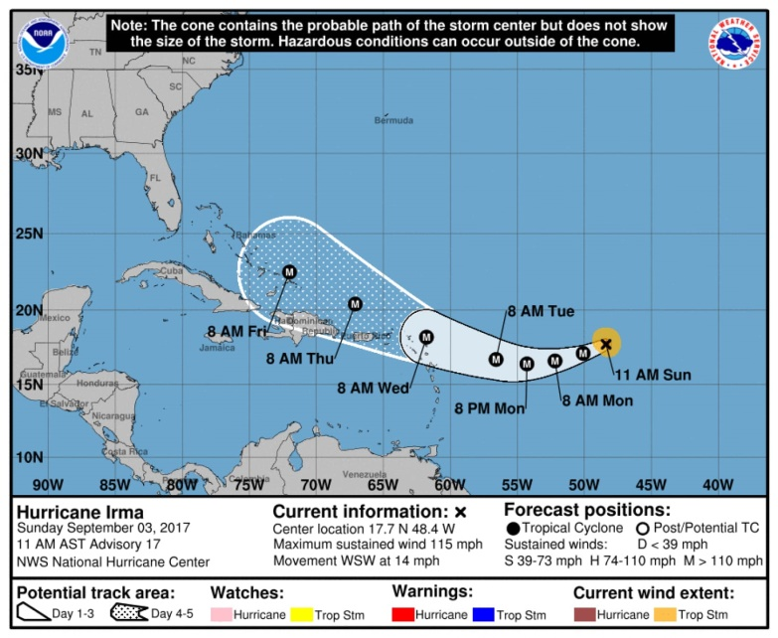
In the longer range, beyond five days, we turn again to the model ensembles. Rather than relying on a single model or a single model run, we look at ensembles which generate dozens of model runs, each using slightly different initial conditions as input. The more similar the model tracks are to one another, the higher the forecast confidence. The larger the spread among the model tracks, the lower the forecast confidence. Watching the trends in these ensembles also helps wash out any erratic run-to-run changes.
Both the European and U.S. ensemble models below show similar forecasts with relatively high-probability tracks through about 168 hours (Saturday). Both then show a wide spread of track scenarios beyond that time, with landfall from Florida to New England possible, or staying out to sea. Note the European (ECMWF) ensembles show a little more potential for curving back out to sea than the U.S. (GEFS) ensembles, although even the European still shows a significant risk of U.S. landfall. On average, the European model is more skillful than the U.S. GEFS model for tropical cyclone tracks, and so far in Irma’s brief history, it does indeed have lower track errors.
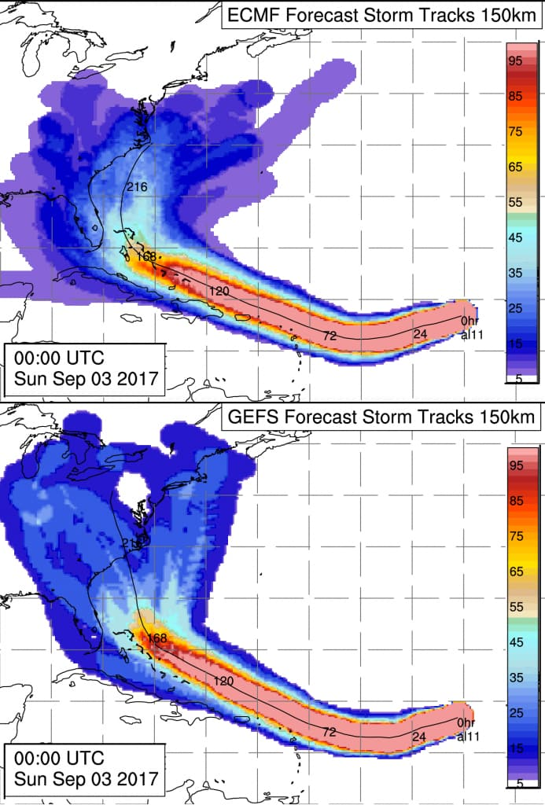
Ensemble-based track probabilities out to 10 days from the ECMWF model (top) and the GFS model (bottom). (A. Brammer/UAlbany)
The trend over the past couple of days has been to keep Irma further south for longer, bringing it closer to the United States, but still turning toward the north near the coast. With this in mind, locations from South Florida up to New England are most definitely still in play and need to be paying close attention. With the shape of the coastline, you can easily see above how a slight difference in timing of that northward turn makes all the difference.
As far as impacts and timing, we can offer some hypothetical scenarios — that is, *IF* the hurricane were headed for Location A, it would make landfall on Date A. These are not official forecasts, only estimates based on current long-range model guidance. Dangerous tropical storm-force winds would typically arrive about a day earlier.
South Florida: Saturday/Sunday (Sept. 9/10)
South Carolina, North Carolina: Sunday/Monday (Sept. 10/11)
Delmarva, Long Island, Cape Cod: Monday/Tuesday (Sept. 11/12)
Looking through the records going back to 1851, 11 previous tropical cyclones passed within 200 miles of Irma’s current position as well as its three-day and five-day forecast positions (based on Sunday’s 5 a.m. Eastern Daylight Time advisory). Some infamous ones in that short list are the Great Miami Hurricane of 1926, Hurricane Gloria in 1985 and Hurricane Floyd in 1999. Note that six of the 11 recurved before reaching the U.S. East Coast.

Wells Fargo Fake Account Update
Wells Fargo & Co. raised its estimate for how many bogus accounts employees may have created, a sign the bank is still struggling to move past a scandal that sparked record fines and congressional investigations.
An outside review into more than 165 million deposit and credit-card accounts found an additional 1.4 million that were potentially unauthorized, bringing the total to about 3.5 million, according to a statement Thursday from the San Francisco-based firm. The revised estimate covers January 2009 to September 2016, almost twice as long as the period examined in the initial review.
The disclosure of even more fraudulent accounts threatens to catapult Wells Fargo back into the political crosshairs just as Congress returns Sept. 5 from its summer recess. The scandal came to light almost a year ago after regulators slapped Wells Fargo with fines of $185 million over its sales practices, prompting congressional hearings and resulting in the bank naming new leaders, clawing back executives’ pay and beginning an overhaul of its retail division.
“New data should cause some lawmakers to re-engage on the issue,” Isaac Boltansky, an analyst with Compass Point Research & Trading, said before the new tally was announced. Democrats will again argue it proves Washington needs to keep rules tight on financial firms, while Republicans will continue to fault Consumer Financial Protection Bureau officials for not spotting the misconduct themselves, Boltansky said.

Expanded Review
Wells Fargo expanded its review after Washington lawmakers lambasted the company following former Chief Executive Officer John Stumpf’s testimony last September about the bank’s sales practices. Under pressure, the bank agreed to review records dating back to 2009, rather than through 2011 as it initially did.
The company said it has paid or identified $10.7 million in customer compensation related to the investigation. The figure includes $7 million of refunds, up from $3.3 million the bank had previously disclosed. It also includes $3.7 million related to what it described as the “complaints process/mediation.”
“There’s never just one cockroach in the kitchen,” Berkshire Hathaway Inc. CEO Warren Buffett, whose firm is the largest shareholder in Wells Fargo, said Wednesday in an interview on CNBC. “Anytime you put the focus on an organization that has hundreds of thousands of people working for it, you may very well find it wasn’t just the one that misbehaved.”

Online Service
The expanded review also uncovered about 528,000 potentially unauthorized online bill-pay enrollments, highlighting users with only one “minimal” payment and no further use of the service. “The analysis did not definitively identify whether an enrollment was authorized by a customer or not, and properly authorized enrollments are likely part of this total,” Wells Fargo said in the statement, adding that affected customers will be refunded $910,000 for related fees and charges.
“Today’s announcement is a reminder of the disappointment that we caused to our customers and stakeholders,” CEO Tim Sloan said on a conference call Thursday with reporters. “We apologize to everyone who was harmed by unacceptable sales practices that occurred in our retail bank.”
The company has no other reviews under way and isn’t planning additional ones, allowing it to focus on making refunds to customers, according to Oscar Suris, a spokesman. Sloan said no additional Wells Fargo workers will be fired in the wake of the new findings.
Shares of the company, which have dropped 7.2 percent this year, declined 0.4 percent to $51.17 at 9:58 a.m. in New York trading.
Read more: Wells Fargo’s new board chair
Democrats led by Representative Maxine Waters of California earlier this month called for a House Financial Services Committee hearing about a separate scandal at Wells Fargo involving unwanted car insurance imposed on auto-loan customers. And Senator Elizabeth Warren of Massachusetts wrote to the Federal Reserve to again press for the removal of board members who served during the original accounts review period of 2011 to 2015.
Wells Fargo has worked to minimize the impact of the new tally, describing the additional accounts as those it couldn’t rule out from lacking customer authorization. Sloan said the company erred on the side of its customers during the review, so the figures might include some accounts that were properly authorized.
When it fined Wells Fargo last year, the CFPB ordered the bank to identify all customers affected by its sales misconduct and set aside $5 million for those harmed.
The new review doesn’t go back as far as 2002, the year that executives first knew about the sales misconduct and fired employees over it, according to investigators hired by the company’s board. Lawyers representing customers who said they were harmed by the bank’s abusive sales practices claimed in a lawsuit, known as Jabbari v Wells Fargo, that bank employees probably created 3.5 million bogus accounts starting in May 2002. Wells Fargo is awaiting final approval to settle that case for $142 million.
“We’re very comfortable that the amount of the Jabbari settlement is more than sufficient to address the needs of our current and former customers,” Sloan said on the call
Trump was Right Again: ANTIFA Call
President Trump was crucified by the mainstream media a few weeks back after hosting an improvised press conference and saying there was "blame on both sides" for the violence in Charlottesville that resulted in the death of a counterprotester. The comments resulted in most of Trump's advisory councils being disbanded, as CEO's around the country pounced on the opportunity to distance themselves from the administration, and heightened calls from CNN for impeachment proceedings.
The problem is that while Trump's delivery probably could have been a bit more artful, the underlying message seems to be proving more accurate with each passing day and each new outbreak of Antifa violence.
As Politico points out today, previously unreported FBI and Department of Homeland Security studies found that "anarchist extremist" group like Antifa have been the "primary instigators of violence at public rallies" going back to at least April 2016 when the reports were first published
Federal authorities have been warning state and local officials since early 2016 that leftist extremists known as “antifa” had become increasingly confrontational and dangerous, so much so that the Department of Homeland Security formally classified their activities as “domestic terrorist violence,” according to interviews and confidential law enforcement documents obtained by POLITICO.

Since well before the Aug. 12 rally in Charlottesville, Virginia, turned deadly, DHS has been issuing warnings about the growing likelihood of lethal violence between the left-wing anarchists and right-wing white supremacist and nationalist groups.

Previously unreported documents disclose that by April 2016, authorities believed that “anarchist extremists” were the primary instigators of violence at public rallies against a range of targets. They were blamed by authorities for attacks on the police, government and political institutions, along with symbols of “the capitalist system,” racism, social injustice and fascism, according to a confidential 2016 joint intelligence assessment by DHS and the FBI.
Not surprisingly, law enforcement officials noted that the rise in Antifa violence overlapped perfectly with Trump's campaign as they made appearances at rally after rally to incite chaos...all the while making it seem as if violent, racist Trump supporters were to blame. In fact, the fake stream news made a concerted and coordinated effort to associate the appearance of the violence simply because Trump supporters were there. As Trump supporters began defending themselves, it made it extremely easy to leave out the footage showing who threw the firs punch.
“It was in that period [as the Trump campaign emerged] that we really became aware of them,” said one senior law enforcement official tracking domestic extremists in a state that has become a front line in clashes between the groups. “These antifa guys were showing up with weapons, shields and bike helmets and just beating the shit out of people. … They’re using Molotov cocktails, they’re starting fires, they’re throwing bombs and smashing windows.”

Almost immediately, the right-wing targets of the antifa attacks began fighting back, bringing more and larger weapons and launching unprovoked attacks of their own, the documents and interviews show. And the extremists on both sides have been using the confrontations, especially since Charlottesville, to recruit unprecedented numbers of new members, raise money and threaten more confrontations, they say.

“Everybody is wondering, 'What are we gonna do? How are we gonna deal with this?'” said the senior state law enforcement official. “Every time they have one of these protests where both sides are bringing guns, there are sphincters tightening in my world. Emotions get high, and fingers get twitchy on the trigger.”
As you'll likely recall, one such event came in June 2016 when Antifa showed up at a rally in Sacramento and began violently attacking protestors with canes and knives. Some of the DHS and FBI intelligence reports began flagging the antifa protesters before the election. In one from last September, portions of which were read to POLITICO, DHS studied “recent violent clashes … at lawfully organized white supremacist” events including a June 2016 rally at the California Capitol in Sacramento organized by the Traditionalist Workers Party and its affiliate, the Golden State Skinheads.

According to police, counter-protesters linked to antifa and affiliated groups like By Any Means Necessary attacked, causing a riot after which at least 10 people were hospitalized, some with stab wounds.

At the Sacramento rally, antifa protesters came looking for violence, and “engaged in several activities indicating proficiency in pre-operational planning, to include organizing carpools to travel from different locations, raising bail money in preparation for arrests, counter-surveilling law enforcement using three-man scout teams, using handheld radios for communication, and coordinating the event via social media,” the DHS report said.
Of course, it's not just California. As the FBI and DHS note, the Antifa group operates much like terrorist cells with disconnected groups all over the country.
Even before Charlottesville, dozens and, in some cases, hundreds of people on both sides showed up at events in Texas, California, Oregon and elsewhere, carrying weapons and looking for a fight. In the Texas capital of Austin, armed antifa protesters attacked Trump supporters and white groups at several recent rallies, and then swarmed police in a successful effort to stop them from making arrests.

California has become another battleground, with violent confrontations in Berkeley, Sacramento and Orange County leading to numerous injuries. And antifa counter-protesters initiated attacks in two previous clashes in Charlottesville, according to the law enforcement reports and interviews. More recently, the antifa groups, which some describe as the Anti-Fascist Action Network, have evolved out of the leftist anti-government groups like “Black bloc,” protesters clad in black and wearing masks that caused violence at events like the 1999 Seattle World Trade Organization protests. They claim to have no leader and no hierarchy, but authorities following them believe they are organized via decentralized networks of cells that coordinate with each other. Often, they spend weeks planning for violence at upcoming events, according to the April 2016 DHS and FBI report entitled “Baseline Comparison of US and Foreign Anarchist Extremist Movements.”

Dozens of armed anti-fascist groups have emerged, including Redneck Revolt and the Red Guards, according to the reports and interviews. One report from New Jersey authorities said self-described antifa groups have been established in cities including New York, Philadelphia, Chicago and San Francisco.
Meanwhile, even by the spring of 2016, the FBI had already grown concerned enough about Antifa that they began investigating overseas trips by activists out of concerns that they were coordinating with European anarchists to stage large bombings in the U.S.
By the spring of 2016, the anarchist groups had become so aggressive, including making armed attacks on individuals and small groups of perceived enemies, that federal officials launched a global investigation with the help of the U.S. intelligence community, according to the DHS and FBI assessment.

The purpose of the investigation, according to the April 2016 assessment: To determine whether the U.S.-based anarchists might start committing terrorist bombings like their counterparts in “foreign anarchist extremist movements” in Greece, Italy and Mexico, possibly at the Republican and Democratic conventions that summer.

Some of the antifa activists have gone overseas to train and fight with fellow anarchist organizations, including two Turkey-based groups fighting the Islamic State, according to interviews and internet postings.
Alas, we suspect you'll hear precisely nothing about any of this on CNN.
The FBI Was Compromised
A new letter from Senators Chuck Grassley and Lindsey Graham reveal testimony from new witnesses suggesting that former FBI Director James Comey had already started drafting documentation exonerating Hillary Clinton long before interviewing key witnesses, including Hillary herself.
According to the letter, which is based on testimony from James Rybicki, Comey’s Chief of Staff, and Trisha Anderson, the Principal Deputy General Counsel of National Security and Cyberlaw, Comey began drafting a statement to announce the conclusion of the Hillary investigation in April or May 2016, well before he had interviewed up to 17 key witnesses.
Meanwhile, as if that weren't bad enough, the Comey statement was also drafted before immunity deals were struck with Cheryl Mills and Heather Samuelson who seemingly ran point, along with Platte River Networks, to destroy Hillary's emails after a Congressional subpoena had been issued mandating their preservation.
Transcripts reviewed by the Senate Judiciary Committee reveal that former FBI Director James Comey began drafting an exoneration statement in the Clinton email investigation before the FBI had interviewed key witnesses. Chairman Chuck Grassley and Senator Lindsey Graham, chairman of the Judiciary Subcommittee on Crime and Terrorism, requested all records relating to the drafting of the statement as the committee continues to review the circumstances surrounding Comey’s removal from the Bureau.

“Conclusion first, fact-gathering second—that’s no way to run an investigation. The FBI should be held to a higher standard than that, especially in a matter of such great public interest and controversy,” the senators wrote in a letter today to the FBI.

Last fall, following allegations from Democrats in Congress, the Office of Special Counsel (OSC) began investigating whether Comey’s actions in the Clinton email investigation violated the Hatch Act, which prohibits government employees from using their official position to influence an election. In the course of that investigation, OSC interviewed two FBI officials close to Comey: James Rybicki, Comey’s Chief of Staff, and Trisha Anderson, the Principal Deputy General Counsel of National Security and Cyberlaw. OSC provided transcripts of those interviews at Grassley’s request after it closed the investigation due to Comey’s termination.

Both transcripts are heavily redacted without explanation. However, they indicate that Comey began drafting a statement to announce the conclusion of the Clinton email investigation in April or May of 2016, before the FBI interviewed up to 17 key witnesses including former Secretary Clinton and several of her closest aides. The draft statement also came before the Department entered into immunity agreements with Cheryl Mills and Heather Samuelson where the Department agreed to a very limited review of Secretary Clinton’s emails and to destroy their laptops after review.
Q: So moving along to the first public statement on the case or Director Comey’s first statement the July 5, 2016 statement. When did you first learn that Director Comey was planning to make some kind of public statement about the outcome of the Clinton email investigation?

A: The idea, I’m not entirely sure exactly when the idea of the public statement um first emerged. Um it was, I just, I can’t put a precise timeframe on it um but [redaction]. And then I believe it was in early May of 2016 that the Director himself wrote a draft of that statement …

Q: So when you found out in early May that there was, that the Director had written a draft of what the statement might look like, how did you learn about that?

A: [Redacted] gave me a hard copy of it…

Q: So what happened next with respect to the draft?

A: I don’t know for sure um, I don’t know. There were many iterations, at some point there were many iterations of the draft that circulated…
Meanwhile, as a reminder of the timing, if Comey was already drafting a statement clearing Clinton of any wrongdoing in April then it came before any of the following interviews....keep in mind that many people on this list were also granted immunity deals...apparently after Comey had already made up his mind that nothing happened
Mr. Comey’s final statement acknowledged “there is evidence of potential violations of the statutes regarding the handling of classified information” but nonetheless cleared Secretary Clinton because he claimed there was no intent or obstruction of justice. Yet, evidence of destruction of emails known to be under subpoena by the House of Representatives, and subject to congressional preservation requests, was obtained in interviews around the time that Mr. Comey began drafting his exoneration statement.[8] Moreover, the Justice Department entered into highly unusual immunity agreements with Cheryl Mills and Heather Samuelson in June 2016—after Mr. Comey began drafting his exoneration statement—to review Clinton email archives on their laptops.[9]

The immunity agreements limited the FBI’s ability to review Clinton email archives from Platte River Networks that were created after June 1, 2014, and before February 1, 2015, and which had been sent or received from Secretary Clinton’s four email addresses during her tenure as Secretary of State.[10] These limitations prevented the FBI from reviewing records surrounding a March 2015 conference call that Paul Combetta, an employee of Platte River Networks, had with David Kendall and Ms. Mills, the attorneys for Secretary Clinton.[11] After having been initially untruthful and then receiving his own immunity agreement, Mr. Combetta admitted in his third FBI interview, in May 2016, that after a March 2015 conference call with Secretary Clinton’s attorneys, he used BleachBit to destroy any remaining copies of Clinton’s emails.[12]

The limitations in the immunity agreements with Ms. Mills and Ms. Samuelson also kept the FBI from looking at emails after Secretary Clinton left office—the period in which communications regarding destruction or concealment of federal records would have most likely taken place.[13] And finally, the agreements provided that the Department would destroy any records which it retrieved that were not turned over to the investigative team and would destroy the laptops.[14] Despite public claims by the FBI that the laptops were not in fact destroyed, the purpose of that promise to destroy them has not been explained.[15] However, Judiciary Committee staff reviewed the immunity agreements as part of their oversight work, so there is no question that the terms of the agreement called for the Department to destroy evidence that had not been fully and completely reviewed.[16]
The Incredible Comey Chameleon
In her Saturday opening statement on “Justice,” host Jeanine Pirro called on Attorney General Jeff Sessions to open a federal criminal investigation into the actions of Hillary Clinton and former FBI Director Jim Comey because Comey began drafting a letter exonerating Clinton from any wrongdoing before the FBI investigation was complete.
“Jeff Sessions needs to follow his prosecutorial instincts and open a federal criminal investigation into the actions of Hillary Rodham Clinton and impanel a grand jury immediately,” Pirro argued.
She continued, “This woman should not get a free pass because she lost an election. Her reign was one of bold, brazen in your face pay-to-play corruption. And I’m not even talking about the hypocrisy of this so-called women’s rights activists which starts and ends with the women who accused her husband of wrongdoing and contributions to her foundation from countries that literally hate and kill women.
Pirro then said it is “time to go after” Comey.
“[J]im Comey — he needs to be the target of an active criminal investigation for obstruction of justice, conspiracy and perjury,” she demanded. “His prejudging an investigation before 17 witnesses and the target of that criminal investigation were even interviewed is the essence of public corruption. He lied to the senate judiciary committee when he said he only made the decision to not charge, which by the way was not his decision to make in the first place after the investigation was completed.”
The Headless Carman
Many contend that self-driving trucks and cars will not happen anytime soon for numerous reasons (most of them easily refuted).
One of the reasons is of lack of approval from Congress.
That argument will go on the ash heap of history by the end of the year because a bipartisan House Panel Approves Legislation Speeding Up Deployment of Self-Driving Cars.
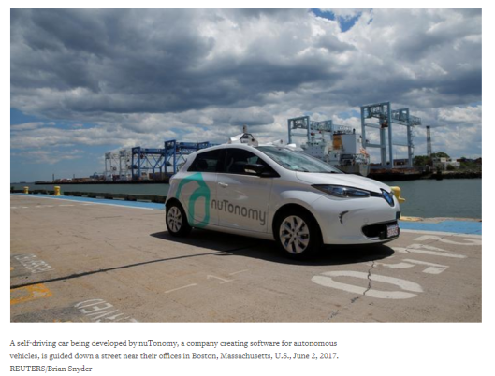
An influential U.S. House committee on Thursday approved a revised bipartisan bill on a 54-0 vote that would speed the deployment of self-driving cars without human controls and bar states from blocking autonomous vehicles.

The bill would allow automakers to obtain exemptions to deploy up to 25,000 vehicles without meeting existing auto safety standards in the first year, a cap that would rise to 100,000 vehicles annually over three years.

Automakers and technology companies believe chances are good Congress will approve legislation before year end. They have been pushing for regulations making it easier to deploy self-driving technology, while consumer groups have sought more safeguards. Current federal rules bar self-driving cars without human controls on U.S. roads and automakers think proposed state rules in California are too restrictive.

The House of Representatives will take up the bill when it reconvenes in September, while senators plan to introduce a separate similar measure.

“Our aim was to develop a regulatory structure that allows for industry to safely innovate with significant government oversight,” said Representative Greg Walden, who chairs the House Energy and Commerce Committee.

Initially, authors proposed to allow automakers and others to sell up to 100,000 vehicles immediately. Representative Frank Pallone said the phase-in period was essential so “millions of exempted cars will not hit our roads all at once.”

Under the House proposal, states could still set rules on registration, licensing, liability, insurance and safety inspections, but could not set self-driving car performance standards.

Automakers praised committee passage, while Consumer Watchdog privacy director John Simpson said preempting state laws “leaves us at the mercy of manufacturers as they use our public highways as their private laboratories.”

The issue has taken on new urgency since U.S. road deaths rose 7.7 percent in 2015, the highest annual jump since 1966.

Automakers say that without changes in regulations, U.S. self-driving car testing could move to Europe and elsewhere.
25,000 Driverless Cars Coming Right Up
This is playing out exactly as I expected. In 2018, there will be 25,000 cars and trucks on the and highways and in cities, driving themselves. I suspect most initial testing will be on highways. If that goes well, there will be 100,000 self-driving cars on the roads by 2019-2020.
Then, once things go well, and I expect them to go well, most of the trucks on the highways will be driverless.
From driver to driverless interstate trucking will take less than a year once final approval is given, no later than 2022, and possibly as soon as 2020.
History Is full of Secret Societies

Black magic is the force that rules the world, so it is the Satanic black magicians which constitute the true controllers of the world – at least in the human earthly realm. The Satanic black magicians pull the strings, not politicians, corporate bosses, military heads, intelligence chiefs or even international bankers – although they also hold many of those roles. The NWO (New World Order) elite fulfill a hidden role and an outer, more respectable public role.

While many Satanic black magicians are also businessmen and bankers, their true ruling power comes from Satanism and the twisted use of humanity’s creative power (black magic), which they then use in their secular roles in society. Symbols Rule the World.
Remember the saying of the Chinese sage Lao-Tzu, who said that “symbols rule the world, not rules or laws”? Symbols communicate at a deeper level than words, because they are decoded by the right, intuitive brain, whereas words are decoded by the left, logical brain. Symbols are able to penetrate more deeply into our subconscious, which is why the elite are so obsessed with their occult corporate and governmental logos of red crosses, rising suns, all-seeing eyes, pyramids, 666, the rings of Saturn and inverted pentagrams (check out the work of Freeman who has done a great job exposing this). Words attempt to rule the world, but they can never be as powerful as symbols.
Ever see Barack Obama’s signature? Ever compare it with the “O” in Monster Energy Drink? Compare the “O’s” with the symbol Phi. Φ is the golden mean. 1.618: 1

What do these occult Illuminati symbols really mean? Find out here. Deciphered from Freemasonry and Kabbalah, Freeman puts all the puzzle pieces together.
Likewise, black magic rules the world. Governments and corporations attempt to rule the world, but they can never be as powerful as black magic.
Before looking at the evidence of elite use of black magic, it is worthwhile remembering a defining aspect of Satanism: the inversion of everything. Black is white, bad is good, wrong is right. This is why the inverted pentagram is such a popular Satanic symbol. George Orwell touched on this in 1984 when he wrote of the ruling class’ propaganda: “War is peace. Freedom is slavery. Ignorance is strength.” Even mind control, developed by the Nazis first in Germany and later at the CIA, uses Satanic principles to confuse its victims, by telling them that pain is pleasure and pleasure is pain, and eventually breaking down victims so they can no longer distinguish between the two.

Bohemian Grove, Skull ‘n’ Bones and Other Secret Societies
Elite figures talking at Bohemian Grove, before the black magic rituals. Note Nixon on the right, and Reagan on the left – at a time when he was not yet president.
There are some secret societies which are mostly political and economic in nature, such as groups like the Trilateral Commission or the CFR (Council on Foreign Relations), who go around convincing the world about the great benefits of globalization (the elite buzzword for centralization of power), global governance and free trade agreements like the TPP. There are others, however, whose purpose is shrouded in more mystery, but seem to involve black magic and Satanic ritual, such as the worshipping of dark gods/entities, the acting out of sexual orgies/fetishes and sacrifice, whether mock or real.
The Bohemian Club, located in San Francisco, is one such group. Every summer in the USA, many key figures of the US elite gather in the tall redwoods of northern California at Bohemian Grove. People such as Henry Kissinger, Richard Nixon, Ronald Reagan, George Bush and other US presidents have attended. Alex Jones successfully infiltrated the Grove once, and was able to videotape one of the rituals that took place there, known as Cremation of Care, which involved hooded figures performing a mock sacrifice black magic ritual beneath a 40 foot owl.
On the other coast of America, at Yale University in Connecticut, lies an old secret society founded in 1832 by William Huntington Russell and Alphonso Taft, known as the Skull ‘n’ Bones society, and its members as “bonesmen”. The late professor Anthony Sutton did some great research on Skull ‘n’ Bones. Members have admitted having to undergo strange initiation rituals such as making sexual confessions in a tomb, while outsiders have heard chilling howls and screams emanating from the windowless Skull ‘n’ Bones crypt.
If you think these secret societies are just perverted people messing around, ask yourself: why would the elite, many of whom are obsessed with power, be involved with them? Why would they engage in such black magic rituals unless they were getting something in return – like more power? These guys control the printing presses of the world, and some have more money than they could possibly spend. It’s power they want, not money. Money is just a means to an end. Is it just a coincidence that in the 2004 US presidential election, where George Bush Jr. and John Kerry were running against each other, that both were bonesmen, with a membership total of around 300 in a country of 300+ million people? Did MSM news anchor Tim Russert get bumped off for asking too many questions to Bush and Kerry about the secret society?

Kubrick, Eyes Wide Shut and Secret Elite Rituals of Sex and Sacrifice
The ordinary person will never be initiated into a Satanic secret society, nor get close enough to witness what really goes on in there. It is therefore interesting when someone who does get close to that world decides to spill the beans and show the world what’s going on. Such a person was Stanley Kubrick, the late great film-maker who many suspect (with strong evidence) was part of the US Government’s fake Apollo moon landing in 1969. Kubrick may have cut a deal with the devil in making a fake moon landing for the elite, because when he handed over the tape for his last film Eyes Wide Shut, he was found dead 4 days later of a heart attack, despite the fact those close to him said he was in fine health and had no history of heart trouble.
Kubrick depicts a black magic scene where women circle a leader, then drop their clothes to become naked, and are later involved in a massive orgy, where all the participants wear masks to hide their true identities. Kubrick hints in the film that this Satanic-sexual black magic ritual also involves sacrifice and murder, by implying that one of the women/prostitutes was killed during or at the end of the ritual.

At the Heart of Black Magic: Demonic Possession
Black magic at its core is really about demonic possession. Since the world is made of energy, not matter, and since energy moves in waves which have frequencies, the Satanic rituals are designed to entrain the energetic bio-frequencies of the participants with that of other dark entities, so that there is a vibrational match. Once there is a frequency resonance or lock, an exchange can then take place: energy, intent or information can go from one being, place or dimension can be transferred into another. This works both ways: the person gets possessed and receives information from certain dark entities, while the dark entities also take something from the person. This theme of possession crops up again and again when exposing the worldwide conspiracy, and has been going on a long time, e.g. Hitler was reported to be demonically possessed by his aide Hermann Rauschning.

The Horrific Phenomenon of Missing Children
It is also black magic that is behind the unspeakable and unconscionable phenomenon of missing children. These children are being deliberately kidnapped and taken down into elite controlled underground facilities where they are mind controlled, turned into slaves and where some of them are even sacrificed at Satanic rituals. If that is too difficult to believe, listen to the testimonies of various mind control victims, researchers, Illuminati defectors, such as Cathy O’Brien, “Mary Anne“, “Svali“, Alex Collier and many others.

Conclusion: Focus on the Deepest Aspects of the Conspiracy
Although it’s important to focus on and expose all aspects of dysfunction in our society – including political corruption, mainstream media consolidation and deception, smart meters, GMOs, toxic vaccines, geoengineering, the militarization of police, fake terrorism, false flag ops, UN Agenda 21, transhumanism and the human microchipping agenda – in order to transform and heal them, it’s crucial to realize that, at a fundamental level, they are all connected. All these issues and more are manifestations of a more primordial evil or unconsciousness in our midst – Satanic black magic. The secretive rituals conducted at Bohemian Grove and elite mansions tell us more about who rules the world than political think tanks or banking cartels, although of course there is an overlap.
If humanity is to rise up and overcome the conspiracy, we must focus our attention on the root of evil (not the branches), and use “white magic” in greater force – the harnessing and funneling of our creative powers to make a world of peace, freedom and love. We must continue to expose the deepest aspects of the conspiracy. At the same time, we have to ensure we are not letting the elite siphon off our precious thoughts, emotions and powers to create their nightmarish world, but rather, using those energies within us to create the world we want with positive intention, focus and conscious manifestation.
Obama Wiretaps: The Fake News
There was no evidence the administration of former President Barack Obama wiretapped Trump Tower during the 2016 presidential election, according to court documents filed late Friday by the Justice Department.
The filing said neither the Justice Department nor the FBI were able to find evidence to support President Donald Trump's claims earlier this year that Obama had done so, The Hill reported Saturday.
The court filings were in response to a Freedom of Information Act lawsuit brought by American Oversight, a government watchdog group which bills itself as nonpartisan, but which the National Review has called "little more than a partisan Democratic group dedicated to destroying its political opponents."
In March, Trump posted a series of tweets in which he claimed Obama wiretapped Trump Tower, but offered no evidence to back up the statements. A spokesman for Obama refuted the accusation, as did former FBI Director James Comey.
Austin Evers, America Oversight executive director, said in a statement the information now showed "President Trump lied when he tweeted that former President Obama 'wiretapped' him at Trump Tower."
The Russia Hunt is Still on
The United States seized control Saturday of three Russian diplomatic posts in the U.S. after confirming the Russians had complied with the Trump administration's order to get out within two days, officials said.
As the Kremlin cried foul, accusing Washington of bullying tactics, the U.S. disputed Moscow's claims that American officials had threatened to "break down the entrance door" to one of the facilities, and that the FBI was "clearing the premises." Not true, said a senior State Department official, adding that U.S. officials had joined Russian Embassy personnel for walkthroughs of the three buildings.
"These inspections were carried out to secure and protect the facilities and to confirm the Russian government had vacated the premises," the official said in a statement emailed Saturday to reporters by the State Department on condition the official not be named.
Russia has been incensed by the move to shut Russia's consulate in San Francisco and trade offices in Washington and New York, actions the U.S. took in retaliation for Moscow's decision last month to force the U.S. to cut its diplomatic personnel in Russia to 455. Moscow has accused the U.S. of violating international law by shuttering the facilities, a charge the U.S. disputes.
On Saturday, Russia's Foreign Ministry said it had summoned the U.S. deputy chief of mission in Moscow, Anthony Godfrey, to deliver a formal protest note calling the purported trade office search an "unprecedented aggressive action."
The Foreign Ministry also posted video on Facebook that it said showed FBI agents inspecting the consulate general building in San Francisco. In the video, a man in a tie knocks on several numbered doors and enters what appears to be apartment units, taking a quick glance inside before declaring everything in order.
There was no additional comment from the U.S. about whether the FBI was involved in the inspections. The State Department declined to answer additional questions about whether the premises might be searched for intelligence-gathering purposes now that the Russians have left.
A day earlier, black smoke was seen billowing from the chimney at the consulate as the Russians rushed to meet the Saturday deadline, and workers could be seen hauling boxes out of the stately building.
The U.S. did appear to bow to one Russian complaint — that they were given a mere 48 hours to vacate homes used by diplomats and their families. Softening the original order, the U.S. said it had made "separate arrangements" to give families "sufficient time" to pack their belongings and vacate apartments on the consulate grounds.
The U.S. wouldn't disclose how long the Russians would have to move out of the residential part of the consulate, other than to say that Moscow had been informed of the new deadline. In the meantime, the State Department will control all access to the properties, along with the responsibility for securing and maintaining them, the official said.
The closures on both U.S. coasts mark perhaps the most drastic diplomatic measure by the United States against Russia since 1986, near the end of the Cold War, when the nuclear-armed powers expelled dozens of each other's diplomats.
And it comes amid some of the broadest strains in their relationship ever since. The two countries have clashed over the wars in Ukraine and Syria, but most significantly over American allegations that Russia meddled in the 2016 U.S. election to boost President Donald Trump's chances of victory. Investigations continue into whether Trump's campaign colluded with Moscow.

