Jihad Report
Oct 27, 2018 -
Nov 02, 2018
Attacks | 25
Killed | 72
Injured | 112
Suicide Blasts | 4
Countries | 12

How Fast Is Earth Moving?

A new time-lapse videos combines 3,000 images from the DSCOVR satellite's EPIC camera to show a year of Earth's rotation, as seen from a million miles away.
Credit: NASA Goddard via YouTube
As an Earthling, it's easy to believe that we're standing still. After all, we don't feel any movement in our surroundings. But when you look at the sky, you can see evidence that we are moving.
Some of the earliest astronomers proposed that we live in a geocentric universe, which means that Earth is at the center of everything. They said the sun rotated around us, which caused sunrises and sunsets — same for the movements of the moon and the planets. But there were certain things that didn't work with this vision. Sometimes, a planet would back up in the sky before resuming its forward motion.
We know now that this motion — which is called retrograde motion — happens when Earth is "catching up" with another planet in its orbit. For example, Mars orbits farther from the sun than Earth. At one point in the respective orbits of Earth and Mars, we catch up to the Red Planet and pass it by. As we pass by it, the planet moves backward in the sky. Then it moves forward again after we have passed.
Another piece of evidence for the sun-centered solar system comes from looking at parallax, or apparent change in the position of the stars with respect to each other. For a simple example of parallax, hold up your index finger in front of your face at arm's length. Look at it with your left eye only, closing your right eye. Then close your right eye, and look at the finger with your left. The finger's apparent position changes. That's because your left and right eyes are looking at the finger with slightly different angles.
The same thing happens on Earth when we look at stars. It takes about 365 days for us to orbit the sun. If we look at a star (located relatively close to us) in the summer, and look at it again in the winter, its apparent position in the sky changes because we are at different points in our orbit. We see the star from different vantage points. With a bit of simple calculation, using parallax we can also figure out the distance to that star.

How fast are we spinning?
Earth's spin is constant, but the speed depends on what latitude you are located at. Here's an example. The circumference (distance around the largest part of the Earth) is roughly 24,898 miles (40,070 kilometers), according to NASA. (This area is also called the equator.) If you estimate that a day is 24 hours long, you divide the circumference by the length of the day. This produces a speed at the equator of about 1,037 mph (1,670 km/h).
You won't be moving quite as fast at other latitudes, however. If we move halfway up the globe to 45 degrees in latitude (either north or south), you calculate the speed by using the cosine (a trigonometric function) of the latitude. A good scientific calculator should have a cosine function available if you don't know how to calculate it. The cosine of 45 is 0.707, so the spin speed at 45 degrees is roughly 0.707 x 1037 = 733 mph (1,180 km/h). That speed decreases more as you go farther north or south. By the time you get to the North or South poles, your spin is very slow indeed — it takes an entire day to spin in place.
Space agencies love to take advantage of Earth's spin. If they're sending humans to the International Space Station, for example, the preferred location to do so is close to the equator. That's why cargo missions to the International Space Station, for example, launch from Florida. By doing so and launching in the same direction as Earth's spin, rockets get a speed boost to help them fly into space.

How fast does Earth orbit the sun?
Earth's spin, of course, is not the only motion we have in space. Our orbital speed around the sun is about 67,000 mph (107,000 km/h), according to Cornell. We can calculate that with basic geometry.
First, we have to figure out how far Earth travels. Earth takes about 365 days to orbit the sun. The orbit is an ellipse, but to make the math simpler, let's say it's a circle. So, Earth's orbit is the circumference of a circle. The distance from Earth to the sun — called an astronomical unit— is 92,955,807 miles (149,597,870 kilometers), according to the International Astronomers Union. That is the radius (r). The circumference of a circle is equal to 2 x π x r. So in one year, Earth travels about 584 million miles (940 million km).
Since speed is equal to the distance traveled over the time taken, Earth's speed is calculated by dividing 584 million miles (940 million km) by 365.25 days and dividing that result by 24 hours to get miles per hour or km per hour. So, Earth travels about 1.6 million miles (2.6 million km) a day, or 66,627 mph (107,226 km/h).

Sun and galaxy move, too
The sun has an orbit of its own in the Milky Way. The sun is about 25,000 light-years from the center of the galaxy, and the Milky Way is at least 100,000 light-years across. We are thought to be about halfway out from the center, according to Stanford University. The sun and the solar system appear to be moving at 200 kilometers per second, or at an average speed of 448,000 mph (720,000 km/h). Even at this rapid speed, the solar system would take about 230 million years to travel all the way around the Milky Way.
The Milky Way, too, moves in space relative to other galaxies. In about 4 billion years, the Milky Way will collide with its nearest neighbor, the Andromeda Galaxy. The two are rushing toward each other at about 70 miles per second (112 km per second).
Everything in the universe is, therefore, in motion.

What would happen if Earth stopped spinning?
There is no chance that you'll be flung off to space right now, because the Earth's gravity is so strong compared to its spinning motion. (This latter motion is called centripetal acceleration.) At its strongest point, which is at the equator, centripetal acceleration only counteracts Earth's gravity by about 0.3 percent. In other words, you don't even notice it, although you will weigh slightly less at the equator than at the poles.
NASA says the probability for Earth stopping its spin is "practically zero" for the next few billion years. Theoretically, however, if the Earth did stop moving suddenly, there would be an awful effect. The atmosphere would still be moving at the original speed of the Earth's rotation. This means that everything would be swept off of land, including people, buildings and even trees, topsoil and rocks, NASA added.
What if the process was more gradual? This is the more likely scenario over billions of years, NASA said, because the sun and the moon are tugging on Earth's spin. That would give plenty of time for humans, animals and plants to get used to the change. By the laws of physics, the slowest the Earth could slow its spin would be 1 rotation every 365 days. That situation is called "sun synchronous" and would force one side of our planet to always face the sun, and the other side to permanently face away. By comparison: Earth's moon is already in an Earth-synchronous rotation where one side of the moon always faces us, and the other side opposite to us.
But back to the no-spin scenario for a second: There would be some other weird effects if the Earth stopped spinning completely, NASA said. For one, the magnetic field would presumably disappear because it is thought to be generated in part by a spin. We'd lose our colorful auroras, and the Van Allen radiation belts surrounding Earth would probably disappear, too. Then Earth would be naked against the fury of the sun. Every time it sent a coronal mass ejection (charged particles) toward Earth, it would hit the surface and bathe everything in radiation. "This is a significant biohazard," NASA said.
Anti-Gravity is Real?
One of the most astonishing facts about science is how universally applicable the laws of nature are. Every particle obeys the same rules, experiences the same forces, and sees the same fundamental constants, no matter where or when they exist. Gravitationally, every single entity in the Universe experiences, depending on how you look at it, either the same gravitational acceleration or the same curvature of spacetime, no matter what properties it possesses.
At least, that's what things are like in theory. In practice, some things are notoriously difficult to measure. Photons and normal, stable particles both fall as expected in a gravitational field, with Earth causing any massive particle to accelerate towards its center at 9.8 m/s². Despite our best efforts, though, we have never measured the gravitational acceleration of antimatter. It ought to accelerate the exact same way, but until we measure it, we can't know. One experiment is attempting to decide the matter, once-and-for-all. Depending on what it finds, it just might be the key to a scientific and technological revolution.
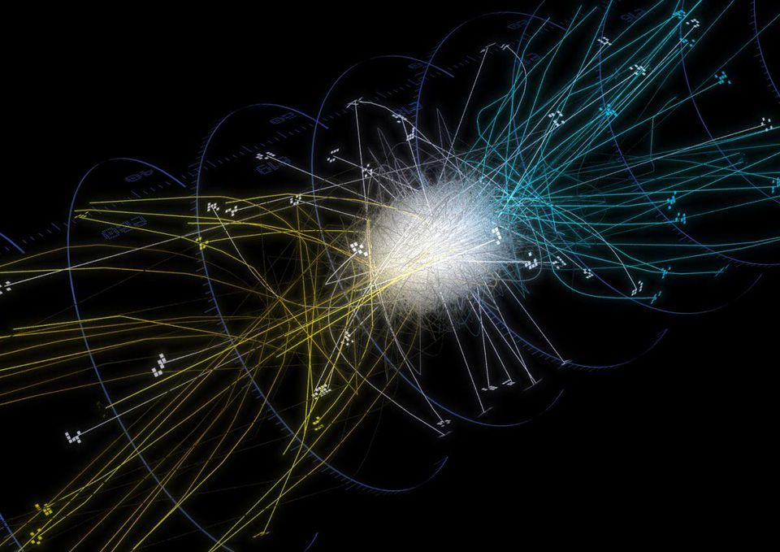
Trajectories of antihydrogen atoms from the ALPHA experiment. We can hold them stable for up to 20 minutes at a time now, and measuring how they behave in a gravitational field is the next logical step.CHUKMAN SO/UNIVERSITY OF CALIFORNIA, BERKELEY
You might not realize it, but there are two entirely different ways of thinking about mass. On the one hand, there's the mass that accelerates when you apply a force to it: the m in Newton's famous equation, F = ma. This is the same as the m in Einstein's E = mc², which tells you how much energy you need to create a particle (or antiparticle) and how much energy you get when you annihilate it away.
But there's another mass out there: gravitational mass. This is the mass, m, that appears in the equation for weight at Earth's surface (W = mg), or in Newton's gravitational law, F = GmM/r². For normal matter, we know that these two masses — inertial mass and gravitational mass — must be equal to something like 1 part in 100 billion, thanks to experimental constraints from a setup designed over 100 years ago by Loránd Eötvös.

YOU MAY ALSO LIKE
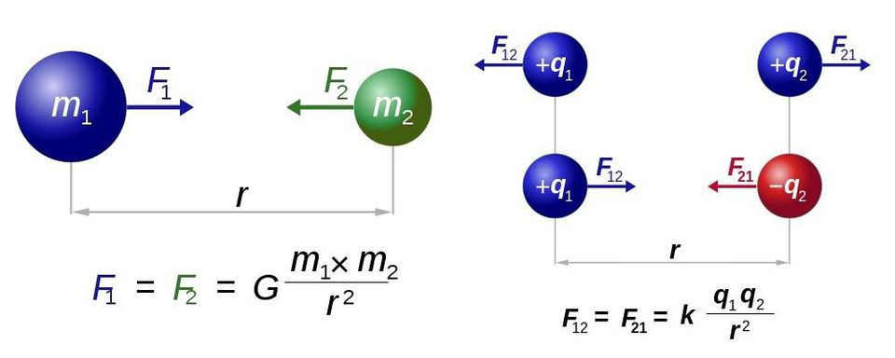
Newton's law of universal gravitation (L) and Coulomb's law for electrostatics (R) have almost identical forms. If the 'm' in the gravitational force obtains a negative sign for antimatter, upcoming experiments ought to reveal it.DENNIS NILSSON / RJB1 / E. SIEGEL
For antimatter, though, we've never been able to measure this at all. We've applied non-gravitational forces to antimatter and seen it accelerate, and we've created and annihilated antimatter as well; we're certain how its inertial mass behaves, and it's exactly the same as normal matter's inertial mass. Both F = ma and E = mc² work just the same for antimatter as they do for normal matter.
But if we want to know how antimatter behaves gravitationally, we can't just go off of what we theoretically expect; we have to measure it. Fortunately, there's an experiment that's running now which was designed to do exactly that: the ALPHA experiment at CERN.
The ALPHA collaboration has come the closest of any experiment to measuring the behavior of neutral antimatter in a gravitational field. With the upcoming ALPHA-g detector, we might finally know the answer.MAXIMILIEN BRICE/CERN
One of the great strides that's been taken recently is the creation of not just particles of antimatter, but neutral, stable bound states of it. Anti-protons and positrons (anti-electrons) can be created, slowed down, and forced to interact with each other, where they form neutral anti-hydrogen. By using a combination of electric and magnetic fields, we can confine these anti-atoms and keep them stable, away from the matter that would cause them to annihilate.
We've successfully held them stable for around 20 minutes at a time, far exceeding the microsecond timescales that unstable, fundamental particles survive. We've struck them with photons, discovering that they have the same emission and absorption spectra as atoms. In every way that matters, we've determined that antimatter's properties are exactly as standard physics predicts them to be.
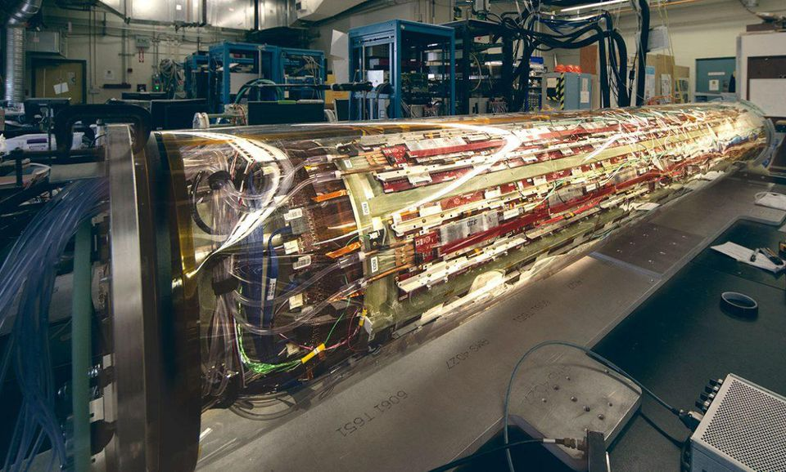
The ALPHA-g detector, built at Canada’s particle accelerator facility, TRIUMF, is the first of its kind designed to measure the effect of gravity on antimatter. When oriented vertically, it should be able to measure which direction antimatter falls, and at what magnitude.STU SHEPHERD/TRIUMF
Except, of course, gravitationally. The new ALPHA-g detector, built at Canada's TRIUMF facility and shipped to CERN earlier this year, should improve the limits on the gravitational acceleration of antimatter down to the critical threshold. Does antimatter accelerate, in the presence of the gravitational field on the surface of Earth, at +9.8 m/s² (down), at -9.8 m/s²(up), at 0 m/s² (no gravitational acceleration at all), or some other value?
From both a theoretical and an applications perspective, any result other than the expected +9.8 m/s² would be absolutely revolutionary.
If there were some type of matter that had negative gravitational charge, it would be repelled by the matter and energy that we are aware of.MUU-KARHU OF WIKIMEDIA COMMONS
The antimatter counterpart of every matter particle should have:
- the same mass,
- the same acceleration in a gravitational field,
- the opposite electric charge,
- the opposite spin,
- the same magnetic properties,
- should bind together the same way into atoms, molecules and larger structures,
- and should have the same spectrum of positron transitions in those varied configurations.
Some of these have been measured for a long time: antimatter's inertial mass, electric charge, spin and magnetic properties are well-known. Its binding and transitional properties have been measured by other detectors at the ALPHA experiment, and line up with what particle physics predicts.
But if the gravitational acceleration comes back negative instead of positive, it would literally turn the world upside down.
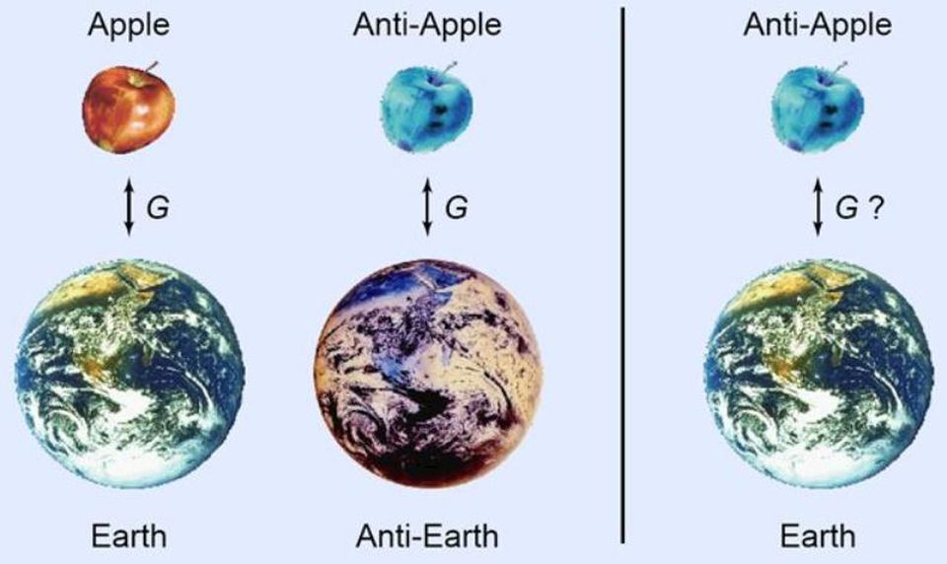
The possibility of having artificial gravity is tantalizing, but it is predicated on the existence of negative gravitational mass. Antimatter may be that mass, but we don't yet know, experimentally.ROLF LANDUA / CERN
Currently, there is no such thing as a gravitational conductor. On an electrical conductor, free charges live on the surface and can move around, redistributing themselves in response to whatever other charges are around. If you have an electric charge outside an electrical conductor, the inside of the conductor will be shielded from that electric source.
But there's no way to shield yourself from the gravitational force. There's no way to set up a uniform gravitational field in a region of space, either, like you can between the parallel plates of an electrical capacitor. The reason? Because unlike the electric force, which is generated by positive and negative charges, there's only one type of gravitational "charge," and that's mass-and-energy. The gravitational force is always attractive, and there's simply no way around that.
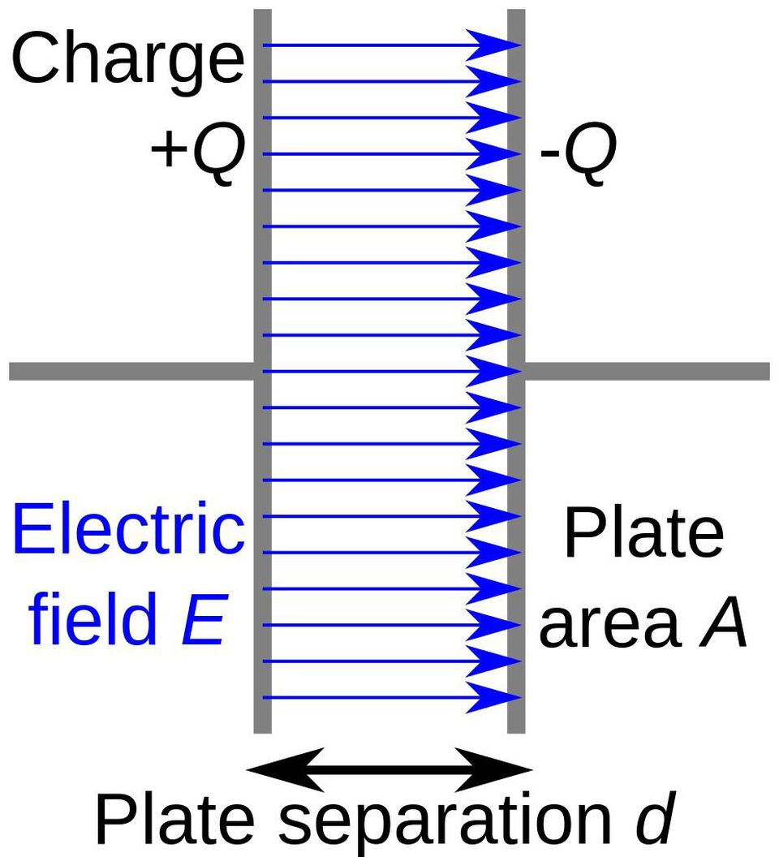
Schematic diagram of a capacitor, where two parallel conducting plates have equal and opposite charges, creating a uniform electric field between them. This configuration is impossible for gravity, unless there's some form of negative gravitational mass.WIKIMEDIA COMMONS USER PAPA NOVEMBER
But if you have negative gravitational mass, all of that changes. If antimatter actually anti-gravitates, falling up instead of down, then gravity sees it as though it were made of anti-mass or anti-energy. Under the laws of physics that we currently understand, quantities like anti-mass or anti-energy don't exist. We can imagine them and talk about how they would behave, but we expect antimatter to have normal mass and normal energy when it comes to gravity.
If anti-mass does exist, though, then a slew of great technological advances, imagined by science-fiction writers for generations, would suddenly become physically possible.
The Virtual IronBird tool for the CAM (Centrifuge Accommodation Module) is one way to create artificial gravity, but requires a lot of energy and only allows a very specific, center-seeking type of force. True artificial gravity would require something to behave with negative mass.NASA AMES
We can build a gravitational conductor, and shield ourselves from the gravitational force.
We can set up a gravitational capacitor in space, creating a uniform artificial gravity field.
We could even create warp drive, since we'd gain the ability to deform spacetime in exactly the way that a mathematical solution to General Relativity, discovered by Miguel Alcubierre in 1994, requires.
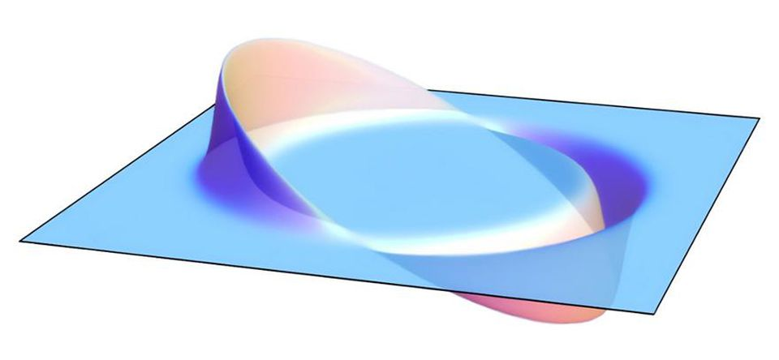
The Alcubierre solution to General Relativity, enabling motion similar to warp drive. This solution requires negative gravitational mass, which could be exactly what antimatter might provide.WIKIMEDIA COMMONS USER ALLENMCC
It's an incredible possibility, one that's considered wildly unlikely by practically all theoretical physicists. But no matter how wild or tame your theories are, you must absolutely confront them with experimental data; only through measuring the Universe and putting it to the test can you ever accurately determine how the laws of nature work.
Until we measure the gravitational acceleration of antimatter to the precision necessary to determine whether it falls up or down, we must keep ourselves open to the possibility that nature might not behave as we expect. The equivalence principle may not be true for antimatter; it may, in fact, be 100% anti-true. But if that's the case, a whole new world of possibilities will be unlocked. We could change the currently-known limits of what humans can create in the Universe. And we'll learn the answer in just a few years through the simplest of all experiments: putting an anti-atom in a gravitational field, and watching which way it falls.
An Alien Solar Sail on its Way?
A mysterious asteroid called Oumuamua, the first interstellar object ever seen in the solar system, could be a gigantic alien solar sail send to look for signs of life, a new study has claimed.
Astronomers from the Harvard Smithsonian Center for Astrophysics (CfA) analyzed the strange cigar shape of the object, and an unexpected boost in speed and shift in trajectory as it passed through the inner solar system last year.
They concluded that the strange asteroid 'might be a lightsail of artificial origin.'
Scroll down for video
+3

Astronomers from the Harvard Smithsonian Center for Astrophysics concluded that the strange asteroid 'might be a lightsail of artificial origin.'

WHAT IS A LIGHTSAIL?
Much like the wind pushing a sailboat through water, solar sails rely on sunlight to propel vehicles through space.
The sail captures constantly streaming solar particles, called photons, with giant sails built from a lightweight material.
Over time, the buildup of these particles provides enough thrust for a spacecraft to travel in space.
The study – 'Could Solar Radiation Pressure Explain 'Oumuamua's Peculiar Acceleration?', which recently appeared online – was conducted by Shmuel Bialy, a postdoctoral researcher at the CfA's Institute for Theory and Computation (ITC) and Professor Abraham Loeb, the director of the ITC, the Frank B. Baird Jr. Professor of Science at Harvard University, and the head chair of the Breakthrough Starshot Advisory Committee.
The researchers say the strange acceleration could the result of solar radiation pushing a giant solar sail.
They found a sail that was only a fraction of a millimeter thick (0.3-0.9 mm) would be sufficient for a sheet of solid material to survive the journey through the entire galaxy.
Lightsails with similar dimensions have been designed and constructed by humans, including the Japanese-designed IKAROS project and the Starshot Initiative with which he is involved.
'Considering an artificial origin, one possibility is that ‘Oumuamua is a lightsail, floating in interstellar space as a debris from an advanced technological equipment,' they wrote.

Two Thirds of Americans Want End to Anchor Baby Invasion

President Donald Trump is considering an executive order restricting birthright citizenship for illegal aliens’ children, which could create a Supreme Court test case that could end that misinterpretation of the Constitution’s Fourteenth Amendment, either through presidential action or through legislation.
The original meaning of the Fourteenth Amendment’s Citizenship Clause promises birthright citizenship to people born on U.S. soil only if they are not citizens of a foreign nation, giving Congress the option of denying citizenship to the children of foreigners. Critics would be wise to hold off criticizing President Trump’s planned executive order focusing on illegal aliens until they see what is in it.
Everyone is suddenly talking about the first clause of the Fourteenth Amendment, which provides, “All persons born or naturalized in the United States, and subject to the jurisdiction thereof, are citizens of the United States and of the State wherein they reside.”
Several pivotal moments in American history shine light on the meaning of those words.
The Supreme Court decided its most infamous case, Dred Scott, in 1857. John Sanford owned Scott as a piece of property. The Court held that black people were not U.S. citizens, and thus federal courts lacked jurisdiction to hear Scott’s lawsuit challenging his status as a slave. Dred Scott marked a turning point on the issue of slavery, and four years afterward America descended into the Civil War.
The movie Lincoln recounts how, as he was leading the Union to victory in the Civil War, President Abraham Lincoln pushed the Thirteenth Amendment through Congress to end slavery. It was a Republican-led effort, in which Lincoln the Republican peeled off just barely enough Democrats to get the requisite two-thirds in Congress to send the proposed amendment to the states for ratification.
Congress proposed the Thirteenth Amendment to the states on January 31, 1865. On December 6, 1865, the necessary three-fourths of states voted to ratify the amendment, adding its words to the Constitution. Section 2 of that amendment authorized Congress to pass new legislation consistent with ending slavery.
Lawmakers invoked that authority just months after ratification, passing the Civil Rights Act of 1866 on April 9 of that year. That statute included a citizenship clause that provided, “All persons born in the United States, and not subject to any foreign power, excluding Indians not taxed, are hereby declared to be citizens of the United States.”
Some members of Congress like Rep. John Bingham (R-OH), who supported rights for newly freed blacks, nonetheless opposed the Civil Rights Act, explaining that they believed such legislation went beyond the authority granted by Section 2 of the Thirteenth Amendment to pass laws enforcing the end of slavery.
They argued instead that a new constitutional amendment was needed, and immediately drafted and pushed for congressional debate of a proposed Fourteenth Amendment. Key provisions from the Civil Rights Act were rewritten as part of the new draft amendment, including the Civil Rights Act’s citizenship clause, but changing the words “and not subject to any foreign power” to “and subject to the jurisdiction [of the United States].”
The purpose of the Citizenship Clause was to supersede Dred Scott, securing citizenship for black Americans. The current debate is over how broadly Congress and the ratifying states acted when they amended the Constitution to undo Dred Scott’s denial of citizenship.
Article I, Section 8, Clause 4 of the Constitution gives Congress plenary authority over immigration and naturalization, subject only to the additional restriction now imposed by the Fourteenth Amendment.
But the Citizenship Clause is only a floor that Congress cannot go below. Congress can be as generous as it wants to concerning citizenship above that floor; lawmakers could pass a law granting citizenship to every person who ever enters this nation, or even to all 7 billion people on the planet.
What exactly is the floor decreed by the Fourteenth Amendment’s Citizenship Clause?
The entire debate over birth citizenship turns on a single question: Did Congress change the meaning of “not subject to any foreign power” in the Civil Rights Act when it substituted “subject to the jurisdiction thereof” in the Fourteenth Amendment, or was Congress merely using alternative words that meant the same thing?
The Congressional Globe – which was the authoritative source for congressional debates in the 1860s – only provides limited material, but enough to conclude that Congress was retaining the original meaning. There is no widespread discussion on the House or Senate floors to suggest that lawmakers thought they were adopting a different standard in the constitutional amendment than they had approved just months ago for the Civil Rights Act.
To the contrary, Sen. Lyman Trumbull (R-IL) – who was instrumental in shaping the language and getting the amendment through the Senate – said during debates that “subject to the jurisdiction” of the United States meant subject to its “complete” jurisdiction. In other words: “Not owing allegiance to anybody else.”
Likewise, Sen. Jacob Howard (R-MI), who introduced the language of the amendment’s jurisdictional language on the floor of the Senate, insisted that the term should be construed to mean “a full and complete jurisdiction,” and “the same jurisdiction in extent and quality as applies to every citizen of the United States now” (meaning now that the Civil Rights Act had been passed), except for Native Americans.
On that note, the Senate rejected a proposed change by Sen. James Doolittle (R-WI) to add back words to exclude “Indians not taxed,” to mirror the Civil Rights Act. But that idea to add the exclusion was rejected, because lawmakers concluded that Native Americans on reservations, even though on American soil – and thus subject to the jurisdiction of U.S. laws – where not “subject to the jurisdiction” of the United States in the political sense that the amendment used the term, and thus that the words about excluding them could be cut without changing the amendment’s meaning.
The Fourteenth Amendment was voted out of Congress and sent to the states on June 13, 1866. It was ratified by the states two years later on July 9, 1868.
The first Supreme Court case discussing the Citizenship Clause was the Slaughter-House Cases of 1873, a mere five years later. Although Slaughter-House is routinely criticized today for its confusing ruling on the Fourteenth Amendment’s Privileges or Immunities Clause – a separate provision that is completely irrelevant to birthright citizenship, so does not warrant further discussion here – the Court did make a clear statement about the Citizenship Clause.
The Court in Slaughter-House explained, “the phrase ‘subject to the jurisdiction’ was intended to exclude from [birthright citizenship] children of … citizens or subjects of foreign States born within the United States.” That reading is completely consistent with the language of the Civil Rights Act of 1866.
The greatest constitutional scholar of the time, Thomas Cooley, agreed in his famous 1880 book, The General Principles of Constitutional Law. He wrote that “subject to the jurisdiction” “meant full and complete jurisdiction to which citizens are generally subject, and not any qualified and partial jurisdiction, such as may consist with allegiance to some other government.”
The Supreme Court directly ruled on the Citizenship Clause a decade after Slaughter-House in the 1884 case Elk v. Wilkins, where a Native American who was born on a reservation moved to Nebraska and attempted to register to vote. When he was denied voter registration because he was not a U.S. citizen, he filed suit.
The Court held that the Citizenship Clause did not guarantee John Elk birthright citizenship, because “subject to the jurisdiction” means “not merely subject in some respect or degree to the jurisdiction of the United States, but completely subject to their political jurisdiction, and owing them direct and immediate allegiance.”
“Indian tribes, being within the territorial limits of the United States, were not, strictly speaking, foreign states,” the Court continued, since U.S. law had jurisdiction reach there. Nonetheless, as their members were expected to owe part of their political allegiance to the tribes, “they were alien nations, distinct political communities,” and thus not “subject to the jurisdiction” of the United States for purposes of the Fourteenth Amendment.
The Supreme Court elaborated that although John Elk and other Native Americans on reservations were:
within the territorial limits of the United States, members of, and owing immediate allegiance to, one of the Indian tribes (an alien though dependent power), although in a geographical sense born in the United States, are no more “born in the United States and subject to the jurisdiction thereof,” within the meaning of the first section of the fourteenth amendment, than the children of subjects of any foreign government born within the domain of that government, or the children born within the United States, of ambassadors or other public ministers of foreign nations.
In 1898, the Court might have departed from this original public meaning in United States v. Wong Kim Ark. The Court held, “a child born in the United States, of parents of Chinese descent, who at the time of his birth were subjects of the emperor of China, but have a permanent domicile and residence in the United States,” was, as a consequence of being born in the United States, a citizen of the United States under the Citizenship Clause.
Wong Kim Ark was the final Supreme Court case speaking directly to this issue. But even if the Court got that one wrong, it has no bearing on President Trump’s executive action. Wong’s parents were lawful permanent residents of the United States who had severed all ties and allegiance to China. President Trump is dealing here with illegal aliens only, not legal aliens. The Supreme Court would not need to overrule Wong Kim Ark to rule in favor of President Trump’s action.
The only possible Supreme Court impediment is a footnote in one modern case, Plyler v. Doe. Written by arch-liberal Justice William Brennan in 1982, Plyler involved a Texas law denying free public-school education to the children of illegal aliens. The plaintiffs challenged that law under the Fourteenth Amendment’s Equal Protection Clause, which does not allow a state to deny “equal protection of the laws” to any person “within its jurisdiction.” (Note that “within its jurisdiction” is different wording than “subject to the jurisdiction thereof” in the Citizenship Clause.)
In footnote 10 of that decision, the stridently liberal Brennan inserted that “no plausible distinction with respect to Fourteenth Amendment ‘jurisdiction’ can be drawn between resident aliens whose entry into the United States was lawful, and resident aliens whose entry was unlawful.”
Plyler was a 5-4 liberal decision. Not only did conservatives like Justice William Rehnquist dissent, but so did all the moderates, such as Justice Sandra Day O’Connor. Modern conservative lawyers have looked for an opportunity to overrule Plyler and its footnote 10 for years, and now they may have an opportunity to do so.
Because the Citizenship Clause is a different Fourteenth Amendment provision than the Equal Protection Clause, it is also possible that the Court could rule in favor of President Trump without revisiting Plyler at all.
President Trump’s imminent order could set up a test case both of the meaning of the Citizenship Clause, and critics should refrain from opining until they see what is in the expected executive order, lest they risk embarrassment.
Some federal welfare programs are restricted for noncitizens. Foreigners are not eligible for Supplemental Security Income (SSI) or various other programs, even if they are in the U.S. legally, unless they have been here for many years. Illegal aliens are excluded from even more programs.
President Trump could order the relevant departments and agencies not to enroll children born to illegal aliens into these programs, contending that they should not be regarded as U.S. citizens. That would likely spark a legal challenge, which would eventually reach the Supreme Court.
One unexpected issue here is the separation of powers question: How much can a president do under the Constitution and current federal law to address birthright citizenship, versus what matters need to be left to Congress? There is no question that only Congress can literally change a statute, but how much can a president do without new action by Congress?
The strength of the legal challenge will turn in part over what precisely the executive order commands, and in another part on this distinction between legislative and executive power. One would think that President Trump’s opponents would have learned by now that they risk embarrassment when they cavalierly say that a president’s actions are illegal; in Trump v. Hawaii, the Court upheld President Trump’s travel ban as being authorized by Congress’s current law, despite talking heads’ smug assurances that the travel ban was blatantly illegal.
President Trump has at least two routes to victory through a legal fight. It must be noted for both that a legal challenge to an executive order issued in November 2018 would almost certainly not make it all the way to petitioning the U.S. Supreme Court until after the cutoff in mid-January 2020 for cases to be decided before the presidential election, so this issue will likely still be pending when Americans go to the polls in November 2020 to vote for president.
The first route to victory is that the Supreme Court could hold that the specific provisions of the executive order are authorized under current statute. If so, President Trump wins outright.
The second is that the Court could hold that one or more of those provisions require congressional action, but could signal that the Constitution permits such changes. If so, there would be a massive push to tweak current statute. The American people will have been debating this issue for two full years by that time, and would by 2021 be educated by the Supreme Court’s final decision as well. This could lay the groundwork, such that the same political momentum that would secure a second term for President Trump could also secure the votes to change the relevant provision of Congress’s Immigration and Nationality Act.
All this would be happening as the president continues to appoint federal judges who believe the Constitution must be interpreted according to its original public meaning. President Trump may well have a third Supreme Court vacancy before this matter is argued before the justices, securing even more a reliable originalist majority on the Court.
President Trump has elevated a national discussion on an extraordinarily important issue that has been building for decades. He appears to be shaping the very battlefield on which he will fight, on a matter that tens of millions of voters care about deeply.
The Globalist Human Sacrifice

Mexico City Cardinal Carlos Aguiar Retes said he is confused by the migrant caravan heading north from Honduras, since it appears they do not want to enter the United States but just to make a scene at the border.
“I’m certainly surprised by this caravan. I wonder why they’re doing it, because they don’t want to go into the United States, they just want to make a demonstration at the border,” Retes told the online news site Crux this week.
“It’s a bit strange because it seems that there are many who’ve already returned,” the cardinal added. “Then, at the beginning they were only from Honduras, but now I’ve read they’re mostly from Guatemala.”
Pope Francis has seemed to discount the possibility that the caravan was orchestrated by international operatives looking to make a public statement, saying this week that the large number of those marching from Honduras to the United States was due to the tendency of migrants to group together and form a community.
Using the example of the “caravan traveling from Honduras to the United States,” Francis said that migrants prefer to stick together, to move as a group rather than to go it alone like “free agents.” In this way, migrants form their own “communities.”
The pope is a close friend of the highest-ranking prelate in Honduras, Cardinal Oscar Rodriguez Maradiaga, the bishop of Tegucigalpa. Over the past year, Maradiaga has been at the epicenter of a series of scandals ranging from financial mismanagement and embezzlement of funds, to protecting a sexually abusive bishop, to covering up a homosexual “epidemic” in his diocesan seminary.

Maradiaga, the coordinator of the pope’s C9 council of cardinal advisers on curial reform who has sometimes been referred to as the “vice-pope” for his extraordinary influence in the Francis pontificate, was due to retire last December when he turned 75, but the pope chose not to accept his resignation and kept him in place as bishop of Tegucigalpa.

The leaders of the major Catholic migration and relief agencies in the United States also issued a joint statement this week, appealing for “humane solutions that honor the rule of law and respect the dignity of human life.”

“As Catholic agencies assisting poor and vulnerable migrants in the United States and around the world, we are deeply saddened by the violence, injustice, and deteriorating economic conditions forcing many people to flee their homes in Central America,” the statement read.
“While nations have the right to protect their borders, this right comes with responsibilities. Governments must enforce laws proportionately, treat all people humanely, and provide due process,” it said.
“We affirm that seeking asylum is not a crime. We urge all governments to abide by international law and existing domestic laws that protect those seeking safe haven, and to ensure that all those who are returned to their home country are protected and repatriated safely,” it said.
Obama’s ISIS Offensive Suffers a Massive Loss
The Syrian Arab Army (SAA) uncovered a large quantity of weapons and ammunition on Thursday, left behind by the so-called “Islamic State” (ISIS/ISIL/IS/Daesh) in the Deir Ezzor Governorate. The ammunition was the "Property of the United States of America."
Questions are now arising that ask "How did the notorious terrorist group ISIS, get their hands on U.S. military ammunition?"
Has the United States actually been supplying ISIS all along?
Is ISIS a defacto U.S. Proxy entity, cutting-off people's heads, waging war, and committing atrocities for the United States?
WHO, exactly, is running U.S. foreign policy? Worst of all, WHO, exactly, is in control of the United States Military, that a hideous, violent, murderous, terrorist group like ISIS is supplied with US military ammunition?

According to the Syrian Arab News Agency (SANA), the military uncovered a large cache of US-made weapons and ammunition that were left behind by ISIS in the strategic city of Al-Mayadeen. The Syrian Arab Army uncovered the weapons while combing through Al-Mayadeen and its surrounding area, SANA reported.
A SANA reporter said that during the combing operation to cleanse the liberated areas from the terrorist remnants, the authorities uncovered a cache containing 450,000 bullets of US-made medium-caliber machine guns from ISIS' remnants in the Al-Mayadeen area.
According to the US Government, the United States has been "fighting ISIS" for years. Did we somehow manage to lose a few battles and suffer the theft of our Ammunition in those losses? There certainly has not been any public news of the US losing to ISIS. So how did 450,000 rounds of machine gun ammo go missing? Did the US supply this ammunition to someone else inside Syria? Did that "someone else" get so badly defeated this ammo was lost? Who? When? Where? Why?
Or is this simply a situation that many have speculated on for years; that it was the Obama Administration itself, and its "coalition partners," who CREATED ISIS, and have been funding, supplying, arming and training these murderous maniacs all along?
In any case, the US role in Syria continues to be an embarrassment for the American people. Despite claims by the former Obama administration that they were "fighting ISIS" it wasn't until Russia entered the fight that any real progress was made.
The facts are that ISIS has been a focus of Trump’s military for nearly two years, but the political forces inside Obama’s Pentagon are proving to be a much tougher enemy. It took 8 years and many innocent lives, including the lives of Ambassador Chris Stevens and the Navy seals who protected him, to transfer these weapons into the hands of Al Qaeda, which became ISIS. It was all part of his new Islamic State.
The Russians are again our allies in this fight against Islam. No. I didn’t make a mistake. The free world is at war with Islam. Germany is gone. France is gone. The UK will soon be gone as well. There are millions of foreign citizens illegally inside America as we speak, and they are being mobilized, funded, and trained by Barack Hussein Obama and his Organization for Action non-profit. George Soros and other billionaires like Michael Bloomberg are pouring millions every week into the overthrow of America. It is time they had their funds seized and their assets sold off to build the Southern border wall.

The Wave Wars
Regarding the upcoming election on Tuesday November 6, 2018, there can only be one of three possible outcomes:
1.) Blue Wave
2.) Red Wave
3.) No Wave
The third result would, of course, be manifested as dramatic wins and losses for both Republicans and Democrats with either party coming out slightly ahead overall.
But given the perceived high stakes of this particular election as a referendum on President Donald Trump, the winners will be determined by those voters who fear the most. Certainly, there is much anger in this election, and that’s what happens: When people become scared, they get angry.
Trump supporters fear losing their nation to globalism, open borders, offshoring, and politically-correct fascism; which is just another name for Cultural Marxism.
Liberal Democrats on the other hand, don’t fear for America, per se, but rather their collective existence which requires everything mentioned heretofore that Trump supporters will vote against.
In other words, on Tuesday, some Americans will be voting for national sovereignty and to uphold the U.S. Constitution, whereas others will vote for a new world order, globalist orthodoxies, and economic redistribution by means of a powerful centralized government.
Regardless of who wins, however, there remains the possibility that the allegorical train has already left the proverbial station. Or stated another way, it may be America is already gone.
Consider the fact that U.S. Corporations are now fascist.
Four months after Donald Trump was elected, The Washington Post adopted its slogan “Democracy Dies in the Darkness”. That is, in fact, downright Orwellian because the Amazon.com titan, Jeff Bezos, attended the Bilderberg conference in Watford, Hertfordshire, England in June of 2013 and purchased the Washington Post four months later, in October 2013. Within six months, even the liberal Huffington Post reported concerns over Bezos’ collusion with the United States Central Intelligence Agency:
The Post is supposed to expose CIA secrets. But Amazon is under contract to keep them. Amazon has a new $600 million “cloud” computing deal with the CIA. The situation is unprecedented….
American journalism has entered highly dangerous terrain.
Of course, the Washington Post had been a CIA Mockingbird publication for some time, under the stewardship of its previous owner Katharine Graham. And, today, internet social media companies like Twitter and Facebook have also aligned with the Democrats, on behalf of the powerful, centralized state.
Even the world’s largest online search engine company, Google, uses the tagline “Don’t be evil”. It’s just another Orwellian mind-trick because the CIA made Google:
In reality, Google is a smokescreen behind which lurks the US military-industrial complex.
Therefore, it is no surprise that Republican candidates have had their ads censored by the online behemoth during this election season. As of this writing, the most recent example of the “Don’t be evil” company’s digital warfare on a GOP candidate took place on Tuesday October 30, 2018 when the following ad for Rep Marsha Blackburn (R-Tenn) was obviously deemed too effective for Google’s liking:
Hopefully, the reader will be able to view the 30 second video before Google’s YouTube platform takes it down.
In a free nation, when corporations like Nike go full Kaepernick, we don’t have to buy their shoes. And since Google really IS evil, we can just use another search engine. Even better, in a free country, entrepreneurs can start up competitive companies and let the free-market sort it all out, right?
Wrong.

The online platform Gab was an alternative to Twitter and now it’s gone. The excuse? A psycho shooting up a synagogue in Pittsburgh – although those who politicized that event obviously cared more for negating American’s First and Second Amendment rights than for those murdered. Gab says they’ll be back soon. We’ll see. In any case, in a free nation, their viability should never have been questioned, let alone challenged, over unrelated circumstances.

During Brett Kavanuagh’s Supreme Court nomination process, the Democrats also completely bared their collective asses and looked like rats and fools to common sense Americans. When polls began to show an energized Republican base about to neutralize any hope for a Blue Wave, the Orwellian Media quickly switched channels to show the slow-motion Latin American invasion. When that backfired as well, what happened next? Shock and awe anarchy committed by a Cuban-Caucasian Native American Deplorable and an Anti-semitic Caucasian Never Trumper.

Do you believe in coincidences?
Next, the Orwellian Media reported the mail-bomber, and synagogue shooter, as exemplifying the decline of America under Trump’s incendiary rhetoric and divisive politics.
In response, Trump doubled down on the Orwellian Media as the “enemy of the people”:
There is great anger in our Country caused in part by inaccurate, and even fraudulent, reporting of the news. The Fake News Media, the true Enemy of the People, must stop the open & obvious hostility & report the news accurately & fairly. That will do much to put out the flame…
….of Anger and Outrage and we will then be able to bring all sides together in Peace and Harmony. Fake News Must End!
— Donald J. Trump (@realDonaldTrump) October 29, 2018
Whether or not the white Native-American mail-bomber was a patsy, or leftist operative, and even if the anti-Semitic synagogue shooter was a MK Ultra asset who answered his phone at just the right time – it doesn’t matter. What matters most is how these types of events are always politicized by the Political Left and morphed into mind-control by the Orwellian Media. They are, in fact, the enemy.
Undoubtedly, the puppetmasters manipulate their puppets by perception. But it only works for so long because reality is inevitable.
The science-fiction author, Philip K. Dick, once said:
Reality is that which, when you stop believing in it, doesn’t go away.
Therefore, it’s always a mere matter of time before the puppetmasters are seen as lying manipulators. Or, at the very least, the luckiest bastards ever to have published photos of a pristine white van, plastered with strangely unfaded pro-Trump stickers, owned by a whiter than average homeless Indian who just sent pipe-bombs to all of the modern-day heroes of the American Democratic Party.
Immediately, cell phone news applications like “Flipboard” were sending out all of the right information to all of the left people: That the perp was a registered Republican, white-van-owner, and that…
A White Van Laden With Stickers Is at Center of Bombing Investigation…. One sticker has a Photoshopped image of President Trump standing on a tank, haloed by fireworks with an American flag behind him. “Dishonest Media,” and “CNN Sucks,” reads another one, the cable network’s logo affixed to it. And then there are the memes expressing support for the president and animosity toward his critics.
At the same time, CNN was calling the bomb recipients “Trump Targets” as the Orwellian Media breathlessly reported on how the incident had curtailed Republican enthusiasm in the midterms. Also that the mail bomb story had successfully diverted attention from the Kavanaugh fiasco and the Honduran Caravan coverage; both of which we’re perceived as galvanizing Republicans.
By way of Tweet, Trump agreed:
Republicans are doing so well in early voting, and at the polls, and now this “Bomb” stuff happens and the momentum greatly slows – news not talking politics. Very unfortunate, what is going on. Republicans, go out and vote!
— Donald J. Trump (@realDonaldTrump) October 26, 2018
Call this blogger a paranoid tin-foil-hatter, but the whole Cesar Sayok Deplorable Mail-Bomber movie of the week seemed reminiscent of the Kavanaugh debacle. It was a classic in-your-face operation that screamed:
“Look what we can do whenever we want”.
At the same time, the failed bomb plot was perfect fodder to play as propaganda to the loony left who bought it all like they do Chinese junk on Black Friday.
When the conservative internet personality, Alex Jones, was banned from social media last summer, both he and the internet activist, Mike Adams, predicted false flags were coming prior to the midterms. Adams exclaimed:
For the last two months, I’ve been warning about the rising risk of a major false flag attack taking place before the mid-term elections. The aggressive, unprecedented PURGE of Alex Jones / InfoWars underscores the desperation of the totalitarian deep state that’s about to make a move to eliminate President Trump and / or steal the elections…..
The radical Left is escalating its violence across America, and the tech giants are dramatically escalating their censorship actions to silence all independent voices that might question any “official” narrative. It all points to something big about to come down — something so big that only the official narrative can be allowed to be heard or spoken.
Adams has since identified the process as first the “vilification” of Jones, then the “censorship”, and then the operation as transitioned into the “kinetic phase”. We were also warned how the media shock and awe would be blamed on Donald Trump. Without fail, all of it happened over the last several days and, conveniently, just prior to the midterms.
Adams’ prediction is also very chilling regarding the Honduran Caravan being turned into a kill zone in the days before the election. Remember, Trump said he would send in the military and the mob would NOT be allowed into the U.S. There are now reports of 15,000 troops gathering on America’s southern border. If Trump keeps the caravan out by force, the Orwellian Media will have a field day portraying Trump as Hitler and the illegal invaders as Jews queued up before the oven doors. At the same time, no questions will be raised as to how well-timed, coordinated, and sufficiently funded, was the caravan. And if Trump allows the mob to cross the border, then his word will be shown as no good to his base.
Tricky business, indeed.
Regardless, on any other week, NBC burying information that would have discredited Brett Kavanaugh’s accusers, and attorney Michael Avenatti being referred to the Department of Justice for investigation – would have been YUGE stories. But that’s exactly how the Orwellian Media works. They emphasize various propagandic narratives while simultaneously tossing any contravening reporting right down the memory hole.
It is nothing less than the electronic programming of the masses. Combine this with the censorship and memory-holed jettisoning of truth-tellers from online platforms, along with Google’s biased search engine reporting – and if there is a Blue Wave in a few days, these will be the reasons.
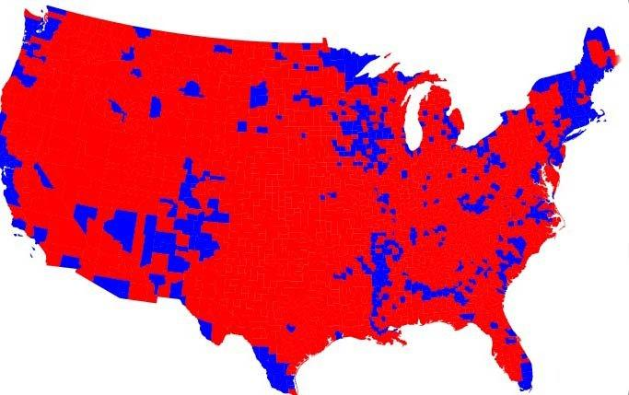
It seems heritage Americans, with their guns, now remain as the allegorical last man standing between the U.S. Constitution and all-out globalism.
Drive down any city street, in any neighborhood, prior to the vote on November 6, 2018, and you’ll see neighbors right next door to each other, and just across the street from one another, with opposing candidate signs in their windows and yards. This means these Americans are, literally, living and sleeping just yards away from their ideological enemies.
We are now in the soap box phase. On Tuesday comes the ballot box phase. Then, regardless of outcome, we will very possibly enter into the bullet box phase. Of course, that’s why the Orwellian Media requires endless news stories starring explosive projectile dispensers: To generate the necessary urgency to corner any criminals quickly followed by their immediate electronic prosecution, judgment, and sentencing.
The Democrats are afraid of guns, so they only want a powerful centralized state to have them. They also fear not being able to abort their babies, the weather (i.e. Climate Change), and transgenders losing their Obama-ordained bathroom privileges with your wives and daughters.
The Republicans fear the insanity of Democrats, the New World Order, and outcomes far more sinister than even Orwell imagined:
The pulp fiction horror writer, H.P. Lovecraft, once said:
The oldest and strongest emotion of mankind is fear, and the oldest and strongest kind of fear is fear of the unknown.
And Donald Trump has stated:
My whole life is about winning. I don’t lose often. I almost never lose.

Frightening prospects, indeed.
But even if Trump and the Republicans hold the line, it will have been just another battle in the long war.

Civil War, by Any Other Name
In the wake of the sending of bomb-like devices of uncertain capability to prominent critics of US President Donald Trump and of a mass shooting at a Pittsburgh synagogue (both Trump’s fault, of course) – plus a migrant invasion approaching the US through Mexico – there have been widespread calls for toning down harsh and “divisive” political rhetoric.

Of course given the nature of the American media and other establishment voices, these demands predictably have been aimed almost entirely against Trump and his Deplorable supporters, almost never against the same establishment that unceasingly vilifies Trump and Middle American radicals as literally Hitler, all backed up by the evil White-Nationalist-in-Chief, Russian President Vladimir Putin.

Those appealing for more civility and a return to polite discourse can save their breath. It’s much, much too late for that.

When Trump calls the establishment media the enemies of the people, that’s because they – together with their passive NPC drones and active Antifa enforcers – are enemies, if by “the people” we mean the historic American nation. Trump’s sin is that he calls them out for what they are.

Trump didn’t cause today’s polarization, he only exacerbates it because he punches back. Good, may he continue to do so. Pining for a more well-mannered time in a country that belongs to another, long-gone era is futile.

American politics is no longer about a narrow range of governing styles or competing economic interests. It is tribal. Today’s “tribes” are defined in terms of affinity for or hostility to the founding American ethnos characterized by European, overwhelming British origin (a/k/a, “white”); Christian, mainly Protestant; and English-speaking, as augmented by members of other groups who have totally or partially assimilated to that ethnos or who at least identify with it (think of Mr. Hamadura in The Camp of the Saints).

(Unfortunately we don’t have a specific word for this core American ethnic identity to distinguish it from general references to the United States in a civic or geographic sense. (Russian, by contrast, makes a distinction between ethnic русский (russkiy) and civic/geographical российский (rossiiskiy).) Maybe we could adapt Frank Lloyd Wright’s “Usonian”? “Or Americaner,” comparable to Afrikaner? “Or Anglo-American”?)

Since the Left gave up on its original focus on industrial workers as the revolutionary class, the old bourgeois/proletarian dichotomy is out. Tribes now line up according to categories in a plural Cultural Marxist schematic of oppressor and victim pairings, with the latter claiming unlimited redress from the former. As the late Joe Sobran said, it takes a lot of clout to be a victim in America these days. The following is a helpful guide to who’s who under the new dispensation:

In most of the above categories there are variations that can increase the intensity of oppressor or victim status. For example, certified victimhood in a recognized category confers extra points, like Black Lives Matter for race (it is racist to suggest that “all lives matter”) or a defined religious group marginalized by “hate” (mainly anti-Jewish oranti-Muslim, but not something like anti-Buddhist, anti-Rastafarian, or even anti-atheist or anti-Satanist because no one bothers about them; anti-Christian victimhood is an oxymoron because “Christian” is inherently an oppressive category). In addition, meeting the criteria for more than one category confers enhanced victimhood under a principle called “intersectionality.”

In the same way, there are aggravating factors in oppressor categories, such as being a policeman (an enforcer of the structure of oppression regardless of the officer’s personal victim attributes, but worse if straight, white, Christian, etc.) or a member of a “hate” subculture (a Southerner who’s not vocally self-loathing is a presumed Klan sympathizer; thus, a diabetic, unemployed, opioid-addicted Georgia cracker is an oppressor as the beneficiary of his “white privilege” and “toxic masculinity,” notwithstanding his socio-economic and health status). Like being Southern, living while genetically Russian is also an aggravating factor.

Creatively shuffling these descriptors suggests an entertaining game like Mad Libs, or perhaps an endless series of jokes for which you could be fired if you told them at work:

Two people walk into a bar.

One is a Baptist, straight, male Virginia state trooper whose ancestors arrived at Jamestown.

The other is a one-legged, genderqueer, Somali Dervish WIC recipient illegally in the US on an expired student visa.

So the bartender says … [insert your own punch line here].

While Patrick Buchanan is right that the level of domestic violence today is not up to what the US experienced in 1968, the depth of the existential divide is much greater. This is why it’s perfectly acceptable for a homosexual, black MSM news anchor to describe “white men” collectively as a “terror threat,” but when a straight white, female counterpart makes a clumsy but mild observation about ethnic role-playing it’s a firing offense. (Note that while “female” is an assigned victim category, white females can be “gender traitors” if they are seen as putting their “racial privilege ahead of their second-class gender status”; to remain victims in good standing and an “allies” of higher-caste victim groups they need to learn to just “shut the f**k up” when POC sisters with superior oppressed status are holding forth.)

The victim side accuses its opponents of a litany of sins such as racism, sexism, homophobia, Islamophobia, etc., for which the solution is demographic and ideological replacement – even while denying that the replacement is going on or intended. This is no longer ordinary political competition but (in an inversion of von Clausewitz attributed to Michel Foucault) politics “as the continuation of war by other means.” In its immediate application this war is a second American civil war, but it can have immense consequences for war on the international stage as well.

To attain victory the forces of victimhood championed by the Democratic Party need to reclaim part of the apparatus of power they lost in Trump’s unexpected 2016 win. (Actually, much of the apparatus in the Executive Branch remains in Democratic hands but is only of limited utility as a “resistance” under the superficial Trumpian occupation.) As this commentary appears it is expected that on November 6 the GOP will retain control of the US Senate but the House of Representatives will flip to the Democrats.

That’s what’s “supposed” to happen, just as Hillary Clinton was “supposed” to win the White House two years ago. How things will actually play out though is anybody’s guess.

But for the sake of discussion, if the expected scenario comes to pass the last chance Trump’s election afforded to save what is left of the American nation is likely to come to an end. We can anticipate three results:

First, on the domestic political front, while Democrats and their MSM echo chamber have cooled down talk of impeaching Trump, it will return with a vengeance on November 7 (coincidentally, Great October Socialist Revolution Day) if the House changes hands. In contrast to the GOP’s dithering in the area of investigations and hearings relevant to the US-UK Deep State conspiracy to overturn the 2016 election (which will be buried forever), the Democrats will be utterly ruthless in using their power with the single-minded purpose of getting Trump out of office before 2020. They won’t waste much time on the phony Russian “collusion” story (Robert Mueller’s report will be an obscenely expensive dud), they’ll focus like a laser on getting Trump’s tax returns and dredging up anything they can from his long involvement in the sharp-elbowed, dog-eat-dog world of New York property development and construction, confident they can find something that qualifies as a high crime or misdemeanor. (Some racist language couldn’t hurt, either.) The model will be Richard Nixon’s Vice President Spiro Agnew, who was forced out of office on charges relating to his time in Maryland politics years earlier. Even the GOP’s retention of the Senate would be far from a guarantee that Trump won’t be removed. It’s easily foreseeable that a dozen-plus Republican Senators would be thrilled to get rid of Trump and restore the party’s status quo ante with Mike Pence in the Oval Office. As with Nixon, Republicans will panic at whatever dirt the Democrats dig up and demand Trump resign for the “good of the country and the party,” as opposed to the way Democrats formed a protective phalanx around Bill Clinton. Unlike Nixon, Trump might choose to fight it out in the Senate and might even prevail. In any case, a change in control of just one chamber means an extended political crisis that will keep Trump boxed in and perpetually on the defensive.

Second, for Trump’s supporters and other dissenters from the Regime of Certified Victims, the walls will continue to close in. The digital ghettoization of alternative views to “protect our democracy” from supposed outside meddling conflated with “hate online” will accelerate, with social media a particular target for censorship. The Deep State’s intelligence and law enforcement organs will step up actions to penalize any resistance to Leftwing violence, while perpetrators of such violence will rampage with impunity. Trump has done nothing to protect free speech online or in public places while his enemies continue to contract the space for both – but things can and likely will get much, much worse if the Democrats feel the wind at their back after next week. Such vestigial protections of religion, free speech, right to bears arms, and others that we still possess – for now – aren’t likely to survive much longer as the edifice of the old America continues to crumble under the malfeasance of the very Executive, Legislative, and Judicial officials who pretend to be its custodians.

Third and most ominously, chances of a major war could increase exponentially. If Trump is fighting for his life, chances of purging his terrible, horrible, no good, very bad national security team will go from slim to none. Any hope of a national interest-based policy along the lines Trump promised in 2016 – and which still seems to be his personal preference – will be gone. Thankfully, South Korea’s President Moon Jae-in has run with the ball through last year’s opening and hopefully the momentum for peace in Northeast Asia will be self-sustaining. With any luck, the Khashoggi imbroglio between Washington and Riyadh will lead to America’s “downplaying and eventually abandoning the anti-Iranian obsession that has so far overshadowed our regional policy” and to an end the carnage in Yemen, even as the Syria war lurches toward resolution. Still, the US remains addicted to ever-increasing sanctions, and despite warnings from both Russia and China that they are prepared for war – warnings virtually ignored by the US media and political class – the US keeps pressing on all fronts: outer space, the Arctic, Europe (withdrawal from the INF treaty), Ukraine, the South China Sea, the Taiwan Strait, Xinjiang, and elsewhere. Trump is expected to meet with Putin and Chinese President Xi Jinping following the US election, but they may have to conclude that he is not capable of restraining the war machine nominally under his command and will plan accordingly.
The Ground Assault
An Ohio Muslim man has been accused of plotting to spark a bloody civil war by provoking standoffs between American militia leaders and federal authorities, reports Joseph Farah’s G2 Bulletin.
“We pull something off like filling militia leaders computers and phones with child sexual abuse then tip the fbi,” said the suspect, according to a court filing uncovered by the Investigation Project on Terrorism.
“When the militias see their leaders are being arrested left and right, they’ll panic,” he continued. “Then we start off assassinations … soon militias will have standoffs with the feds which will turn bloody.”
The suspect is Naser Almadaoji, 19, a naturalized U.S. citizen from Iraq. IPT reported he was arrested at John Glenn International Airport in Columbus, Ohio. He was attempting to travel to Astana, Kazakhstan, “hoping then to be smuggled into Afghanistan to be trained by the ISIS affiliate.”
He was charged with attempting to provide material support to the ISIS branch in Afghanistan and Pakistan, known as Wilayat Khorasan, the report said.
The details from an FBI affidavit said he was questioned by Customs and Border Protection last winter following a trip to Egypt and Jordan.
“It isn’t clear what triggered it, but the FBI had a confidential source posing as an ISIS supporter contact Almadaoji in August via a messaging app,” IPT said.
Almadaoji later told the informant he wanted to trigger a civil conflict between the U.S. government and anti-government militias.
“I imagined a scenario of the collapse of the US as a nation,” he said. “… They have alot [sic] of weak spots 2 really weak spots that would ignite the deadliest civil war on earth if the right spots are poked.”
Almadaoji also envisioned a repeat of the Oklahoma City bombing in 1995 in which a vehicle was exploded next to a federal building, killing 168 people.

The 2018 Election Results
Voters across the country have been crowding into polling places and mailing in ballots in numbers rarely seen in an off-year election.
In some states, as The Courier Tribune notes, more people are on track to cast ballots in early voting than in the entire election in 2014.
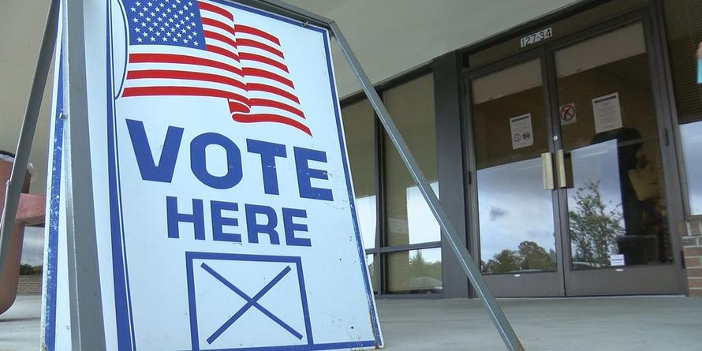
Democrats hope that surge indicates they may be succeeding in mobilizing a crucial demographic (because Democrats rely heavily on the votes of younger people and minorities, who are less consistent in their voting than are older whites, their candidates usually benefit from a higher turnout).
But Republicans are also energized, turning out in larger numbers than Democrats so far in Florida, for example, where a cliffhanger race for governor features a Donald Trump acolyte competing against a progressive who would be the state’s first African-American governor.
Nationwide, as early voting was coming to a close in many states Friday, more than 30 million ballots had already been cast. Turnout is hitting a pace closer to what’s typically seen in presidential elections. It has the potential to be the highest in an off-year election since 1966.
“When you look at some of these states, the numbers are eye-popping,” said Michael McDonald, a political science professor at the University of Florida and one of the country’s leading experts on voting patterns.
Overall, the most either side can tell is what has consistently been true of Florida since 2000: The statewide contests are likely to be very close.
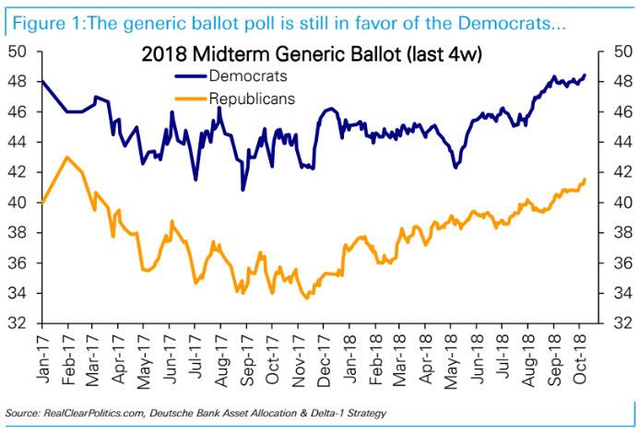
Of course, none of this early-voting trend actually means anything statistically relevant - despite the best efforts of MSNBC et al. to spin it to the left's advantage.
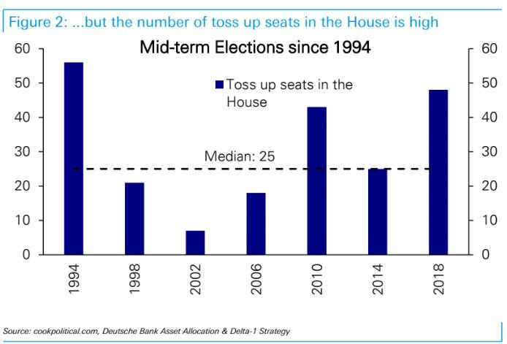
As Salil Mehta points out in his Statistical Ideas blog, everyone recognizes that the 2016 election polls were chaotic.
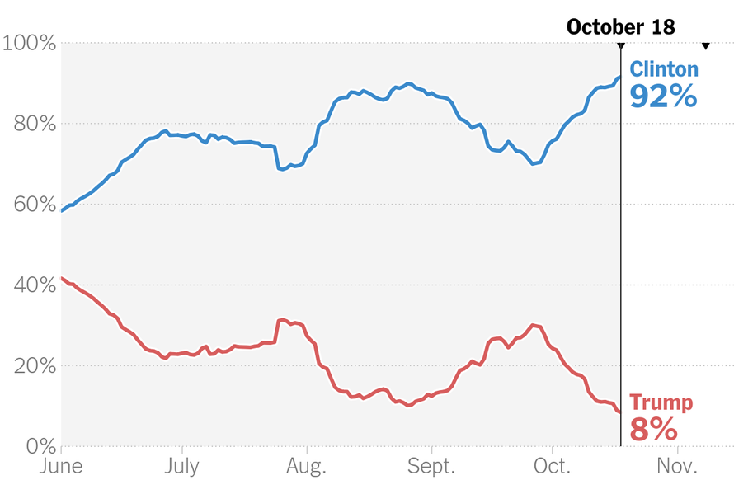
You can't put a positive spin on fake 90% “probability”, with a straight face. But to save face, the forecasters behind those polls have certainly tried! Meanwhile in the months leading up to the 2016 election, we had correctly reasoned that Hillary Clinton had closer to only a 50% probability. The gulf between what the mainstream news pushed out, and our reality, was indeed that wide.
Interestingly, all pollsters from back then are still in force. Same work this go around. Not much different. Polls currently indicate that the Democrats have an 80%-85% “probability” of overtaking Congress. To some, this seems nearly as (too) high as the fake “probability” they were being told in 2016. Is it still a sure thing, this time? We will briefly discuss below that we instead see the Democrats with a 55%-60% probability. Indeed a gulf still exists, but obviously it is not as exuberant as was the case in 2016.
Now for ground rules, let's reiterate that our website has never been politically biased. We care about people with differing views, and our sole intention if to focus on the probability theory concepts. With that, let’s discuss three major math themes that are worth reinforcing this go around, for the 2018 midterm forecasts.
The first theme is that the major pollsters are using a highly limited small sample size of longitudinal polls in order to formulate estimates of their errors. They also assume a nice clean, normal distribution even though their limited data is noisy. The result of these issues is that pollsters (such as competing statistician Nate Silver) continuously give absurdly high "probabilities" for outcomes that then fail to materialize. Here is a reminder of some of his high-profile failed forecasts, each with very high "probabilities" stated for occurring:
- 2015, 75% probability on United Kingdom election
- 2016, Donald Trump at 98% to lose GOP primaries
- 2016, Donald Trump at >90% in Alaska primary
- 2016, Hillary Clinton at >90% in Michigan primary
- 2016, Hillary Clinton at >90% in Indiana primary
- 2016, Hillary Clinton at 90% in Wisconsin primary
- 2016, Hillary Clinton at >70% in general election
- 2017, 75% probability on Alabama senate election
Don't worry; for every high “probability” call that you can pick up that he has gotten right. We can provide at least one high "probability" call that he instead got wrong. So much for high probabilities! And this brings us to our second theme, which is that pollsters are still stating too low a self-assessed “margin of error”. See this chart below...
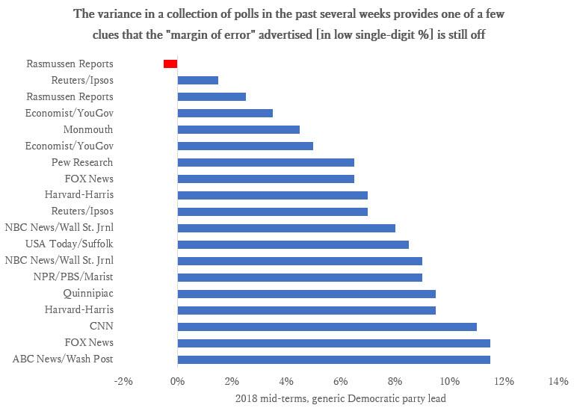
Twitter Ads info and privacy
Even Nate Silver aches from these polling “probability” auto-variances as well.
"The range of outcomes in the House is really wide," he explained.
"Our range, which covers 80 percent of outcomes goes from, on the low end, about 15 Democratic pickups, all the way to low to mid 50s, 52 or 53."
For example, in a tiny time span, we have had to shake our heads as his “probability” (in one of his three various polling flavors that's allegedly smoother) confusingly oscillate roundtrips from 77%, down to 70%, up to 84%, and back down below 70%, and back up to over 84%!
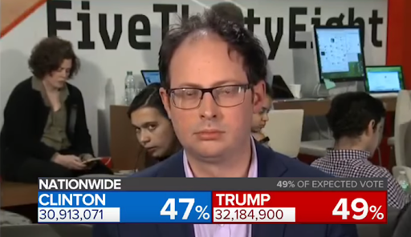
That's how insanity works; not probability. And we noted ex-ante to this 2018 polling season, that this would be among the fingerprints remaining on his flawed polling logic.
So our first two themes we described above combine to show the >80% “probability” (that's popularly said for Democrats to take over Congress in 2018) is way too high. Directionally it's correct, but our estimate of <60% is far more realistic.
Our third theme was the problematic "transmission" of the polling data to the overall election outcomes, which is inherently more difficult in this mid-term, versus 2016 and 2014 elections. Why wouldn't current pollsters recognize that? Mid-term polls are smaller, noisier, must work their way through a small number of competitive seats, etc. Those relationships are not as tight as in general elections, which themselves proved onerously difficult in the current Trump-era for these modern pollsters to get ahead of.

