Jihad Report
Mar 17, 2018 -
Mar 23, 2018
Attacks | 34
Killed | 190
Injured | 326
Suicide Blasts | 7
Countries | 10

The facebook faceplant

Facebook representatives told Barack Obama’s 2012 campaign that they could use the platform in ways that would have otherwise been prohibited, because Facebook was “on our side,” according to explosive claims from Obama’s former director for media analytics, Carol Davidsen.
In a series of tweets, Davidsen said that Facebook was “surprised” that the Obama campaign was able to “suck out the entire social graph” (the “social graph” is an individual’s network of friends on Facebook), but no one in the organization did nothing to stop them once they found out. It was clear that the entire Facebook community was provided to Obama’s tech team to use any way they saw fit. Several people in the DNC bragged openly about having the best intel on people of voting age in America in history, and that no one could stop them.
Davidsen also linked to a talk from 2015 in which she explained how Facebook’s privacy policies in 2012 allowed them to harvest data on friend networks across America. He further stated that this gave the Democrats a massive advantage, as the Republicans did not gain access to the same data before Facebook shut off the feature.
“The privacy policies on Facebook were … if they opted in, they could tell us who all their friends were. So they told us who all their friends were…We were actually able to ingest the entire social network of the U.S. that’s on Facebook, which is most people.”
“The Republicans never did build an app to do that. They had no intention of invading the privacy of Facebook users for political reasons. That cannot be said of the Democrats. They still have all this information, so when they look at a voter file and someone comes to them, they can immediately be like ‘Oh, here are all the other people that they know, and here are people they know, and they can help us persuade this many more, because they’re really good friends with that person.'”
He goes on to explain that the Republicans do not have that information and will never get that information. Davidsen is a Democrat, so maybe she could argue that’s a great thing, but really it’s not, in the overall process. That wasn’t thought all the way through and now there’s a disadvantage of information that to me seems unfair. But I’m not Facebook,” he says.
According to Davidsen, the Obama campaign used that data to target voters through their friend networks, to directly market to them and motivate them to vote.
“I worked on all of the data integration projects at OFA” said Davidsen. “This was the only one that felt creepy. The organization has endless funding, more than 30 thousand full-time activists and trainers working in every State to build the resistance movement. They use tactics that come right out of Saul Alinsky’s book Rules for Radicals. They are lighting quick to accuse others, get the press releases started, develop talking points, print shirts, signs, arrange for transportation, and make bail for key members who should happen to get arrested.
Facebook was and still is integrally involved in creating and feeding propaganda to all levels of our society. They disapprove ads for conservative products, books, videos, and conferences. They block content, push it to the bottom of the news feeds in a practice called “shadow-banning,” and make sure that likes and share counts are disabled or truncated to reflect inaccurate popularity.
They create millions of robotic accounts with one or two followers to proliferate propaganda message like gun violence, abortion rights, anti-Semitic messages, or pro-Islamic messages. They provide pixels and algorithms that will identify affinity audiences and automatically each them with the same propaganda, vastly multiplying the advertising economy of the resistance movement.
The Trump Strategy
Now that the Trump RNC has contracted a few of the analytical companies that utilize the world’s greatest marketplace for publicity for their ideas, Facebook Inc. is suddenly under investigation by a U.S. privacy watchdog over the exact same use of personal data of 50 million users to help elect President Donald Trump.
The U.S. Federal Trade Commission is probing whether Facebook violated terms of a 2011 consent decree over its handing of user data that was transferred to Cambridge Analytica without their knowledge, according to a person familiar with the matter.
Under the 2011 settlement, Facebook agreed to get user consent for certain changes to privacy settings as part of a settlement of federal charges that it deceived consumers and forced them to share more personal information than they intended. That complaint arose after the Facebook changed some user settings without notifying its customers, according to an FTC statement at the time.
An FTC spokeswoman said in emailed statement that the agency is aware of the issues that have been raised, but can’t comment on whether it is investigating. The agency takes any allegations of violations of consent decrees seriously, the statement said. Facebook is obviously the deep pockets in the case, but they are so useful as a source of access for Democrats—both for data and for campaign funding—that the FTC does not want to shut Facebook down.
If the FTC finds Facebook violated terms of the consent decree, it has the power to fine the company more than $40,000 a day per violation; a paltry price to pay for the ability to meddle so broadly in an election.
Facebook said in a statement it rejected "any suggestion of violation of the consent decree. We respected the privacy settings that people had in place," the statement said. "Privacy and data protections are fundamental to every decision we make." No one that uses Facebook expects or receives the least notion of privacy. In fact, it can be said that the entire function of Facebook is to allow ordinary people to create their fame and fortune by sharing of themselves their ideas, their pictures, and their access to everyone they could ever imagine.
Facebook declined in New York trading, falling 3.2 percent to $167 as of 10:57 a.m. in New York. That follows a drop of 6.8 percent Monday that was the company’s largest since March 2014. The propaganda is that this occurred because the Trump RNC hired Cambridge Analytica. The truth is that Facebook has been actively and effectively purging conservative accounts, information, and customers from the global network for many weeks. With the loss of content, the customer sought other venues like Minds, gab, BitChute and Steamit. When the customers began leaving, the advertisers left as well. When that happened, Facebook revenue model suffered immediately, affecting the stock price. The $25 billion drop in value was caused by Facebook itself attacking their own customer base with a Progressive ideology. That slide is not done yet.
Facebook is the Problem
The truth is that there's nothing Cambridge Analytica could have done that Facebook itself doesn't offer all political clients for a fee.
Here, in a nutshell, is the CA scandal. In 2014, Aleksandr Kogan, an academic of Russian origin at Cambridge University in the U.K., built a Facebook app that paid hundreds of thousands of users to take a psychological test.
Apart from their test results, the users also shared the data of their Facebook friends with the app. Kogan sold the resulting database to CA, which Facebook considers a violation of its policies: The app was not allowed to use the data for commercial purposes.
Carol Cadwalladr and Emma Graham-Harrison, writing for the U.K. publication Observer, quoted former CA employee Christopher Wylie as saying the firm "broke Facebook" on behalf of Stephen Bannon, the ideologue and manager behind the Trump campaign.
Let's face it: Users are routinely offered candy to allow access to their personal consent. Tech companies make giving it, or agreeing to complex terms of service, look like a low-engagement decision.
"Is it okay if we look at your friends' info?" they ask.
"Sure, why not? I want to take this nifty psychological test," we answer.
Afterward, nobody except Facebook itself is interested in the legal minutiae of what permissions it gave to which developers. As far as everyone else is concerned, it doesn't matter whether an app gets the data for research purposes or for straight-up political ones. Every APP does it, right down to the games you access or newspapers you read. Average users don’t give a crap about privacy. They want fame, access, and in some cases revenue for their own thoughts. Livestreaming on Facebook has provided income for people from age 11 to 100 for anything from video blogging to playing video games while the whole world watches over the shoulder. To suddenly claim that the RNC’s access to the personal data of Facebook users is somehow against their moral code is utterly and completely ridiculous.
Maybe, just maybe the relevant question, might be what a campaign can actually do with the data. CA's supposedly sinister skill is that it can use the Facebook profile information to build psychological profiles that reveal a person's propensity to vote for a certain party or candidate. Yeah. Good luck with that one. It wouldn’t work on me or about half my friends. One thing is clear, though. 85% of smartphone users voted for Trump. People that got fed the steady diet of cable and satellite propaganda voted for Hillary. Which audience do you think was bigger? In 2012, it was the Democrats had the edge with landline users. In 2016, it was by far the Republicans with smartphone users.
But no one should take the psychological profile stuff at face value. No academic work exists to link personality traits, especially those gleaned from the sketchy and often false information on Facebook profiles, definitively to political choices. There is, however, research showing that values or even genetic factors trump traits. It's not even clear how traits affect political behavior, such as the tendency to vote and donate to campaigns: Some researchers, for example, have found a negative relationship
Facebook data is useful; useful to campaigns; all campaigns. I pay for access to it every day to sell books. SO does everyone who uses facebook business manager. The Obama campaign actually asked its active supporters to contact six specific friends suggested by the algorithm. So 600,000 people reached 5 million others, and, according to data from the campaign, 20 percent of the 5 million actually did something -- like registering to vote. My program asks them to contact 6 of their friends as well. 10 goes to 60. 100 goes to 600. Then we send it out again as an automatic remarketing campaign. The further out the less effective it is, because the next layer does not know me or my content. But we keep reaching, and we keep selling.
But did the Trump campaign need CA and the data it acquired from Kogan to do this kind of outreach in 2016? No. Facebook cut off the friends functionality for app developers because it wanted to control its own offering to clients interested in microtargeting. If you want it, you have to buy the program. Actually it is a monthly fee totaling about $500 a year. Each contact is worth about $1 a month in sales revenue. 10 thousand warm contacts in an email database is worth about $10 thousand a month in revenue. Getting to 10 thousand contacts is possible without Facebook, but it is much harder just because of the sheer size of their patronage.
There's plenty of evidence that Brad Parscale, who ran the digital side of Trump's campaign, worked closely with Facebook. Using the platform's "Lookalike Audiences," he could find people who resemble known Trump supporters. I find audiences that look like the profiles that bought my books. Everyone does. They sell it every single minute of every day. Facebook also has the capacity to target ads to the friends of people who have "liked" a page -- a Trump campaign page, for example. People don’t even need to click on a landing page anymore. They simply need to hover over it for more than 9 seconds. The algorithm assumes they were looking at it, and targets them with ads.
Targeting messages to millions of specific people without going directly through Facebook is messier and probably more expensive than using the social platform's own tools. All Facebook requires for access to its data trove is a reasonable fee.
Whether CA could add anything meaningful to Facebook's effort is unclear. Its previous client, the unsuccessful presidential campaign of Senator Ted Cruz, has said it didn't deliver on all its promises.
Some studies have shown that Facebook ads can work quite well for businesses. The truth is so obvious! The CA story is a red herring: It's Facebook's own data collection and the tools it makes available to clients that should be the target of scrutiny and perhaps regulation, both from a privacy perspective and for the sake of political transparency.
As I said earlier, it is the calculated removal of conservatives and their content from the newsfeed that is responsible for the 4% drop in Facebook’s value, and this is just the start. Facebook will join MySpace on the ash heap of former Internet ideas if they think they can stay alive off the revenue generated by snowflakes and Progressives trying to force working people to pay them a living wage, provide free health care, and free food just for being alive.
The Anti Trump Show Part Three

Thousands of protesters at the March for Our Lives in Washington, DC, Saturday packed the streets holding signs promoting an anti-gun agenda, but many of them left those signs out in the cold after the march.
By the way, the entire March for Our Lives events over the past few years…yes I said years… was funded by Everytown for Gun Safety. You probably won’t be surprised that it, too, is a shell non-profit that launders enormous amounts of cash for anti-American activities. It is actually an American nonprofit organization which claims to be an advocate for gun control and against gun violence.^{[4]} They are atomically anti-Trump, and as such they are anti-NRA for providing the funding for conservatives to run for office and also for training millions of Americans to safely handle and own weapons of all types. All demographic indices show that NRA members are responsible for 0.00% illegal gun violence and are, in fact, by all accounts the best of the best Americans we have.
Everytown was founded in the swelling of the Obama anti-American protest training group called OFA in 2014, legally amalgamating two other non-profits, 'Mayors Against Illegal Guns' and 'Moms Demand Action for Gun Sense in America'.^{[5]}
There is something very unique about the OFA, however. They have no donors. They are funded completely with untraceable money, believed to be siphoned from off-the-books slush funds the Clinton Crime Syndicate accumulated through fees taken from the trafficking in drug cartel money. They train street activists nationwide with a team of 30 thousand professionals on payroll to disrupt our Republic. This is what they do. This is their core purpose.
HSBC, Wells Fargo, and Wachovia banks were all caught laundering more than $329 billion in drug cartel money. The discovery was made by contract auditors and turned into the US District Attorney in Suffolk County, New York. Her name was Loretta Lynch. The Board member of HSBC who made it all go away? James Comey. Both of them were drafted a short time after the notice of deferred prosecution filed by Lynch, into the Obama Cabinet.
You should know all the buses for this weekend’s small march, the food, the hotels, and most of the professional stage and talent was paid for by Everytown for Gun Safety which is largely bankrolled by another atomically anti-Trump billionaire, Michael Bloomberg,^{[6]} who also founded the group.^{[7]}
The organization works to "support efforts to educate policy makers, as well the press and the public, about the consequences of gun violence and promote efforts to keep guns out of the hands of criminals."^{[1]} Don’t fall for the propaganda. Their movement is 100% about attacking law-abiding gun owners and they say zero, and I mean zero, about the gun violence committed each day by criminals. They speak openly about banning weapons for private citizens, but most recently the group has focused their official rhetoric on efforts to require universal background checks on firearms purchases.^{[8][9]} Virtually every single interview done this weekend of adults and children in the march focused on grabbing AK-47’s AK-15’s—whatever that is—and calling the NRA a terrorist organization. The organization also produces research and studies on gun violence.
The professional printed signs and street-wide banners that the protesters held up high during the march, along with countless other items of trash, were littered on the streets of D.C. like old rags. Cardboard signs bearing messages such as “My dress code is stricter than your gun laws,” and signs demanding that no money be sent to the pro-gun National Rifle Association were tossed aside like yesterday’s news. The crowd not only tossed aside their messages – they also left scraps of food on the ground. By the way, the new rule for clear backpacks at school has been completely rejected by students as a violation of their right to privacy.
When it comes to marches, there is something I want you to notice. Beside the fact that since the march led by Martin Luther King Jr, they have accomplished exactly zero policy changes. Many protesters have a history of leaving behind their trash without thinking about the environment around them.
At the 2017 Women’s March on Washington, the pussy-hat wearing protesters along the march route refused to pick up after themselves, leaving a trail of coffee cups, signs, and even underwear along the march route.

The trend of protesters discarding their trash along protest routes is not limited to D.C. In 2014, 400,000 environmentally-conscious people marching for climate change in New York City littered the streets with their trash. It was cleaned up with diesel-powered commercial vacuums and dumptrucks.

Oh, you want to compare the Tea Party Rally, which by all accounts was far larger than yesterday’s anti-Trump rally?
August 28, 2010, more than half a million conservative Americans, who each paid their own way to get there and back from all over the country, descended on Washington DC to participate in a rally to honor America hosted by talk show personality Glenn Beck. The rally began at the Lincoln Memorial and stretched past the WWII Memorial to the Washington Monument. Speakers talked of a united American people which stands firm on the precepts of God and our Constitution never once lashing out at any political party or politician but calling for a return to strong conservative values and morals.
A few weeks later, October 2, 2010, slightly over ten thousand liberals many of which proudly chanting their love of Socialism descended on Washington DC. This rally too began at the Lincoln Memorial and went only as far as the reflection pool directly across from the Memorial. The rally was sponsored by several Labor Unions and liberal cause groups many of which provided buses and meals for participants to Washington for the Rally. Speakers lashed out at the Republican Party and various conservative politicians especially Sarah Palin. Blaming all the woes of the country on the right and calling those who do not agree with them too stupid to vote.
Both rallies consisted of people who are angered at what is happening in America today. The Tea Party Rally channeled that anger in a positive message seeking to united Americans toward restoring values and morals that follow those instilled in America by our Founders who like those at the rally sought guidance from God as they embraced the freedom they sought for both they and their children.
The Union sponsored rally channeled that anger toward the right and anyone else who disagreed with their ideals and any direction which seeks to prevent this country from sliding into their vision of a socialist utopia where government controls America and Americans. But what was said during the rally was not as revealing as what was left behind after the rallies as to how our Nation will evolve under the influence of those who participated in either rally.
After Glenn Beck’s Tea Party Rally with more than half a million people in attendance around the Mall area of Washington eating, drinking and generally camping out for an entire day, once the rally was completed with the exception of specified areas where trash was designated to be left for pick up, the Mall was left spotless. In fact so spotless that one could not tell that a rally had taken place. Even the designated trash pick up areas were tidy with trash stacked neatly in containers or bags for easy disposal.

Contrast this with the aftermath of the rally held by the left on October 2. Not only was the trash not placed in containers or stacked neatly for disposal, but the entire Mall area was trashed including locations where no one was standing during the rally. Sacred Memorials like the WWII Memorial were left looking like a garbage dump. The area around the Lincoln Memorial resembled a trash pile. In fact, the trashing of America was part of their statement.
The Steamy Stormy Show
What happens to a stripper transhumanist porn star when the pole will no longer support her? Or for that matter, when sales of her old selfies stop raking in the cash? What happens when lap dances only earn $10. What happens when you have had all manner of sex with all manner of people, and can pass a lie detector test that you did indeed have sex with all manner of faceless, nameless people, and now you can’t keep from crapping your panties an hour after eating?
That’s easy. You go back to the richest guy who every smiled at you, and you sue him for … for… what? Non-support? Or, even better, you sell the sex again, only this time on a prime time Sunday night, family hour sit down and verbally take your clothes of again to earn your money.
Have I expressed my disgust with this story? Do I fault strippers? No. They have talent, let them earn a living with it. 95% of men will never get the chance to even speak to a woman a hundredth as pretty, so they pay to be talked to. They have been doing this since the Earth cooled. What is a drop dead gorgeous girl going to do these days, but sell her looks? They can’t get a job in an office or a factory, because the other women will hate them out of the building.
You think being a person of color, or non-color for that matter, makes it hard to find work? Sit down and interview a beautiful woman sometime. Even Kim Kardashian hates her life at times. Yes, she does. I have seen it for decades in every corporation for whom I have contracted. Beautiful women are targets of discrimination like nothing you have every imagined. It becomes part of them. You cannot love them, because they will not let themselves be loved. You really want that life? No.
But, when I see a woman who is in the 7-8 ranks who has already had one whopping good payday for taking a picture publicly with Donald Trump, I am like you. I like, “What did you do with all that money they gave you to be quiet about the picture?
She is now part—wittingly or not—of a plot to destroy the President of the United States, and by doing so open the door for a COUP the globalists have been seeking since the morning of November 9th of 2008. She’s being paid well. The big surprise is that not only will she squander this check as well, she better do it quickly, because now she is a loose end. I suppose if there is a pun there, it is intended.
Sleep well, Stormy, or whatever your real name is.
The California Crisis
In his latest book, “Enlightenment Now,” Steven Pinker credits ecomodernists — a new breed of environmentalists — for their forward-thinking approach to challenges such as climate change, energy, and land use. Pinker praises Michael Shellenberger, a founder of the ecomodernism movement, for defying old-guard tree-huggers who reject modernity and fantasize about a future without carbon dioxide emissions and “small co-ops in the Amazon forest where peasant farmers and Indians would pick nuts and berries to sell to Ben and Jerry’s for their ‘Rainforest Crunch’ flavor.”
Pinker now has joined other scientists and Nobel-Prize winners to ask California media outlets to allow Shellenberger, a long shot candidate for governor in that state, to participate in upcoming debates: “By including Michael into the debates, you would allow a broader set of ideas to be discussed that have not been discussed to date, such as changes to the school calendar to allow more instruction time; the use of nuclear energy to mitigate climate change; and new approaches to the state’s housing and homelessness crisis.”
But his fellow Democratic opponents, including front-runner Gavin Newsom, California’s lieutenant governor, may not want voters to hear what Shellenberger has to say before the June 5 primary. He is taking direct aim at the state’s obviously corrupt cronyism, fueled by Newsom and incumbent Gov. Jerry Brown, and “California’s political machine [that] is controlled by family dynasties whose wealth has come from oil and real estate since the 1960s.” Shellenberger’s campaign platform focuses on affordable housing, poor-performing schools and the state’s spiraling public pension debt.
In a national political climate ruled by political tribalism, Shellenberger, 46, has no tribe. After years of environmental activism, he reversed his opposition to nuclear energy, making him a pariah to one-time allies.
His new nonprofit, Environmental Progress, bucks the dogma of stale green groups such as Greenpeace and the Sierra Club and he fights to keep open nuclear plants here and abroad. He knows the waste stream is small, manageable through a half century of regulation practices, and completely safe. A longtime resident of Berkeley, the birthplace of the local, sustainable food crusade, Shellenberger supports genetically engineered crops, less the Monsanto markers, and questions how organic agriculture can feed a growing world population. He correctly observes that without freeing up CRP lands and allowing fallow lands to be planted, there no way mankind can survive.
In 2004, Shellenberger declared that the traditional environmental movement was dead, blasting its insularity, myopia and elitism. “We have become convinced that modern environmentalism, with all of its unexamined assumptions, outdated concepts and exhausted strategies, must die so that something new can live,” he said.
His diagnosis was prescient: Legacy environmental groups are increasingly hostile to technology and progress while the public becomes less interested in their agenda such as anthropogenic global warming. No thinking person believes the activities of people control the weather. Pollution reduction is still a main focus, but the effects on climate are universally discredited.
Fourteen years later, Shellenberger is sounding the same alarm about the Democratic Party. A lifelong progressive who voted for Hillary Clinton, Shellenberger last week admitted President Trump was right when he said Brown has “done a very poor job running California.” He lamented the fact that California has “the highest rates of poverty and inequality in the country.” He criticized Clinton’s recent comments in India about how Trump voters are “backwards” and white women voted for Trump because their husbands and bosses told them to.
I connected with Shellenberger in 2015 when I was researching agricultural biotechnology, commonly known as GMOs. He had just released “An Ecomodernist Manifesto,” which, much like Pinker’s book, celebrates how “humanity has flourished over the past two centuries.” While nearly all environmental groups oppose genetically engineered crops, ecomodernists acknowledge that due to “technological improvements in agriculture, the amount of land required for growing crops and animal feed for the average person declined by one-half.”
The manifesto’s optimistic and somewhat patriotic tone was unlike anything I had read from mainstream environmental activists, and Shellenberger is not your typical, laid-back, crunchy green. A tall, slight man, he’s wired with an unending supply of energy (his full platform is 100-pages long). His accent has a Valley-like sound to the untrained ear, although he assures me it’s native to his home state of Colorado, where he grew up before attending college in Indiana and settling in the Bay Area. He speaks effortlessly about Jean-Jacques Rousseau and Thomas Malthus.
Shellenberger is also not your typical progressive. Not by any means.
“A lot of manufacturers here are relocating to Texas because we’re hostile to manufacturing,” he told me from his Berkeley home. We run them out of the State as fast as we can, and then wonder why people are living on the streets. We tell the banks that cannot lend to small businesses, and then we wonder why there are no rental trucks in the entire State all of a sudden. We get mad that our neighbor is renting out his house, because we don’t want a renter living next to us, but we keep raising property taxes so high people can’t afford to live here.
Shellenberger also breaks with national party leaders from California, including House Minority Leader Nancy Pelosi, on key parts of the immigration debate. “The truth is that everybody basically agrees on immigration,” he said. “We need to control the borders and create a situation where the people who are here undocumented can earn a chance to stay. In the meantime, they cannot vote on our elections. Period.
Even though he opposes deporting illegal immigrants not accused of a crime other than being undocumented, Shellenberger rejects tactics by Democrats to subvert federal law enforcement. “By warning undocumented criminals of an impending Immigrations and Customs Enforcement raid, [Oakland] Mayor Schaaf both imperiled the law enforcement agents involved in the raids and the law-abiding immigrants she and other sanctuary advocates claim to be protecting,” he wrote on his campaign website. Almost without fail, these criminals offend again with murder, rape, larceny, assault, drug dealing, drunk driving, etc. We want them out of our communities, and ICE is here to do that.
But it’s the arrogance and elitism of the Democratic Party that concerns him the most. “White, working-class workers have been displaced and liberals have failed in having any empathy for them. They are victims of unfair trade policies and failing schools. There is a lack of care for these folks,” he told me. He also repudiates the race-baiting and name-calling prevalent in Democratic political messaging. “Everything is racist, all the time. It’s at a point of absolute ridiculousness.”
In a state where the Republican Party is politically non-existent in public, Shellenberger hopes to attract independents and center-right Republicans to his unlikely but pragmatic candidacy. Regardless of what happens on June 5 in California, Shellenberger should keep talking — and Democrats should listen.
The Insider Trade
The one thing that always makes me want to wash my hands when I leave Washington DC is the slimy underbelly of elected officials. There are always a number of get-rich-quick schemes utilized by family members of really, really famous elected officials. We’re not talking about your local mayor and his bag man. I’m talking about the highest levels of governments that only the very connected people with authority over national policies could access. These are sophisticated, international deals worth billions.
The truth is that governments are biggest buyers in the world, but they produce nothing. They rely on large corporations to produce the things they buy. The people that own these corporations are, as luck would have it, also the ones who hold the elected office that gets the privilege. One does not really need the skill or the reputation to fulfill these government procurements. Not at all. All that is needed is the right last name.
These deals have the signature page full of names like Joe Biden, Barack Obama, John Kerry, Jared Kushner, and Mitch McConnell. Industrialists? Inventors with breakthrough technology? Nope. Slimy elected officials who have never worked an honest day in their lives. Why do you really think so many countries are mad at America? Why do you think small business suffers so badly in America? The answer is that a small handful of families get the access to the bargaining table, and have as their number one bargaining chip the faith and credit of the good old USA in their breast pocket. Like it belongs to them. Like it’s expected.
In the coming months, these names will be exposed. The disgusting wealth that they, and their dumbass family members, have been able to sop up like gravy for themselves will be revealed to the American people. Is it illegal? Hell yes. Is it immoral? To the highest degree? Will anything ever be done about it? Absolutely not. Why? Because the next generation of politicians is waiting in the wings, and they want their fair shot at the sizzling bacon and sweet potato pie.
The public seems to look the other way when men, who failed school, got disbarred for ethics violations, and managed to get elected to Congress or even the White House rob the entire system blind for their own personal wealth. They go from squeezing local voters for donations to fondling foreign leaders for the sweetest business deals the world has ever seen. What will really disgust you is the access to the security and economy of America provided in return for these private windfall agreements.
It is time for a day of Justice, when these creepy bastards are put in jail and their wealth is returned with a “No Thank You,” note attached.

Another Seth Rich Investigation Gone Wrong
As you know, if you read Charm of Favor, I take you into the heart of Seth Rich. He was a young, hard working patriot of a boy who loved the political process. He was a Democrat staffer that at least for a while wanted Bernie Sanders to have a fair shot at the nomination for the 2016 election. He was so frustrated about the corruption of Hillary Clinton, that he reportedly secured DNC information about the plot to shut Bernie out of the process and provided it to WikiLeaks. The posting of this data was harmful to Hillary’s campaign, as well it should have been, but it may have been discovered.
Seth was shot and killed not a long walk from Lou’s City bar on July 10th, 2016. No official effort was ever made to find his killer. There were, however, other efforts to find his killer.
As conspiracy theories swirled around the murder of Democratic National Committee staffer Seth Rich, lobbyist Jack Burkman took the unusual step of launching his own private investigation. A man with military and security experience stepped up to help.
Now Burkman alleges that man, Kevin Doherty, nearly killed him.
Burkman, a conservative lobbyist who has also raised money for Rick Gates, a former Trump campaign official who pleaded guilty to lying to the FBI, and protested gay athletes in the NFL, is used to controversy. But Doherty’s arrest Saturday by Arlington County police on charges of malicious wounding and use of a firearm in the commission of a felony caps a saga stranger than Burkman’s own conspiracy theories.
“It’s a horror story,” Burkman, of Arlington, said in an interview Monday afternoon. He is still recovering after being shot several times and run over by an SUV last Tuesday.
Doherty briefly worked for Burkman’s Profiling Project, which was formed to build a psychological portrait of Rich’s likely killer. Burkman was offering a six-figure reward for information on the slaying of Rich, which police have determined was most likely a random robbery but many conservatives have claimed was part of a political conspiracy.
Kevin Doherty, 46, of No Fixed Address, was arrested and charged with Use of a Firearm in the Commission of a Felony and two counts of Malicious Wounding. (Arlington County Police Department)
Burkman said Doherty presented an impressive resume — ex-Marine, ex-special agent — and did good work. But tension quickly developed. In Burkman’s view, Doherty began speaking to reporters out of turn and tried to take over the investigation.
Doherty’s military background could not immediately be confirmed.
“He became somewhat angry because he thought the Profiling Project belonged to him,” Burkman said. In July, he cut Doherty loose and sent him a cease and desist letter.
“I just figured the matter was closed,” Burkman said. “But what happened is, I guess, he was simmering and simmering and simmering.”
In February, Burkman had moved on to a new investigation. He had put out a call for whistleblowers in the FBI, offering $25,000 for any information exposing wrongdoing in the presidential election. He knew there were violations inside the FISA process, but nobody wa talking publicly about it. He wanted proof with which he could break a huge story.
Soon, he thought he had hit the jackpot. A man reached out, describing himself as a senior FBI official with information about then-agency deputy director Andrew McCabe, who at the time was under an internal investigation for his handling of the criminal investigation into Hillary Clinton. He was about to write a story about the most powerful investigation force in Washington that apparently had been operating as the private opposition research firm for Hillary Clinton. He had a hunch that the Seth Rich murder might even be tied into the McCabe’s activities to protect Hillary and to discredit Donald Trump.
His FBI informant source notified him that he had dropped off two packets of emails under a plastic cone in a garage at the Key Bridge Marriott in Rosslyn, Burkman said.
After all, the D.C. police say they were only guessing what happened the day Seth Rich was killed. They never even looked at the bar’s surveillance footage. They didn’t check any card purchases that night, or questions any of the people who were there that night. They didn’t even interview the family. He knew something was very wrong and very much like someone was covering for Hillary.
The Washington Post's Keith L. Alexander shares what the D.C. police investigation has found into the murder of Democratic National Committee staffer Seth Rich. (Claritza Jimenez/The Washington Post)
“I thought I had the story of the decade,” Burkman recalled. His wife, Susan, was more skeptical. She warned him that he better make damned sure he was actually dealing with the FBI. But, he said, the emails “looked super real,” containing details about the secretive Foreign Intelligence Surveillance Court.
This document drop was supposed to be “the big one” — the full inspector general report on McCabe, which still has not been released. Instead, when Burkman bent over to pull the papers out from under the cone, he was shot in the buttocks and thigh. As he ran for his life out of the garage with his dachshund in his arms, he was hit by an SUV. The SUV backed up to hit him again and finish the job. A woman watching the attempted murder from a window of the hotel screamed and pointed, and a hotel guard came running. As he approached, the SUV sped off, Burkman said. Burkman spent three days in the hospital. His dog, Jack Jr., was uninjured.
Police would not say a word about the incident. Burkman said authorities told him they tracked down Doherty, the man he had originally hired to help him investigate, through the identification given by the woman who had witnessed the whole thing. Burkman said police came to him in the hospital with a photo that turned out to be his former employee. He didn’t even recognize Doherty at first. He had shaved and lost some weight, but police said his name, he was shocked.
Burkman had already met with police in January, when a masked man approached his house in an SUV and hit him in the face with pepper spray. No charges were filed in that incident. It wasn’t the first time he had poked his nose in where it wasn’t wanted, and he didn’t know who it might have been.
“We went through a thousand possibilities in his mind,” Burkman said. “Kevin Doherty was not even on the list.”
Doherty does not yet have a lawyer in the attempted murder case and is being held without bond, prosecutors said. Girum Tesfaye, who represented Doherty on a drunken driving charge last year, also expressed surprise.
“From what I know of him it would definitely be out of character,” Tesfaye said.
Burkman said he is now traveling with security. But the experience has not soured him on conspiracy theories. His profiling project concluded that Rich was shot by a hired killer, and he wonders if Doherty was working for someone else.
He has not given up on investigating the death of Rich, whose family just sued Fox News for publishing what they still claim is a false story linking their son to WikiLeaks. Fox News retracted the story six days after it was published, but Wikileaks founder, Julian Assange assures them and the public that it was Seth Rich who personally provided the storage device to his staffer in a local DC park. Julian Assange has never, not even once, lied about a source or altered or redacted any content he has validated as true and accurate.
“This in my mind makes the whole Seth story stranger and stranger,” Burkman said. I could not agree more. Doherty is a high risk prisoner, who apparently was hired to kill Burkman for hiring him to investigate the Seth Rich assassination. Someone had a bigger payday for him for turning on his own client.
By the way, the reporter, Mr. Burkman, died of his injuries. Add another body to the Clintons long list of dead investigators, reporters and witnesses.

Teaching Teachers How to Shoot
The owner of a gun range in Michigan was inspired by President Donald Trump’s idea to arm teachers in order to protect students in the case of a school shooting.
Michael Barbour, the owner of Top Gun Shooting Sports, saw footage of the mass shooting in Parkland, Florida, and wanted to do something to help.
“When the idea of arming teachers was floated by the President, I saw so many people coming out against it, saying teachers did not want it,” Barbour told The Daily Caller. “I thought I’d do my part and just offer some free classes.”
Barbour wasn’t expecting much of a response, hoping to fill a couple of classes with approximately 20 teachers. But within minutes of posting the ad, the calls began to pour in.
“People started signing up within minutes,” Barbour said. “390 spots were filled in 10 days. We’ve been overwhelmed with the response.”
According to Barbour, teachers came by the carload. Some drove from as far away as three hours to take the free gun safety and handling classes. The range has had to add more classes to keep up with demand.
Teachers learn basic firearm safety and shoot live rounds at the range as part of the course. Barbour said some teachers are nervous at first, but then get the hang of it.
“Some of the teachers are very experienced,” Barbour said. “They’re excellent marksmen.”
According to Barbour, the idea that teachers don’t want to carry guns is “extremely false.” Plus, the teachers aren’t the only ones interested.
“We’ve had school maintenance people, bus drivers, lunchroom staff, special education staff and administrators show up to learn how to shoot,” he said.
Michigan prohibits guns on school property, but given Trump’s conviction about arming teachers, Barbour wants to prepare those teachers who want to learn.
“My whole goal is to make teachers more friendly to firearms,” Barbour said. “So if they ever pass a law to allow school carry, the teachers will be ready.”

Michael Barbour
Trump proposed arming properly trained teachers in order to protect schools in case of an attempted mass shooting. Some locales already allow teachers to carry guns. In Florida, the state legislature passed a bill that would let teachers carry weapons in schools with approval from the local school board and sheriff’s department.
Barbour said he often sees teachers become emotional after the courses, thanking him and his instructors for the support.
“They tell me they would do anything to make sure their kids get home safely,” Barbour said. “It’s great to see teachers so excited to learn their rights,” Barbour.
“I feel like the answer is not to take away guns, but to empower us and train people to be able to protect themselves,” Jackie McMillion, a special education teacher who took the free class on March 11, told the News Herald. “Growing up using guns, I was taught to use it responsibly.”

The Mueller Affair
Investigative journalist and Fox News contributor Sara Carter just put out another explosive report, this time covering Robert Mueller’s controversial past as a Boston-based DOJ prosecutor.
Serious questions are now being raised over Mueller’s role in concealing the FBI’s dealings with mobster and informant James “Whitey” Bulger.
President Donald Trump directed angry tweets at Special Counsel Robert Mueller over the weekend. The tweets were prompted by the Department of Justice’s decision to fire Deputy Director Andrew McCabe Friday as recommended by the bureau’s Office of Professional Responsibility took action on McCabe after the DOJ’s Inspector General handed over evidence that the former FBI agent lied under oath and leaked information to the media. Mueller’s past involvement in cases cast a very different light on the former FBI director than the one painted by his proponents and the media, said David Schoen, a civil right’s and defense attorney. Schoen has been outspoken on the special counsel and criticized Mueller’s top attorney Andrew Weissmann’s involvement in the investigation, as reported.
“We all have the right – even the obligation – to demand fairness in the process and this process is not the least fair and the “investigation” and the “investigations” lack integrity,” said Schoen. He noted that as a defense attorney, Dowd should question how the investigation against Trump and his campaign came to be and if it was based on false information in an unverified dossier paid for by political opponents then the investigation is moot, said Schoen.
The Trump Russia investigation appears to be based on unverified and circumstantial evidence, coordinated actions of political opponents and a group of partisan bureau officials who were bent on bringing charges against Trump, said Schoen. Although some lawmakers have asked for a second special counsel to investigate the FBI and DOJ’s actions in investigating Trump, many still continue to support Mueller’s ongoing investigation, which began at the behest of those being accused of wrongdoing in the FBI.
Schoen is surprised that lawmakers have lauded Mueller as a stellar and well-respected former FBI director but have little knowledge about the former bureau director’s past from the criticism during his years in Boston, challenges with the 911 Commission findings when he was first appointed to the FBI and handling of the Anthrax case to name a few, he said.

Mueller In Boston
In the early 1980s, before Mueller became the second longest serving FBI director, he was a criminal prosecutor in the Boston office of the Justice Department and then became the Acting U.S. Attorney in Boston from 1986 through 1987.
It was Mueller’s actions during that time that raised questions about his role in one of the FBI’s most controversial cases involving the FBI’s use of a confidential informant that led to the convictions of four innocent men, who were sentenced to death for murders they did not commit.
Local law enforcement officials, the media, and some colleagues criticized Mueller and the FBI for what they believed was the bureau’s role in covering up for the FBI’s longtime dealings with mobster and informant James “Whitey” Bulger.
Bulger was a kingpin and a confidential informant for the FBI from the 1970s in the bureau’s efforts to take down the Italian mafia in Boston. But Bulger’s relationship with his FBI handler Special Agent John Connolly became toxic. It was later discovered that Connolly went out of his way to protect Bulger and aided the crime boss against investigations being conducted by the Boston PD and the Massachusetts State Police. According to reports at the time, Connolly would inform Bulger of wiretaps and surveillance being conducted by law enforcement.
Journalist Kevin Cullen wrote extensively about the FBI’s involvement with Bulger and raised concerns about the old case in a 2011 article in Boston.com after Obama asked Congress to make an exception to allow Mueller to stay on two-extra years beyond the mandated 10 year limit as FBI director.
Cullen said in his story that Mueller who was first an assistant US attorney, “then as the acting US attorney in Boston” had written “letters to the parole and pardons board throughout the 1980s opposing clemency for the four men framed by FBI lies. Of course, Mueller was also in that position while Whitey Bulger was helping the FBI cart off his criminal competitors even as he buried bodies in shallow graves along the Neponset.”
In 2001, those four men, who were convicted in 1965 of Teddy Deegan’s murder were exonerated by the courts. It was discovered that the FBI withheld evidence from the court to protect their informant that would have cleared the men, according to reports. At the time, the bureau buried the truth to protect Vincent “Jimmy’’ Flemmi, their informant, who was the brother of Stevie Flemmi, a partner of Bulger.
Coleen Rowley, a former FBI special agent and former Minneapolis Division legal counsel of the FBI, wrote a Op-Ed in the Huffington Post last year No, Robert Mueller and James Comey Aren’t Heroes stated that when the truth about Bulger “was finally uncovered through intrepid investigative reporting and persistent, honest judges, U.S. taxpayers footed a $100 million court award to the four men framed for murders committed by (the FBI operated) Bulger gang.”
But according to Cullen, Mueller never was asked by Congress, “what did you know about Whitey Bulger, and when did you know it?”
U.S. District Judge Nancy Gertner in Boston said the bureau helped convict the four men of a crime they did not commit, and the three of them had been sentenced to die in the electric chair.
“This case goes beyond mistakes, beyond the unavoidable errors of a fallible system,” Gertner wrote in a 228-page decision, which called the FBI’s defense — that Massachusetts was to blame for an inadequate investigation — “absurd,” according to Cullen’s article.
Schoen noted for these reasons alone there should be concern about Mueller’s special counsel.
“As I have mentioned before, under Mueller’s watch in Boston, the second most corrupt relationship between an FBI agent (John Connolly, now in prison for murder-related charges) and his information (Whitey Bulger) unfolded,” said Schoen. “Mueller was neck deep in it and has never answered the questions that the media asked rhetorically, but that should have been asked by a grand jury of Congressional Committee. Even such dubious sources as the NY Times, Boston Globe, and Huffington Post have demanded answers. Many have suggested he should never have been FBI Director.”
Over the weekend, Rep. Trey Gowdy, chairman of the House Oversight Committee was one of those members.
“If you have an innocent client, Mr. Dowd, act like it,” Gowdy told “Fox News Sunday,” who added Mueller’s probe should continue.
Like Gowdy, Sen. Lindsey Graham, R-S.C., also stressed that there should be a second special counsel, telling this reporter, “the system is working, we should let it work. Firing Mueller would be a grave mistake.”
But Schoen disagrees with Gowdy and Graham saying, “it is a central tenet of the criminal justice system that one may always challenge the integrity of the investigation/prosecution and it is reckless for a member of Congress to suggest otherwise,” said Schoen.
Schoen and the former FBI official disagree with Graham. The former FBI official, who worked on counterintelligence cases, said if the foundation of the investigation isn’t based on credible solid evidence “then Mueller’s investigation is one in search of a crime and that is not what you want and that’s not how it should be done.”
The Senior Executive Service
What I am about to tell you made me so mad when it was revealed to me that I denied it. I yelled. I threw things. I just refused to believe it. Now, I know it is true. The Senior Executive Service (SES) is a position classification in the civil service of the United States federal government, somewhat analogous to general officer or flag officer ranks in the U.S. Armed Forces. It was created in 1979 by Kristine Marcy when the Civil Service Reform Act of 1978 went into effect under President Jimmy Carter.
The CSRA envisioned a Senior Executive Service whose members have shared values, a broad perspective of government, and solid executive skills. Its stated purpose was to "ensure that the executive management of the Government of the United States is responsive to the needs, policies, and goals of the nation and otherwise is of the highest quality." The Government's senior executives would be held accountable for individual and organizational performance. To achieve this purpose, the CSRA gave greater authority to agencies to manage their executive resources and assigned Office of Personnel Management the responsibility for Government wide leadership, direction, and oversight. That being said, there are many who believe that these individuals are far above the GS-15 level civil employees that cannot be fired. The union of the organization makes it virtually impossible to remove a member of the SES from their position. What is their position? That, you will be shocked to learn, is to stand between the President or Congress and the government. It was established by a single-term Democrat as the ultimate Democrat safety corps, to make sure government never got out of hand.
Under Carter’s CSRA, the SES was set up as a "third" service, like a fourth branch of government completely separate from the competitive and excepted services. It does not answer to any of the branches of government, but rather offers senior oversight for all branches of government. It, and it alone, authorizes Guidance, direction, discipline, and even enforcement actions if necessary to make sure that government operates the way the SES determines it should.
It replaced over 60 separate executive personnel authorities covering from one to several thousand positions. Top management positions that had been subject to disparate rules and practices, with requirements for prior approval of almost every personnel action, were joined into a unified and distinct personnel system that provided for considerable agency authority and flexibility. No one need authorize anything they did. No one was required to approve anything. There was no red tape to worry about.
Since 1979, OPM's approach to executive resources management has gradually evolved from the traditional regulatory and procedure oriented approach to one that focuses on leadership, provides expert assistance and quality services to agencies and executives, and preserves merit principles and other government wide interests. Our goal today is to maintain a proper balance between the agencies' need for what Harry Truman called flexibility and OPM's responsibility to preserve the Government wide interests of a corporate, merit-based executive service.
According to the Office of Personnel Management, the SES was designed to be a corps of executives selected buy the inner circle of the group for their leadership and loyalty qualifications, serving in key positions just below the top Presidential appointees as a link between them and the rest of the Federal (civil service) workforce. In other words, the Presidential appointees could be given direct access to the Federal government. They must go through the SES positions, considered to be above the GS-15 level of the General Schedule, and below Level III of the Executive Schedule. Career members of the SES ranks are eligible for the Presidential Rank Awards program.
What is that? Well, these people don’t wear uniforms, but they do enjoy receiving medals. The Presidential Rank Awards program is an individual award program granted by the United States Government to career Senior Executive Service (SES) members and Senior Career Employees within the OPM-allocated Senior-Level (SL) or Scientific-Professional (ST) community. The awards have been given annually by the President of the United States since the establishment of the Senior Executive Service in 1978[1] except for a brief period of suspension from 2013 to 2014. The Presidential Rank Award honors high-performing senior career employees for "sustained extraordinary accomplishment." Executives from across Government are nominated by their agency heads, evaluated by citizen panels, and designated by the President. Winners of these awards are deemed to be strong leaders, professionals, or scientists who achieve results and consistently demonstrate strength, integrity, industry, and a relentless commitment to excellence in public service.[2]
These awards were suspended by President Obama in 2013[3] in favor of some non-monetary recognition given the US Budget sequestration in 2013.[4] In 2014, President Obama announced the reinstatement of the Presidential Rank Awards programs.[5]
Distinguished Executive
The Presidential Rank Award of Distinguished Executive is highest annual award for career SES members. Prior to 1999, Distinguished Executives received a lump-sum payment of $20,000. Congress raised the amount of the Distinguished Executive awards granted in 1999 to 35 percent of the executive's annual salary. All recipients also receive a framed Distinguished certificate featuring a gold emblem signed by the U.S. President and a gold Rank Award pin.
No more than one percent of the career Senior Executive Service corps can receive the Distinguished Executive Rank Award in a given year. Of the U.S. Government's 1.8 million civilian employees, only 6,800 have risen to be career Senior Executives.
Meritorious Executive
The Presidential Rank Award of Meritorious Executive is second-highest annual award given to selected career SES members. The award may be given to no more than 5% of the members of the SES in any given year. Meritorious Rank Award recipients receive 20 percent of basic pay, a framed Meritorious certificate featuring a silver emblem signed by the U.S. President and a silver Rank Award pin.
Senior Career Employees
In 2001, Congress first authorized Rank Awards for Senior Professionals, with designations, criteria and tangible awards similar to those for Senior Executives. The first such awards were given in 2003.
Distinguished Senior Professional
The Presidential Rank Award of Distinguished Senior Professional is highest annual award for SL/ST career professionals. It may be awarded to no more than 1% of the members of the SL/ST corps in a given year. Recipients receive a cash award of 35% of their salary, a framed Distinguished certificate featuring a gold emblem signed by the U.S. President and a gold Rank Award pin.
Meritorious Senior Professional
The Presidential Rank Award of Meritorious Senior Professional is awarded annually to selected SL/ST career professionals. It may be awarded to no more than 5% of the members of the SL/ST corps in a given year. Meritorious Rank Award recipients receive 20% of basic pay, a framed Meritorious certificate featuring a silver emblem signed by the U.S. President and a silver Rank Award pin.

Up to 10% of SES positions can be filled as political appointments rather than by career employees About half of the SES is designated "Career Reserved", which can only be filled by career employees. The other half is designated "General", which can be filled by either career employees or political appointments as desired by the administration. Due to the 10% limitation, most General positions are still filled by career appointees. There are 680 non-career members of the SES.
Senior level employees of several agencies are exempt from the SES but have their own senior executive positions; these include the Federal Bureau of Investigation, Central Intelligence Agency, Defense Intelligence Agency, National Security Agency, Transportation Security Administration, Federal Aviation Administration, Government Accountability Office, Members of the Foreign Service, and government corporations. These senior level employees make up the experience and authority behind the appointed offices of the world’s most capable and powerful intelligence community.
(Effective on the first day of the first applicable pay period beginning on or after January 1, 2015)^{[3]}
 | Minimum | Maximum
Agencies with a Certified SES Performance Appraisal System | $121,956 | $183,300
Agencies without a Certified SES Performance Appraisal System | $121,956 | $168,700
Unlike the General Schedule (GS) grades, SES pay is determined at agency discretion within certain parameters, and there is no locality pay adjustment.
The minimum pay level for the SES is set at 120 percent of the basic pay for GS-15 Step 1 employees ($121,956 for 2015). The maximum pay level depends on whether or not the employing agency has a "certified" SES performance appraisal system:^{[4]}
- If the agency has a certified system, the maximum pay is set at Level II of the Executive Schedule ($183,300 for 2015).
- If the agency does not have a certified system, the maximum pay is set at Level III of the Executive Schedule ($168,700 for 2015).
Total aggregate pay is limited to the salary of the Vice President of the United States ($230,700 for 2015).
Among other things, the chart below shows high numbers of PAS positions in the State and Justice Departments. That’s due to the hundreds of ambassadors, U.S. Attorneys, and U.S. Marshals, all of whom require Senate confirmation. You can also see that nearly a third of the total number of PA positions are concentrated in the Executive Office of the President.
The scale and breadth of the task of making so many critical appointments is daunting, and underscores the need for transition teams to get started early in order to fully staff the leadership of the next administration.
The Grand Jury is in Town
The former FBI informant at the heart of the Russian Uranium scandal, William D. Campbell, has given an exclusive, on camera interview to The Hill - in which he reveals that he was interviewed in December by FBI agents from the Little Rock, Arkansas for five hours about the Clintons.
Of note - Campbell's attorney is Victoria Toensing, a former Deputy Assistant Attorney General under Reagan who is now handling the Mueller investigation for President Trump along with her husband, former federal prosecutor Joe diGenova (also of note, newly minted National Security Advisor John Bolton was Reagan's Assistant AG, presumably while Toensing was a Deputy Assistant AG in the criminal division).

After Campbell spent decades working for the CIA, he was "turned over" to the FBI for counterintelligence work due to relationships he had forged deep within the Russian uranium industry. While deep undercover, Campbell uncovered two related bribery schemes involving Russian nuclear officials, an American trucking company, and efforts to route money to the Clinton Global Initiative (CGI) through an American lobbying firm in order to overcome regulatory hurdles, according to reports by The Hill and Circa.
Campbell collected over 5,000 documents and briefs over a six-year period beginning in 2009, some of which are said to detail efforts by Moscow to route money to (CGI) through lobbying firm APCO Worldwide - including video evidence of bribe money related to the Uranium One deal being stuffed into suitcases.
Officials with APCO - the lobbying firm accused of funneling the money to the Clinton Global Initiative, told The Hill that its support for CGI and its work for Russia were not connected in any way, and involved different divisions of the firm.
In January, the Little Rock FBI field office opened a new investigation into the Clintons and their various charitable foundations - focusing on pay-for-play schemes and tax code violations, according to law enforcement officials and a witness who wishes to remain anonymous.
The officials, who spoke only on condition of anonymity, said the probe is examining whether the Clintons promised or performed any policy favors in return for largesse to their charitable efforts or whether donors made commitments of donations in hopes of securing government outcomes.
The probe may also examine whether any tax-exempt assets were converted for personal or political use and whether the Foundation complied with applicable tax laws, the officials said. -The Hill (1/4/2018)
Campbell told The Hill that the Arkansas agents specifically asked about donations to the Clinton charitable trusts:
Campbell said he was asked specifically about whether donations to the Clintons charitable efforts were used to influence U.S. nuclear policy during the Obama year, and that agents questioned him extensively about claims the Russians made to him that they had routed millions of dollars to an American lobbying firm in 2010 and 2011 with the expectation it would be used to help President Clinton's charitable global initiative while major uranium decisions were pending before Hillary Clinton's State Department. -The Hill
"They were looking into the Clintons, and the information that I provided to them about the Clintons and about what was said and confirmed by Russian leadership seemed to be very important to them,” Campbell said, his appearance obscured to hide his identity.
Campbell gave closed-door testimony to three Congressional panels in February - which Congressional Democrats Adam Schiff and Elijah Cummings wrote, smearing Campbell as he suffered from cognitive issues due to chemotherapy.
The former CIA and FBI asset dismissed the Democrats' attacks as partisan.
“I am not a Republican. I am not a Democrat. I’m not an independent. I am a damn American,” he said. “I'd like to remind those Democratic staff members who wrote that interview summary that none of 'em have ever worked undercover as a confidential informant … and put themselves in clear and present danger with Russian criminals who are breaking U.S. law."
Moreover, after details of Campbell's undercover work for the FBI first emerged in an October 2017 report by The Hill - which did not divulge his name, Michael Isikoff of Yahoo News and Joel Schectman of Reuters published articles smearing Campbell, saying he was "so unreliable that prosecutors dropped him as a witness" in a case unrelated to his undercover work - while two "senior officials" within the Justice Department fed Congressional investigators the same thing during a December 15 briefing.
Both statements were lies, as the case was related to Campbell's undercover work, and he was dropped as a witness after the Baltimore U.S. Attorney's office botched their case - which Campbell's testimony would have weakened.
In response to the smears, Victoria Toensing fired off a letter to Attorney General Jeff Sessions on Tuesday demanding an investigation into Campbell's character assassination - CC'ing DOJ Inspector General Michael Horowitz, along with several Congressional Investigators and others involved in the matter.
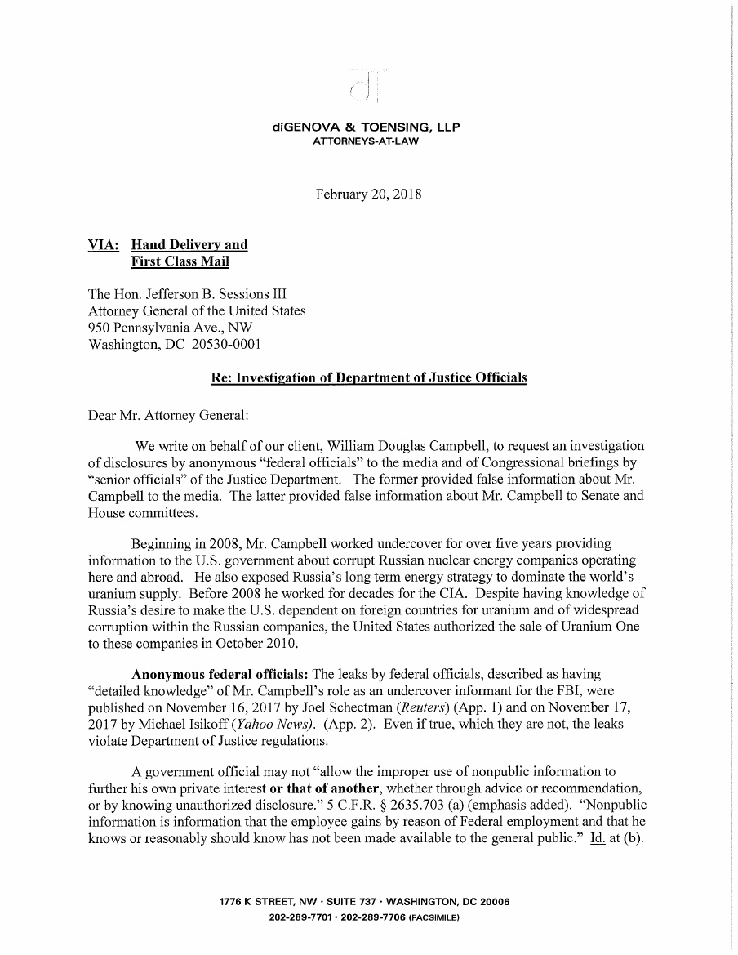

The Trojan Horse
On Friday, the last day for which the US government had funding, a 2,200 page Omnibus bill was carted into the Oval Office for the President’s signature. It had been created in a massive copy and past party over at Mitch McConnell’s house with staffers, interns, and advisors. The Trojan horse of a bill was dressed up to look like a strong and slick military horse, but its belly was filled with Democrats reeking of appletinis.
President Trump called a press briefing and did a massive head fake, tweeting that he was considering vetoing the bill. Before the day was done, and after what apparently was a final push by General Mattis to secure the funding to rebuild the military, he signed it. His base is not happy. The Democrats, are dancing in the streets. In the 241 year history of the Congress, Republicans have never had a 60-vote majority. They have never even once had the ability to overcome the filibuster threat imposed by the Democrats.
They knew he was bluffing. He had no choice. Not really. The government could have shut down, and the entire 36-member Freedom Caucus would not have offered support to sign such a bill to keep it open. No one would win, least of all the military. The one thing he wanted that could overshadow most of the other crap in this bill was the funding for the wall. The Democrats and the other globalist elites in Congress were effectively poking Trump in the eyes sand telling him that his wall will never be funded.
There is one things about budgets. They are just budgets. The money doesn’t get spent that way anyway. What could Trump do? Well later, after signing the unread 2,232 page bill, he invoked the Consolidated Appropriations Act of 2018. The letter is below:
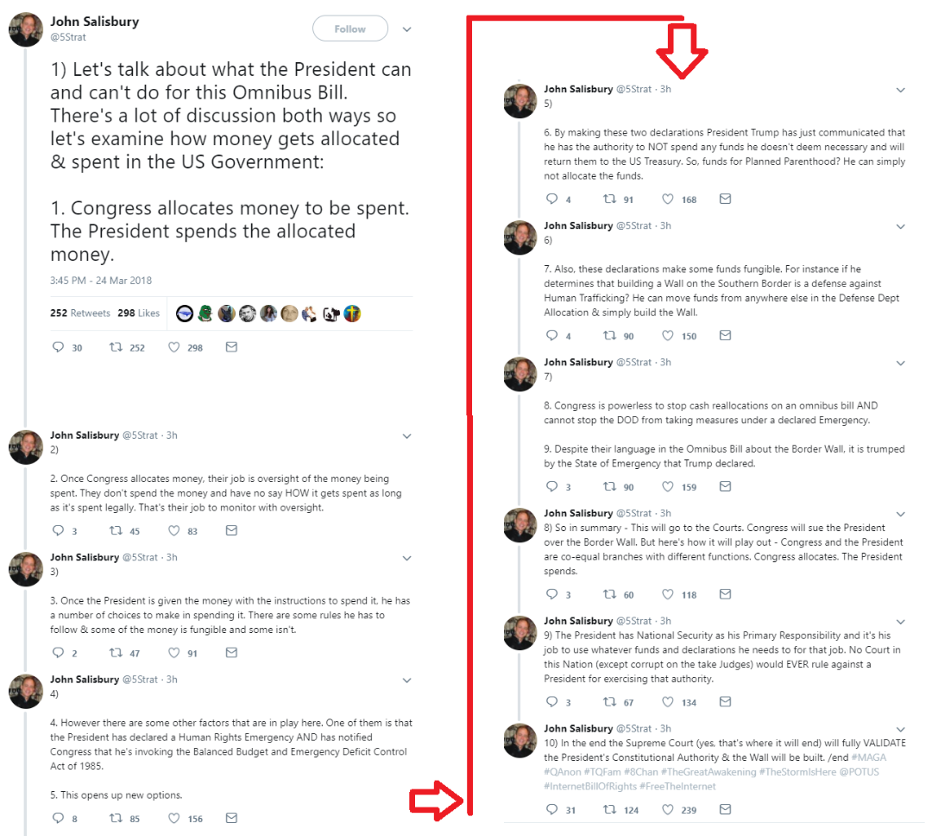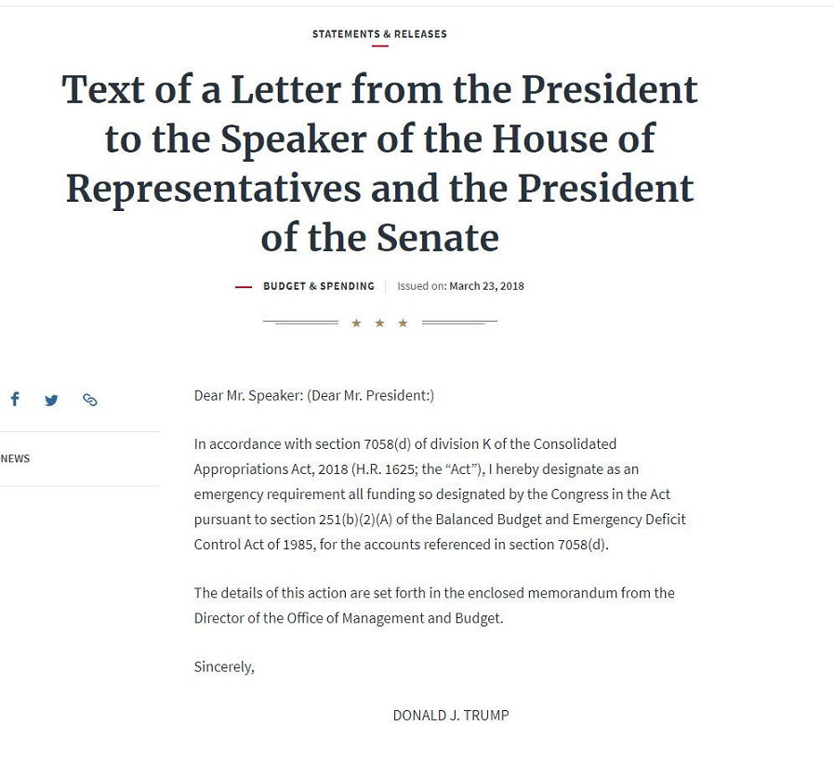
Now, normally, this would only allow him to take a few billion dollars from the international health supports to spend the way he pleases. But, last night at 11PM ET on Earth Radio in Jacksonville, Florida I floated the idea that the border wall is a matter of national security on several levels. It stops the invasion. It slows down illegal drugs from coming into our country. It slows down human trafficking. It protects the US Border Patrol agents who are assaulted every day. I suggested that Trump use the $700 billion military budget and the US Army Corps of Engineers to build the wall. I commented on how successful they were in building the Panama Canal.
This morning at 6:33, Donald Trump Tweeted this:
“Because of the $700 & $716 Billion Dollars gotten to rebuild our Military, many jobs are created and our Military is again rich. Building a great Border Wall, with drugs (poison) and enemy combatants pouring into our Country, is all about National Defense. Build WALL though M!
Let's talk about what the President can and can't do for this Omnibus Bill. There's a lot of discussion both ways so let's examine how money gets allocated & spent in the US Government:

1. Congress allocates money to be spent. The President spends the allocated money.
2. Once Congress allocates money, their job is oversight of the money being spent. They don't spend the money and have no say HOW it gets spent as long as it's spent legally. That's their job to monitor with oversight.
3. Once the President is given the money with the instructions to spend it, he has a number of choices to make in spending it. There are some rules he has to follow & some of the money is fungible and some isn't.
4. However there are some other factors that are in play here. One of them is that the President has declared a Human Rights Emergency AND has notified Congress that he's invoking the Balanced Budget and Emergency Deficit Control Act of 1985.
5. This opens up new options.
6. By making these two declarations President Trump has just communicated that he has the authority to NOT spend any funds he doesn't deem necessary and will return them to the US Treasury. So, funds for Planned Parenthood? He can simply not allocate the funds.
7. Also, these declarations make some funds fungible. For instance if he determines that building a Wall on the Southern Border is a defense against Human Trafficking? He can move funds from anywhere else in the Defense Dept Allocation & simply build the Wall.
8. Congress is powerless to stop cash reallocations on an omnibus bill AND cannot stop the DOD from taking measures under a declared Emergency.
9. Despite their language in the Omnibus Bill about the Border Wall, it is trumped by the State of Emergency that Trump declared.

9) So in summary - This will go to the Courts. Congress will sue the President over the Border Wall. But here's how it will play out - Congress and the President are co-equal branches with different functions. Congress allocates. The President spends.
10) The President has National Security as his Primary Responsibility and it's his job to use whatever funds and declarations he needs to for that job. No Court in this Nation (except corrupt on the take Judges) would EVER rule against a President for exercising that authority.
11) In the end the Supreme Court (yes, that's where it will end) will fully VALIDATE the President's Constitutional Authority & the Wall will be built. /end #MAGA #QAnon #TQFam #8Chan #TheGreatAwakening #TheStormIsHere @POTUS #InternetBillOfRights #FreeTheInternet

In a later tweet, Salisbury speculates:
This has got Mulvaney's fingerprints all over it...
Note that Nick Mulvaney, head of the OMB, outmaneuvered and outsmarted Elizabeth Warren’s cat’s paws at the Consumer Financial Protection Board, and became simultaneously the director there in order to begin dismantling its burdensome regulations. Taking advantage of Warren's design, he is now immune from Congressional oversight there. There is little doubt that he is highly skilled at using bureaucratic and legal frameworks.
I am not a constitutional lawyer, and have no idea if this strategy would work. But I like the way it promises to get the job done.

New Home Sales Continue Drop for 4th Month
Don’t even act like you are surprised. After a surprise rebound in existing home sales (even as condo sales slumped), new home sales were expected to rebound in Feb from their 7.8% plunge in January, but grossly disappointed, dropping 0.6% MoM - the 3rd monthly drop in a row.
This is the first time new home sales declined for 3 straight months since Q1 2014.
Your credit score affects your financial life in multiple ways: Lenders assign interest rates based on the bracket your score falls in. Landlords often require a minimum credit score in order to rent an apartment without a co-signer on the lease. Poor credit even affects how much homeowners pay for insurance.
How does your credit score stack up against the average for your age group? Here are the average scores by age, as of April 2017:
- 18-29 years old: 652
- 30-39 years old: 671
- 40-49 years old: 685
- 50-59 years old: 709
- Age 60+: 743
Add to that the fact that According to a 2017 GOBankingRates survey, more than half of Americans (57 percent) have less than $1,000 in their savings accounts.
While that's an improvement from last year, when 69 percent of Americans reported having less than $1,000 in savings, a higher percentage have no savings at all: 39 percent, up from 34 percent in 2016. Whitehouse said it’s not surprising that such a large percentage of people don’t have savings. “Unfortunately, many people are living paycheck to paycheck, struggling to pay off student loans and credit cards,” he said. “For those saddled with an enormous amount of debt, building savings can feel like climbing Everest.”

Average American Savings by Age: Older Americans Are Better at Saving
The average (or typical) American savings account balance varies greatly by age. However, one trend is clear from the 2017 survey responses: Savings account balances generally increase with age.
Millennials (ages 18 to 34) are more likely than other generations to have nothing saved. And adults 65 and older are more likely to have $10,000 or more in a savings account. Of course, time could play a role. Older adults have had more years to build their savings.
However, other factors could explain the disparity in savings accounts across generations.
More Millennials Have No Savings
In line with the overall survey results, millennials have gotten both better and worse at saving money. For example, a greater percentage of millennials now have $10,000 or more in savings. And, a smaller percentage have less than $1,000 in savings.
However, there’s a growing percentage of those who actually have nothing saved. Here’s a look at how much young millennials (ages 18 to 24) have in savings accounts this year compared to last year.
Compared to younger millennials, the percentage of older millennials with $0 in a savings account is lower — and so is the year-over-year change. Still, there’s an increase of 8 percentage points among older adults who have nothing saved compared to last year’s survey.
However, some are getting better at saving. This year’s survey saw an increase of 5 percentage points among older millennials who have at least $10,000 in savings accounts, too.
So, why is it that a higher percentage of all millennials have nothing stashed in a savings account? It could be a combination of factors.
For example, young adults tend to have low starting salaries and a heavy student loan debt, which might be making it hard for them to build savings, said Whitehouse. In fact, GOBankingRates’ 2016 Debt survey found that 36 percent of 18- to 24-year-old millennials and more than 40 percent of 25- to 34-year-old millennials have student loan debt.
But, it might also come down to millennials’ saving and spending habits. A separate survey found about half of all millennials are living paycheck to paycheck. Even worse: 72 percent of young millennials and 61 percent of older millennials admit they currently don’t have enough money to cover six months of living expenses.
Generation X Catching Up on Savings
A greater percentage of Gen Xers have $0 in savings compared to last year. But, the increase isn’t as high as it is among millennials.
This year, 38 percent of younger Gen Xers (ages 35 to 44) have $0 saved, which is only an increase of 3 percentage points from 2016. And, there has been a marked decline in the percentage of those with less than $1,000 in savings. The percentage of young Gen Xers with less than $1,000 saved fell 18 percentage points this year.
But perhaps this is the most encouraging news: There has been a noticeable increase — 12 percentage points — of those with $10,000 or more stashed in a savings account.
Baby Boomers Boosting Savings Significantly
Baby boomers (ages 55 to 64) have shown significant improvement in their savings over the past year.
Although one-third of boomers say they have $0 saved, that percentage hasn’t budged since last year. Meanwhile, the percentage of those with less than $1,000 saved has fallen 20 percentage points from 2016. And, the percentage of boomers with $10,000 or more saved has nearly doubled. This sounds good, but fewer than 10% of this age group are buying homes. They either rent, or they already own a home and lack the motivation to sell and move up by buying a higher-value home. Some are even cashing out and going debt free for the remainder of their lives.
“As the current wave of baby boomers retires, they are increasing their savings versus years past,” Whitehouse said. “The market crash of 2008 is still in the back of their minds, and they are increasing savings to protect against the next drop.”
Perhaps these results give more insight into boomers’ retirement savings habits. In its 2017 Retirement Savings survey, GOBankingRates found that nearly 30 percent of boomers ages 55 and older have nothing saved for retirement. However, when compared to other age groups, a greater percentage of boomers have at least $300,000 saved for retirement.
But, do they have enough saved to truly retire comfortably? Only time will tell.
The Bolton Maneuver
President Donald Trump’s newly appointed national security adviser, John Bolton, reportedly plans to “clean house” at the National Security Council.
Sources told Foreign Policy that Bolton’s planned purge will start with Obama administration holdovers and eventually broaden to include leakers and those disloyal to the president.
“Bolton can and will clean house,” a former White House official told Foreign Policy.
Another official issued a warning to former Obama officials — “Everyone who was there during Obama years should start packing their shit.”
But the purge reportedly won’t stop with former Obama appointees. A source told Foreign Policy that Bolton intends to “remove almost all the political [appointees] McMaster brought in.”
One Bolton source put a damper on the report, saying it was “premature” to talk about staff changes. Another cautioned that any staff changes, were they to be signed off on by Bolton, would be slow in coming because of the time it takes to process security clearances, which will likely leave Bolton with most current staff for President Trump’s upcoming May meeting with North Korea’s Kim Jong Un.
However, Matthew Freedman, a Republican consultant and Bolton adviser who is helping to manage the transition, is reportedly “overly ambitious about cleaning house,” according to a Republican source, although Freedman himself told Foreign Policy there was currently “no list” of people to fire.
Rocket Man…the Real One
He finally went up — just like the self-taught rocket scientist always pledged he would.
He came back down in one piece, too — a little dinged up and his steam-powered vessel a little cracked up.
Still, mission accomplished for a guy more daredevil than engineer, who drew more comparisons to the cartoon character Wile E. Coyote from his critics than he did to iconic stunt man Evel Knievel.
"Mad" Mike Hughes, the rocket man who believes the Earth is flat, propelled himself about 1,875 feet into the air Saturday before a hard landing in the Mojave Desert. He told The Associated Press that outside of an aching back he's fine after the launch near Amboy, California.
"Relieved," he said after being checked out by paramedics. "I'm tired of people saying I chickened out and didn't build a rocket. I'm tired of that stuff. I manned up and did it."
There were no reports he got a peak over the edge of the world at the table holding it up.

