Jihad Report
Jun 30, 2018 -
Jul 06, 2018
Attacks | 39
Killed | 148
Injured | 179
Suicide Blasts | 2
Countries | 10
Groundwork for Federal Election Protection Act
Late in 2016, we created a stir by suggesting that Donald Trump was likely right when he claimed that millions of noncitizens had illegally voted in the U.S. election. Now, a study by a New Jersey think tank provides new evidence that that's what happened.
Last November, just weeks after his Electoral College win that gave him the presidency, then President-elect Donald Trump tweeted, "In addition to winning the Electoral College in a landslide, I won the popular vote if you deduct the millions of people who voted illegally."
The reaction was angry and swift, with the left accusing him of being an "internet troll" and of hatching a "Twitter-born conspiracy theory."
At the time, we noted that a group called True The Vote, an online anti-voter-fraud website, had claimed that illegals had cast three million votes last year. The media and left-wing groups immediately portrayed True The Vote as a fringe group with little credibility.
The only problem is, a study in 2014 in the online Electoral Studies Journal made a quite similar claim: In the 2008 and 2010 elections, they said, as many as 2.8 million illegal noncitizen votes were cast, "enough to change meaningful election outcomes including Electoral College votes and congressional elections," said the study, authored by Jesse T. Richman and Gushan A. Chattha, both of Old Dominion University, and David C. Earnest of George Mason University.
The bombshell was this: "Noncitizen votes likely gave Senate Democrats the pivotal 60th vote needed to overcome filibusters in order to pass health care reform and other Obama administration priorities in the 111th Congress."
It got little coverage in the mainstream media, and what coverage it did get was almost entirely dismissive.
Now comes a new study by Just Facts, a libertarian/conservative think tank, that used data from a large Harvard/You.Gov study that every two years samples tens of thousands of voters, including some who admit they are noncitizens and thus can't vote legally.
The findings are eye-opening. In 2008, as many as 5.7 million noncitizens voted in the election. In 2012, as many as 3.6 million voted, the study said.
In 2016, the U.S. Census Bureau estimates that there were 21.0 million adult noncitizens in the U.S., up from 19.4 million in 2008. It is therefore highly likely that millions of noncitizens cast votes in 2016.
And it was no accident. Democrats had extensive get-out-the-vote campaigns in areas heavily populated by illegal aliens. As far back as 2008, Obama made sure that those who wanted to vote knew it was safe, announcing that election records would not be cross-checked with immigration databases.
And last year, the Obama White House supported a court injunction that kept Kansas, Alabama and Georgia from requiring proof of citizenship to register to vote. The message was sent, loud and clear: If you're a noncitizen or here illegally, don't be afraid. You're free to vote. No one will stop you.
We don't know the exact number of illegal votes. No one does. But the data that are available suggest that the number of illegal votes was substantial — probably in the millions, as Trump said — and likely had a significant impact on the election's outcome.
Even Democrats should find this troubling; every vote cast by a noncitizen voter negates the vote of a citizen voter. It's that simple. It's time the Democratic Party started living up to its name and stop encouraging noncitizens and illegal aliens to vote in our election

Good Mom With a Gun

A suspect allegedly tried to steal a car with two toddlers in the back seat on July 4 and ended up hospitalized with a gunshot wound to the head.
WTSP reports that the mother was out of the car at a Shell station south of Dallas, Texas, around 10 pm when the suspect allegedly jumped into the vehicle and begin to take off. A Dallas woman who got a firearm to protect herself didn’t know she would be using it just hours later after a carjacker tried to take her vehicle with her children inside. The mother jumped into the passenger seat and begged him not to take the car but he refused her request. The mother then reached into the glove compartment, pulled out a handgun, and shot the suspect in the head.
The mother said, “I’m not a killer but I do believe in defending what’s mine. I proceeded to jump in my backseat and told the gentleman to stop, to get out the car. He would not get out of the car. He turned around and looked at me,” she said.

“I reached over the armrest to get my glove compartment and that’s when I fired at him once I got the gun from my glove compartment.” She added, “I hope that woke him up.”

Our genius carjacker still tried to make off with the vehicle, but he ended up running it off the road and crashing it in the fence for obvious reasons. He would proceed to collapse in the middle of the street. The suspect was taken to the hospital, where NBCDFW reports his injuries were listed as non-life threatening.
The two toddlers were not injured.
When children are involved, obviously the authorities are going to be very understanding of that,” attorney Toby Shook, who is not involved in the case, told KDFW. “The law says that if a reasonable person in her situation would have acted the same way, found it immediately necessary to protect herself or a third party, in this case her children, then that’s legitimate self-defense.
SCOTUS Saves America from the OFA
The Supreme Court has never held that a legislative district map can be unconstitutional on "partisan gerrymandering" grounds, and this past week was no exception when it rejected the Democrats' lawsuit in the Gill v. Whitford case from Wisconsin. That is a victory for the voters of Wisconsin and the nation, and for the Constitution.
The Supreme Court's dismissal of this case for lack of standing - Litigation 101 - also is a major blow to former Obama Attorney General Eric Holder's litigation strategy to impact the 2018 state elections: to rig the system for Democrats in the redistricting battle that will ensue after the 2020 election cycle. Had the plaintiff Democrats won, it would have been the biggest gift to lawyers in a very long time. Our nation's courts would have been open to lawsuits alleging that maps are unconstitutional because a candidate or party lost. And courts would have had to determine questions of political partisanship, which threatens to erode trust in the judiciary as one of the last nonpartisan institutions.
Legislative map-drawing has been a political process that is, by design, executed in state legislative chambers closest to the people they represent. The Republican State Leadership Committee argued to the court in its amicus brief that partisan gerrymandering of the kind alleged in Wisconsin simply does not violate any "well-developed and familiar" constitutional right. Democrats argue that a political party is entitled to a proportionate share of seats based on their statewide vote totals - a "right to win" - when America has a winner-take-all system, where winning individual elections, not running up votes in safe districts, is what matters. For the Supreme Court, or any lower court, to even consider the Democrats' argument would suggest that all voters only vote one party, and that we adopt a style of government closest to a European parliament, rather than a constitutional republic.
The Democrats' argument of one-party voting in the Wisconsin case doesn't even track with recent election history in the Badger State. In 2012, four Republicans won in state assembly districts carried by President Obama, some by double digits. Democrats flipped two state Senate seats that year: the 1st and 10th districts.
After a decade of record losses at the ballot box at the state level by Democrats, Republicans now control 67 of 99 state legislative chambers, having flipped nearly 1,000 state legislative seats on district lines largely drawn by Democrats. Within the past year, liberals and progressives, under the leadership of Eric Holder and Barack Obama, have feverishly turned to the nation's courts to steal the power of map-drawing away from locally elected officials - and are raising tens of millions of dollars to do it.
While Democrats would like to replicate the success of the Republican State Leadership Committee's REDMAP program from 2010, the success of that program is based on having candidates and policies that voters want. Because they are bankrupt on good policy, the first listed priority of Holder's National Democratic Redistricting Committee (NDRC) is to litigate. This goes hand-in-glove with what Mother Jones reported in 2014when an official with the Ohio AFL-CIO stated: "We figured out a long time ago that it's easier to elect seven judges than to elect 132 legislators."
Notably absent in the efforts by the Holder-Obama alliance was public comment on the other case in front of the Supreme Court (Benisek v. Lamone), where Republicans acted against a map drawn by Democrats for which former Gov. Martin O'Malley (D-Md.) said under oath, "Part of my intent was to create a map that, all things being legal and equal, would, nonetheless, be more likely to elect more Democrats rather than less." Also absent was any comment on then-Sen. Barack Obama's drawing of his own Illinois state Senate district, to give him better access to high-income liberal donors to bolster his political career.
Holder's definition of "fairness" is nothing more than a naked power grab by Democrats. If you don't see through this very calculated effort by Team Obama-Holder, look no further than the three federal lawsuits filed by Holder's NDRC last week, alleging violations of the Voting Rights Act in Alabama, Georgia and Louisiana; Holder's own Justice Department approved the 2011 maps for all three states.
Sadly, the Holder group's priority, as stated on its Twitter account, is to litigate, not actually help candidates campaign for votes at the ballot box, like Republicans did on Democrat-drawn lines in 2010.
If the Obama-Holder effort is successful in rolling back Republican legislative majorities, there is more to be lost than control of redistricting. States with GOP governors and legislative majorities have demonstrated how to grow jobs, spur innovation and provide children with a better education by reducing taxes and regulatory burdens on businesses, enacting litigation reform and right-to-work laws, restoring solvency to government pension plans, and putting in place school choice, charter schools and school accountability standards. Contrast Republican-led states with New York, Connecticut, California and Illinois, where progressive-left Democrats have driven up taxes, appeased the unions and trial lawyers, thrown money at bad schools and lost jobs as people and businesses relocated elsewhere
Uranus Collided With Planet Twice the Size of Earth
It turns out that Uranus is so weird because of a massive collision billions of years ago.
A new study confirms that this collision with a huge object — which was approximately twice the size of Earth — could have led to the planet's extreme tilt and other odd attributes.
Uranus, the planet with the unforgettable name, is unique in a number of ways. "All of the planets in the solar system are spinning more or less in the same way … yet Uranus is completely on its side," Jacob Kegerreis, the new study's lead author and a researcher at Durham University's Institute for Computational Cosmology in the U.K., told Space.com. And this isn't the only thing that makes the planet so strange.
Uranus also has a "very, very strange" magnetic field and is extremely cold, even though it "should" be warmer, according to Kegerreis. In this study, Kegerreis and his team of astronomers seek to explain many of the planet's odd features by attributing them to a collision with a massive, icy object about 4 billion years ago. [Photos of Uranus, the Tilted Giant]
To better understand how the impact affected Uranus' evolution, the team used a high-powered supercomputer to run a simulation of massive collisions — something that has never been done before. This study confirms an older study that suggested Uranus' significant tilt was caused by a collision with a massive object.

Scientists used a high-resolution simulation to confirm that an object twice the size of Earth collided with Uranus and altered its tilt.
Credit: Jacob Kegerreis/Durham University
The researchers suspect that this object was probably a young protoplanet, made up of rock and ice. This collision is "pretty much the only way" that we can explain Uranus' tilt, Kegerreis said.
Amazingly, Uranus retained its atmosphere after this impact. The researchers think that this is because the object only grazed the planet, hitting it hard enough to change its tilt but not enough to affect its atmosphere, according to a statement from Durham University.
It's likely that this type of event isn't uncommon in the universe: "All the evidence points to giant impacts being frequent during planet formation, and with this kind of research, we are now gaining more insight into their effect on potentially habitable exoplanets," Luis Teodoro, study co-author and researcher at the BAER/NASA Ames Research Center, said in the statement.

This composite image, created in 2004 with Keck Observatory telescope adaptive optics, shows Uranus' two hemispheres.
Credit: Lawrence Sromovsky, University of Wisconsin-Madison/W.W. Keck Observatory
But this enormous object crashing into Uranus did more than just knock it into a new tilt. According to this research, when the object hit Uranus, some of the debris from the impact may have formed a thin shell that continues to trap heat coming from the planet's core. This could at least partially explain why Uranus' outer atmosphere is extremely cold.
According to Kegerreis, this collision could also explain two other oddities about the tilted planet. First, it could explain how and why some of Uranus' moons formed. The researchers think that the impact could have knocked rock and ice into the young planet's orbit — debris that later became some of Uranus' 27 moons. Additionally, they think that the collision could have altered the rotation of any moons that already existed at the time. Last year, a separate study also explored this aspect of the collision.
The researchers also suggest that the collision could have created molten ice and lumps of rock inside the planet, which tilted its magnetic field, according to the statement.
Following this study, the researchers hope to study this collision with even higher-resolution simulations to better understand Uranus' evolution, according to Kegerreis. He also noted that the team aims to study Uranus' chemistry and the different ways that an impact like this could have affected its atmosphere
Deep Impact?
The first mission designed to hunt a meteorite that crashed into the ocean has now discovered what may be tiny fragments of the meteorite's crust, researchers say.
On March 7, three National Oceanic and Atmospheric Administration (NOAA) weather stations detected the fall of a meteorite about 15.5 miles (25 kilometers) off the coast of Washington state. "The fall was widely seen around local areas and widely heard around local areas — it came with some loud sonic booms," Marc Fries, the cosmic dust curator for NASA, told Live Science.
Fries estimated this fall might yield about 4,400 lbs. (2,000 kilograms) of meteorites. He also calculated the largest meteorite might weigh about 9.7 lbs. (4.4 kg) and have a diameter of about 5 inches (12 centimeters). [Crash! The 10 Biggest Impact Craters on Earth]
"This is the largest meteorite fall I've seen in 20-plus years of radar data," Fries said.
The details the scientists had regarding the fall suggested the meteorite was unusually strong, Fries said. This knowledge, in combination with the fact the meteorite landed on a soft seafloor as opposed to dry land, suggested this ocean fall might yield large, relatively intact meteorites for scientists to study.
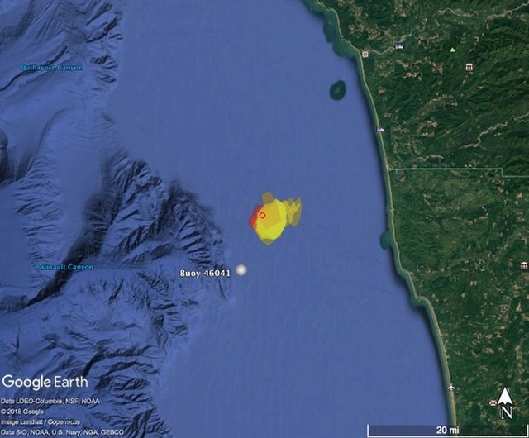
The meteorite fragments were found off the coast of Washington state.
Credit: Mark Fries/NASA
Until now, scientists had never intentionally recovered a meteorite from the ocean, Fries said. In the past, researchers had accidentally discovered a couple of meteorites from drilling samples taken from the seafloor, he noted. However, this latest endeavor is the "first intentional search for meteorites from the ocean," Fries said.
Ocean Exploration Trust, a scientific research nonprofit organization, worked with scientists from NOAA's Olympic Coast National Marine Sanctuary, NASA and the University of Washington to locate any meteorites from this fall.
On July 1, the Exploration Vessel Nautilus investigated about 0.4 square mile (1 square kilometer) of water in the Olympic Coast National Marine Sanctuary, located off the coast of Washington state, sailing about 330 feet (100 meters) above the seafloor. The ship used multibeam sonar to map the seafloor, but the team "didn't really see any smoking-gun signature of a meteorite, any change to the texture of the seafloor," Nicole Raineault, leader of the expedition and the vice president of exploration and science operations at the Ocean Exploration Trust, told Live Science.
On July 2, the scientists deployed two remote-controlled submarines — the Hercules and the Argus — to investigate the seafloor. If the researchers saw anything interesting through the cameras of these remotely operated vehicles, they directed the robots to pick them up using either magnets or a suction pump.
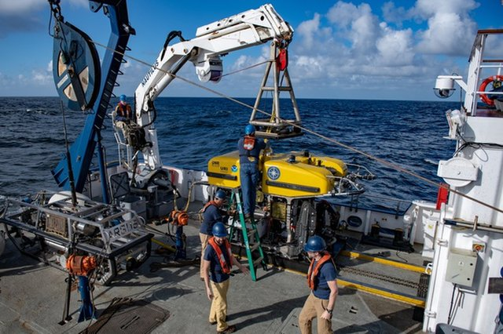

Scientists aboard the Exploration Vessel Nautilus launch the ROV Hercules to search for meteorite fragments off the coast of Washington state.
Credit: Susan Poulton/Ocean Exploration Trust
The researchers did not spot any meteorites, as the seafloor was very soft, "and in all likelihood, any meteorites sank into the seafloor," Fries said.
However, after returning to the lab and spending 6 hours analyzing sediment, the team identified what seemed to be meteorite fragments in the last sample they had gathered, Fries said. "So far, we see two small fragments," he said.
"The meteorite fragments are small, melted pieces of rock," Fries said. Each about 2 to 3 millimeters [0.08 to 0.12 inches] large, they likely came "from the outside of a meteorite. When a meteor enters the atmosphere, it accrues what's called a fusion crust — "you have flash-melting of the rock, which coats the rock like pottery glaze," he said.
The reason Fries thinks these fragments are from the recent meteorite fall is that they are "basically made of glass, and such flash-melted glassy materialsdo not tend to last long in seawater." Moreover, these fragments "looked like they came from a small pit in the seafloor," Fries said. "It's some evidence that they came from something that fell."
Now, Fries and his colleagues will analyze these fragments in the lab to see what they are made of. "If they are meteoric in origin, we can tell what kind of meteorite they came from," he said.
Additional smaller meteorite fragments may lurk in sediment that the researchers collected. "We regularly deal with specks naked to the eye," Fries said. "We can deal with smaller things."
There are no plans to return to the site to look for more meteorite fragments, but, Fries said, "I certainly wouldn't mind going."
World UFO Day
Are we alone? Unfortunately, neither of the answers feel satisfactory. To be alone in this vast universe is a lonely prospect. On the other hand, if we are not alone and there is someone or something more powerful out there, that too is terrifying.
As a NASA research scientist and now a professor of physics, I attended the 2002 NASA Contact Conference, which focused on serious speculation about extraterrestrials. During the meeting a concerned participant said loudly in a sinister tone, "You have absolutely no idea what is out there!" The silence was palpable as the truth of this statement sunk in. Humans are fearful of extraterrestrials visiting Earth. Perhaps fortunately, the distances between the stars are prohibitively vast. At least this is what we novices, who are just learning to travel into space, tell ourselves.
I have always been interested in UFOs. Of course, there was the excitement that there could be aliens and other living worlds. But more exciting to me was the possibility that interstellar travel was technologically achievable. In 1988, during my second week of graduate school at Montana State University, several students and I were discussing a recent cattle mutilation that was associated with UFOs. A physics professor joined the conversation and told us that he had colleagues working at Malmstrom Air Force Base in Great Falls, Montana, where they were having problems with UFOs shutting down nuclear missiles. At the time I thought this professor was talking nonsense. But 20 years later, I was stunned to see a recording of a press conference featuring several former US Air Force personnel, with a couple from Malmstrom AFB, describing similar occurrences in the 1960s. Clearly there must be something to this.
With July 2 being World UFO Day, it is a good time for society to address the unsettling and refreshing fact we may not be alone. I believe we need to face the possibility that some of the strange flying objects that outperform the best aircraft in our inventory and defy explanation may indeed be visitors from afar – and there's plenty of evidence to support UFO sightings.

The Fermi paradox
The nuclear physicist Enrico Fermi was famous for posing thought provoking questions. In 1950, at Los Alamos National Laboratory after discussing UFOs over lunch, Fermi asked, "Where is everybody?" He estimated there were about 300 billion stars in the galaxy, many of them billions of years older than the sun, with a large percentage of them likely to host habitable planets. Even if intelligent life developed on a very small percentage of these planets, then there should be a number of intelligent civilizations in the galaxy. Depending on the assumptions, one should expect anywhere from tens to tens of thousands of civilizations.
With the rocket-based technologies that we have developed for space travel, it would take between 5 and 50 million years for a civilization like ours to colonize our Milky Way galaxy. Since this should have happened several times already in the history of our galaxy, one should wonder where is the evidence of these civilizations? This discrepancy between the expectation that there should be evidence of alien civilizations or visitations and the presumption that no visitations have been observed has been dubbed the Fermi Paradox.
Carl Sagan correctly summarized the situation by saying that "extraordinary claims require extraordinary evidence." The problem is that there has been no single well-documented UFO encounter that would alone qualify as the smoking gun. The situation is exacerbated by the fact that many governments around the world have covered up and classified information about such encounters. But there are enough scraps of evidence that suggest that the problem needs to be open to scientific study.

Cover of the October 1957 issue of pulp science fiction magazine Amazing Stories. This was a special edition devoted to 'flying saucers,' which became a national obsession after airline pilot Kenneth Arnold sighted a saucer-shaped flying objects in 1947.

UFOs, taboo for professional scientists
When it comes to science, the scientific method requires hypotheses to be testable so that inferences can be verified. UFO encounters are neither controllable nor repeatable, which makes their study extremely challenging. But the real problem, in my view, is that the UFO topic is taboo.
While the general public has been fascinated with UFOs for decades, our governments, scientists and media, have essentially declared that of all the UFO sightings are a result of weather phenomenon or human actions. None are actually extraterrestrial spacecraft. And no aliens have visited Earth. Essentially, we are told that the topic is nonsense. UFOs are off-limits to serious scientific study and rational discussion, which unfortunately leaves the topic in the domain of fringe and pseudoscientists, many of whom litter the field with conspiracy theories and wild speculation.
I think UFO skepticism has become something of a religion with an agenda, discounting the possibility of extraterrestrials without scientific evidence, while often providing silly hypotheses describing only one or two aspects of a UFO encounter reinforcing the popular belief that there is a conspiracy. A scientist must consider all of the possible hypotheses that explain all of the data, and since little is known, the extraterrestrial hypothesis cannot yet be ruled out. In the end, the skeptics often do science a disservice by providing a poor example of how science is to be conducted. The fact is that many of these encounters – still a very small percentage of the total – defy conventional explanation.
The media amplifies the skepticism by publishing information about UFOs when it is exciting, but always with a mocking or whimsical tone and reassuring the public that it can't possibly be true. But there are credible witnesses and encounters.
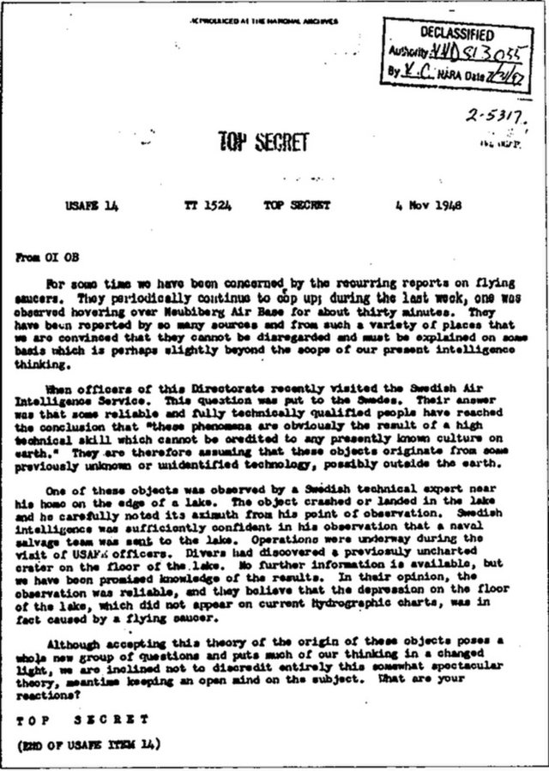
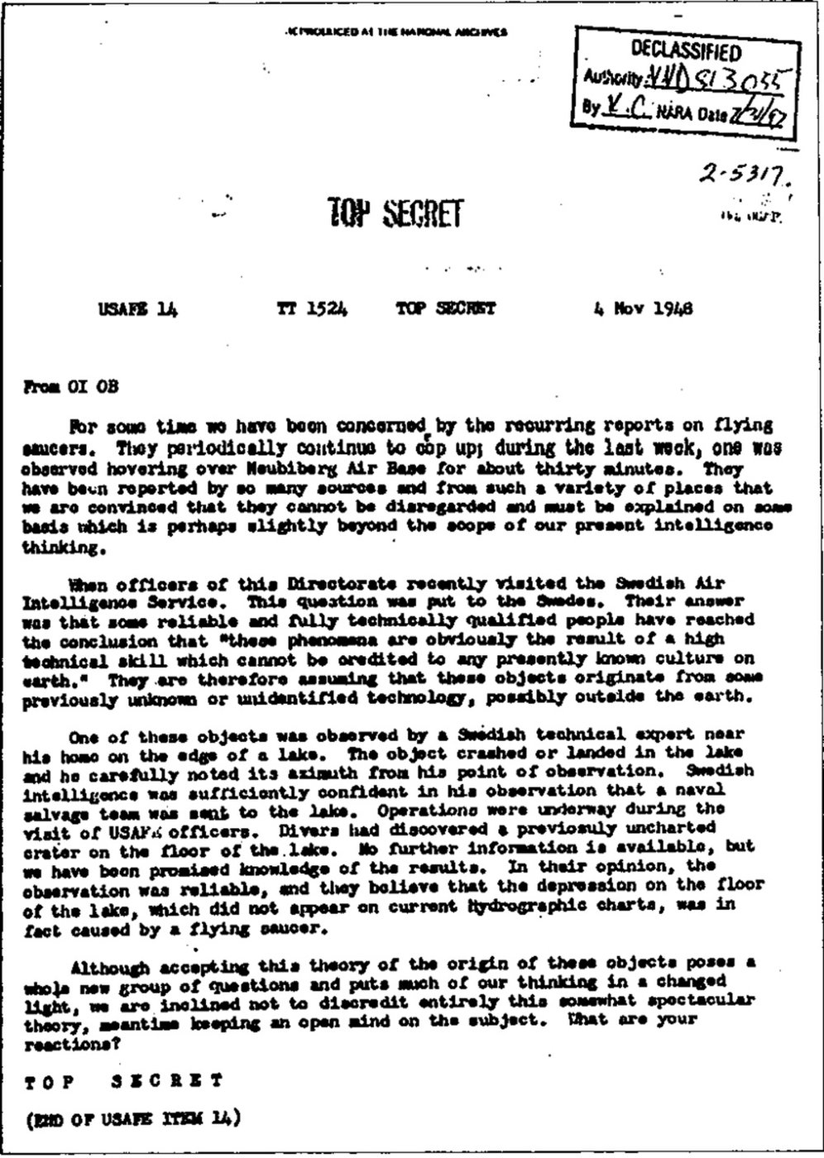
1948 Top Secret USAF UFO extraterrestrial document. United States Air Force
Credit: United States Air Force

Why don't astronomers see UFOs?
I am often asked by friends and colleagues, "Why don't astronomers see UFOs?" The fact is that they do. In 1977, Peter Sturrock, a professor of space science and astrophysics at Stanford University, mailed 2,611 questionnaires about UFO sightings to members of the American Astronomical Society. He received 1,356 responses from which 62 astronomers – 4.6 percent – reported witnessing or recording inexplicable aerial phenomena. This rate is similar to the approximately 5 percent of UFO sightings that are never explained.
As expected, Sturrock found that astronomers who witnessed UFOs were more likely to be night sky observers. Over 80 percent of Sturrock’s respondents were willing to study the UFO phenomenon if there was a way to do so. More than half of them felt that the topic deserves to be studied versus 20 percent who felt that it should not. The survey also revealed that younger scientists were more likely to support the study of UFOs.
UFOs have been observed through telescopes. I know of one telescope sighting by an experienced amateur astronomer in which he observed an object shaped like a guitar pick moving through the telescope's field of view. Further sightings are documented in the book "Wonders in the Sky," in which the authors compile numerous observations of unexplained aerial phenomena made by astronomers and published in scientific journals throughout the 1700s and 1800s.

Evidence from government and military officers
Some of the most convincing observations have come from government officials. In 1997, the Chilean government formed the organization Comité de Estudios de Fenómenos Aéreos Anómalos, or CEFAA, to study UFOs. Last year, CEFAA released footage of a UFO taken with a helicopter-mounted Wescam infrared camera.
The countries of Brazil, Canada, Denmark, Ecuador, France, New Zealand, Russia, Sweden and the United Kingdom have been declassifying their UFO files since 2008. The French Committee for In-Depth Studies, or COMETA, was an unofficial UFO study group comprised of high-ranking scientists and military officials that studied UFOs in the late 1990s. They released the COMETA Report, which summarized their findings. They concluded that 5 percent of the encounters were reliable yet inexplicable: The best hypothesis available was that the observed craft were extraterrestrial. They also accused the United States of covering up evidence of UFOs. Iran has been concerned about spherical UFOs observed near nuclear power facilities that they call "CIA drones" which reportedly are about 30 feet in diameter, can achieve speeds up to Mach 10, and can leave the atmosphere. Such speeds are on par with the fastest experimental aircraft, but unthinkable for a sphere without lift surfaces or an obvious propulsion mechanism.
In December 2017, The New York Times broke a story about the classified Advanced Aviation Threat Identification Program, which was a $22 million program run by the former Pentagon official Luis Elizondo and aimed at studying UFOs. Elizondo resigned from running the program protesting extreme secrecy and the lack of funding and support. Following his resignation Elizondo, along with several others from the defense and intelligence community, were recruited by the To the Stars Academy of Arts & Science, which was recently founded by Tom DeLonge to study UFOs and interstellar travel. In conjunction with the launch of the academy, the Pentagon declassified and released three videos of UFO encounters taken with forward looking infrared cameras mounted on F-18 fighter jets. While there is much excitement about such disclosures, I am reminded of a quote from Retired Army Colonel John Alexander: "Disclosure has happened. … I've got stacks of generals, including Soviet generals, who’ve come out and said UFOs are real. My point is, how many times do senior officials need to come forward and say that this is real?"

A topic worthy of serious study
There is a great deal of evidence that a small percentage of these UFO sightings are unidentified structured craft exhibiting flight capabilities beyond any known human technology. While there is no single case for which there exists evidence that would stand up to scientific rigor, there are cases with simultaneous observations by multiple reliable witnesses, along with radar returns and photographic evidence revealing patterns of activity that are compelling.
Declassified information from covert studies is interesting, but not scientifically helpful. This is a topic worthy of open scientific inquiry, until there is a scientific consensus based on evidence rather than prior expectation or belief. If there are indeed extraterrestrial craft visiting Earth, it would greatly benefit us to know about them, their nature and their intent. Moreover, this would present a great opportunity for mankind, promising to expand and advance our knowledge and technology, as well as reshaping our understanding of our place in the universe.
Kevin Knuth, Associate Professor of Physics, University at Albany, State University of New York.

Tennessee Demands to Withdraw from Federal Refugee Law

So, you think it is illegal for States to refuse to comply with Federal immigration law? Think again. The country’s 4th State has said, “Enough.”
The state of Tennessee is appealing the dismissal of its lawsuit against the federal government’s “voluntary” federal refugee-relocation program.

“The federal government is forcing the tax-paying citizens of Tennessee to fund the federal refugee resettlement program despite their elected state officials withdrawing from the program,” explained Kate Oliveri, a lawyer for the Thomas More Law Center, which is representing the state.
TMLC appealed to the 6th U.S. Circuit Court of Appeals after a federal court dismissed the case. Oliveri charged the court “erred, not only in allowing this usurpation of state funds, but also by holding that the General Assembly cannot bring a lawsuit to defend against any usurpation of its power.”
Tennessee withdrew from the federal program, but the federal government then assigned a private organization to run its resettlements in Tennessee, prompting the lawsuit.
The feds threatened to cut billions of dollars in funding from the state if it didn’t pay the costs of the program. In the complaint, filed in 2017, TMLC explained there are critical constitutional questions, such as whether or not the federal government force the state to pay for a voluntary program from which it formally has withdrawn.
Citing Supreme Court Chief Justice John Roberts’ admonition that the states “are separate and independent sovereigns” and “sometimes they have to act like it,” the state authorized TMLC to file the appeal after the district court dismissed the case.
The state officially withdrew from the federal refugee resettlement program in 2007, but “the government continues, to this day, to commandeer state tax dollars to fund it,” TMLC said.
It’s all part of the fight over the settlement of refugees from the Middle East in small communities nationwide that escalated under the administration of Barack Obama and continues under the Trump administration.
One concern is that terrorists could be brought to the U.S. under the guise of being a refugee. Also, critics have noted that many “refugees” are simply young men looking for economic opportunities, and they are overwhelmingly Muslim.
The case was filed on behalf of the state of Tennessee, the Tennessee General Assembly, and state legislators Terri Lynn Weaver and John Stevens. It charged that the federal refugee program violates the principles of state sovereignty under the Tenth Amendment.
“Tennessee has a history of supporting the Tenth Amendment and state sovereignty,” the legal team explained. “In 2009, House Joint Resolution 108, which passed in the Senate 31-0 and in the House by 85-2, demanded that the federal government halt its practice of imposing mandates upon the states for purposes not enumerated by the U.S. Constitution.”
TMLC said that when Congress adopted the Refugee Resettlement Act in 1980, the intent was to assure full federal reimbursement for the costs. But those reimbursements soon were reduced and were eliminated entirely by 1991.
That left Tennessee taxpayers on the hook financially for a program imposed by Washington. When the state withdrew, the federal government simply appointed Catholic Charities of Tennessee, a private group, to run it. The program is funded with taxpayer money. The state contends the Constitution forbids the federal government from “commandeering state funds” to support the federal program.
Richard Thompson, the organization’s chief counsel, said: “This case involves critical constitutional issues regarding the appropriate balance between the powers of the federal government and the states. Our lawsuit and appeal focuses solely on the unconstitutional manner in which the federal program is currently operating in the state of Tennessee. The district court decision dismissing this case conflicts with several U.S. Supreme Court opinions upholding state sovereignty against overreach by the federal government. The purpose of this lawsuit is to preserve the balanced constitutional relationship between the Federal government and the States as intended by our Founding Fathers, and which is so crucial to our individual liberties.”
The TMLC brief contends the district court made a mistake in determining that the state failed to make a claim upon which relief could be granted. The lower court also said it didn’t have subject-matter jurisdiction. The brief said the effect of the federal governments’ actions is “to deprive Tennessee of its sovereignty and regulate it in its sovereign capacity.”
“The federal government therefore carries out its refugee resettlement program through economic dragooning of state funds and instrumentalitis, which is impermissible under the Tenth Amendment to the United States constitution and in excess of the federal government’s powers under the Constitution’s Spending Clause.”

#WalkAway: The rest of the story

The victory of Alexandria Ocasio-Cortez over longtime Democratic congressman Joe Crowley of New York inspired some hysterical punditry. We were told that the 28,000 people that voted in a district of more than 600,000 had decided the fate of the political universe. Ocasio-Cortez, in this telling, heralds the coming of Democratic Socialist, multiracial, female-dominated America. It is a stark type and a shadow of the WalkAway movement. Why? Because Cortez didn’t win this primary. Not by a long shot. The fact is that Joe Crowley lost.
The 28-year-old bartender and community activist is the Democrat of the future—according to no less an authority than the chairman of the Democratic National Committee. And in a polarized media climate, with hyperbolic insinuations of "civil war" and calls for the harassment of political opponents, one is tempted to believe that romanticism and extremism grow ever stronger. Half the sexy bartenders in New York have college degrees and could each get 28,000 votes if they ran. Those are the facts.
What’s even more telling is that DNC leadership snatched her micro-vote and hoisted it up on the flagpole as a rallying cry for their base. What happens next is the total and complete collapse of the Democrat Party.
For one thing, New York politics is sort of the equivalent of the Las Vegas party scene—what happens there tends to stay there. Crowley was boring and out-of-touch; Ocasio-Cortez is sexy and brainless with popping brown eyes and a tireless campaigner. That really means she never shuts up. No really. She never closes her mouth long enough to listen to what people are asking her,or telling her. Have you actually listened to any of her interviews? The key word is vacuous.
Her picture of democratic socialism is all rainbows and unicorns, ambiguous platitudes and aspirations. And the numbers involved in the primary were so small that randomness has to have played some part in her 4,000-vote win. That is basically two apartment complexes. Two. Ocasio-Cortez is neither a threat to America nor to the American right. But she is representative of the transformation of the American left.
The only civil war happening at the moment is within the Democratic Party. The old-guard corporatists are under attack from activists with radical goals and immoderate tempers. They are cornered, old, and extremely dangerous. You can trace a line from Occupy Wall Street in 2011 through Black Lives Matter in 2013 through Bernie Sanders in 2016 through the Women's March a year later, the beatings and torchings by a thuggish mob known as ANTIFA, Tom Steyer’s threat of nuclear war and Maxine Waters's impeachment campaigns. The growing prominence of Democratic Socialists of America, and the movement to abolish Immigration and Customs Enforcement today are only the symptoms of gangrene spreading throughout the party.
How long Nancy Pelosi remains Democratic leader depends on her blood oxygen content. It ain’t looking good. During a recent telephone town hall, activists demanded Chuck Schumer stop President Trump's Supreme Court pick (he can't) and back up Auntie Maxine (he'd be crazy to). The intellectual energy, if you can call it that, is on the farther reaches of the left blogs, publications and most certainly every single TV channel including Fox News. And please, don’t leave out Hollywood.
This is a trend that has been building for some time but over the last two years acquired galvanic force. Why? You know why. Is it because the nature of the threat that Donald Trump represents to the left? Is it because, as Victor Davis Hanson has argued, Trump denied the left the power it considers its due? Or is it because Barack Obama, despite all of his purple rhetoric and fantastic publicity, was unable even to approach his goal of "fundamentally transforming" America—because he left the Democratic Party a smoking ruin, and bequeathed a regulatory and policy legacy as fragile as a paper crane?
All of these explanations for the resurgent left have some merit. I am especially partial, naturally, to the one that pins responsibility on Obama, who raised the hopes of a generation that the waters would cease to rise only to hand over command of the ship eight years later to Donald Trump and become a Netflix producer. Still, it is important to recognize that the collapse of the center-left is not limited to America. It is a global phenomenon. Obama and Clinton may have broken the Democratic Party, but don't hold them responsible for the destruction of the French Socialists, the fall of the Italian Democratic Party, the takeover of Labor by Jeremy Corbyn, the worst result by the German Social Democratic Party since World War II, and the triumph of López-Obrador in Mexico.
If there is a common denominator to these electoral shakeups, it is the politics of migration. The overthrown establishments all benefited from the economics of illegal immigration and used migrants as chits in a humanitarian sweepstakes in which the leader who signals the most virtue wins. Migration became a symbol for the "flat world" of globalization where not just people but also cultures, goods, and investments flowed freely, borders had little meaning, and sovereignty was pooled upwards to transnational bureaucracy as identity was reduced to racial, ethnic, religious, or sexual characteristics. The fantastic wealth produced by the global marketplace enriched the center-left to such a degree that its adherents became walled off from the material, social, and cultural concerns of the working people they professed to represent. And so middle-class workers who believe a country's leadership ought to be accountable to a country's citizens went elsewhere—devastating the ranks of the center left and creating a vacuum for the neo-socialists of the twenty-first century.

Ant Man and Wasp

I'm not entirely sure I could recall for you the plot of the first Ant-Man film. There was something about a thief played by Paul Rudd stealing a suit that makes him small from a scientist played by Michael Douglas who had a daughter played by Evangeline Lilly and also the aforementioned characters wanted to stop Michael Douglas's work from falling into the hands of the congressman from House of Cards, who was evil because capitalism.
And that's fine! Not every comic book film needs to be a mega-event with enormous stakes that have wide-ranging ramifications for the world in which the characters exist. Not every action-adventure flick needs to be a commentary upon our times. Not everything has to be "memorable" or "interesting after the fact." The Marvel Cinematic Universe is, by its nature, disposable and not particularly suitable for multiple viewings. Ant-Man was simply the purest distillation of that ethos. There's something refreshing about these films being as inconsequential as their source material.
Ant-Man and the Wasp marks the return of Scott Lang (Rudd), who has been confined to house arrest for taking part in the climactic superhero battle in 2016's Captain America: Civil War. He's just a few days away from being released when a psychic transmission from the, ah, quantum realm (trippy subatomic space, basically?) spurs him to get in touch with Dr. Hank Pym (Douglas) and Pym's daughter, Hope Van Dyne (Lilly). The gang has to head into the quantum realm to rescue Janet Van Dyne (Michelle Pfeiffer), who has been stuck in the micro-verse for decades.
To rescue her, they'll need a doohickey owned by the delightfully named southern dandy, Sonny Burch (Walton Goggins), and have to fend off attacks from Ghost (Hannah John-Kamen), a one-time SHIELD hit-woman whose body has been destabilized by quantum particles, or something. She can walk through walls and put hands through bodies and do all sorts of neat stuff.
There is action aplenty, with Hope donning the Wasp costume, which is basically like the Ant-Man costume but with wings and laser blasters that go pew-pew-pew. Director Peyton Reed has fun with scale, shrinking cars to Hot Wheels-sized autos and blowing them back up again as the heroes and villains race through San Francisco. Like its predecessor, Ant-Man and the Wasp features a sort of faux-adventurousness in its action sequences: It sticks to the standard MCU beat (you better believe there's a black SUV that's going to flip during a high-speed chase and there's no shortage of acrobatic fist fights) but does so in ways that emphasize the special powers of Ant-Man. The whole thing contributes to Marvel's patented brand of familiar originality. All these movies are basically identical, stylistically, but each also has a patina of creativity that blinds viewers to the fact that they're seeing the same thing over and over again.
Michael Peña provides expert comic relief as Lang's buddy and business partner, Luis. Ditto Abby Ryder Fortson, who plays Lang's daughter, Cassie. The whole thing is zippy and fun and more or less unmemorable. I heartily recommend it if you're looking for a mid-summer diversion. Make sure to stick around for the mid-credits scene! Movie ain't over 'til you've sat through ten minutes of credits waiting for a gag or two.
The Straits of Hormuz

I’m in the electric truck businesses. High fuel prices make people look for my company. I truly think we’re ready to stop digging up our planet and shoveling it into our gas tanks to burn. I know I am ready. My trucks are tough, durable, affordable and fast. What have I warned for a few years? If something happens in the Straits of Hormuz, fuel will double in price. Well, here we go.

Iranian military officials are threatening to enact a naval blockade in the Strait of Hormuz, a key shipping lane for oil in the Persian Gulf, if the United States follows through with efforts to block all of Iran's oil exports under a rash of new economic sanctions on the Islamic Republic, according to regional reports.
Ali Jafari, commander of Iran's Revolutionary Guard Corps, or IRGC, warned the Trump administration to not "make any stupid move to halt Iran's oil export," vowing that if the U.S. administration follows through with this threat, Iranian forces will shut down the Strait of Hormuz for all nations, a move that could cripple the regional flow of crude oil products.
"We stand ready to put in action President Hassan Rouhani's latest position that if Tehran were not able to export its crude oil through the Strait of Hormuz, no other country would be able to do so," Jafari was quoted as saying in Iran's state-controlled press.

The plan to shut down the critical shipping lane is said to be endorsed by Iranian President Hassan Rouhani, who, along with other top Iranian officials, has been working on contingency plans to combat U.S. economic sanctions on Tehran following President Donald Trump's decision to walk away from the nuclear agreement.
Meanwhile, Iran's representative to the Organization of Petroleum Exporting Countries, or OPEC, blamed Trump for rising oil prices, claiming that the president's rhetoric could force oil prices to rise to $100 per barrel.

The Trade War Game Show

Beijing (AFP) - The first shots have been fired in a trade war between China and the United States that experts say could be damaging for the world economy.
The two superpowers on Friday imposed tit-for-tat tariffs on billions of dollars of cross-border trade.
While US President Donald Trump has brushed off warnings that trade frictions with powerful partners like China could harm the US, Beijing has other weapons in its arsenal beside tariffs to cause damage in a fight.
- Cruising for a bruising -
Tom Cruise films, Starbucks coffee, the iPhone X and the Buick are all best-sellers in China and authorities could find all sorts of ways to make life difficult for them, says Louis Kuijs, Asia analyst at Oxford Economics.
China "has less ammunition left in terms of imposing tariffs but history shows that there are various other measures it could take to inflict pain on US companies," said Kuijs.
He cited "scaled-up health, safety and tax checks, delaying the import of goods and boycotts of US goods."
Chinese port officials have already started upping inspections of American pork and cars, causing severe delays.
- Buick boycott -
General Motors now sells more cars in China than it does in the US -- and many other iconic American brands now derive a large proportion of revenue from the fast-growing Chinese market.
China could either tie up these firms in red tape or encourage an effective boycott by Chinese consumers, experts said.
Mark Williams, chief Asia economist at Capital Economics, said Beijing could arrange a "propaganda campaign, which allows officials to remain at arm's length from the resulting disruption to sales."
"In the past, these have proved both effective and fast," said Williams, noting that similar campaigns against South Korea and Japan at times of political tension "led to 50-percent falls in car sales by those countries' firms in a single month."
Last year, Chinese consumers suddenly turned against South Korean retailer Lotte, which was forced to shut three-quarters of its shops in China after providing Seoul with land to deploy an American anti-missile shield that Beijing opposes.
- School's out -
China may start limiting the number of big-spending tourists and its 350,000 students that head to the US each year, which would have a big impact on the American market.
"Chinese spending on travel and education in the US is similar in size to its spending on US soybeans and aircraft -- the two largest goods purchases," said Williams.
China has previously limited tour groups to pressure Taiwan and South Korea, noted the expert.
However, he added: "China may feel that US universities have limited leverage over the Trump administration and limiting student numbers could undermine efforts to upgrade China's technical and scientific capabilities."
- Boeing blow-out -
Boeing sells a quarter of its planes in China, the second-biggest market in the world, and the US aerospace giant is neck-and-neck with European rival Airbus.
This could be another pressure point, as most Chinese airlines are under state control with their orders strictly piloted by Beijing.
Even though orders are planned for the next five years, nationalistic state-run tabloid Global Times has already sounded a warning, saying Beijing could "adjust the sales volumes."
- Debt and devaluation -
With its enormous currency reserves, China holds some $1.2 trillion in US treasury bonds and officials have reportedly started to slow or halt their purchases.
While some see this as a powerful bargaining chip with Washington, it is a double-edged sword for Beijing as dumping the bonds would cause self-inflicted losses.
Another weapon at Beijing's disposal is the yuan, tightly controlled by the central bank, which it could depreciate to bolster exporters.
But again, this could be a self-inflicted wound since it might provoke sizable capital outflows out of China.
Julian Evans-Pritchard from Capital Economics said: "While a weaker currency could offset some of the economic damage done by US tariffs, the wider risks to financial stability would not be worth taking."
- Korean co-operation -
If economic weapons don't work, Beijing could turn to politics. Trump relies heavily on Chinese cooperation to rein in the nuclear ambitions of North Korea's Kim Jong Un -- especially in terms of maintaining sanctions.
Petro-Masculinity: The Ultimate Male Disease

I was out riding around with no particular place to go, in my muscle car one day. All of a sudden, I was confronted by a feminist professor at Virginia Tech University warning me that fossil fuels are contributing to a warped sense of “masculine identity” and “authoritarianism” among men. I think at this point, I totally agreed with her.
Her name is Cara Daggett, and she teaches classes on politics and global security at Virginia Tech. She was quick to inform me that she had written the widely read essay entitled “Petro-masculinity: Fossil Fuels and Authoritarian Desire” for the most recent issue of Millennium: Journal of International Studies.
Evidently, she was ignited into a publication frenzy in response to the 2016 election, and brilliantly coined the term “petro-masculinity” to describe what she sees as a convergence of “climate change, a threatened fossil fuel system, and an increasingly fragile Western hypermasculinity.”
“Petro-masculinity, like fossil fuel systems, arguably has global dimensions,” Daggett asserts. “However, like other masculinities, petro-masculinity should be understood as manifesting in multiple, and locally specific, ways.”
I was so impressed with her ability to put a string of hitherto unassociated words into a complete and grammatically correct sentence, that I had to hear more. She continued to lecture me.
“Petro-masculinity approaches masculinity as a socially constructed identity that emerges ‘within a gender order that defines masculinity in opposition to femininity, and in so doing, sustains a power relation between men and women as groups.”
Heck. All these years I thought women were just turned on my by dual exhaust and smooth carburetor. Or maybe it was the fat tiers in the back and the way the engine idles like eight randomly firing shotguns inside of a galvanized steel trashcan. Or maybe it was the way my bicep kind of bulges when I put my arm on the rolled down window with one hand on the wheel. I’m pretty sure the same exact set of standards applied when chariots were drawn by horses with legs instead of pistons.
According to the professor, unlike the “hegemonic masculinity” of the past—which is a general term to describe masculinity under patriarchy—Daggett claims that petro-masculinity is a recent phenomenon, specifically triggered by global warming. Damn, I knew the reason we couldn’t bottle this stuff had to do with something illusively complicated like that.
Petro-masculinity, she claims, ultimately aims “to defend the endangered status quo, entrenching the petrocultures that have historically propped up Anglo-European fossil-burning men.” I guess that means the internal combustion engine is here to stay. Thank God for little favors. And I mean that in a totally gas-guzzling way. Believe me when I tell you that no man ever won the second glance from a woman by boasting of his incredible fuel economy or how far he can drive his hybrid on batteries before the engine has to start up. To this day, nothing makes that little fuzz on the arm become fully erect like the short tap of the gas pedal in neutral.
She was not impressed. Which, by this point, did not bother me in the least. She continued to lecture. “In this context,” she continued, “burning fossil fuels can come to function as a knowingly violent experience, a reassertion of white masculine power on an unruly planet that is perceived to be increasingly in need of violent, authoritarian order,” Daggett argues.
I’ll be the first to admit that this petro-masculinity, clearly a subset of my already famous toxic masculinity, usually involves activities that are loud and dangerous, but I think the term violent is a little misguided.
According to the professor, men’s desire to burn fossil fuels can also explain the concept of misogyny. Now, I’m no expert on women, but I have seen enough proof to fill the library of Congress that the guy with the car gets the girls. Now, there’s just no doubt about this.
“Fossil-fueled life has always been violent,” she says, later adding that “fossil violence” should “also be appreciated as a misogynist tactic, if we follow Kate Manne to think of misogyny not as an individual belief—the hatred of women—but instead as a set of practices.”
I think Miss Daggett, it has to be Miss, has been spending a little too much time in the female professor’s lounge up at the University. At this point, I suggested that perhaps she go spend some time in the female lounge in the history department. She would find out life under kings and tyrants has always been violent long before anyone knew what petroleum was. Lord only knows how many fights were started over women. But that’s a whole different professorial paper.
I mentioned that the laptop she used to write this paper of hers, was made with oil. I pointed to her drab synthetic clothing, also made from oil, her sneakers, made from oil, and the campus-provided house she lives in are all protected from the elements with products ranging from paint to pipe to insulation all made from oil. In fact, far less than half the chemicals made from oil are burned for energy.
Now, I love women. No, seriously. Life would be so completely wasted without them. I think the only people who hate women, truly, are women.
The academic declined to comment after my short and flawless defense. Besides, she was never really clear how petroleum jelly fit into the equation.

Trump Moves to Cut Off the Revolt
The one thing we know about revolts, is that they cost money. Lots of money. As it turns out, the soldiers of the Coup don’t work for free. They need transportation, signs, rent, and of course drugs. Trump has been moving lately inside the agencies to cut off the flow of taxpayer cash to major Democrat bundlers, donors and organizers. As you know. Obama dumped $23.5 billion just in DOE grans to his political infrastructure. There was other money as well. One of the largest and most steady source of cash for the revolt against America designed years ago and implemented by Obama is healthcare.
The Trump administration halted billions of dollars in payments to health insurers after the Centers for Medicare and Medicaid Services, the agency that administers programs under Obamacare, announced on Saturday it was freezing payments to insurers that cover sicker patients, saying a federal court ruling ties its hands. The move brought a sharp response from health insurers warning of market disruptions and even higher costs.
The payments are intended to help stabilize health insurance markets by compensating insurers that had sicker, more expensive enrollees in 2017. The government collects the money from health insurers with relatively healthy enrollees, who cost less to insure.
In a Saturday announcement, the CMS said the move was necessary because of a February ruling by a federal court in New Mexico, which found that the federal government was using an inaccurate formula for allocating the payments; it added that the trial court in New Mexico "prevents CMS from making further collections or payments under the risk adjustment program, including amounts for the 2017 benefit year, until the litigation is resolved."
The CMS, which is part of the Department of Health and Human Services, added that the court’s ruling bars the agency from collecting or making payments under the current methodology, which uses a statewide average premium, Bloomberg reported.

President Trump on Monday unveiled his budget proposal for the 2019 fiscal year, which makes significant cuts to some federal agencies and projects as part of an effort to slash the federal deficit by $3 trillion over the next 10 years.
As part of that effort, Trump has proposed eliminating funding for several agencies, grant programs and institutes. While lawmakers are unlikely to enact most of Trump's proposal, here’s a look at some of the centers and agencies the White House wants to merge wasteful agencies to cut costs:
Taking aim at the sprawling federal bureaucracy, President Donald Trump’s administration released a detailed proposal Thursday to reorganize a number of federal agencies and merge the Education and Labor departments. The latest in a long string of attempts to rein in the government, the plan met with instant skepticism and faced long odds in Congress.Trump teed up his budget director to present highlights of the plan with an acknowledgement that the topic can make eyes glaze over: “Would the media like to hear Mick Mulvaney’s report, or would you find it extraordinarily boring and therefore not fit for camera?” Trump teased to reporters at a Cabinet meeting.
Undeterred, Mulvaney jumped right in, styling the document as a “drain the swamp” plan meant to control Washington’s bureaucracy on a grand scale and saying past presidents’ efforts had failed for lack of follow-through.
Mulvaney said the plan would modernize the federal government through consolidations and reorganizations not seen since the days of President Franklin Roosevelt. “We’re almost 20 percent into the 21st century but we’re still dealing with a government that is from the early 20th century,” Mulvaney said.
The budget chief offered several examples underscoring the byzantine nature of federal regulations. Mulvaney told the president that a salmon swimming in the ocean is regulated by the Commerce Department, but once it swims upriver it’s overseen by the Interior Department. And if it uses a fish ladder, that’s governed by the U.S. Army Corps of Engineers. “This is stupid, this makes no sense,” Mulvaney said.
That brought to mind President Barack Obama’s 2011 State of the Union address, in which he pointed to the different regulatory agencies overseeing salmon, whether the fish is swimming in fresh water or salt water. “And I hear it gets even more complicated once they’re smoked,” Obama said at the time.
When the Clinton administration sought to “reinvent” the government in the 1990s, Vice President Al Gore famously donned safety glasses on David Letterman’s late-night show as he smashed an ash tray with a hammer to demonstrate cumbersome government regulations.
Paul Light, a professor of public service at New York University, said various reorganization plans have been hashed and rehashed for decades but have ultimately failed because of stubborn resistance in Congress.
“You’re not just asking members of Congress to reorganize agencies, you’re asking them to reorganize the appropriations process and give up their subcommittee positions,” Light said. “There’s not a single member of Congress ready to give up those authorities.”
“You can put these pieces together in many ways,” Light said. “But that doesn’t make them work any better.”

The latest plan was met with skepticism among lawmakers, too. Sen. Patty Murray, D-Wash., said members of both parties had pushed back against Trump’s proposals “to drastically gut investments in education, health care and workers — and he should expect the same result for this latest attempt to make government work worse for the people it serves.”
Sen. Lamar Alexander, R-Tenn., the chairman of the Health, Education, Labor and Pensions Committee, which oversees the two departments that would be merged under the plan, said he was open to changes. “I think it’s always wise to look for greater efficiency in how our government operates and will study the proposal carefully,” he said.
The proposal stems from an order signed by Trump in March 2017 calling for a review of the federal government aimed at identifying redundancies and streamlining agencies.
Among the specific proposals outlined is a plan to merge the departments of Education and Labor into a single Department of Education and the Workforce, or DEW. The combined agency would oversee programs for students and workers, ranging from education and developing skills to workplace protections and retirement security.
It would also create a single food safety agency under the Agriculture Department and move the Supplemental Nutrition Assistance Program, also known as SNAP, from the USDA to Health and Human Services, which would be renamed the Department of Health and Public Welfare and be refocused more broadly on public assistance programs.
OMB did not offer a specific timeline for which it would seek the various changes but said it would work with Congress. Trump is the latest Republican president to try to streamline the role of the Education Department, which was created during President Jimmy Carter’s administration. President Ronald Reagan sought to eliminate the department during the 1980s but backed down amid a lack of support in Congress.
Randi Weingarten, the president of the American Federation of Teachers, a union representing 1.7 million teachers and education professionals, said under normal circumstances combining the education and labor departments might make sense as a way of bringing together education and workforce development programs.
“But there is nothing normal about this administration, so we’re extremely skeptical of the motivations here, given how hostile (Education Secretary) Betsy DeVos and President Trump have been to public education, workers and unions,” Weingarten said.
X-Squared Radio Right Again
I drew some criticism of my recent publication of Charm of Favor about a claim I made that the tidal wave of refugees into the EU was part of master plan orchestrated to distribute soldiers so well, that the entire continent could be taken down in a week without the supply chain problem faced by other invading forces. Even the Allied invasion force of D-Day ran into supply chain issues. Ammo, food, fuel, and repairs had to be fed into the system from the air in a massive coordinated effort to reach Berlin before the C-rations ran out.
Well, the $10 trillion misappropriated by the Obama Administration and well placed funds from multiple billionaires solved the issue. We were right again. The Catholic church is being used as a pawn in a well-orchestrated plan to radically alter the Christian identity of European nations through mass migration, said Bishop Athanasius Schneider in a bombshell interview last week.
Schneider, who serves as auxiliary bishop of Astana, Kazakhstan, told the Italian daily Il Giornale that the current migrant crisis “represents a plan orchestrated and prepared for a long time by international powers to radically alter the Christian and national identity of the peoples of Europe.”
To achieve their objectives, these powers abuse “the true concept of humanism and even the Christian commandment of charity,” Schneider said, exploiting the moral authority of the church for anti-Christian purposes.
The powers in question “use the enormous moral potential of the church and their own structures to achieve their anti-Christian and anti-European goal more effectively,” he said.
The interview was released in the midst of a series of initiatives by Pope Francis to bring about a “change in mindset” regarding immigration by focusing on the positive contributions of immigrants rather than the negative fallout from mass migration.
Asked for his opinion of Italian populist politician Matteo Salvini, who now serves as interior minister, the bishop said he is unqualified to speak on Italy’s political situation but praised the general direction that Italy is now taking, especially by standing up to the European Union (EU), which he compared to the Soviet Union.
The bishop said he would applaud the government of any European nation that “tries to accentuate its own sovereignty and its historical, cultural, and Christian identity in the face of the totalitarianism of a sort of new Soviet Union, which today is called the European Union and has an unmistakably Masonic ideology.”
Schneider’s words were especially poignant given his background, having been born in the Soviet Union in 1961, the child of ethnic German Catholics whom Joseph Stalin sent to gulags after the Second World War.
The criticisms leveled by Bishop Schneider echoed similar concerns voiced by Hungarian Prime Minister Viktor Orbán, who has also fought to retain the “Christian” identity of Europe as well as his country’s national sovereignty.
Orbán has called out left-wing billionaire George Soros for his scheme to flood Europe with millions of migrants in an attempt to blur national borders, saying that the European Union is following “Soros migrant plans” with its forced immigration quotas.
The Hungarian prime minister said in 2017 that Soros and the EU seek to bring in the one million migrants annually to create an EU immigration force to undermine the national sovereignty of member states.
Suspect Escapes the Secret Service
We see a lot of car chases in the movies. Well, in Bruce Willis style, Secret Service is investigating a crash that shut down I-66 in Rosslyn Sunday morning at 4:35. Now there is not much else to this story, but this brings some excellent questions to mind. Why would a car with two people in it take off the wrong way down I-66?
Well, maybe they were drunk. Nope. The driver of that car has a White House military pass.
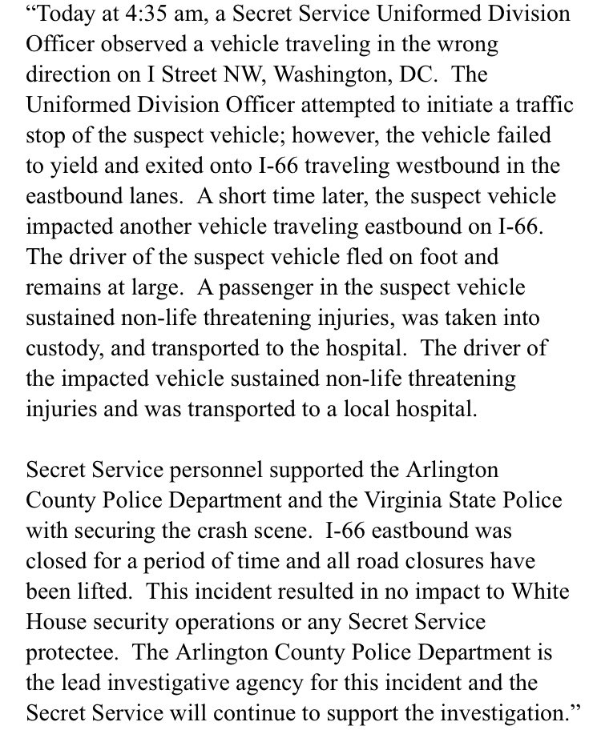
According to a spokesperson with the Secret Service, their officer attempted to stop a car traveling in the wrong direction on I Street NW DC. Now, let’s just hold it right there. Why would a Secret Service office try to stop a car at 4:30 in the morning? Why would it become necessary to escape by going the wrong way down I-66? It turns out that the Secret Service officer chased the suspect all the way into Virginia. That's when the driver got onto I-66 heading westbound in the eastbound lanes.
A short time later, the suspect crashed into two oncoming cars, got out of the vehicle, and ran away, leaving the injured passenger behind. The passenger in the suspect's car was transported to a nearby hospital with non-life threatening injuries and was taken into custody. The driver of the other car also suffered non-life threatening injuries.
One of the cars was straddling the concrete divider wall was almost torn in half. The man with that White House military pass was driving that car was tough enough to take a hit like that and then run away on foot and disappear.
The Secret Service has not identified the injured individuals. The Secret Service says neither White House security nor anyone protected by the agency was impacted. A description of the suspect has not yet been released.
The Secret Service did not immediately detail why they were on the scene. The identification of the officers is not being released. The names or conditions of the passenger and the injured drivers is not being released. If they were conscious, they may be able to identify the escaped suspect. The agency later said that Secret Service personnel helped to secure the scene. That is what happens when they want to make sure any classified evidence that may have been on the scene was not made public. Arlington County Police will now lead the investigation.
Clintons Undone
Okay, here is what we know. Bill and Hillary are together again. Well, not really together, together, but together on the same commercial flight without a security person in sight. Yeah, you heard me right. A commercial flight to JFK from somewhere on a smaller, older commuter jet like an MD-80 with a tiny first-class section. They were videoed in security being checked through by what appear to be Federal Air Marshalls. They were again videoed from across the aisle while the plane was loading from a position not more than 6 feet away. Who shot the video? Why was this person allowed to film the Clintons? Did they know they were being filmed? The book Bill Clinton was clearly holding on his lap was Crimson Lake by Candice Fox. Synopsis:
“Six minutes in the wrong place at the wrong time – that’s all it took to ruin Sydney Detective Ted Conkaffey’s life. Accused but not convicted of the brutal abdiction of a 13-year old girl, Ted is now a free man – and public enemy number one. He flees north to keep a low profile amidst the steamy, croc-infested wetlands of Crimson Lake.”
If you read the book, Charm of Favor, you will know that the Syndicate uses books in publicly-aired pictures to send coded messages to one another. Who received that message when it was posted on Instagram and Twitter? Without Secret Service going, “Hey what are you doing there?” Who got the message? Was this a veiled threat of blackmail if someone doesn’t step in and help them escape when they reach New York?

